THE COMMONWEALTH OF VIRGINIA
THE VISITORS OF JAMES MADISON UNIVERSITY

Governance Committee
April 21, 2022
Meeting Room 2

Agenda

- Approval of Minutes February 17, 2022 & March 23, 2022

- WMRA Delegated Signature Authority*
Jack Knight, University Legal Counsel

- Executive Committee Composition*

- Qualifications and Competencies of Board Members
- Board Retreat

- Board Self Evaluation

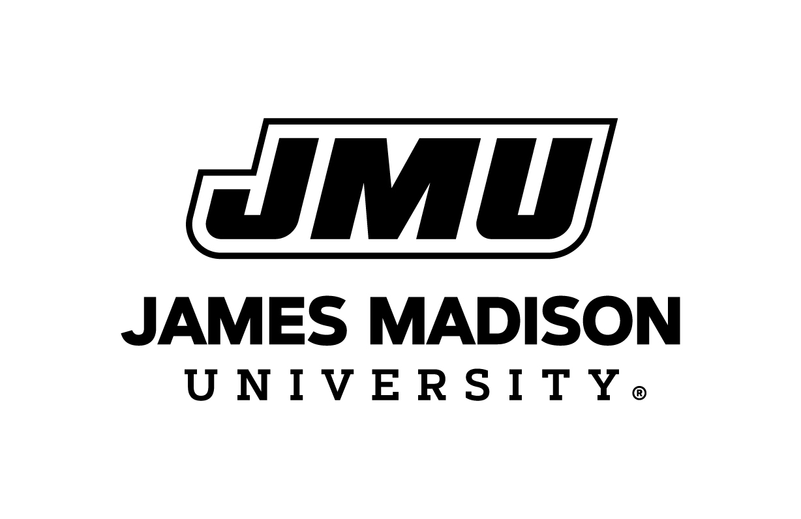
Board of Visitor
April 21,2022

