THE COMMONWEALTH OF VIRGINIA
THE VISITORS OF JAMES MADISON UNIVERSITY

Governance Committee
Thursday, February 17, 2022
Meeting Room 2
10:30 a.m.

Agenda

- Approval of Minutes – November 18, 2021 *

- Board Self Evaluation

- Nominating Committee Recommendations

- Executive Committee Composition

- Qualifications and Competencies of Board Members

- Professional Development

- Strategic Review of Trends and Long-Term Goals

* Action Required

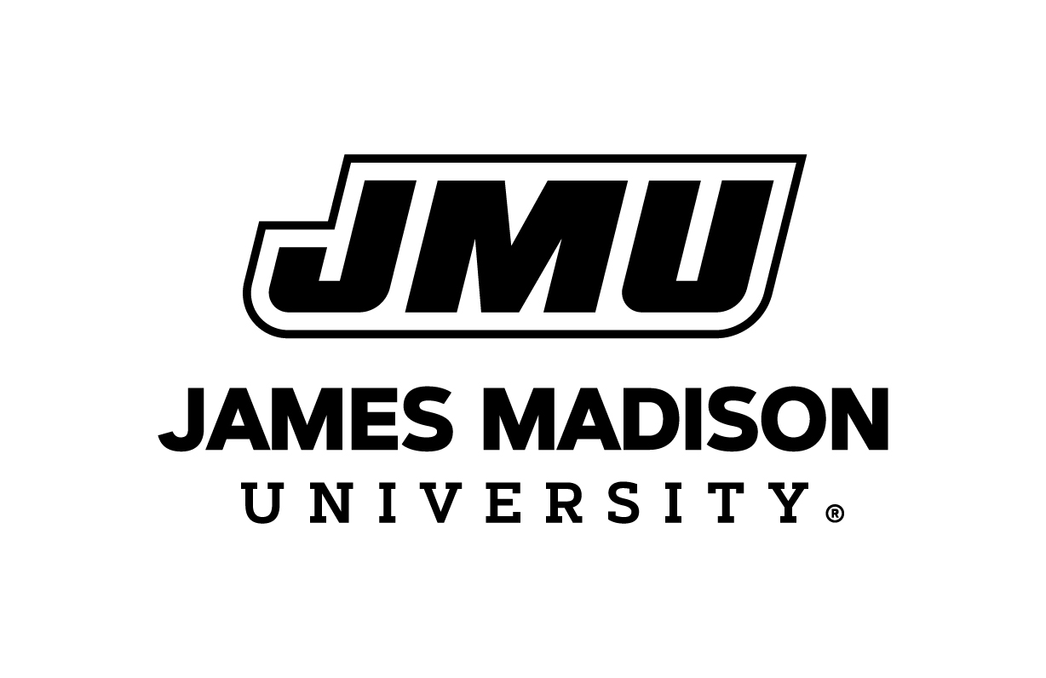
Board of Visitor
February 17, 2022

