THE COMMONWEALTH OF VIRGINIA
THE VISITORS OF JAMES MADISON UNIVERSITY

Ad Hoc Governance Committee
Thursday, September 23, 2021
Meeting Room 3
3:15 pm

Agenda

- Review committee structures

- Review the Board Manual for updates and revisions

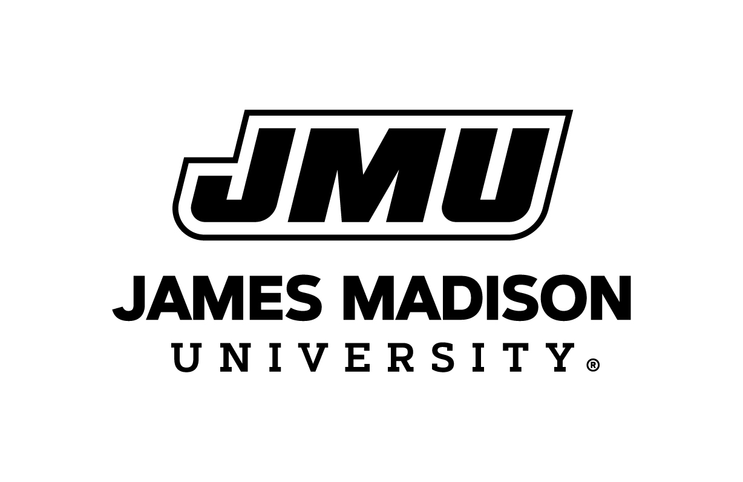
Board of Visitor
September 23, 2021

