The Union 256 (7/21)

Event Services: 540.568.5555 | Scheduling: 540.568.6330 | Email: theunion@jmu.edu | MSC 3506

**EVENT INFORMATION**

Event Title: _______________________________________________________________________

Event Date(s): _____________________________________________________________________

Event Time: ________ am / pm ________ am / pm

***\*\*NOTE: This is the actual time of your event and does not include set-up time\*\****  **Customer setup time must be scheduled ahead of time in EMS**

**CONTACT INFORMATION**

Org./Dept. Name: ________________________________________________________________

Contact/N&B Name: ____________________________ Contact/N&B Phone #: __________________________

Onsite Contact: ________________________________ Onsite Contact Phone #: _________________________

*If different from above*

**EVENT DETAILS**

*Included In Space: PC (or Laptop connection w/audio), LCD Projector, DVD, White Board, HoverCam*

Create Your Own: Please indicate on the diagram where you would like the equipment placed

____ 8’ Tables (max 41) ____ 5’ Round Tables (max 17)

____ Chairs (max 180)

Notes: ___________________________________________

_________________________________________________

_________________________________________________

Additional Equipment: Please indicate on the diagram where you would like the equipment placed

____ Wireless Mic (max 2) ____ Lapel Mic (max 2)

____ Coat Rack (max 2) ____ 10’ Pipe & Drape (max 10)

____ Portable Dry Erase Boards (max 2)

____ Portable Lectern (max 1)

Notes: __________________________________________

________________________________________________

*The Union Event Services Use Only:*

Ref#: ___________________ DATE REC:________________ INT:_____________ BM’s Approval: __________________________

Additional Customer Setup Time: START__________ END_____________

Details For Setup (early arrival): ____________________________________________________________________________________

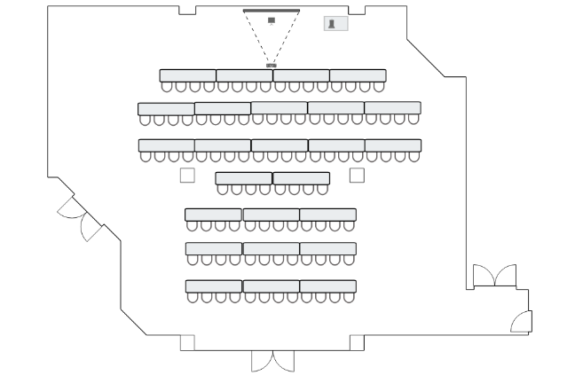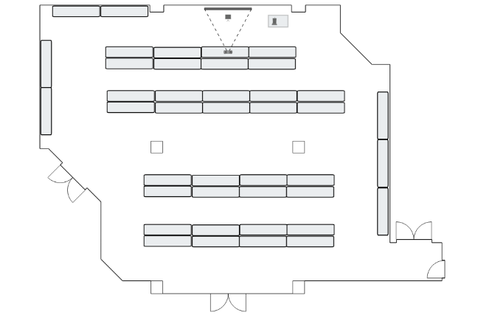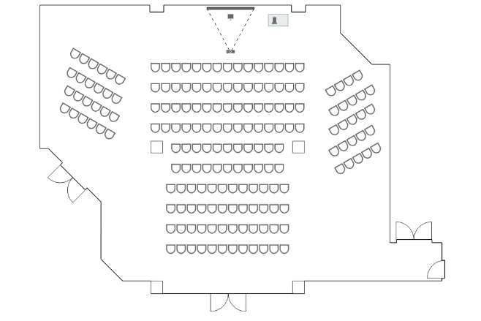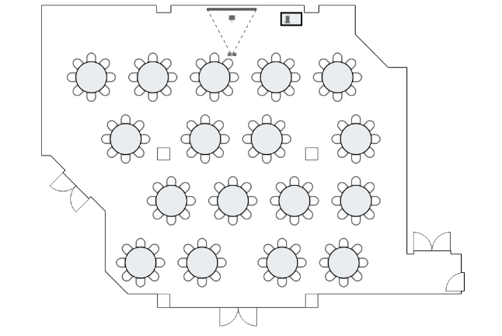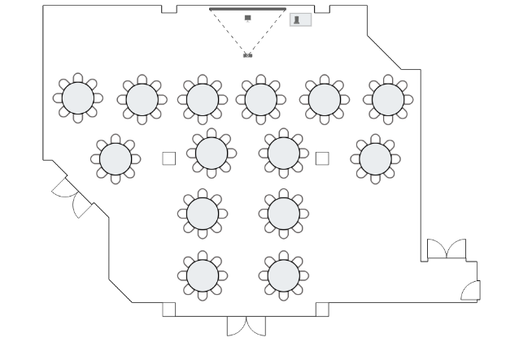

Banquet - no presentation (max 136)

Estimated Attendance: ________



Banquet - presentation (max 112)

Estimated Attendance: ________



Poster Fair (max 41 tables)

Estimated Attendance: ________



Classroom (max 108)

Estimated Attendance: ________



Theater (max 180)

Estimated Attendance: ________



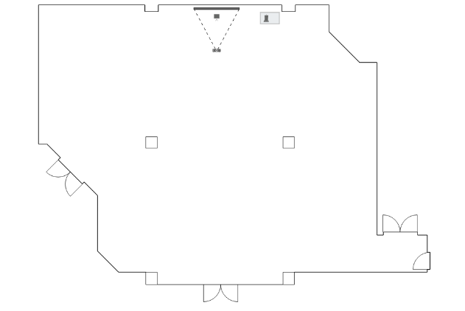

Create Your Own

Estimated Attendance: ________

