SA Purpose and Values Questionnaire Analysis

In November we sent out a survey to everyone in Student Affairs with the following prompt:
______________________________________________________________________________

In creating a new mission and vision for Student Affairs, we are essentially agreeing on a road map to lead us toward a new destination. As Student Affairs moves forward, some may find clearly marked and open roads that lead directly toward our intended destination. Others may come across roadblocks or detours that require rerouting or the building of entirely new roads. With our map in hand and destination in mind we can more easily work together to embrace the change required to achieve our goals, confront challenges along the road, and celebrate our successes.

We are reaching out today to ask you to take part in creating our map and choosing our destination. As we move forward into the future, it is essential that we move forward together. Thank you for taking the time to respond to the following prompts. Your input is invaluable in helping us craft a new mission and vision for Student Affairs at James Madison University.

- What should the purpose of Student Affairs be in the future?
- What comes to mind when you consider the following values?
  - Students First
  - Bold Leadership
  - Crossing Borders
  - Belonging
  - New Ways for Opening New Doors
  - Valuing and Caring for Our People
_________________________________________________________________________________

We received 103 responses to the survey. Below you’ll find the analysis of each of the seven prompts in the order they are listed above. Each section contains a bar graph that quantifies common themes/statements we found in your responses and a write up or bulleted list that will provide more nuance. We also chose to include specific responses (italicized and in quotes) that could serve as conversation starters.

I want to give a massive thank you to everyone that participated in the survey. Also, thank you to those members of the assessment council/others that participated in the analysis of the results: Jamie Williams, Aimee Stright, Sarah Sunde, Tripp Purks, and Gabe Gilmore. Each section was analyzed by at least two people with each of us taking 2-3 sections. We are planning to have someone available at each of the Strategic Planning Sessions to answer questions you might have. In the meantime, please don’t hesitate to contact me with any questions on the methods or information found below.

Best,

Jonathan Stewart
Associate Director of Finance, IT, and Assessment

Prominent Themes:
- Development of students’ knowledge/learning, skills/abilities, and values/attitudes/dispositions
  - Through programming and opportunities
    - Characteristics of programs/opps
      - Challenging
      - Engaging
      - Compliment curricular learning
      - Provide tools
      - Enriching
      - Balancing
      - Supportive
      - Holistic
      - Grounded in theory and assessment
      - Application based
  - Areas:
    - Academic
      - Transition
      - Access
      - Enrollment
    - Personal
      - Best version of self/self-actualization/self-awareness
      - Independence
      - Resilience/Coping Mechanisms
      - Connection
      - Leadership
      - Self-Authorship
      - Health & Wellness
      - Boundary setting
      - Cognitive Complexity
      - Emotional intelligence
    - Lifelong learning
      - Transitions
      - Consequences to actions
    - Career Readiness
      - Work ethics
      - Work-life balance
      - Time management
    - Cultural
      - Humility
      - Competence
      - Appreciation
    - Community orientation
      - contributing members of society
      - sense of community responsibility/social responsibility
- Divisional Characteristics
  - Adaptable
  - Understand student development
  - Compliments “academic experience”
  - “To become the national standard for student affairs”
  - Collaborative
  - Time orientation of services & support
  - Strong and organized leaders
  - Aligned with JMU mission
- Customer Service & Support
  - Working with “less privileged” students
  - “Support the overall academic mission of the university”
  - Managing student needs
  - Students first
  - “serve every JMU student equally and equitably…”
- Shaping climate and community
  - Safety
  - Building relationships and connections
    - Sense of belonging
  - Equity
  - Inclusivity
  - “finds a HOME at JMU”
  - Dismantling systems of oppression

Specific Responses/Conversation Starters:
- “Student affairs should be grounded in a holistic approach to student learning and development that recognizes and dismantles systems of oppression that impede the student experience. These systems include but are not limited to: racism, colonization, sexism, ableism, classism, etc. Student affairs professionals must recognize the role we play in perpetuating assumptions and systems that continue to impede student growth and development. Each office ought to center marginalized students and their experiences, challenge dominant narratives that limit possibilities, and advocate for new approaches and programs that embrace every student. Student affairs must be positioned in a way that allows every student to realize and maximize their agency as humans. We must shift our focus away from solely administration and embrace our role as educators and the responsibilities that encompass that orientation. These include creating equitable experiences, using inclusive practices and pedagogy, and grounding our work in critical and relevant theory.”

- The purpose of Student Affairs is to enhance student development by engaging students in co-curricular learning opportunities that challenge students to embrace themselves, others, and the world from diverse perspectives and experiences.

- To cultivate a climate and opportunities that elevate equity, challenge the status quo, build interpersonal connections, and encourage students to become the best version of themselves.

- To go beyond the classroom to ensure students have opportunities to explore their own identity and positionality in relation to others, the community, and the pursuit of social justice.
- “To facilitate the services and experiences that support and challenge JMU's students in their learning and growth.”

STUDENTS FIRST

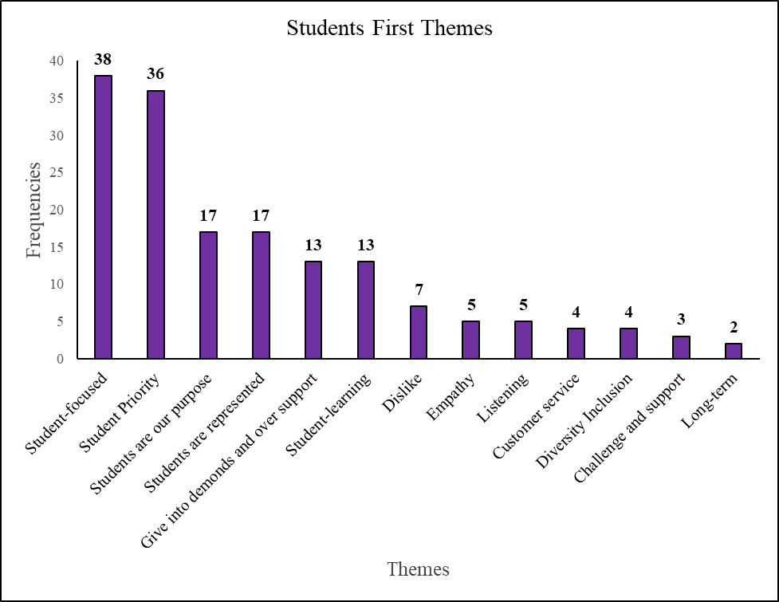

Prominent Themes:

- Need to do a better job thinking about underrepresented student populations, often we assume there is a single JMU student and that is not the case.
- Need student voices in the decision making process
- Students should be our priority
- Students are the divisions why, purpose, mission, reason, etc. that we do our work
- Tie to the university mission to promote citizenship, engagement, learning, long-term impacts, ethical reasoning, etc.
- Be mindful that we cannot speak to just one student experience
- Assist in the personal and academic growth of students
- Value the student experience
- Resources and services should align to meet student where they are

Specific Response/Conversation Starter

“Making sure that student outcomes are at the forefront of the work we do. Balancing satisfaction with the goal of developing students with a holistic approach. Helping student to understand the why behind policy and procedure that they may not initially agree with.”

The common interpretation is that students are the focus and priority of the work done at JMU, and many faculty and staff wrote that students are the reason why they are here and are at the core of everything they do. The most common critique of this theme is that it could mean giving in to everything the students want, even if it is not what is best for them. Instead of only putting their wants first, students should be given what they need to develop and grow. Questions regarding diversity issues were also common, such as which students are actually put first when different students’ wants and desires conflict? The vast majority of the feedback is positive and sees “students first” as meaning they should be considered as the highest priority for every decision that is made. Those who offered criticisms did not completely disagree with the statement, but could see certain shortcomings associated with it. Recommend another title that is based in Student Learning, Learning Centered, Student Success, Student Development to emphasize the learning, growth, and development that our division plays in a student experience.

Bold Leadership

Prominent Themes
- Try new things (All levels of staff should be empowered to do this)
  - Be innovative and forward thinking
    - Inspirational
  - Challenge the status quo
  - Test assumptions/ “history”
  - Don’t be afraid of failure
  - Take the risk/embrace uncertainty
- Do what is right, not popular
  - Speak out and up
  - Transparency (follow through)
- Lead with a vision
  - Have a “why” that guides our actions that is transparent
  - Trust in professionals (no micromanaging)
  - Encourage collaboration
    - within student affairs AND academic affairs
  - Pursue “big, hairy, audacious goals” (BHAG’s)
  - Make value based decisions
- Ask for feedback
  - Early and often
  - Wide range of professionals and students
- Put resources in the hands of professionals
  - Hiring
  - Programming
- Care about the professionals
  - Work-life
  - Spiritual
  - Professional growth
  - Celebrate staff members accomplishments (give credit where it is due)
  - Challenge and support
  - Create systems to retain and develop professionals
    - Especially within a culture of leadership

Specific Response/Conversation Starter

“create a community of thoughtful leaders who inspire and share a passion and vision for student-centered experiences”

Crossing Borders

Prominent Themes:
- Inclusion
  - Feeling accepted, welcomed
  - Open-mindedness
- Collaboration/Partnerships
  - Breaking down silos
  - Share strengths
  - Working towards a shared outcome/goal
- Respecting boundaries
  - Appreciating differences
- Challenge assumptions and encourage growth
  - How can we make this happen
  - Meet students where they are
- Open and honest communication
- Everyone has a seat at the table
- Collaboration
  - Focus on inclusion/diversity
  - Shared outcomes/goals
  - “True collaboration” and cooperation
- Breaking Down Silos
  - Safety to ask hard questions
  - Stepping out of comfort zone
- Cultural Humility
  - Respect and understanding of differences
  - Provide diversity of experience without burdening diverse students
- Concerns with the language/political connotation

Specific Response/Conversation Starter

“Willingness to pursue our purpose and mission in a way that transcends the artificial boundaries that traditionally define and constrain higher education. Thus it involves not just cooperation, but true collaboration and partnership, in and out of the division. “

Belonging
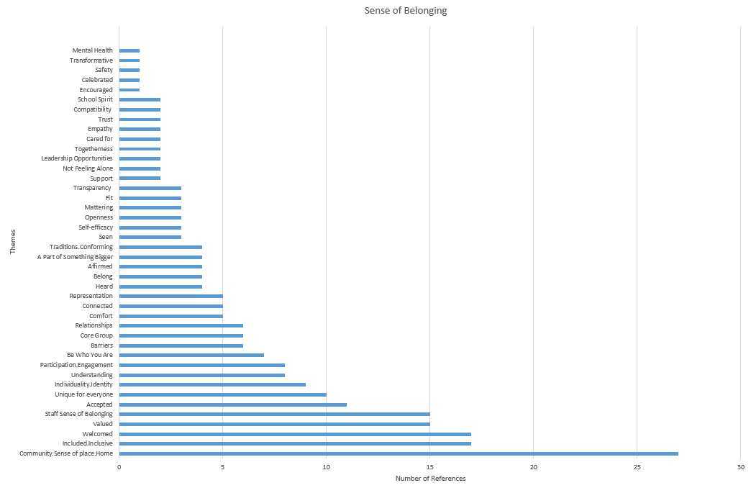

Prominent Themes:
- Community
  - a place to engage
  - a core group with comfort and trust
  - shared values
  - Finding “their people”
- Climate/JMU Culture
  - Currently, a sense of belonging is not is not the reality for many JMU students & staff
  - challenging hiring and enrollment practices
  - avoid stereotyping/norming of the “typical” JMU student
  - need to challenge systemic and JMU cultural barriers
  - striving to more explicitly reach folks with historically marginalized identities or dispositions that may be more hesitant to engage
  - Some mention tradition positively, but most referenced were made negatively
  - Not enough emphasis on the importance of “belonging” and the mental health implications that come with “loneliness”
  - Acknowledging the marginalization and systemic issues that have been perpetuated within the institution
  - The need to avoid putting the responsibility on folks with marginalized identities to be the only folks taking risks, dismantling systems, and teaching/informing others
  - Currently, unintentionally attributing associations to certain identities that we should not be
    - CMSS “only serves ‘one type of black person’”
    - SOGIE is housed within the Health Center “...we are linking identity groups to health which sends the wrong message and indirectly causes our students to believe there is something wrong with them…”
- Individuality
  - “belonging” is different for everyone
  - personal identity can play a significant role
  - providing space for contributions/direction/guidance from all
- Benefits
  - more willing to give back
  - more willing to support community mission
  - strengthens the community
  - retention
- Feeling
  - valued
  - heard
  - comfort
  - included
  - able to be who you are
  - accepted
  - welcomed
  - togetherness

Specific Responses/Conversation Starters
- “...to have a meaningful connection that is transformative in a way that best suits them, not that they feel they have to look and act a certain way to be part of the group. JMU has a strong culture of conforming and I think it is time for us to break down that culture and open it up to show that we are a community made up of many different backgrounds, races, ethnicities, abilities, sexual orientation, religions, etc. and we want students to explore their values, beliefs, and identities to find their place and transform this community because they are member of it, not just passively belong”
- “Creating a sense that every student and staff member feels they have a valued place in this community without sacrificing individuality or needing to compromise aspects of their identity.”
- “It’s absolutely imperative that we all pay attention to the things that make students feel as if they matter, as opposed to those things that make them feel marginalized. What that requires is that we change our culture: students will feel like they matter only when the university stops acting as if all students are the same.”
- “...Belonging begins and is founded on understanding of others'. We need to do that work first.”
- “Feeling included and a part of, not just a number to be in the “diversity count”. One of the best metaphors I have heard to describe this is “The quality of knowing that not only can you attend the dance but you can also actually dance and have a good time and experience it fully”.
- “Everyone must be allowed to show up how they need to show up. This means raising the awareness and consciousness of others to a level that supports this for every staff member and student. This includes intentional reflection and self-work and a willingness to engage in difficult conversations. Belonging also demands a fundamental shift in the culture. Currently, many marginalized students and staff members are caught in a double bind. They are told to be authentic, but invalidated when this behavior does not align with implicit and explicit expectations and assumptions. We only allow marginalized voices who are deemed “safe” to speak and lead conversations. If we are going to be about belonging, then the burden must be placed on privileged folks to shift their behavior and organizations to make this a reality. Marginalized folks should not feel the burden to fit into a culture that doesn't value them.”

New Ways for Opening New Doors

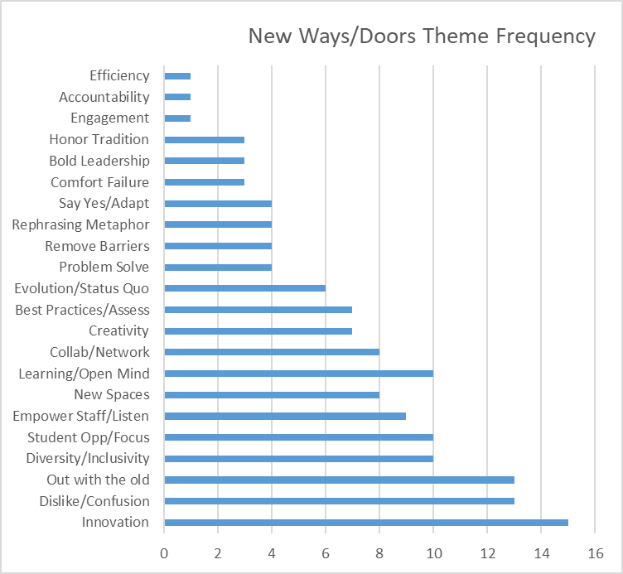

Prominent Themes:

- Innovation
  - New ideas/creativity
  - Creating new spaces
- Student Focus
  - Best practices
  - Adapt as student needs change
  - Culture of improvement/learning/development
- Remove Barriers/Empower Staff
  - Listen to all staff
  - Empower staff to make change
  - Collaboration
- Challenge the status quo
  - Push past the ‘old way’ mentality
- Inclusivity
  - Inviting new voices
  - Ensuring safe space for new voices is available
- General rephrasing/key words
  - Change, creativity, innovate, new path, new ideas, learning, evolve
- There is a decent amount of confusion/dislike for this phrase, wording, and what this implies.
  - general critique of the phrasing
  - fear of change
  - desire to honor tradition.

Specific Responses/Conversation Starters

“The significant problems we face cannot be solved at the same level of thinking we were at when we created them.” -Einstein

The overall interpretation is that we should be finding new and unique ways of learning and doing things. We shouldn’t accept the way things are because that’s how we’ve done it in the past, but should strive to challenge the status quo and find innovative ways of achieving our goals. An open mind is key. Many saw it as referring to breaking down barriers and making JMU more accessible/inclusive of students with diverse background and abilities. A few found it similar to Bold Leadership, and others thought it had many of the same faults as other values regarding the overgeneralization and need for clarifying statements. Some would prefer that the statement be more direct and say that we should be adaptable and flexible instead of summing it up in a “cliché” phrase.

Valuing and caring for our people

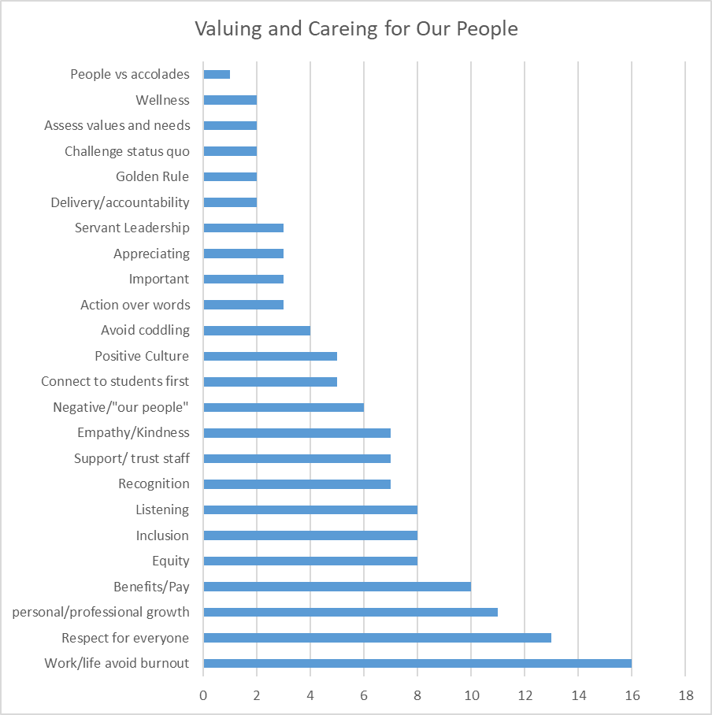

Prominent Themes:
- Actions speak loudly
  - Reflection in hiring practices?
  - Monetary reward (salary reflecting work)
  - Accountability
- See the individual, not the employee
  - Acknowledge successes
    - Show appreciation
  - Encourage culture of respect
  - Emphasize professional AND personal development
  - Mental health importance emphasized
- Clear expectations
  - Understanding of personal commitments
  - Culture of asking questions
  - “culture that doesn’t penalize saying “no” when you are unable to take on additional tasks.”
- How are we creating communities for our staff?
  - i.e. for different identities
- Seek Feedback (variety of methods)
  - Conversations
  - Surveys
- Create opportunities to grow
  - Professional development
    - Incorporate knowledge from SA in workshops
  - New skills
  - How can New SAPS model be applied in different levels
  - Promotions?
  - Emotion behind feeling valued?
- Concern that we are being exclusive by saying “our people”
  - How do we make this more inclusive “all people?”
- Thoughts to combine students first and this one because both encompass the sentiments of what is being conveyed and it is believed that this should encompass students and faculty/staff
- Comments were made that if we value/care for people then ultimately we will all be better
- Tension between who is valued – new student affairs professionals, staff with children, young professionals, and there needs to be consistency because we all have very different life circumstances.
- Push toward work-life balance, self-care, supporting personal lives, recognition that staff are not robots, etc.
- Taking time to get to know people and emphasize the relational aspect of our work
- Being trusted, respected, and not micromanaged to allow staff to do the job they were hired to do. Provide appropriate resources and feedback throughout the process
- Listening to others and not assuming what we think we know
- Setting clear expectations, consistency within the division. Being mindful that not everyone can get what they want and there will be times when people are uncomfortable, tough conversations will be had, etc.

Specific Response/Conversation Starter

- “We value and care for our students, our staff, and the larger JMU community. We provide students with resources so that they have equal footing among their peers. We treat each student as an individual.”

