




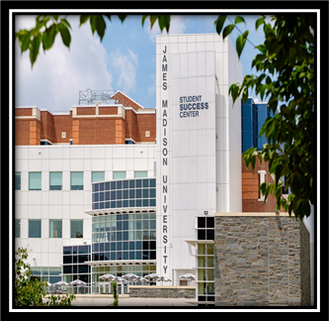
Student Employment Newsletter

August 2026

STUDENT ELIGIBILITY
Student Employees MUST be enrolled at least half-time (6 credit hours for undergrad/5 credit hours for grad).
Federal Work Study (FWS) Students will need to provide their Financial Aid Offer letter to show their FWS eligibility. This document needs to be kept in the student’s personnel file.

Please review our Website and the Supervisor & Student Employee Handbooks for all hiring information.

1 ON 1 TRAININGS

Need Student Employment training? Contact us for 1 on 1 or small group training by completing the Q uestionPro request form.
Possible agenda items:
- Overview of Student Employment
- Hiring Paperwork
- I9 Process
- Student Employment Policy and Procedures
- PageUp
- Hiring Procedures (PageUp, interviewing, hiring)
- 20-hour rule
- FWS

 JOB FAIR

The Part-Time Job Fair will be held on August 27th from 1 pm to 4 pm. Register HERE by August 22nd.

Be sure you are signed up through our ListServ to receive important Student Employment updates.

FEDERAL WORK STUDY (FWS)

This year, students who qualify for FWS will be eligible to earn up to $4,900. FWS hours and earnings should be tracked. We have a tracking spreadsheet on our Supervisor Resources page under Sample Forms. FWS student employees cannot start until the first day of classes, August 26, 2026, and must end by May 12, 2027.
If you need to hire FWS earlier than the first day of classes, you must hire as IE, then transfer to FWS on 8/26/26.

 TIMESHEETS
Supervisors are responsible for verifying that student employees are keeping accurate/up to date timesheets.
Be sure students do not exceed 20 hours per week, and are turning timesheets in on time to be paid accurately and on the correct pay date.
Please refer to Payroll Forms for up-to-date timesheets and instructions.

 I9's

It is prohibited that a student employee begin their employment before their I9 form is completed
(Sections 1 & 2).

For completion of Section 1 of the Form I9, provide this video to your students for instructions to complete Section 1 and the next steps for Section 2. Please visit the List of Acceptable Documents for I9 completion. For Section 2 the student employee will need to provide either one item from List A OR one item from BOTH Lists B and C at their scheduled appointment. All documents presented must be ORIGINAL and UNEXPIRED. No copies will be accepted.
A confirmation email that the I9 is complete and the student employee may begin working will be sent from studentjobs@jmu.edu. This will go to whoever the student says completed their hiring paperwork. If this confirmation needs to be sent to someone else please tell your student so they know who to tell us.
Under NO circumstances should the student employee be volunteering their time until the I9 is complete.

TRAININGS


SUPERVISING STUDENT EMPLOYEES
ON THURSDAY, AUGUST 6TH, 2026
1:30 PM - 3:30 AM
WINE-PRICE, PATHWAYS TRAINING CENTER, G006 MYMADISON - TD2577
STUDENT EMPLOYMENT ESSENTIALS TRAINING
ON THURSDAY, AUGUST 13TH, 2026
9:00 AM - 11:00 AM
WINE-PRICE, PATHWAYS TRAINING CENTER, G006 MYMADISON - TD1463



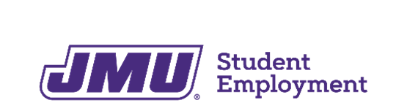

STUDENT EMPLOYMENT OFFICE STUDENT SUCCESS CENTER, 5TH FLOOR 738 S. MASON STREET
HARRISONBURG, VA 22807
MSC 3519
studentjobs@jmu.edu www.jmu.edu/student-employment

