

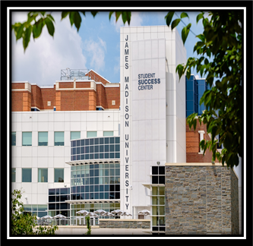
Student Employment Newsletter

March 2026

SUMMER AND FALL HIRING
Be sure to start posting your positions on PageUp for Summer and Fall. You can find instructions HERE on how to post.
For Institutional Employment (IE) it's best to begin hiring before Summer Break. That way hiring paperwork and I9s can be completed before Student Employment's busy season; Fall startup (August-September).
Federal Work Study (FWS) funds are not available for Summer positions. You can begin posting FWS positions on PageUp starting June 1st. Students should receive their Offer Letter from The Office of Financial Aid and Scholarships mid-June. The Offer Letter will notify students of their FWS eligibility. FWS student employees cannot start until the first day of classes, Wednesday August 26th, 2026 and must end by Wednesday May 12th, 2027.
If you need to hire FWS earlier than the first day of classes, you must hire as IE then transfer them to

FWS on 8/26/26.
 EPARS

1 ON 1 TRAININGS
Need Student Employment training? Contact us for 1 on 1 or small group training by completing the QuestionPro request form.
Possible agenda items:
- Overview of Student Employment
- Hiring Paperwork
- I9 Process
- Student Employment Policy and Procedures
- PageUp
- Hiring Procedures (PageUp, interviewing, hiring)
- 20-hour rule
- FWS

STUDENT EMPLOYEE APPRECIATION WEEK
This year, Student Employee Appreciation
Week will take place from April 13th to 17th, 2026.
This week serves as a time to show appreciation for all our Student Employees.

Some examples of appreciation can be: goodie bags, a potluck, "Thank You" notes, pizza, etc.

I9's
When submitting ePARs for your student employees, be sure of the following: Sections 1 and 2 of the I9 are complete, copies of Social Security Cards are legible, and that Position Descriptions (PD), Employee Information Forms (EIF), and/or Graduate Assistantship Contracts (GA) are signed.
We can only accept either physical/wet signatures or AdobeSign signatures.

Do not attach W-4, VA-4, or Direct Deposit Forms to the ePAR. Originals of those documents need to be mailed to Payroll Services at MSC 5706.
SEOTY
We’ve received all of your nominations for your outstanding Student Employees, Thank you!

A winner and two runner ups will be chosen from the nominations received. They’ll be acknowledged and awarded a Scholarship during the Student Employee of the Year Celebration.

The winner and runner ups will be announced during Student Employee Appreciation Week.


It is prohibited that a student employee begin their employment before their I9 form is completed
(Sections 1 & 2).

For completion of Section 1 of the Form I9, provide this video to your students for instructions to complete Section 1 and the next steps for Section 2. Please visit the List of Acceptable Documents for I9 completion. For Section 2 the student employee will need to provide either one item from List A OR one item from BOTH Lists B and C at their scheduled appointment. All documents presented must be ORIGINAL and UNEXPIRED. No copies will be accepted.
A confirmation email that the I9 is complete and the student employee may begin working will be sent from studentjobs@jmu.edu. This will go to whoever the student says completed their hiring paperwork. If this confirmation needs to be sent to someone else please tell your student so they know who to tell us.
Under NO circumstances should the student employee be volunteering their time until the I9 is complete.

TRAININGS


STUDENT EMPLOYMENT ESSENTIALS TRAINING
ON THURSDAY, MARCH 12TH, 2026
9:00 AM - 11:00 AM
WINE-PRICE, PATHWAYS TRAINING CENTER, G006 MYMADISON - TD1461
STUDENT EMPLOYMENT ESSENTIALS TRAINING
ON THURSDAY, APRIL 9TH, 2026
9:00 AM - 11:00 AM
WINE-PRICE, PATHWAYS TRAINING CENTER, G006 MYMADISON - TD1462



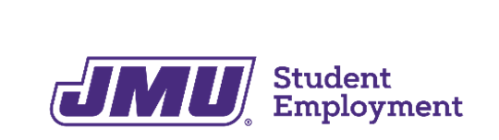

STUDENT EMPLOYMENT OFFICE STUDENT SUCCESS CENTER, 5TH FLOOR 738 S. MASON STREET
HARRISONBURG, VA 22807
MSC 3519
studentjobs@jmu.edu www.jmu.edu/student-employment

