www.newi9.com

Step 1:
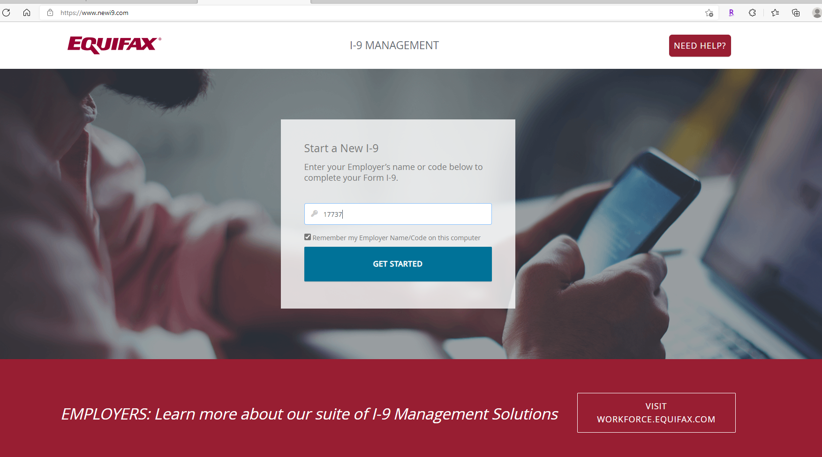

Employer Code: 17737
Click “Get Started”

Step 2:
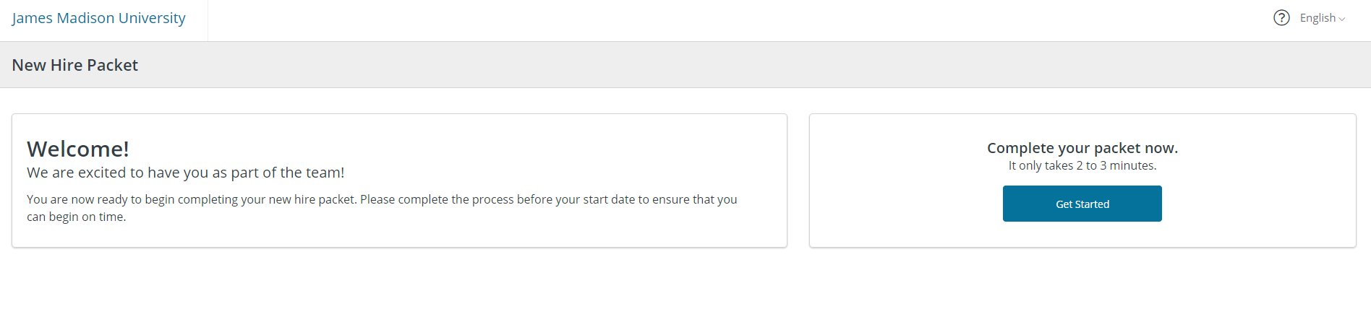
Click “Get Started”

Step 3:
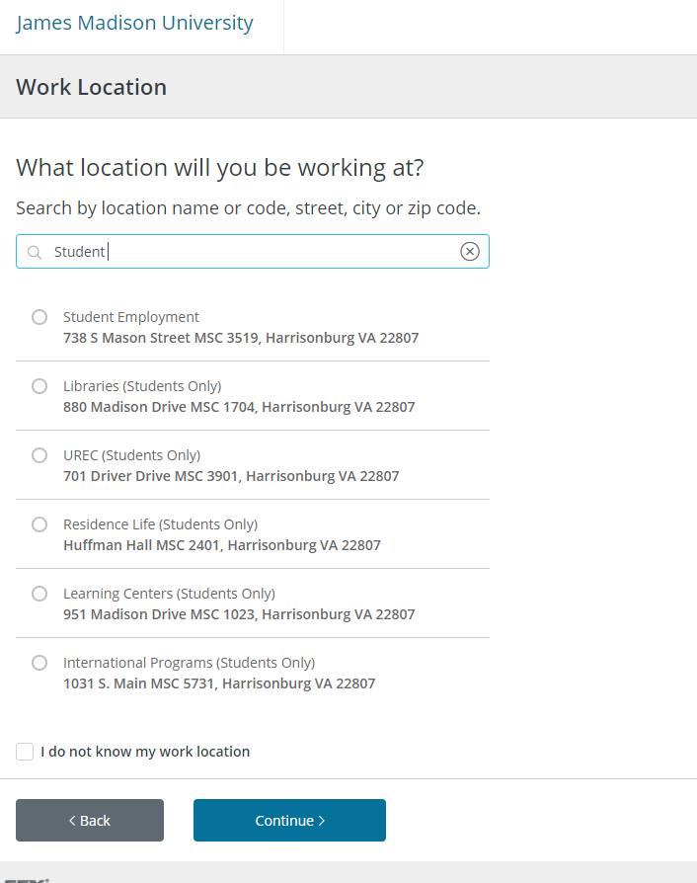
In the search box type “Student”
The above list will appear
Select – Student Employment
*If you student will be working in a Super User department they will need to select their respective department
Click “Continue”

Step 4: (next page)
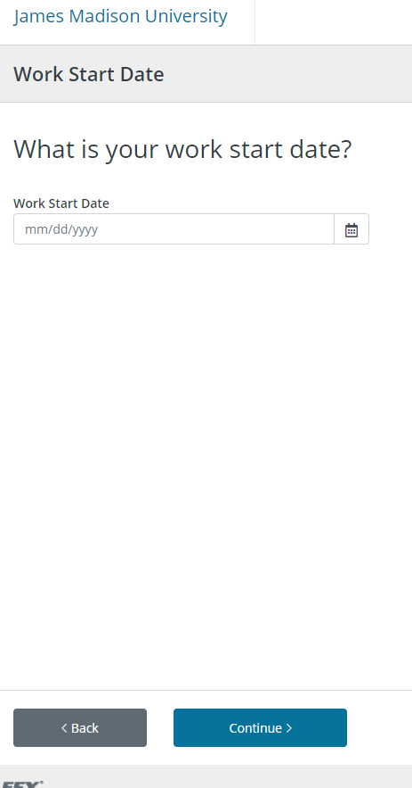
Enter intended start date

Step 5:
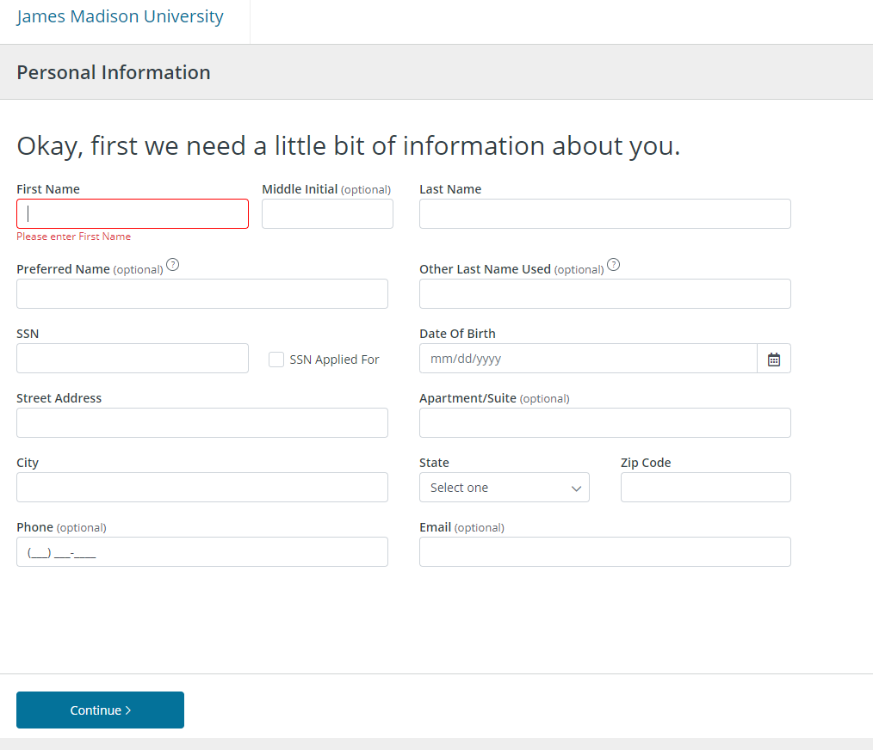

Enter personal information, click “Continue”

Step 6:
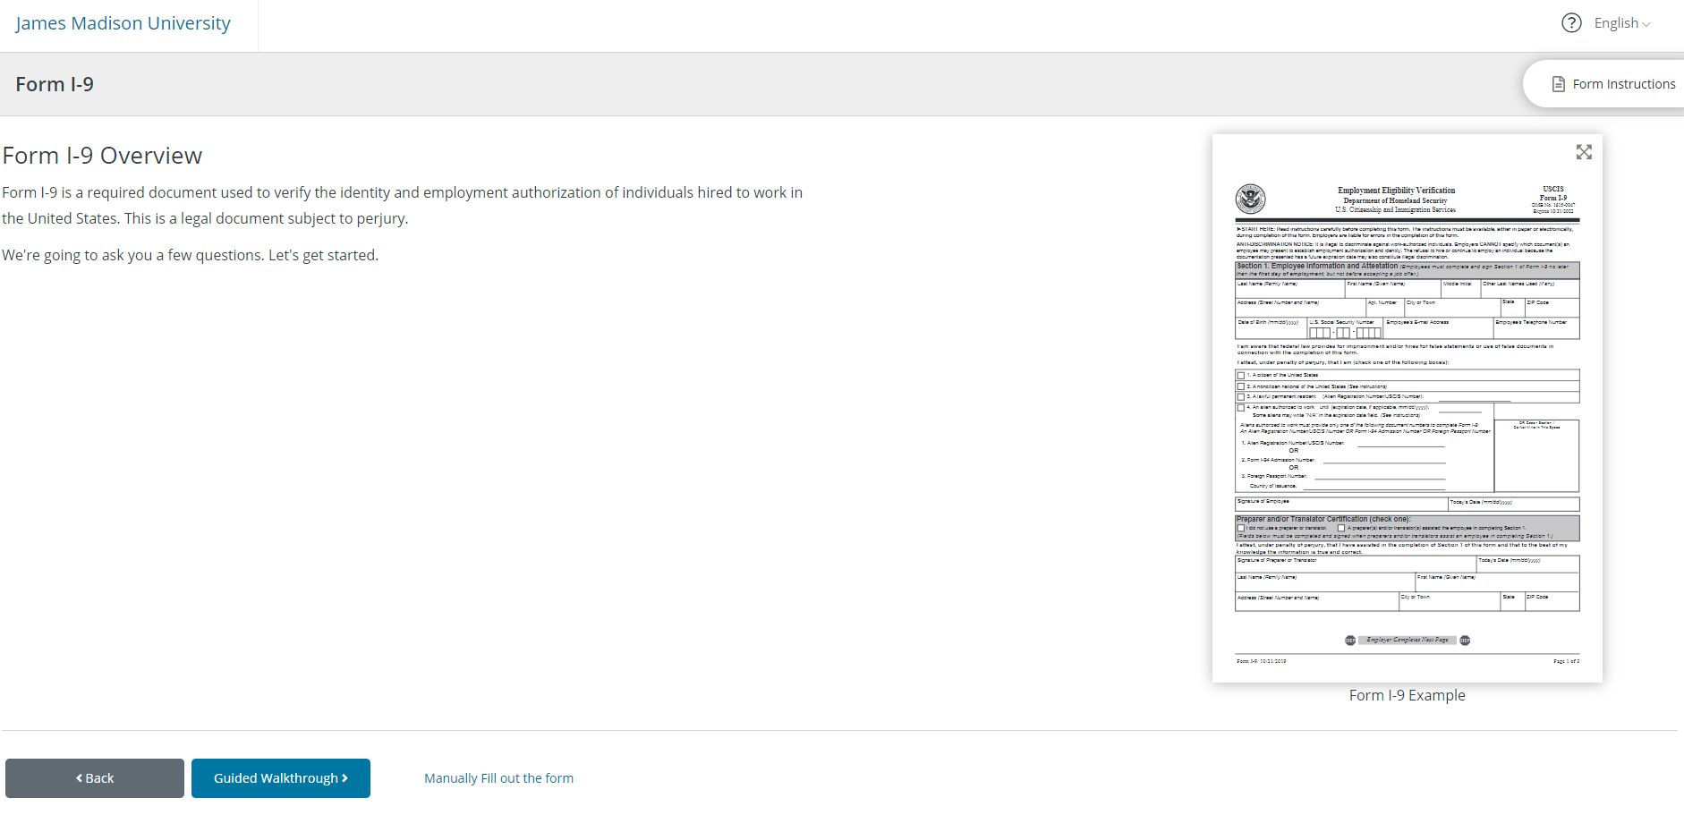
Read information, click “Manually fill out the form”
OR
Click on Guided Walkthrough if you wish for the system to take you through each box of section 1

Step 7: Manually fill out the form – selected
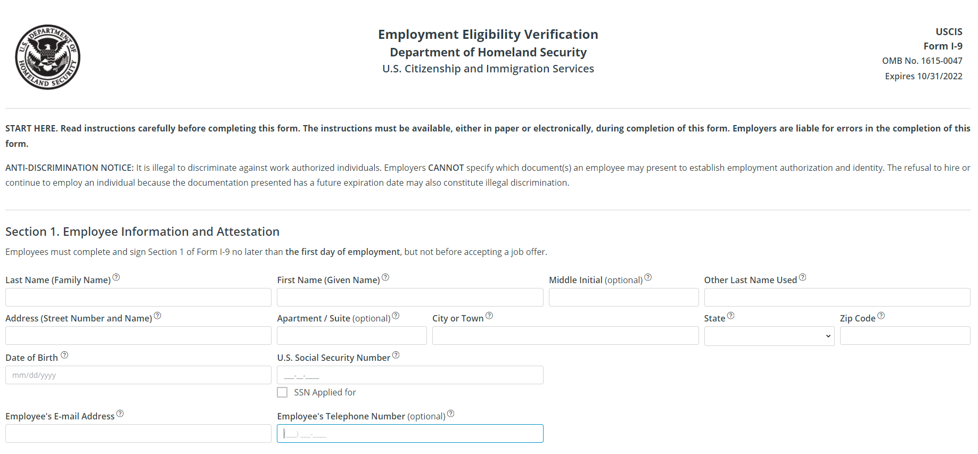
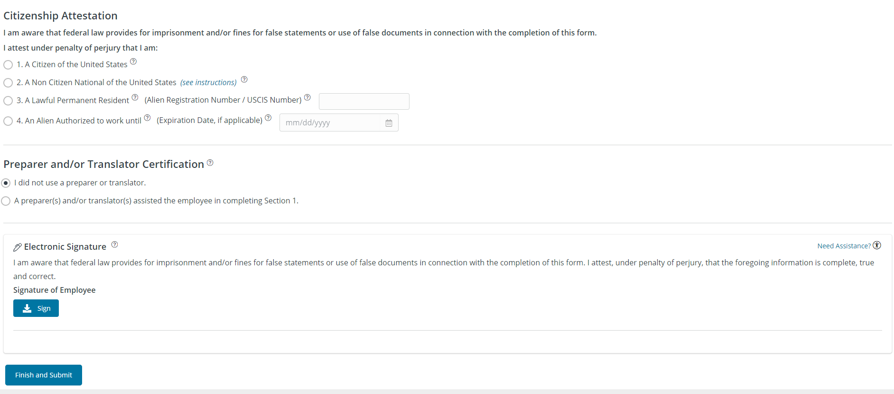
Complete, review, edit any errors, click “Sign”
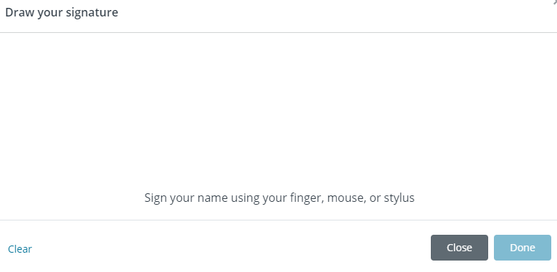
Sign and click “Done”
Click “Finish and Submit”

Step 8:
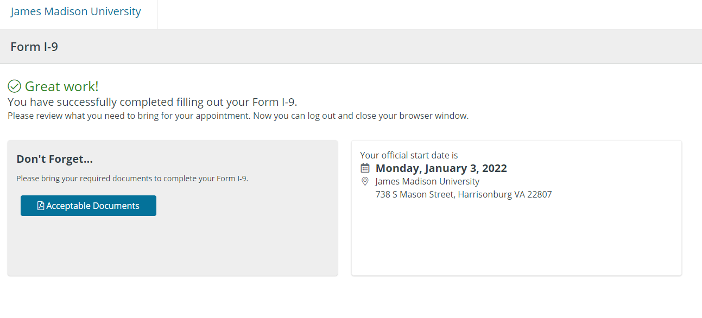
Click “Acceptable Documents” to view what documents the student will need to bring to the Section 2 appointment with Student Employment.
Section 1 of the I9 form is complete!

An email from studentjob@jmu.edu will be sent to the student with instructions on next steps to complete Section 2 of the I9 form.

