**Science On a Sphere**

**Programs for Middle School Groups: ready-to-implement lessons and a teaching tutorial**

**Pilot Version IV**

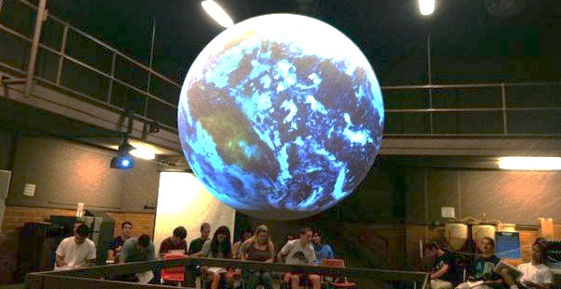

**Authors: Editors:**

**Jennifer Mangan, Ph.D. Christie-Joy B. Hartman, Ph.D.**

**Kristen St. John, Ph.D.**

**Reviewers: Christy Bradburn**

**Mace Bentley, Ph.D.**

**Robert Brent, Ph.D.**

**Hilary Peddicord**

***Development of this material was partially supported by a grant from the Ohrstrom Foundation.***

Table of Contents

Overview of the Lessons 3

Acknowledgements 4

Lesson 1: Globes vs. Maps 5

Lesson 2: Hurricanes 10

Lesson 3: Tornadoes 34

Supplemental Material: Teaching Demonstration Video 43

# Overview of the Lessons

The purpose of the lessons in this manual is to provide teachers and facilitators with a relevant and effective resource for teaching with Science On a Sphere (SOS) and assessing students’ learning. The lessons were developed for use with middle school students but could be adapted to other grade levels. Where feasible, lessons were correlated to the Virginia Standards of Learning (SOLs) and the Next Generation Science Standards.

The manual includes:





Learning Objectives[[1]](#footnote-1) Presentation Tips



Correlations to Virginia SOLs Instructor Script



Correlations to Next Generation Audience Frequently Asked

Science Standards Questions (FAQs)



Dataset Descriptions Pre & Post Lesson Assessment



Student Handouts & Worksheets

The manual also includes instructions to access a supplemental video that illustrates an interactive lesson with Science On a Sphere. The video is interspersed with commentary regarding pedagogy with SOS.

The manual is in pilot form. Please email [stewardship@jmu.edu](mailto:stewardship@jmu.edu) if you have any feedback on the lessons presented here.

# Acknowledgements

# The editors thank James Barnes, Instructor, Department of Integrated Science and Technology for his work assembling and editing some parts of the manual. We also thank Mace Bentley, Professor, Geographic Science Program, School of Integrated Sciences, Robert Brent, Associate Professor, School of Integrated Sciences and Hilary Peddicord, Education Specialist, National Oceanic and Atmospheric Administration for reviewing this manual. We appreciate the grant from the Ohrstrom Foundation that partially supported this work.

# Lesson 1: Globes vs. Maps

Content adapted from NOAA Research-Forecast Systems Laboratory; original material “Lessons for Teachers No. 1: Map versus Globe” at <https://sos.noaa.gov/_media/cms/lessons/SOS_Lesson_1.pdf>

Run time: 15 minutes



## Learning Objectives

Students will be able to compare and contrast images on a map and a globe. Students will be able to apply the concepts of distance, direction, scale, and area and articulate how they can be distorted when representing a round object on a flat surface.

## ::::::Icons:noun_93125_cc.png

## Correlations to Standards of Learning

WG.1: The student will use maps, globes, satellite images, photographs, or diagrams to:

1. obtain geographical information about the world’s countries, cities, and environments;
2. apply the concepts of location, scale, map projection, or orientation;

## 

## Datasets

**Blue Marble**

The Blue Marble is a detailed, true-color depiction of the Earth. The cloud image is a composite of three days’ worth of data. <http://sos.noaa.gov/Datasets/dataset.php?id=82>



## Handout

**World Map Based on Miller Projection**

<https://sos.noaa.gov/_media/cms/lessons/SOS_MillerProjColor_Final.pdf>



Presentation Tips

* You may want to introduce the lesson by talking briefly about spherical displays and how SOS in particular was developed (see https://sos.noaa.gov/what-is-sos/history-of-sos/), but be sure that the depth of technical detail is appropriate for a middle school audience.
* If your students are not familiar with images of global environmental data, it may be helpful to begin the lesson by showing “GLOBE: Students of the Earth Movie” (see https://sos.noaa.gov/datasets/globe-students-of-the-earth-movie/).



## Instructor Script

## 

**Blue Marble**

*Welcome to Science On a Sphere, developed by the National Oceanic and Atmospheric Administration (NOAA). You’ll see the sphere appears as a globe – a spherical model that represents the Earth on a smaller scale. The image is a detailed, true-color depiction of the Earth. Can you find North America? Asia? The Atlantic Ocean? The Pacific Ocean? Antarctica? Greenland?*

*Sometimes, the Earth, or part of the Earth, is represented on a two-dimensional (flat) surface. This representation of the Earth is called a map.*

*How are maps and globes similar and different?*

* + Both provide us with information about the world.
  + A globe is a sphere; a map is flat.
  + A map is more convenient to carry.
  + Maps can be used to focus on a small area of the Earth closer up. Even the large globe here shows relatively little detail.

*A map projection is a means of representing all or part of the round Earth on a flat surface. I am handing out a map based on the Miller projection. You’ll see the map uses colors to illustrate elevation of the land above sea level. Greens are for the lowlands, yellow for middle elevations, and orange and brown for highlands.*

*We are going to compare this map to the globe.*

For the questions below, accept any logical answers and encourage observations and inferences.

*How does the appearance of Antarctica differ on this map compared to the globe?*

* + On this map, Antarctica appears long, narrow, and enormous!
  + On the globe, Antarctica appears smaller and more round.

*How does the appearance of Greenland differ on this map compared to the globe?*

* + On this map, Greenland looks larger and wider.
  + On the globe, Greenland looks smaller and narrower.

*What can you conclude about shape and size on a globe compared to this map? Which is more accurate to scale?*

* + The Miller projection does not accurately display polar areas. The distortion of areas and shapes is extreme in high latitudes.
  + Scale is more accurate on the globe.

Use the overlay feature to show the names of countries. Ask students to locate Cape Horn, Chile and Tasmania, Australia on their flat maps.

*Looking at your map, what is the most direct route from Cape Horn, Chile to Tasmania, Australia?*

* + On this map, the most direct route appears to be a straight line over the ocean between the South Africa and Antarctica.

Stop the animation on the Sphere so that the geographic locations above are visible. Tilt the Sphere to allow a clear view of Antarctica. Using the laser pointer trace the path between Cape Horn and Tasmania staying over the ocean between South Africa and Antarctica.

*Is there a more direct route between these two locations?*

* + Yes, heading south over Antarctica is much shorter distance.

Note: Point out that the route would look straight in Google Earth, for example. But it could look curved on the Sphere because the laser pointer is literally moving over the curved sphere. A useful resource regarding this is <http://gis.stackexchange.com/questions/6822/why-is-the-straight-line-path-across-continent-so-curved>.

You can repeat this activity for travel between Seattle, Washington and Astana, Kazakhstan.

*What can you conclude about the distances and directions on this map compared to the globe?*

* + Distances are more accurate and direct routes are easier to find on a globe than on this map.

*“A map projection is used to portray all or part of the round Earth on a flat surface. This cannot be done without some distortion. Every projection [including the Miller projection] has its own set of advantages and disadvantages. There is no ‘best’ projection. Every flat map misrepresents the surface of the Earth in some way. No map can rival a globe in truly representing the surface of the entire Earth. However, a map or parts of a map can show one or more—but never all—of the following: True directions. True distances. True areas. True shapes.”* (source: <https://egsc.usgs.gov/isb//pubs/MapProjections/projections.html>).

*The choice of map depends on how the map will be used.*

## Pre & Post Assessment



The following assessment can be given to measure student knowledge before and after the lesson.

*1. Which of the following may be distorted on a map?*

1. Distance
2. Landmass Shape
3. Landmass Size
4. **All of the above**

*2. On a map based on the Miller projection, the poles (Antarctica and Greenland) appear \_\_\_\_\_\_\_ than they really are.*

1. Smaller
2. **Larger**

*3. Which two continents are actually closer than they appear on a map based on the Miller projection?*

1. North America & South America
2. North America & Africa
3. **Africa & Australia**
4. Africa & Europe

*4. The shortest actual travel distance between two cities can always be found by drawing a straight line between the cities on a map.*

1. True
2. **False**

# Lesson 2: Hurricanes

By Jennifer Mangan, Ph.D., Associate Professor, Department of Interdisciplinary Liberal Studies, James Madison University

Run time: 45 minutes



## Learning Objectives

Students will be able to identify the main ingredients for hurricane formation. They will be able to identify the stages of hurricane development, where they develop, and the paths they take. The Coriolis Effect and its influence on these storms will be discussed and the role of latent heat will be addressed.

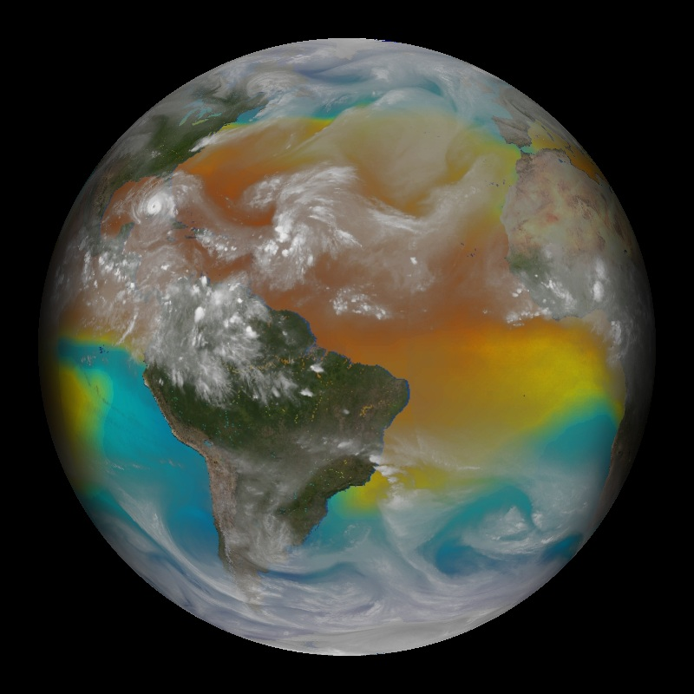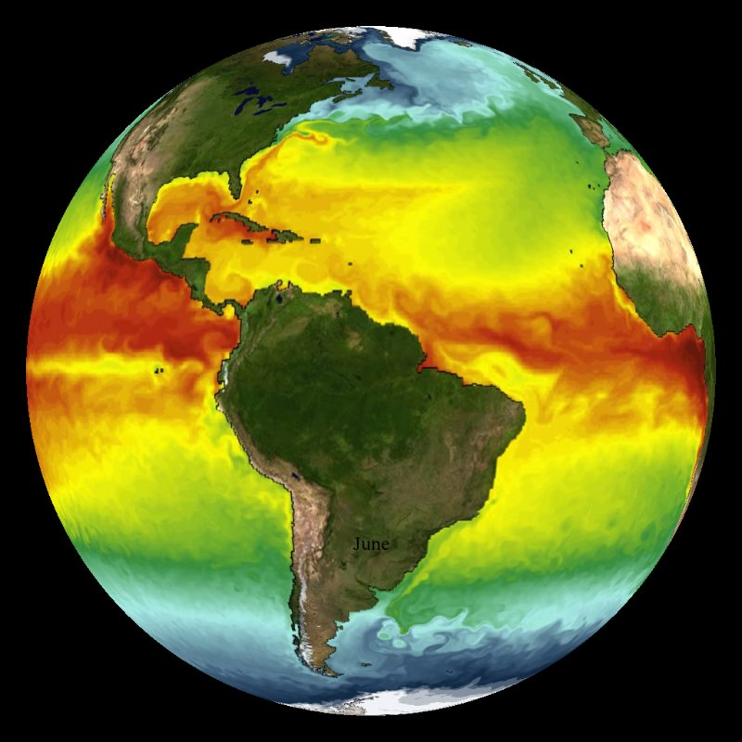

***Left: Hurricane Season: Water Vapor and SST – 2005[[2]](#footnote-2)***

***Right: Sea Surface Temperature NOAA Model (with vegetation)[[3]](#footnote-3)***



## Correlations to Virginia Standards of Learning

ES.12: The student will investigate and understand that energy transfer between the sun and

Earth and its atmosphere drives weather and climate on Earth. Key concepts include:

1. Observation and collection of weather data
2. Prediction of weather patterns
3. Severe weather occurrences, such as tornadoes, hurricanes, and major storms

SS. 4.6: The student will investigate and understand how weather conditions and phenomena occur and can be predicted. Key concepts include:

1. Weather phenomena
2. Weather measurements and meteorological tools
3. Use of weather measurements and weather phenomena to make weather predictions.

# Correlations to Next Generation Science Standards

ESS2.C: The Roles of Water in Earth’s Surface Processes

* + The complex patterns of the changes and the movement of water in the atmosphere, determined by winds, landforms, and ocean temperatures and currents, are major determinants of local weather patterns. (MS-ESS2-5)

ESS2.D: Weather and Climate

* Weather and climate are influenced by interactions involving sunlight, the ocean, the atmosphere, ice, landforms, and living things. These interactions vary with latitude, altitude, and local and regional geography, all of which can affect oceanic and atmospheric flow patterns. (MS-ESS2-6)
* Because these patterns are so complex, weather can only be predicted probabilistically. (MS-ESS2-5)
* The ocean exerts a major influence on weather and climate by absorbing energy from the sun, releasing it over time, and globally redistributing it through ocean currents. (MS-ESS2-6)



## Datasets

**Blue Marble**

The Blue Marble is a detailed, true-color depiction of the Earth. The cloud image is a composite of three days’ worth of data. <http://sos.noaa.gov/Datasets/dataset.php?id=82>

**Hurricane Season – 2012**

The 2012 Atlantic hurricane season shown in this dataset tied several other years as the third most active year in recorded history. <http://sos.noaa.gov/Datasets/dataset.php?id=372>

**Sea Surface Temperature NOAA Model (with vegetation)**

This dataset shows how the global ocean's surface water temperatures vary over the course of a few years. In addition to seeing the effects of the seasonal cycle, the viewer can see how surface ocean currents and eddies transport heat and water around the globe. The images were generated from a state-of-the-art computer model of Earth's climate created at NOAA's Geophysical Fluid Dynamics Laboratory (GFDL). <http://sos.noaa.gov/Datasets/dataset.php?id=132>

**Hurricane Season: Water Vapor and SST – 2005**

This dataset is a water vapor satellite image with sea surface temperatures below it available from June 30, 2005 through October 31, 2005. Because water vapor emits radiation, satellites can be set to detect water vapor in the atmosphere. All clouds contain water vapor, so when the satellite detects an area with a high concentration of water vapor, it is detecting a cloud. The clouds in hurricanes are easy to detect because they are well formed and contain an excess of water vapor.

<https://sos.noaa.gov/Datasets/dataset.php?id=2>

**Hurricane Tracks: Cumulative – 1950-2005**

The dataset shows the paths of all tropical cyclones from 1950 through 2005. Circles represent tropical cyclones, squares represent subtropical cyclones and triangles represent extratropical cyclones. The colors indicate the maximum sustained wind speed. <http://sos.noaa.gov/Datasets/dataset.php?id=5>

**Hurricane Season – 2005**

This dataset shows the 2005 hurricane season, the first season in which four major hurricanes hit the U.S. Hurricane Katrina was one of those major storms. It was one of the strongest storms to impact the U.S. coast during the last 100 years, causing widespread devastation along the central Gulf Coast. <http://sos.noaa.gov/Datasets/dataset.php?id=3>

**Wave Heights – Hurricane Katrina 2005**

This animation shows predicted wave heights from a NOAA wave forecasting model, called WAVEWATCH III®. Model predictions are shown in the Atlantic Ocean during the time period that Hurricane Katrina occurred. <http://sos.noaa.gov/Datasets/dataset.php?id=490>

**Hurricane Season - 2017**

2017 was the most costly hurricane season on record and tied for fifth as the most active season since records began in 1851. This visualization names both Atlantic and Pacific hurricanes in 2017, including record-breaking hurricanes Harvey, Irma, Maria, and Ophelia.

<https://sos.noaa.gov/datasets/hurricane-season-2017/>

**Hurricane Harvey: Clouds with Precipitation - 2017**

Hurricane Harvey was an extremely destructive Atlantic hurricane which became the first major hurricane to make landfall in the U.S. since Wilma in 2005. Harvey captured a record for the wettest tropical hurricane in the contiguous U.S. dropping over 51 inches of rain in southeastern Texas. Harvey could very well also be the most expensive hurricane in U.S. history, with estimates of damage topping 200 billion dollars.

<https://sos.noaa.gov/datasets/hurricane-harvey-clouds-with-precipitation-2017/>

**Hurricane Irma: True Color (GOES-16) - 2017**

This True Color animation showing Hurricane Irma and a little bit of Hurricane Maria (also seen is a Pacific tropical cyclone named Katia), is made from NOAA's next generation GOES-16 satellite before it became operational as GOES-East. GOES satellites orbit about 22,000 miles from the surface of the Earth in geostationary orbit and because they rotate with the Earth, they only see one hemisphere.

<https://sos.noaa.gov/datasets/hurricane-irma-true-color-goes-16-2017/>

**GOES-16 Tracks the Big Three**

This short movie recaps highlights of Hurricanes Harvey, Irma, and Maria featuring GOES-16 ABI imagery, plus a loop of Hurricane Harvey displayed with Geostationary Lightning Mapper (GLM) data.

<https://sos.noaa.gov/datasets/goes-16-tracks-the-big-three/>

**Sea-Surface Temperature Anomaly - Real-time**

This real-time sea surface temperature visualization is provided by the NOAA Visualization Lab using data from NOAA’s Coral Reef Watch. The data combines measurements from all current geostationary and polar-orbiting satellites, including U.S. satellites and those of international partners such as Japan and Europe. Those measurements are then subtracted from the long-term mean SST for that day to create the anomaly. Since the data is at 5 km/pixel resolution, not only can you see large-scale patterns such as El Nino and La Nina, but also many smaller features, such as hurricane wakes.

<https://sos.noaa.gov/datasets/sea-surface-temperature-anomaly-real-time/>

**Clouds (colorized) – Real-time**

This visualization is a composite of GOES, Meteosat, and MTSat satellite data. Meteosat and MTSat are similar to GOES, but are operated by other countries. This real-time, color enhanced visualization is shaded so that the significant clouds are brightly colored in order to stand out from the surface. The lowest clouds are white, medium level clouds are shades of purple, and the highest clouds are teal. The background of this image is the "Blue Marble." The data is consistently updated so that the past thirty days of data are available.

<https://sos.noaa.gov/datasets/clouds-colorized-real-time/>

## Hurricane Tracking Worksheet (Page 1 of 4)



Hurricane Sandy is famous for doing a lot of damage to the U.S. coast, especially in New Jersey. It also hit the Virginia coastline. Using the coordinate data and the Atlantic Basin Hurricane Tracking chart, plot the hurricane’s track.

**Plotting tips**:

* Longitude and latitude may be displayed as degrees, minutes and seconds or as decimals. In this case, longitude and latitude are displayed as decimals. To make the points easier to plot on your map, you may want to round the decimals to the nearest whole number in the space provided.
* Note where the storm changes category, e.g. from tropical storm to hurricane, or between hurricane categories. Use these symbols:

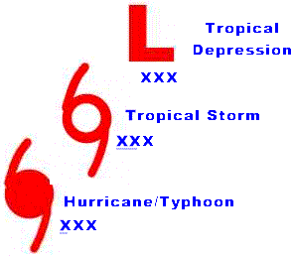tropical storm  tropical depression  hurricane/typhoon[[4]](#footnote-4)

* It is not necessary to use the above symbols for every point, just where the category changes.
* After you have made your dots on the map corresponding to the latitudes and longitudes on the data sheet, connect each storm’s dots lightly with your pencil.

## Questions

1. Where on the Earth did this storm originate? Why do you think it formed there?

2. What weather conditions do you think exist where the storm was formed?

3. Where does the storm completely die out? Why do you think this happens?

## ::::::Icons:noun_26704_cc.png Hurricane Tracking Worksheet (Page 2 of 4)

4. Do you think we are likely to have a big hurricane problem here at our location? Why or why not?

5. The Saffir-Simpson Hurricane Wind Scale is a 1 to 5 rating based on a hurricane's sustained wind speed. This scale estimates potential property damage.

a. What is the highest category of hurricane that Sandy reached according to the Saffir-

Simpson Hurricane Wind Scale (below)? Circle your answer in the table below.

b. What type of damage can be expected as a result? Underline your answer in the table

below.

**Table 1. Saffir-Simpson Hurricane Wind Scale**

**(table source:** [**http://www.nhc.noaa.gov/aboutsshws.php**](http://www.nhc.noaa.gov/aboutsshws.php)**)**

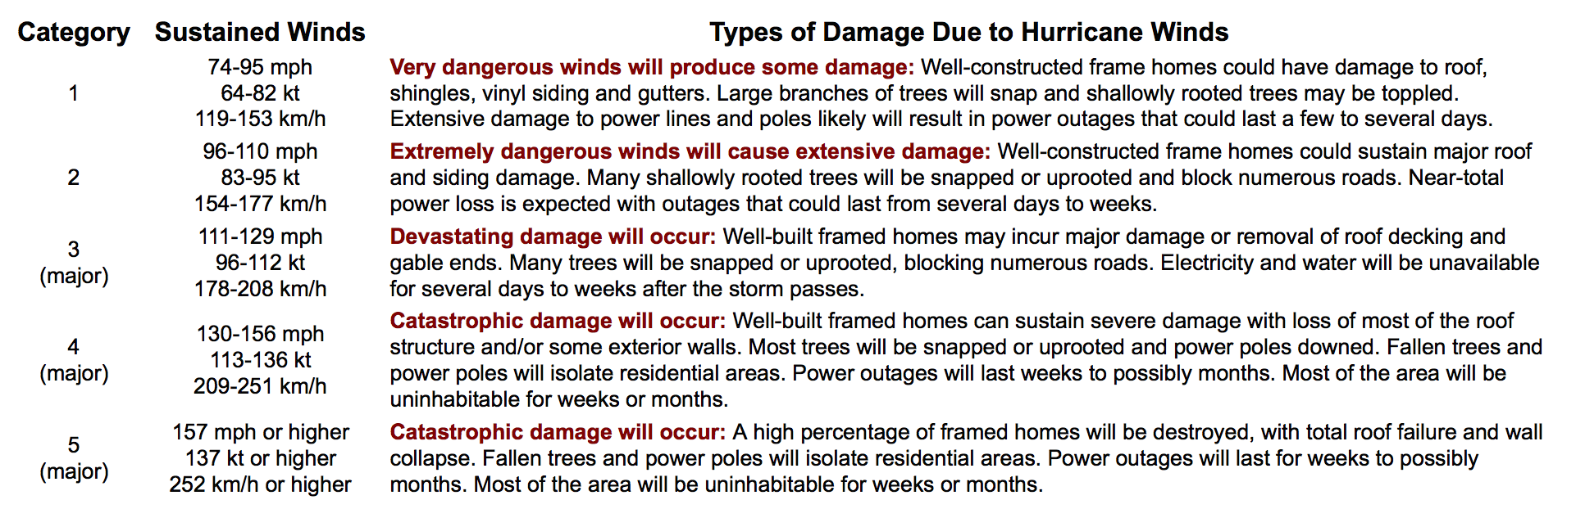

6. Why did Hurricane Sandy do so much damage in New Jersey but a lot less damage in Virginia?

## Hurricane Tracking Worksheet (Page 3 of 4)



**Table 2. Best Track for Hurricane Sandy, October 22-29, 2012**

**(source:** [**http://www.nhc.noaa.gov/data/tcr/al182012\_sandy.pdf**](http://www.nhc.noaa.gov/data/tcr/AL182012_Sandy.pdf)**)**

|  |  |  |  |  |  |  |
| --- | --- | --- | --- | --- | --- | --- |
| Date/Time (EST) | Latitude (N) | Latitude (N) rounded to nearest whole degree | Longitude (W) | Longitude (W) rounded to nearest whole degree | Wind Speed (kt) | Stage |
| 10/22/12; Noon | 13.1 |  | 78.6 |  | 30 | Tropical depression |
| 10/22/12; 6:00 pm | 12.7 |  | 78.7 |  | 35 | Tropical storm |
| 10/23/12; Noon | 12.6 |  | 78.4 |  | 40 | Tropical storm |
| 10/24/12; Midnight | 14.7 |  | 77.3 |  | 55 | Tropical storm |
| 10/24/12; 6:00 am | 15.6 |  | 77.1 |  | 60 | Tropical storm |
| 10/24/12; Noon | 16.6 |  | 76.9 |  | 65 | Hurricane |
| 10/24/12; 7:00 pm | 17.9 |  | 76.6 |  | 75 | Hurricane |
| 10/25/12; 5:25 am | 20.0 |  | 76.0 |  | 100 | Hurricane |
| 10/25/12; 9:00 am | 20.9 |  | 75.7 |  | 95 | Hurricane |
| 10/25/12; 6:00 pm | 23.3 |  | 75.3 |  | 90 | Hurricane |
| 10/26/12; 6:00 am | 25.7 |  | 76.4 |  | 70 | Hurricane |
| 10/26/12; Noon | 26.4 |  | 76.9 |  | 65 | Hurricane |
| 10/27/12; Midnight | 27.5 |  | 77.1 |  | 60 | Tropical storm |
| 10/27/12; Noon | 28.8 |  | 76.5 |  | 70 | Hurricane |
| 10/27/12; 6:00 pm | 29.7 |  | 75.6 |  | 70 | Hurricane |
| 10/28/12; 6:00 am | 31.3 |  | 73.9 |  | 65 | Hurricane |
| 10/28/12; 6:00 pm | 32.8 |  | 72.0 |  | 65 | Hurricane |
| 10/29/12; 6:00 am | 35.3 |  | 70.5 |  | 80 | Hurricane |
| 10/29/12; 6:00 pm | 38.3 |  | 73.2 |  | 80 | Hurricane |
| 10/29/12; 9:00 pm | 38.8 |  | 74.0 |  | 75 | Extratropical |
| 10/30/12; Midnight | 39.5 |  | 74.5 |  | 70 | Extratropical |

 **Hurricane Tracking Worksheet (Page 4 of 4)**

## :tracking_chart_atlantic.pdf Hurricane Tracking Worksheet Answer Key

## (source: http://www.nhc.noaa.gov/pdf/tracking\_chart\_atlantic.pdf)

**HURRICANE TRACKING WORKSHEET (PAGE 4 OF 4)**



1. Where on the Earth did this storm originate? Why do you think it formed there?

* **The storm originated between 10 degrees N and 15 degrees N of the equator, east of Nicaragua and north of Panama (in the tropics) because it requires a source of heat and warm water. Both of these things can be found in the tropics.**

2. What weather conditions do you think exist where the storm was formed?

* **Students will have broad, general answers to this question, which is fine. Answers should allude to warmth and humidity. Some might understand that low pressure must be present.**

3. Where does the storm completely die out? Why do you think this happens? **The storm dies out near 40 degrees N, over New Jersey.**

* **The storm completely dies out 1) over land, and 2) as it goes north, i.e. to cooler latitudes.**
* **Since hurricanes need water and warmth to exist, if they lose either one or both of these things, the storm will dissipate.**

4. Do you think we are likely to have a big hurricane problem here at our location?

* **Sample answer for Harrisonburg, VA: Harrisonburg is not likely to have a BIG hurricane problem but we certainly can get storms our way, as seen with Hurricane Irene just a few years ago (2011). We had strong winds and heavy rainfall as parts of that storm passed over the region. However, we are far enough from the coast that hurricanes are not likely to hit full strength with regularity.**

5a. What is the highest category of hurricane that Sandy reached according to the Saffir-Simpson Hurricane Wind Scale?

* **Sandy reached maximum sustained winds of 115 miles per hour (100 knots) shortly before making landfall in Cuba on October 25. Sandy was a Category 3 hurricane at that point. (source:** [**http://www.nhc.noaa.gov/data/tcr/AL182012\_Sandy.pdf**](http://www.nhc.noaa.gov/data/tcr/AL182012_Sandy.pdf)**)**

5b. What type of damage can be expected as a result?

* **Devastating damage will occur. Well-built framed houses may incur major damage or removal of roof decking and gable ends. Many trees will be snapped or uprooted, blocking numerous roads. Electricity and water will be unavailable for several days to weeks after the storm passes.**

6. Why did Hurricane Sandy do so much damage in New Jersey but much less damage in Virginia?

* **Sandy did not hit Virginia directly. The coast was affected by the winds, but Sandy was out in the Atlantic off the Virginia coastline.**
* **Sandy hit the coast of New Jersey as a Category 1 hurricane.**
* **Category 1 wind speeds of 74 to 95 miles per hour (62 to 82 knots) are strong enough to do serious damage. And, winds from Sandy generated a large *storm surg*e. “Storm surge is simply water that is pushed toward the shore by the force of the winds swirling around the storm. This advancing surge combines with the normal tides to create the hurricane storm tide, which can increase the mean water level 15 feet or more.” (source: http://www.noaa.gov/resource-collections/hurricanes). Anyone who has tried to move a jug of water knows how heavy water is. Imagine the force of lots of water hitting buildings and coastal structures.**  Presentation Tips



* ***Orient*** your audience to the Sphere with the Blue Marble dataset, if you have not done so in the previous lesson. You might also use this time to talk briefly about spherical displays and how SOS in particular was developed (see https://sos.noaa.gov/what-is-sos/history-of-sos/), but be sure that the depth of technical detail is appropriate for a middle school audience.
* ***Shorten*** the program by eliminating your discussion of latent heat if needed.
* ***Familiarize yourself*** with recent major storms, such as Katrina, Irene, Sandy, Harvey and Irma. Katrina was of national interest while Sandy and Irene were also of local interest.
* ***Familiarize yourself*** with the most recent hurricane season for both the Atlantic and Pacific Ocean basins.
* ***Lengthen*** the program by discussing any hurricanes that have been in the news within the last year. Talk about who the hurricane impacted and how the hurricane affected the environment, economy and society.
* ***Familiarize yourself*** with the terms tropical disturbance, tropical depression, tropical storm, hurricane and extratropical.
* ***Distribute*** the worksheet developed for this script at your discretion as time allows. It can be used in a number of ways:
  + Complete the hurricane tracking activity either as a group on the flat screen in the Sphere Theater or give individual handouts.
  + Distribute the worksheet before the Sphere presentation and have students work individually or in small groups to complete the exercise and answer the questions. Then do the Sphere presentation and have them write the correct answers as they encounter them during the show.
* Use the worksheet as an assessment of the presentation. Distribute it for individual work after the presentation has been completed.
* ***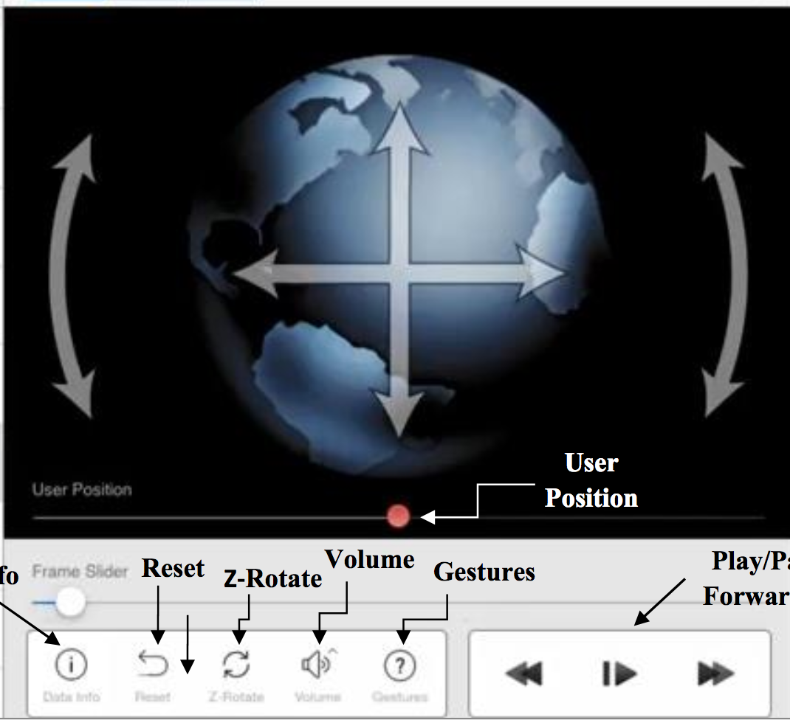***The following datasets may be used in conjunction with the worksheet: “Hurricane Season -2012” and “Wave Heights - Hurricane Sandy 2012”.
* ***Rotate on the z-axis*** for better viewing of the Northern Hemisphere. This is done on the iPad.

***Right: iPad controller screen with rotation icon shown.***

## Research Sources

The information in this outline represents the essentials for facilitating the lesson. Since this lesson is meant to be very interactive, preparation for student questions is essential. Each of the datasets has a page on the NOAA Science On a Sphere website. Here are some other useful links:

* NOAA Science On a Sphere

<http://sos.noaa.gov>

* NOAA National Hurricane Center

<http://www.nhc.noaa.gov/>

* Weather Channel Hurricane Information

<http://www.weather.com/storms/hurricane>

## ../../Desktop/is.png Instructor Script

### Blue Marble (skip if you have just presented Lesson 1: Globes vs. Maps)

*This is Science On a Sphere, developed by the National Oceanic and Atmospheric Administration (NOAA).* Have students orient themselves with respect to the globe. *Can you find North America? Asia? The Atlantic Ocean? The Pacific Ocean?*

### Hurricane Season – 2012

Tilt the Sphere on the z-axis and point out that this allows a better view of the Northern Hemisphere.

*Can anyone describe what a hurricane is?*

* + A hurricane is a large, rotating tropical storm.

*Where do they typically form?*

* + They form over warm tropical ocean waters.

*Do you know of any famous hurricanes?*

* + Responses are likely to include Katrina, Sandy, Harvey, Irma and Maria.

*Hurricane Katrina hit Louisiana in 2005. Hurricane Sandy hit New Jersey in 2012 and Hurricane Harvey hit Texas in 2017. Hurricane Irma and Hurricane Maria hit Puerto Rico in 2017.*

*If you live in Virginia, you probably hear the most about hurricanes that happen in the Atlantic Ocean. Does anyone know what we call a hurricane that happens in the Pacific Ocean?*

* + A typhoon

*Hurricanes are sometimes referred to as tropical cyclones (particularly when they occur in the Indian or South Pacific Oceans).*

Have students observe the looping dataset, and have them look for storm names as they appear.

*What shape are these storms?*

* + Circular

*How are they moving?*

* + They are rotating in a circular pattern – counter-clockwise in the Northern Hemisphere. They are also moving east to west.

*What causes storms to rotate?*

* + The Coriolis Effect

### *The rotation of the Earth makes air currents appear to be deflected as they move, resulting in curved wind paths. This apparent deflection, called the Coriolis Effect, sets up the complex global wind patterns that also drive surface ocean currents. It is named after the French mathematician Gaspard Gustave de Coriolis (1792-1843), who studied waterwheels to understand the transfer of energy in rotating systems. (source:*[*https://oceanservice.noaa.gov/facts/tradewinds.html*](https://oceanservice.noaa.gov/facts/tradewinds.html)*) The Coriolis Effect is a phenomenon that contributes to any long distance movement across the surface of the Earth, especially wind and ocean currents. The Coriolis Effect alters the direction of anything moving with respect to the ground. It is caused by the spin of the Earth on its axis. In the Northern Hemisphere, the Coriolis Effect causes storms to rotate counter-clockwise (to the left). In the Southern Hemisphere, storms rotate clockwise (to the right).*

### Note: The spin is only apparent when fluids (such as air and water) move across Earth’s surface. See the PBS video- <https://www.youtube.com/watch?v=i2mec3vgeaI>.

Identify the eyes of hurricanes as they appear.

*The eye is a region of very low pressure and sometimes people directly under the eye have clear skies and low wind; they often think the hurricane has passed but this is not true. The eye wall rims the eye and is the location of the strongest winds and most intense portion of the hurricane.*

### Sea Surface Temperature NOAA Model (with vegetation)

Tilt the Sphere down on the z-axis to allow for a better view of the Northern Hemisphere.

*What do you think this visualization is showing us?*

* Sea Surface Temperature. SST is an abbreviation for sea surface temperatures.

*What do you notice about the pattern of colors and what does that tell us about sea surface temperatures?*

* There is more red near the equator and more blue near the poles. This tell us that sea surface temperatures are warmer near the equator and colder near the poles.

*Do you think sea surface temperatures are consistent year-round?*

* Sea surface temperature, much like the atmosphere’s temperature, is constantly changing. Water warms up and cools down at a slower rate than air, so daily variations are hard to observe in the ocean. However, seasonal variations can be seen as the warmest water near the equator expands toward the United States during the summer months and withdraws during the winter months.

*Why do you think SST is important in relation to hurricanes?*

* Hurricanes form over regions of warm water. They require ocean temperatures of at least 80°F (26.5°C) for their formation and growth. The warm water must be present through a relatively deep layer (~150 ft, 50 m) of the ocean. (source: <http://www.aoml.noaa.gov/hrd/tcfaq/A16.html>)

*A hurricane is a large heat engine storm. It gets its energy from warm air, a relatively deep layer of warm water, and the sun. A hurricane cannot form over land or over cool water.*

*Latent heat is one of the main reasons for hurricane formation. Though the air may be humid over the ocean, it is not at 100% relative humidity. Therefore, the water evaporates, changing from liquid to vapor and rises into the atmosphere. The energy required to cause this change of state comes from the Sun. The Sun’s energy becomes latent (stored or reserved in the vapor) ready to be released when the vapor condenses into a liquid. The tremendous amount of latent heat released when the water vapor condenses into a liquid (the huge cloud mass of a hurricane) complete this heat-engine cycle of absorbing and releasing latent heat and maintains the hurricane’s strength.*

*Latent heat is the heat absorbed or released when water changes phases. Evaporation is a cooling process that takes energy from the Earth to turn liquid into gas (water into water vapor, ocean into clouds). Think about when you get out of the pool on a warm day- do you ever feel chilly? The same thing is occurring; the water is evaporating off of your skin, taking the heat with it. The opposite of evaporation is condensation, which is a heating process. When water vapor condenses into water, it releases energy from the vapor.*

### Hurricane Season: Water Vapor and SST – 2005

Tilt the Sphere on the z-axis to allow for a better view of the Northern Hemisphere.

*Where do you see hurricanes forming?*

* + In the Tropics, low latitudes, near the equator, over the ocean.

*Why don’t you see hurricanes forming near the poles?*

* + The water is too cold.

*Where do the hurricanes die out? Why?*

* + Over land – they lose their source of fuel (warm water).

Have students watch the whole continuous loop and note the dates displayed on the sphere.

*Based on what you observed, when is hurricane season?*

* + June 1 to November 30.

*During what months do you see most hurricanes forming?*

* + August/September

*The first day of summer is in June. Why is peak hurricane season in the North Atlantic late summer and early fall?*

* + This ties back into latent heat; water takes time to heat up. Oceans in the North Atlantic are at their warmest after warming gradually all summer. Water needs to be at least 26.5 °C (80°F) in order for hurricanes to form.

### Hurricane Tracks: Cumulative – 1950-2005

Direct the students to the Saffir-Simpson Hurricane Wind Scale.

*How many categories of hurricanes are there?*

* + The Saffir-Simpson Hurricane Wind Scale has five categories. Winds need to be at least 74 miles per hour for a storm to be classified as a hurricane.

Discuss the four stages of hurricane development: tropical disturbance, tropical depression, tropical storm, and hurricane. See background on these at: <http://scijinks.jpl.nasa.gov/hurricane/>. See <http://www.nhc.noaa.gov/aboutgloss.shtml> for definitions (if needed) of subtropical and extratropical.

*Storms are assigned a name at the tropical storm stage of development, before reaching hurricane status. (source:* [*https://public.wmo.int/en/About-us/FAQs/faqs-tropical-cyclones/tropical-cyclone-naming)*](https://public.wmo.int/en/About-us/FAQs/faqs-tropical-cyclones/tropical-cyclone-naming))

*Why are hurricanes named?*

* + It helps to ease confusion since there may be more than one hurricane or tropical storm at one time.

*Naming of tropical storms follows a strict procedure established by an international committee of the World Meteorological Organization. They use alternating boys’ and girls’ names, in alphabetical order, starting with ‘A’ each season. For the Caribbean Sea, Gulf of Mexico and the North Atlantic, there are six full alphabetical lists, and on the seventh year they start over with the first list. Names can be re-used in different years, though some especially severe hurricanes may have their names retired. Similarly, for the Eastern North Pacific six lists are used in rotation.*

*What category of hurricane is most common?*

* + Category 1, but most storms don’t even make it to qualify as a hurricane at all.

*Where do you see the majority of these storms?*

* Lower latitudes, in or near the tropics.

### Hurricane Season - 2005

Tilt the Sphere on the z-axis to allow for a better view of the Northern Hemisphere. Have students look for Hurricane Katrina forming. Let the dataset loop several times to allow the audience to find the storm.

*The 2005 hurricane season shattered records that have stood for decades - most named storms, most hurricanes and most category five storms. There were 28 named storms, 15 hurricanes, seven major hurricanes (category 3, 4, 5), and four category 5 hurricanes. It was also the first season in which four major hurricanes hit the U.S. The season started early and ended late with two tropical storms in June (which hadn’t happened since 1986) and three tropical storms in November with one that formed in December and dissipated in January.*

*Even with all these records, the 2005 hurricane season will arguably be most remembered for Hurricane Katrina, which devastated parts of Mississippi, Louisiana and in particular, New Orleans. Over 1600 people died during the storm and an estimated cost for all the damage is $75 billion, making Katrina the most expensive hurricane ever. (source: https://sos.noaa.gov/datasets/hurricane-season-2005/)*

*Where did you see Hurricane Katrina developing?*

* + Over the Caribbean

*When do you see Hurricane Katrina forming?*

* Late August

*What do you think the weather and climate conditions are like in the Caribbean?*

* + Warm air, warm water, frequent small storms

Point out the organization of the clouds and the rotation of the storm. See if they can find the eye.

**Wave Heights – Hurricane Katrina 2005**

*What was predicted to happen to wave heights as Hurricane Katrina moved through the Gulf of Mexico?*

* + Wave heights were predicted to increase.

*How high were waves predicted to get?*

* + Wave heights were predicted to be up to 14 meters. Actual wave heights of up to 15.9 meters (55 feet) were recorded in the Gulf of Mexico.

*Storm surge is rising of sea level at the shore due to storm winds. When storm surge occurs at high tide, total wave height is at its maximum and damage can be especially high.*

*Hurricane Katrina actually made first landfall on the southern tip of Florida, as a Category 1 storm, but spent little time over land and therefore lost little energy before moving over the warm waters of the Gulf of Mexico and quickly gained energy to a Category 5 hurricane as it turned north towards the coast again. It was a Category 3 when it made landfall with sustained winds of 125 mph. (source:* [*https://www.weather.gov/media/publications/assessments/Katrina.pdf)*](https://www.weather.gov/media/publications/assessments/Katrina.pdf))

*Why did Katrina cause so much damage as a Category 3 hurricane?*

* + Category three hurricanes are very powerful. They have wind speeds of 111-130 mph, heavy rains and can result in storm surge.
  + The region where Katrina hit was vulnerable. The city of New Orleans is below sea level, with levees built to keep water out of the city. After Katrina, nearly 80% of New Orleans was under water, primarily due to failure of the levees. Conditions of poverty and poor evacuation strategies further contributed to the devastation of Hurricane Katrina.

*The U.S. cities of New Orleans, LA, Mobile, AL, and Gulfport, MS bore the brunt of Katrina’s damage. Rainfall rates exceeding 1 inch per hour along with an immense storm surge resulted in flooding of many coastal cities. (source:* [*https://www.weather.gov/media/publications/assessments/Katrina.pdf)*](https://www.weather.gov/media/publications/assessments/Katrina.pdf))

**Hurricane Season - 2017**

*After a long lull in major hurricanes striking the U.S. (2005 - 2017), the 2017 season was an extremely destructive season, featuring 17 named storms in just the Atlantic Ocean, tying it with 1936 as the fifth-most active season since records began in 1851. All ten of the Atlantic hurricanes occurred in a row, the greatest number of consecutive hurricanes in the satellite era. In addition, it is by far the costliest season on record, with a preliminary total of over $368.66 billion (USD) in damages, which is more than double the cost of 2005’s total, and nearly all of which was due to three of the season's major hurricanes — Harvey, Irma, and Maria. (source: https://sos.noaa.gov/datasets/hurricane-season-2017/)*

*What do you notice about the timing of Harvey, Irma and Maria? Why is this significant?*

* All three hurricanes occurred within one month in August – September. This created unprecedented challenges for coastal communities and first responders.

**Hurricane Harvey: Clouds with Precipitation - 2017**

*Here’s a look a Hurricane Harvey, an extremely destructive Atlantic hurricane.*

*Using the scale shown, how much precipitation was associated with Harvey?*

* + 50 mm per hour (almost 2 inches).

*With a record of 51.88 inches, Harvey is the wettest tropical hurricane on record in the contiguous U.S. The resulting floods inundated hundreds of thousands of homes, displaced more than 30,000 people, and prompted more than 17,000 rescues. Harvey caused at least 83 confirmed deaths. Preliminary estimates for economic losses are between 70 and 200 billion dollars. Harvey was a Category 4 when it hit Texas.*

*What do you think contributed to Harvey’s record-breaking rainfall? (Hint: note the timeline of Hurricane Harvey.)*

* + The system stalled along the gulf coast for four days.

**Hurricane Irma: True Color (GOES-16) – 2017**

*This True Color animation showing Hurricane Irma and a little bit of Hurricane Maria (also seen is a Pacific tropical cyclone named Katia) is made from NOAA's next generation GOES-16 satellite. GOES satellites orbit about 22,000 miles from the surface of the Earth in geostationary orbit and because they rotate with the Earth, they only see one hemisphere.*

*Describe the path of Hurricane Irma.*

* + Hurricane Irma made landfall in the Caribbean (as a Category 5 hurricane) then hit Florida (as a Category 4 hurricane).

*Hurricane Irma was the strongest tropical storm ever observed in terms of sustained wind speed, with 36 hours of sustained Category 5, 185 mph winds.* Irma caused over 100 deaths in the US and the Caribbean.

*Hurricane Maria, seen also in this animation, broke the record for the most intense tropical cyclone to strike the U.S. territories in history. Maria hit Puerto Rico as a Category 4 storm and damaged transportation and communication systems. Recent estimates indicate 4600 deaths in Puerto Rico as result of Maria.*

*Here’s a short video about the tracking of these storms.*

**GOES-16 Tracks the Big Three**

*According to the video, how were these hurricanes tracked?*

* The Advanced Baseline Imager (ABI) on GOES-16 tracked these record-setting storms and supplied critical data to weather forecasters and emergency management coordinators**.**

*Scientists and meteorologists use an arsenal of forecasters, instruments, and computer-based tools to produce the best possible storm projections that extend days into the future. Aircraft and ocean buoys (that measure wave height, wind speed, and ocean temperature) are also used to predict hurricane activity.*

**Sea-Surface Temperature Anomaly - Real-time**

*What is an anomaly?*

* An anomaly is something that differs from the norm.

*This image is showing sea surface temperature anomalies. What do you think the red means?*

* Red indicates warmer than normal temperatures.

*What do you think the blue means?*

* Blue indicates cooler than normal temperatures.

*Sea surface temperature anomaly is the difference between the current temperature and the long-term temperature average. Negative temperature differences indicate that the ocean is cooler than average, while positive temperature difference indicate that the ocean is warmer than average*

*How can this information be used to predict likelihood and severity of hurricanes?*

* Tracking sea surface anomalies helps scientists quickly identify areas of warming and cooling, which can affect hurricane development.

*While storms are generated in certain regions and under similar conditions each year, their movement, strength, and location of eventual landfall are somewhat unpredictable. Severity of the storm is influenced by water temperatures- warmer temperatures produce more powerful storms. As sea surface temperatures continue to increase year after year, the potential for hurricanes also increases in many ways. Warmer seas can result in longer hurricane seasons, more frequent storms, stronger storms, increased unpredictability, and increased range of destructive potential on land.*

**Clouds (colorized) – Real-time**

*Infrared satellite images are used by meteorologists to determine where clouds are, but more importantly, how the clouds are moving. The infrared, IR, satellites work by measuring the infrared radiation that is emitted. Because the emitted radiation is proportional to temperature, the data are converted to temperature values, which can be useful for meteorologists.*

*Based on this cloud image, is there much hurricane formation happening now? Why or why not?*

* Answers will vary depending on cloud cover at the time of the presentation.

*Do you think we are likely to have a big hurricane problem here at our location?*

* Harrisonburg is not likely to have a BIG hurricane problem but we certainly can get storms our way, as seen with Hurricane Irene just a few years ago (2011). We had strong winds and heavy rainfall as parts of that storm passed over the region. However, we are far enough from the coast that hurricanes are not likely to hit full strength with regularity.

## Audience FAQs



*1. Why is there a band with no hurricane tracks on the Cumulative Hurricane Track visual?*

* + The Coriolis Effect, which is necessary to cause rotation of hurricanes and tropical storms, increases with greater latitudes. The Coriolis Effect is negligible within 5 degrees latitude of the equator, therefore tropical storms cannot develop within this belt.

*2. Why do hurricanes move east to west?*

* + See: <https://earthobservatory.nasa.gov/Features/Hurricanes/>

*3. What were some of the hurricanes that had large monetary costs?*

* Hurricane Katrina (2005) struck the Bahamas, Florida, Louisiana, Mississippi, and Alabama, with an estimated U.S. $108 billion in total losses. This compares to U.S. $71 billion for Hurricane Sandy (2012). (source: <https://www.metoffice.gov.uk/weather/tropicalcyclone/facts)>. Hurricane Harvey (2017) hit Texas with an estimated 125 billion in total losses. However, Katrina remains the most costly hurricane in U.S. history, after accounting for inflation (source: https://www.nhc.noaa.gov/data/tcr/AL092017\_Harvey.pdf).

*4. When is hurricane season?*

* + Hurricane season is the portion of the year having a relatively high incidence of hurricanes. The hurricane season in the Atlantic, Caribbean, and Gulf of Mexico runs from June 1 to November 30. The hurricane season in the Central Pacific basin also runs from June 1 to November 30. The hurricane season in the Eastern Pacific basin runs from May 15 to November 30. However, hurricanes can (and do) occur outside this window if the conditions are right. (source: http://www.nhc.noaa.gov/aboutgloss.shtml)

*5. Has anyone ever flown a plane into a hurricane?*

* + Yes, NOAA has aircraft designed for flying into hurricanes and recording scientific data.

1. *How does a hurricane form?*

* Tropical cyclones are like giant engines that use warm, moist air as fuel. That is why they form only over warm ocean waters near the equator. The warm, moist air over the ocean rises upward from near the surface. Because this air moves up and away from the surface, there is less air left near the surface. Another way to say the same thing is that the warm air rises, causing an area of lower air pressure below. Air from surrounding areas with higher air pressure pushes in to the low pressure area. Then that "new" air becomes warm and moist and rises, too. As the warm air continues to rise, the surrounding air swirls in to take its place. As the warmed, moist air rises and cools off, the water in the air forms clouds. The whole system of clouds and wind spins and grows, fed by the ocean's heat and water evaporating from the surface.

## ::::::Icons:noun_33918_cc.png Pre & Post Assessment

The following assessment can be given to measure student knowledge before and after the lesson.

*1. Where on Earth do hurricanes form?*

1. The Arctic
2. **Tropical oceans**
3. Over warm land
4. Antarctica

*2. What causes hurricanes to rotate?*

1. **The Coriolis Effect**
2. Wind high in the atmosphere
3. The equator
4. The jet stream

*3. Which one of these is NOT an energy source for a hurricane?*

1. Warm water
2. Warm air
3. The Sun
4. **Ice**

*4. What do we call the energy absorbed or released when water changes phases?*

1. Solar power
2. Evaporation
3. **Latent heat**
4. The Coriolis Effect

*5. What do we call the center of a hurricane?*

1. The eye wall
2. Rain band
3. **The eye**
4. The zone

*6. At what stage of a hurricane’s life does it get a name?*

1. Tropical disturbance
2. Tropical depression
3. **Tropical storm**
4. Hurricane

*7. When is Atlantic hurricane season?*

1. January through April
2. March through May
3. **June through November**
4. August through October

8. Where are the strongest winds in a hurricane?

1. The eye
2. **The eye wall**
3. The spiral rain bands
4. The outer edge

*9. Most tropical storms never develop into full-blown hurricanes.*

1. **True**

b) False

# Lesson 3: Tornadoes

By Jennifer Mangan, Ph.D., Associate Professor, Department of Interdisciplinary Liberal Studies, James Madison University

Run time: 30 minutes



## Learning Objectives

Students will understand the basic idea of how tornadoes are formed. They will be able to identify the conditions that are needed for a tornado to form and where tornadoes develop.

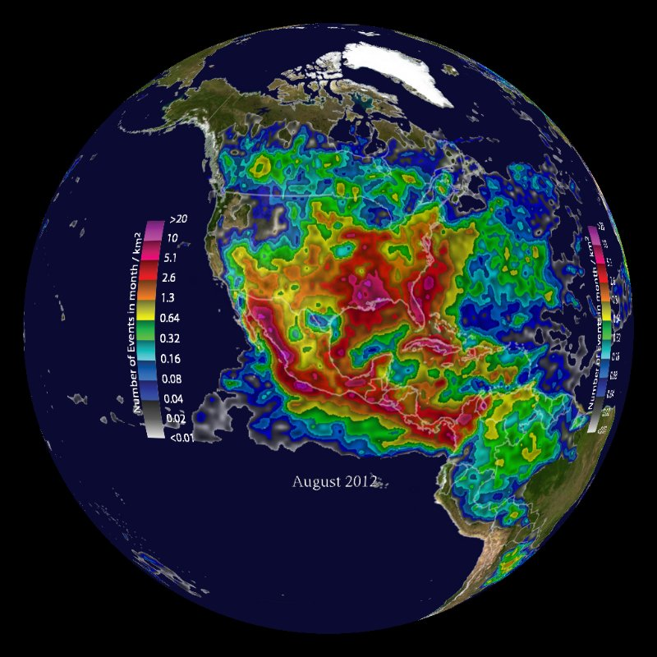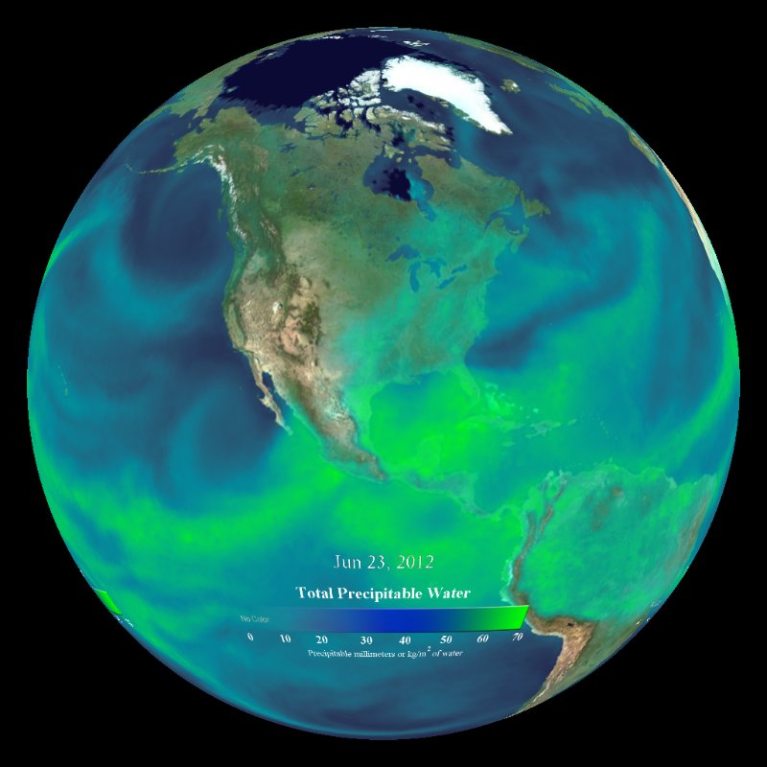

***Left: Lightning Detection – June 2011 – Aug 2012[[5]](#footnote-5)***

***Right: Precipitable Water (Over Land) – Real Time[[6]](#footnote-6)***

## ::::::Icons:noun_93125_cc.png

## Correlations to Virginia Standards of Learning

6.3: The student will investigate and understand the role of solar energy in driving most natural processes within the atmosphere, the hydrosphere, and on Earth’s surface. Key concepts include:

e) The role of thermal energy in weather-related phenomena including thunderstorms and hurricanes

ES.12: The student will investigate and understand that energy transfer between the sun and Earth and its atmosphere drives weather and climate on Earth. Key concepts include:

1. Observation and collection of weather data
2. Prediction of weather patterns
3. Severe weather occurrences, such as tornadoes, hurricanes, and major storms

4.6 The student will investigate and understand how weather conditions and phenomena occur and can be predicted. Key concepts include:

1. Weather phenomena
2. Weather measurements and meteorological tools



## Correlations to Next Generation Science Standards

ESS2.C: The Roles of Water in Earth’s Surface Processes

* + The complex patterns of the changes and the movement of water in the atmosphere, determined by winds, landforms, and ocean temperatures and currents, are major determinants of local weather patterns. (MS-ESS2-5)

ESS2.D: Weather and Climate

* Weather and climate are influenced by interactions involving sunlight, the ocean, the atmosphere, ice, landforms, and living things. These interactions vary with latitude, altitude, and local and regional geography, all of which can affect oceanic and atmospheric flow patterns. (MS-ESS2-6)
* Because these patterns are so complex, weather can only be predicted probabilistically. (MS-ESS2-5)
* The ocean exerts a major influence on weather and climate by absorbing energy from the sun, releasing it over time, and globally redistributing it through ocean currents. (MS-ESS2-6)



## Datasets

**Blue Marble**

The Blue Marble is a detailed, true-color depiction of the Earth. The cloud image is a composite of three days’ worth of data. <http://sos.noaa.gov/Datasets/dataset.php?id=82>

**Cooking Up A Storm**

This is an 8 minute video that teaches an audience about the atmospheric ingredients that go into a typical severe weather day in Tornado Alley. These factors - moisture, instability, lift, and shear - are explained through a series of datasets and creative, descriptive diagrams. <http://sos.noaa.gov/Datasets/dataset.php?id=295>

**Precipitable Water (over land) – Real-time**

Total precipitable water (TPW) in the atmosphere is the amount of water that can be obtained from the Earth’s surface to the "top" of the atmosphere if all of the water and water vapor were condensed to a liquid phase. Significant features that can be identified in this dataset are the atmospheric rivers that flow off the oceans and onto coastal land areas.

<http://sos.noaa.gov/Datasets/dataset.php?id=59>

**GLAPS Model: Sea Surface and Ground Temperature – Real-time**

The Global Analysis and Prediction System (GLAPS) produces maps for several weather parameters over a large global domain. This GLAPS dataset shows sea surface and ground temperature in degrees Fahrenheit. The data are available in real-time, update hourly, and include the data for the past week. <http://sos.noaa.gov/Datasets/dataset.php?id=69>

**Lightning Detection – Jun 2011-Aug 2012**

The Global Lightning Dataset (GLD360) network detects between 1 and 3 million lightning events around the world every day of the year. This dataset shows location and frequency of flashes from June 2011 through August 2012. <http://sos.noaa.gov/Datasets/dataset.php?id=366>



## Presentation Tips

* ***Orient*** your audience to the Sphere with the Blue Marble dataset, if you have not done so in the previous lesson. You might also use this time to talk briefly about spherical displays and how SOS in particular was developed (see https://sos.noaa.gov/what-is-sos/history-of-sos/), but be sure that the depth of technical detail is appropriate for a middle school audience.
* ***Refer*** back to the “Cooking Up a Storm" concepts frequently.
* ***Familiarize yourself*** with any recent tornado activity in the area (2011 tornadoes in Rockingham County are covered in FAQs).
* ***Lengthen*** the lesson by adding the Twister Dashboard: Exploring Three Decades of Violent Storms activity (described on page 41)

## Research Resources

The information listed in this outline represents an effective order to give the presentation in and includes essential facts about tornadoes and their formation. Since this lesson is meant to be very interactive, preparation for student questions is essential. Each of the datasets has a page on the NOAA Science On a Sphere website. Here are some other useful links that we used to find information about tornadoes:

* NOAA Science On a Sphere

<http://sos.noaa.gov>

* University of Chicago, Department of Geophysical Sciences

<http://goo.gl/y16XQK>

* University of California, Department of Atmospheric Sciences

<http://goo.gl/bWkBwH>

* National Weather Service

<http://www.srh.noaa.gov/ffc/?n=torntext>

## ../../Desktop/is.png Instructor Script

### Blue Marble *(skip if you have done in a previous lesson)*

*This is Science On a Sphere, developed by the National Oceanic and Atmospheric Administration (NOAA).* Have students orient themselves with respect to the globe. *Can you find North America? Asia? The Atlantic Ocean? The Pacific Ocean?*

Tilt the Sphere on the z-axis and point out that this allows a better view of the Northern Hemisphere, where we will be observing tornado patterns. As you switch datasets, you will have to re-tilt the Sphere.

*Today we are going to talk about tornadoes. How many of you have seen the movies, The Wizard of Oz or Twister? How many of you think that that is what happens when tornadoes hit?*

*Well, tornadoes do not actually suck you out of Kansas and into a different world like they did to Dorothy in The Wizard of Oz. They are, however, one of nature’s most vicious storms, and they do frequently occur in the central part of Kansas.*

*Who can tell me what a tornado is?*

* + A tornado is a funnel-shaped, rotating column of air that touches both the ground and a cloud above.

*A tornado forms when the updraft of a thunderstorm begins to rapidly rotate. The column of air flowing upwards in a thunderstorm (called the updraft) can begin spinning if the winds in the atmosphere are changing direction as you go higher (called wind shear).*

*Can you guess what country gets the most tornadoes?*

* + The United States does, averaging around 1,200 tornadoes each year

*Can anyone name a state that gets a lot of tornadoes? (hint, hint: The Wizard of Oz)*

* + Kansas, Texas, and Oklahoma commonly receive tornadoes. Most tornadoes in the US occur in a place nicknamed ‘Tornado Alley,’ in the south central U.S.

*Why do you think so many tornadoes occur in “Tornado Alley”?*

* + Tornado Alley has all of the weather conditions needed for tornado formation.

*Let’s watch this short narrated video on how storms form in Tornado Alley, and then we will talk about how tornadoes come from those storms.*

### Cooking Up A Storm

Cue the show and allow the audience to watch.

*Does anyone remember the 4 ingredients they talked about in the video?*

* + Moisture, instability, lift, and shear.

For the next two datasets you can refer back to the points made in the movie. Stress that tornadoes need severe thunderstorms (called a supercell thunderstorm) and very specific ingredients and conditions to form.

### Precipitable Water (over land) – Real-time

*Does anyone know what “precipitable water” is?*

* + It is the amount of water in the atmosphere that can rain down.

*Why do you think it is important to know this when you are thinking about storms?*

* + Storms bring rain, and the amount of rain can determine the severity of the effects of the storm.
  + Humid air is very different from dry air. Moisture is needed to store latent heat, which is the main energy source for the storm. Latent heat is heat absorbed or released during a change of phase at constant temperature and pressure.

*Raise your hand if you can see Mexico* *on the Sphere*. Draw attention to the scale on the Sphere.

*What do you notice about the moisture (green) in the Gulf of Mexico compared to the moisture in the Northwestern United States.*

* There is a lot of moisture (green) in Gulf of Mexico and little moisture in the Northwestern United States

*Where is the line between these air masses?*

* + Central United States – this is Tornado Alley!

*Tornadoes can form anywhere, as long as the four ingredients are present: moisture, instability, lift, and shear. These conditions most commonly align in the central United States, but tornadoes can be generated by any supercell thunderstorm with the correct conditions. When tornadoes do form, their destructive force is unmatched by any other weather phenomenon.*

*With today’s weather, is there any likelihood we will be getting a tornado?*

* + Answers will vary. Remind students that you cannot have a tornado without a thunderstorm first.

### GLAPS Model: Sea Surface and Ground Temperature – Real-time

Point out the scale bar, and have the audience read this map for themselves. *These are near real-time data (typically updated hourly) showing surface temperatures over the last week or so.* Ask the audience where there are warmer temperatures and where there are cooler temperatures in the United States. Use these points to make a further case for different air masses, and the location of Tornado Alley.

### Lightning Detection – Jun 2011-Aug 2012

Point of the scale bar and have the audience watch the data loop once or twice while they orient themselves to the map.

*Where in the U.S. do you see the most lightning?*

* + Florida

*Has anyone ever been to Florida? Was there a thunderstorm while you were there? Thunderstorms are very frequent in Florida, occurring almost daily, but tornadoes are rare there. The thunderstorms that Florida gets are just basic storms, and you need a very severe and well-formed storm (called a supercell thunderstorm) to produce a tornado. Most of the storms we get in Harrisonburg are basic storms also, so we are not a high tornado risk area, but they may occur in any area that experiences thunderstorms*

*What months do you see the most lightning in Tornado alley?*

* + May-August (or a narrower time frame, June-July). These are peak tornado months that coincide with storms on the High Plains (Midwest)*.* Refer again to the “Cooking up a Storm” video from earlier.

*What are some ways that people can stay safe during a tornado?*

* Listen to news reports regarding tornado watches and warnings. Basements and other underground areas are the safest places to seek refuge during a tornado. It is also a good idea to stay away from windows. Tornado winds can reach 300 miles per hour, strong enough for projectile pieces of straw (hay) to penetrate solid wood, like fence posts and tree trunks! Damage paths can be in excess of one mile wide and 50 miles long!
* For general information on tornadoes and tornado detection, see <https://www.nssl.noaa.gov/education/svrwx101/tornadoes/> and <https://www.nssl.noaa.gov/education/svrwx101/tornadoes/detection/>.

 **Twister Dashboard: Exploring Three Decades of Violent Storms**

In this activity, students will investigate three decades of tornado data through an interactive Story Map. The Story Map was created by Esri and the activity was developed by Kristin Wegner for the University Corporation for Atmospheric Research (UCAR) Center for Science Education (see https://scied.ucar.edu/activity/10396/print-all).

****

## Audience FAQs

*1. How often do tornadoes occur in Virginia?*

* + According to NOAA, (1991-2010 data) there are, on average, 18 tornadoes that touch down in Virginia every year. Monthly, 1-4 tornadoes occur during April-October, with the most frequent tornadoes occurring in September (average 4 each September).

*2. When was the last tornado in the area?*

* + During an overnight thunderstorm on April 27-28, 2011, several tornadoes touched down in our area. The most severe began in Fulks Run and traveled nearly parallel to I-81 for over 33 miles, nearly reaching Strasburg!
  + That same night, a tornado touched down just 4 miles east of here, near Rockingham Memorial Hospital, running approximately 3 miles north, crossing both Port Republic Road and Route 33.

*3. What is the difference between a tornado watch and a tornado warning?*

* + A tornado watch is put in place when the conditions suggest a tornado could form in the area, and you should keep an eye on the skies and watch for signs.
  + A tornado warning means that a tornado has been sighted in the area, and you should take cover immediately!



## Pre & Post Assessment

The following assessment can be given to measure student knowledge before and after the lesson.

*1. In which region of the United States are tornadoes most common?*

1. East coast
2. **Midwest**
3. Rocky Mountains
4. West coast

*2. Which one of these is NOT a condition necessary to form a tornado?*

1. **Evaporation**
2. Moisture
3. Instability
4. Shear

*3. When is tornado season?*

1. Spring
2. **Summer**
3. Fall
4. Winter

*4. Tornadoes contain strong rotating winds that have the potential to cause damage.*

1. **True**
2. False

*5. What should you do to protect yourself from a tornado?*

1. Listen to news reports regarding tornado watches and warnings
2. Stay away from windows
3. Seek shelter in a basement or underground area
4. **all of the above**

# Supplemental Material: Teaching Demonstration Video

By Kristen St. John, Ph.D., Professor, Department of Geology and Environmental Science, James Madison University

Duration: 57 minutes

This video provides an example of pedagogical practices with SOS. This video is a recording of an actual interactive climate model lesson by Professor Kristen St. John with her upper division college science students. The video is interspersed with commentary regarding pedagogical practices that are applicable to SOS lessons at the middle and high school level as well as at the collegiate level. The video contains three parts:

**Part 1: Part I: Framing the discussion in the classroom prior to using SOS (20 min)**

**Part 2: Utilizing the SOS climate model datasets (28 min)**

a) Providing handouts with guided questions

Dataset Discussion: GFDL A1B Model - Temperature Change with Business as Usual

b) Orienting students to visualizations

Dataset Discussion: HAD A1B Model - Temperature Change with Business as Usual

Dataset Discussion: GFDL B1 Model - Temperature Change with a More Ecologically Friendly Scenario

Dataset Discussion: GFDL 3714 Model - Sea Ice Change

c) Viewing visualizations multiple times

Dataset Discussion: GFDL Model - Precipitation Anomalies

**Part 3: Using the flat screen: summary and assessment (9 min)**

a) Summarizing the take away message on flat screen

b) Following up with an assessment

Please e-mail [stewardship@jmu.edu](mailto:stewardship@jmu.edu), and you will receive a link to the video and an access code.

1. All icons used in this manual are Creative Commons images and selected from the Noun Project

   <https://thenounproject.com>. Individual designer attribution for each icon is below:

   Learning Objectives: Pete Fecteau, VA SOL Correlations: Jan Christoph Borchardt, Next Generation Science Standards: Adrian Rguez Perez, Dataset Descriptions: Creative Stall, Student Handouts and Worksheets: Jaclyn Ooi, Presentation Tips: mh, Instructor Script: TukTuk Design, Audience FAQs: Anas Ramadan, and Pre & Post Visit Assessment: Berkay Sargin. [↑](#footnote-ref-1)
2. *Space Science and Engineering Center, University of Wisconsin* [↑](#footnote-ref-2)
3. *Dixon, et. al., NOAA / Geophysical Fluid Dynamics Laboratory (GFDL)* [↑](#footnote-ref-3)
4. Depending upon location, tropical cyclones have different names around the world. In the Atlantic and Eastern Pacific they are called hurricanes. In the Western Pacific they are called typhoons. In the Indian Ocean they are called cyclones. (source: http://www.noaa.gov/resource-collections/hurricanes) [↑](#footnote-ref-4)
5. [*Vaisala GLD360*](http://www.vaisala.com/en/products/thunderstormandlightningdetectionsystems/Pages/GLD360.aspx) [↑](#footnote-ref-5)
6. *Advanced Microwave Sounding Unit Project and Special Sensor Microwave Imager* [↑](#footnote-ref-6)