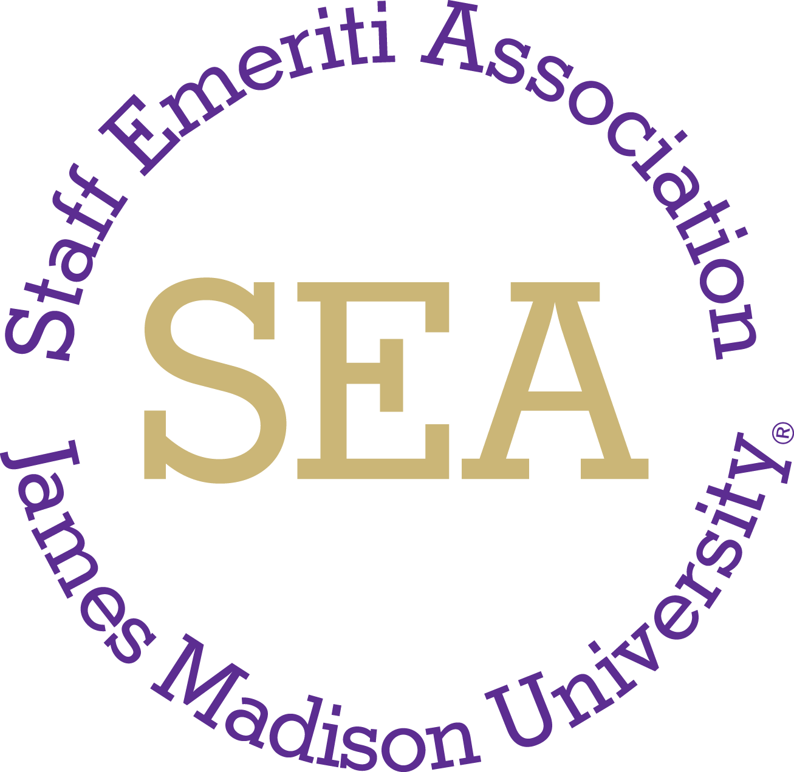

James Madison University Staff Emeriti Association

Minutes – April 22, 2026 11:30 am, Casa Gallardo restaurant

Attendees: Tina Updike, Donna Burch, Jackie Ciccone, Paula See, Kathy Starick and Milla Sue Wisecarver. Absent: Judy Marshall

Approval of Minutes: Minutes from the January 15, 2026 meeting were unanimously approved with a few changes. These will be posted to the SEA website.

Business:

Member Update: Since January 2026, thirteen new members were recognized and have been added to the membership. Currently there are 359 active members with a total of 383 named emeriti.

Goal #3: Increase Awareness: Tina announced that there will be IT website updates to ensure accessibility compliance. Currently the SEA website is not in compliance and Tina will talk with HR to request that changes be made including that only the past 3 years agendas and annual reports are kept on the website. She will also talk with her about the link to the event photos – need to be updated.

Another IT requirement will be for all emeritus staff to sign in to their JMU email account at least every 12 months to maintain their email.

The annual report was approved with no changes. Tina will submit to Amanda Thomas in Human Resources.

Goal #2: Volunteer Activity: We will need to look for a new contact in Advancement as Kathy Sarver has now retired. With her retirement, Amanda Good, Coordinator in Advancement Gifts and Records, will serve as our contact with the food panty. Tina wanted to stress the importance of our support of the Food Pantry and even more so than it has been in recent years.

Hopefully we continue to work with Human Resources as our main University contact.

We wish Kathy the best in her retirement.

Goal #1: Committee Members for Fall 2026-Spring 2027: Judy Marshall has decided not to serve on the SEA steering committee after the 2025-26 year. Her 3 years of service is much appreciated. Jackie Ciccone volunteered to send cards to members as appropriate. Please review the distributed list of active SEA participants and send to Tina any suggestions of new members for next year.

Goal #1: Membership development: Follow-up:
February brunch at First Watch: 18 attendees.
March tour of Rocktown Historical Museum and lunch at El Charro: 28 tour and 28 at lunch.
Everyone agreed that we should possibly hold our Holiday brunch at First Watch. Jackie will contact them to see availability the first week in December.

Spring Events (April-May): April 30 mini-golf and lunch at Mulligan’s followed by ice cream at Smiley’s: 8 mini-golf; 2, maybe 3, driving range; 14 for lunch. Smiley’s 10
Wednesday, May 13- Lunch with President Schmidt, Hall of Presidents room, D-Hall; Tina has asked that all committee members arrive by 10:40 or so to direct and to greet guests. Milla Sue will be sending out the email invitation to all members which will include parking information. Tina talked about how important it was for our group of emeriti staff to show up and share our views with new President.

Fall Events (September-December):
Cross Keys Vineyard – Donna will check on a possible dutch treat luncheon in early September.
Carrier Library tour – Tina will check on a tour of the renovation in early October (October 7, 8 or 9 - fall break). Kathy will talk with Taste of Thai about lunch reservations following the tour.
Holiday brunch – Everyone agreed that we would like to hold our holiday brunch at First Watch the first week of December. Jackie will talk with them and get back with us.

Next Meeting: The next meeting (in August) has not been decided but will let everyone know the date as soon as possible.

