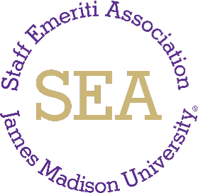
James Madison University Staff Emeriti Association Minutes – Marcb 5, 2024 (10:30 am, Wine Price conference room 3030)
Attendees: Tina Updike, Rosemary Brenner, Donna Burch, Alma Hale-Cooper, Gail May, Judy Powell, Kathy Sarver, Louise White, and Milla Sue Wisecarver.
Approval of Minutes: Minutes from the meeting on Jan. 23, 2024 were unanimously approved. These will be posted to the SEA website.

Business:
- Member Update: No new members since the last Steering Committee meeting in January 2024.
- JMU E-IDs: 36 members are no longer using JMU e-IDs, so their email addresses have been deleted from the JMU system. We have sought updates from Kathy Sarver and HR and have new information on some of the 36.
- Increase awareness: Updates to website continue to be sent to Amanda Thomas in HR. Annual report was sent to David Kirkpatrick in the President’s Office, VP of Administration and Finance Towana Moore, and from HR: Director Chuck Flick, Julie Byers, Amanda Thomas. We will
email members a link to the report on March 18. Bi-annual letter reminding supervisors of the SEA nomination process was sent in February.
- Volunteer activity, JMU Pantry: SEA members continue to make monetary and physical donations to the JMU Pantry. JMU finished second among
eight schools in the February 2024 Sun Belt Conference“Food Fight,” which saw a sizeable increase in donations during the fundraiser.
- Membership development: Recent: Feb. 21 lunch at Romano’s, 27 members, 6 guests, 1 administrator. Upcoming: March 12 (March 13 inclement weather date) tour of Bridgeforth/APC followed by lunch at El Charro.
- Plans for spring: Tuesday, April 30, 10 a.m. Dynamic Aviation tour. Thursday, June 6, SEA’s annual luncheon funded by HR in Montpelier

Room of E-Hall. VP of Admin & Finance Towana Moore will be the speaker.
Next Meeting: Tuesday, May 21, 10:30 am at Wine Price Conference Room 3030.

