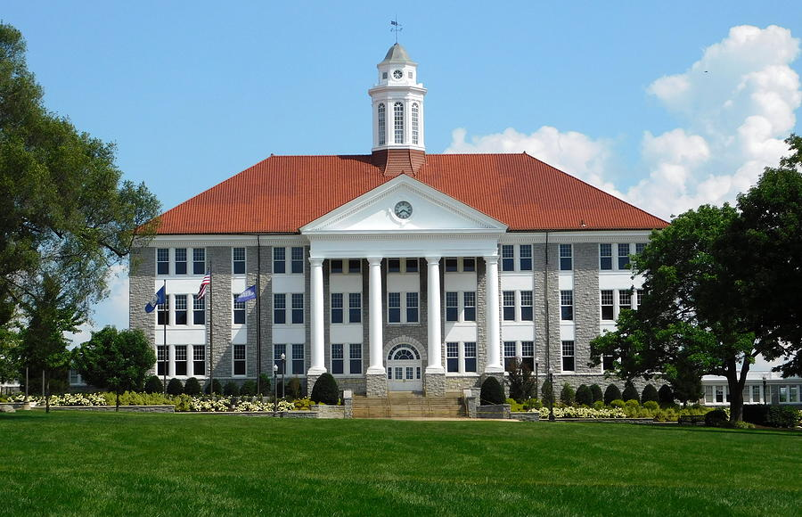

(Insert Building Name) -
Building Emergency Action Plan (BEAP)

(Insert Month 20XX)

James Madison University
Emergency Management

Table of Contents
Table of Contents 2
Record of Changes 3
{Insert Building Name} - Building Emergency Action Plan 4
BUILDING ADDRESS 4
BUILDING USE AND FUNCTION 4
BUILDING COORDINATOR 4
SAFETY MONITORS 4
CAMPUS EMERGENCY CONTACT NUMBERS 5
INTERNAL ASSEMBLY AREAS 6
EVACUATION ROUTE MAPS 6
EVACUATION ASSEMBLY AREAS 6
BUILDING FIRE ALARMS 6
UNIQUE HAZARDS 7
AUTOMATED EXTERNAL DEFIBRILLATOR LOCATIONS 7
FIRE EXTINGUISHER LOCATIONS 8
Annex A: Emergency Information for the Classroom 9
Emergency Guide for Faculty and Instructors in the Classroom 9
Annex B: Evacuation Accountability Sheet 11
Annex C: Persons Requiring Assistance During Emergencies Tracking Form 12

Record of Changes

Changes made to the Building Specific – Building Emergency Action Plan between official approvals should be documented in the Record of Changes table below. The Record of Changes will contain, at a minimum, a change number, the section and/or page number of the change, a description of the change, the date of the change, and the name of the person who made the change. Minor plan changes (such as grammatical or phone number changes) which do not affect the implementation of the plan do not need to be captured in the Record of Changes table.

Updates and submissions must be sent annually to the Office of Emergency Management.

Change Number | Section and/or Page Number | Description of Change | Date of Change | Posted By

{Insert Building Name} - Building Emergency Action Plan

BUILDING ADDRESS

(Provide street address or physical location)

BUILDING USE AND FUNCTION

(Provide the type of building)

BUILDING COORDINATOR

The building coordinator will be responsible for the development, maintenance, and distribution of the BEAP. They serve as the point of contact for all safety and emergency preparedness for the building they are assigned to.
(Building Coordinators should provide contact information which enables officials to make contact at any time.)

Building Coordinators can also refer to the Building Coordinator Handbook.

Primary Building Emergency Coordinator
Name
Title
Office Address
Office Phone
Cell Phone
Home Phone
Email Address

SAFETY MONITORS

Safety Monitors are designated individuals that assist in evacuations during drills and emergencies, assist in the dissemination of safety information, and assist with floor personnel as needed.

During an incident Safety Monitors should:
- Knock on doors and loudly and calmy direct individuals to exits, while simultaneously exiting building.
- Keep stairway doors open and clear
- Instruct any individuals to shut down equipment
- Do not use elevators

After an Evacuation:
- Report any entrapped individuals to fire officials
- Assist in directing individuals to alternative locations set by university leadership.

(Add tables for additional floor/area monitors, as necessary.)
Safety Monitor – (Insert floor/area responsible)
Name
Title
Office Address
Office Phone
Cell Phone
Email Address

CAMPUS EMERGENCY CONTACT NUMBERS

Department/Agency | Phone Number | Website
Life Threatening Emergencies
Police/Fire/Emergency Medical Services (EMS) | 540-568-6911 OR 911
Non-Life-Threatening Emergencies
JMU Police Department | 540-568-6913 | https://www.jmu.edu/police/index.shtml
Harrisonburg Police Department (HPD) | 540-434-4436 | https://www.harrisonburgva.gov/police
Harrisonburg Fire Department | 540-432-7703 | https://www.harrisonburgva.gov/fire
JMU Office of Emergency Management (OEM) | 540-568-7538 | https://www.jmu.edu/safetyplan/index.shtml
JMU Risk Management | 540-468-6766 | https://www.jmu.edu/riskmgmt/index.shtml
JMU Facilities Management (FM) | 540-568-6101 | https://www.jmu.edu/facmgt/index.shtml
JMU University Health Center | 540-568-676 | https://www.jmu.edu/healthcenter/index.shtml
JMU Counseling Services | 540-568-6552 | https://www.jmu.edu/counselingctr/index.shtml
JMU Real Property | 540-568-7204 | https://www.jmu.edu/budgetmgmt/real-property/index.shtml

All campus telephones and emergency call boxes will connect you directly to the JMUPD Communications Center when you call x86911. When dialing 911 from a cellular phone on campus, your call may go to another area law enforcement agency. If/when this occurs, tell the dispatcher that you are on JMU campus to ensure a timely response from JMU Police.

Call from a safe location and remember to stay calm, be prepared to answer questions, and do not hang up until the dispatcher instructs you to do so. If possible, attempt to gather some information that will be helpful for emergency responders such as approximate number of injuries, rooms that are involved, and how to best access the location of the incident/emergency/event.

INTERNAL ASSEMBLY AREAS

Figure A-1: Internal Assembly Areas – (Insert Building Name and Floor Number)
(Contact the Office of Emergency Management to assist in designating an Internal Assembly Area. Using floor plans for each floor of the building, the IAA map(s) will designate safe interior locations where building occupants should gather for accountability while sheltering in place.)

(Insert map here)

Building Name and Number Floor -Internal Assembly Areas
- These (Areas) are the best locations to shelter-in-place during a weather emergency.
- These locations should be located on the ground floor with the fewest windows and doors.
- Any above ground area should have the fewest windows and doors.
- These locations must also be able to lock if being utilized for an active threat.
- Mechanical rooms are NOT appropriate locations to assemble in.
- These are NOT designated areas to use to secure-in-place during an active assailant.

EVACUATION ROUTE MAPS

Figure A-2: Evacuation Route Map – (Insert Building Name and Floor Number)
(Contact the Office of Emergency Management to have an Evacuation Route Map map(s) created. Using floor plans for each floor of the building, the Evacuation Route Map(s) will show primary and secondary routes of evacuation; exit locations; the placement of fire extinguishers, fire alarm pull stations, and automated external defibrillators (AEDs, if applicable), and areas of rescue (if applicable).

(Insert map here)

EVACUATION ASSEMBLY AREAS

Figure A-3: Evacuation Assembly Areas – (Insert Building Name)
(Contact the Office of Emergency Management to have an Evacuation Assembly Area map created. Using an aerial image of the building and vicinity, EAA maps will contain primary and secondary evacuation routes from the building and will designate primary and secondary EAAs for building occupants to gather for accountability. EAA maps are intended to serve as guidance only and should be considered flexible to change as events warrant, e.g., nearby construction, temporary inaccessibility, etc. Using the BEAP and EAA maps as a guide, the BC is responsible for determining the best location for building occupants to gather outside the building during an incident/ emergency/event.)

(Insert map here)

Building Name Primary Evacuation Assembly Area
- Using the closest available exits, building occupants are to evacuate the building and report to EAA 1 located at (describe location).

Building Name Alternative Evacuation Assembly Area
- Using the closest available exits, building occupants are to evacuate the building and report to EAA 2 located at (describe location).
- This secondary location can be used if there is bad weather or an unknown hazard outside, and shelter is needed.

BUILDING FIRE ALARMS
With limited exceptions (e.g., sheds, outbuildings, etc.), all regularly occupied campus buildings are equipped with a centralized, monitored fire alarm system.

Procedures
- The fire/evacuation alarm is a high-pitched annunciator. When fire/evacuation alarm sounds, stop all activities and immediately leave the building. Follow evacuation procedures located in this plan.
- Special attention should be given to persons with hearing/visual/mobility impairments during the notification and evacuation.
- Procedures which may be hazardous if left unattended (e.g., welding, research using flammable materials, etc.) should be shut down prior to evacuation, if safe to do so.
- Verify that doors are closed to reduce the spread of fire and smoke.

UNIQUE HAZARDS
(In the table below, list any unique hazards located in the building. Unique hazards may include gas cylinders, chemicals, combustibles, research activities, biological agents, etc. Add/delete rows as needed.) The full chemical inventory is not necessary.

Description  of Hazard | Location | Contact Person | Office Phone | Cell Phone

AUTOMATED EXTERNAL DEFIBRILLATOR LOCATIONS
Please indicate specific locations of AEDs in the table below. If no AED has been installed in your building, contact Facilities Management Life Safety Supervisor, Jason Geise, at 540-568-5856. Add/delete rows/columns as needed.)

AED Location(s)


FIRE EXTINGUISHER LOCATIONS

Fire Extinguishers Location(s)
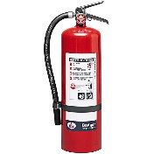

Annex A: Emergency Information for the Classroom
This annex is optional but recommended for most buildings. For administrative buildings where no instructional activities take place, this annex can be deleted.

The importance of emergency preparedness extends into the classroom. Students, even in higher education settings, look to the instructor for guidance and definitive action during an emergency. Faculty and instructors who take a few minutes at the start of each semester to familiarize their students with basic evacuation and emergency procedures will help ensure that they and their students are better prepared for an emergency. The one-page quick reference guide on the following page titled Emergency Guide for Faculty and Instructors in the Classroom is intended to be carried by the faculty/instructor to the classroom.

Emergency Guide for Faculty and Instructors in the Classroom

Students look to the person at the front of the class as the leader of the group. Regardless of class size, students expect the instructor to have answers and a clear plan when an incident, emergency, or event occurs.

What are my responsibilities as the instructor?
- Most importantly: Provide leadership if an emergency arises and follow emergency procedures for all building alarms and emergencies.
- Clearly cover the basic emergency procedures for the class during the first week of class (10 minutes of pre-planning can save lives).
- Know how to report an emergency from the classroom.
- Communicate the evacuation route and Evacuation Assembly Area (EAA) outside the building in case of evacuation. Also explain where the Internal Assembly Area (IAA) is and how it should be used as a shelter-in-place location.
- Evacuate the classroom if a medical emergency occurs to allow emergency responders to access the victim.
- Persons with disabilities who self-identify should be able to provide information on special assistance needs if an incident/emergency/event occurs. Persons with disabilities may need assistance leaving the building during an evacuation.

How do I report an emergency?
Report all emergencies by:
- Calling JMUPD at 540-568-6911 or 911. Save this number in your cell phone.
- State the nature of the emergency.
- Remain on the line until the dispatcher hangs up.

What should I carry with me to class?
- Class roster
- Charged cell phone with battery backup/charging cable
- List of important telephone numbers (i.e. dept. leadership, supervisors, or lab managers, if applicable)

How do I evacuate the classroom?
In many buildings, evacuation routes are posted on building walls at main entrances. Know the evacuation routes for your classroom. Look for illuminated EXIT signs in larger classrooms to determine primary and secondary exits. All fire alarms require mandatory evacuations.

Where do I go after evacuation?
As your class is evacuating the classroom, ensure that everyone is leaving the building. Report to the designated building EEAA. Ensure that your class knows the location and use it to account for students during an evacuation. Remind students to reach out to family and friends notifying them about their safety.

What about a person with a disability?
Four options are available to evacuate a person with a mobility impairment:
- Horizontal evacuation to the outside. Evacuation without using stairs.
- Stairway evacuation by assisting the person to walk or be carried.
- Stay in place unless danger is imminent. Report the location of the person once outside.
- Area of rescue/refuge or other designated location, if available.

What if there is violence or an active THREAT?
- Dial 540-568-6911 or 911 from a cell phone.
- Run: Evacuate the area if safe to do so.
- Hide: Secure the classroom by locking doors; blocking the door with desks/chairs/tables; moving people away from windows and behind items that protect them (desks, chairs, tables). Silence devices and remain very quiet.
- Fight: Only as a last resort, attempt to incapacitate the shooter with improvised weapons.
- Treat the injured using basic first aid (apply pressure to wounds and elevate arms or legs that are bleeding).
- Cooperate with emergency responders.

Annex B: Evacuation Accountability Sheet
Directions: Use this form to account for personnel at the building’s Emergency/Internal Assembly Area (EAA/IAA) when a prepopulated roster is otherwise unavailable. ** This form is to only be used as a guide. Due to the open nature of campus, some occupants may not be in the building or did not evacuate to the assembly area.**

Building: _____________________________________________________________________________

Department/Unit: ______________________________________________________________________

Name | Department/Unit
Please Print or Type
NAME

Annex C: Persons Requiring Assistance During Emergencies Tracking Form
Directions: List all self-identified persons with disabilities who request evacuation assistance during an emergency.*

Name
Room/Building
Phone
Assistance Needed

Name
Room/Building
Phone
Assistance Needed

Name
Room/Building
Phone
Assistance Needed

Name
Room/Building
Phone
Assistance Needed

Name
Room/Building
Phone
Assistance Needed

*DO NOT include this completed list when distributing the BEAP. This information is to be maintained by the Building Coordinator and should not be shared except with those that have been assigned to assist persons with disabilities during a building emergency.

