Laurel Vaccaro, vaccarle@dukes.jmu.edu, March 26th 2020

Lesson Theme: Personal Utopias

Grade Level: 8th grade

Time: Five 60-minute class periods (one or two additional days might be necessary based on classroom needs).
Lesson Overview: Students will be tasked to create a sculpture based on a utopian version of a place of their choice. The sculpture must be mostly made of materials that would be found in the location they choose. Depending on what place the piece is about, students will consider why they chose that location and how they can represent it in an idealized way. Students will also be asked to consider where they could showcase this piece in the place they selected.

Challenge: Students will be challenged to:
- create three-dimensional multimedia works of art
- select a location to base their work on and explain why they chose it
- determine how to visualize aspects of their location through sculptural elements using materials, shapes, colors, installation, and more

Visual Culture Component:
In choosing a location for their personal utopia, students will consider the visual culture of that place. Regardless of each student’s chosen location, they will consider the elements that define their space: materials, colors, patterns, symbols, natural elements, buildings, structures, and so on. Students will be tasked to also consider the sounds, movement, and music related to their chosen location to incorporate in their process. This lesson incorporates our regular surroundings as visual culture from large to small scales.

Virginia Standards of Learning:
Art 8.6 The student will communicate ideas, experiences, and narratives through the creation of original works of art, using selected media.
Art 8.11 The student will create three-dimensional works of art by combining a variety of techniques
and processes.
Art 8.15 The student will analyze how visual organization in works of art affects the communication of ideas.
PS.10 The student will investigate and understand the scientific principles of work, force, and motion: d) technological applications of work, force, and motion.

Lesson Objectives: Create a sculpture to represent a personal utopia based on a place of choice. Incorporate found materials based on the chosen location to create a sculptural composition that could exist in that space. Brainstorm conceptual ideas with sketches and notes on possible locations to choose from.

Vocabulary Words for Visual Analysis:
kinetic sculpture: art that contains movement perceivable by the viewer that relies on motion for its effect
utopia: an imaginary or reimagined place where everything is perfect, idealized, and/or pristine
industrial materials: man-made materials commonly used in construction and infrastructure
natural materials: nature-made materials found all around us
parallels of form: quality of art resulting from looking at a real life reference and designing a composition based off of the basic characteristics of that reference
prototype: an early model of an idea; a three-dimensional sketch in the beginning stages of design

Historical/Cultural/Artist Information: Michio Ihara
Michio Ihara is a Japanese kinetic sculptor currently based in Massachusetts. Born in Paris, France, he went on to receive his Oil Painting BFA from Tokyo University of Fine Arts (where he later became an instructor) as well as a Fulbright Grant to the University of Arizona as well as graduate studies at Department of Architecture, MIT. Additionally, Ihara has experience in artist residencies, international symposiums, and fellowships in New Zealand and Australia.
Ihara’s works consist of kinetic sculptures, and architectural designs, many of which have been showcased at the Rockefeller Center in New York and many other international venues. James Madison University recently acquired an Ihara original sculpture based on the pieces on display at the Albright Miller Residences in Harrisonburg, VA. In discussing “Light and Movement” as pictured below, Ihara states “...as in all my work, the conception evolves from the space and the way the space is used. I spend time in and observe the space before I begin to design the work...” (Hudes).

Image Descriptions:
Michio Ihara
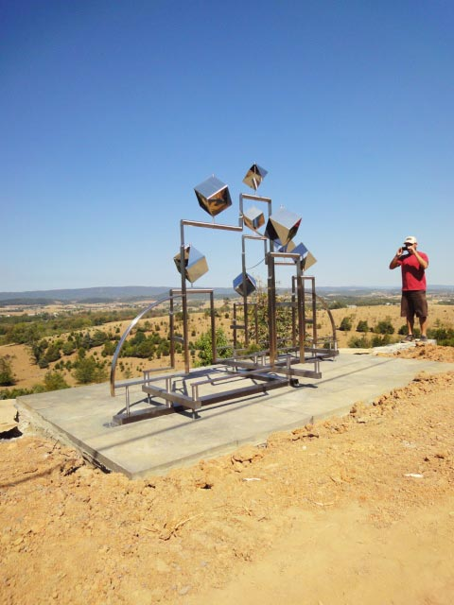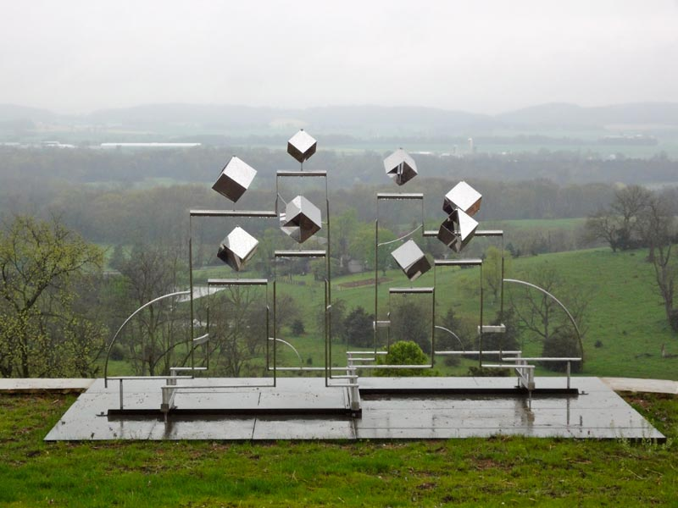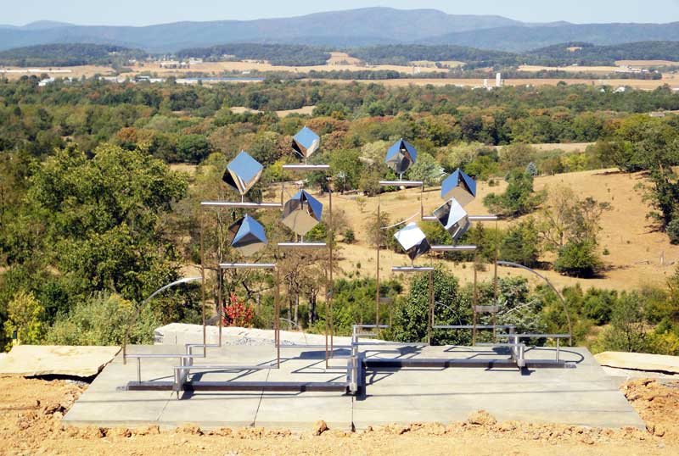
Albright Miller Residences, Harrisonburg VA, 2010
This piece is a freestanding structure made mainly from steel and concrete. Straight and curved metal rods suspend eight metal cubes that all tilt and twist slightly in the wind. As seen in the second image here, the metal rods have a similar shape and distribution to the landscape behind it - different curves and levels that represent the basic shapes of the environment around it.

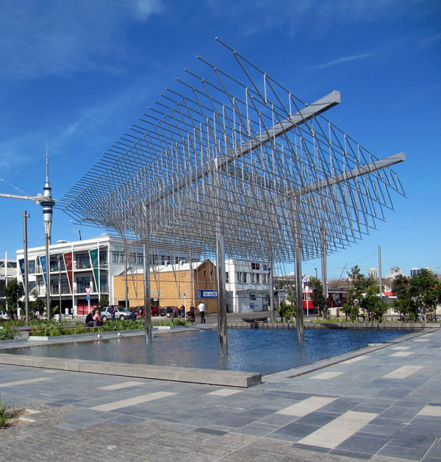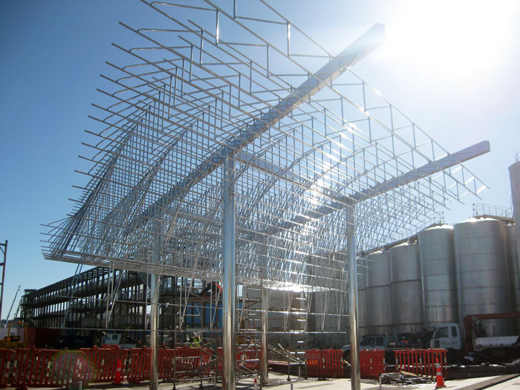
Wind Tree / Jellicoe Plaza, Auckland, New Zealand, 2011
This “tree” moves in the wind much like the first piece. Consisting of metal rods that move in the wind suspended over a square pool of shallow water, this piece is a larger-scale public installation.

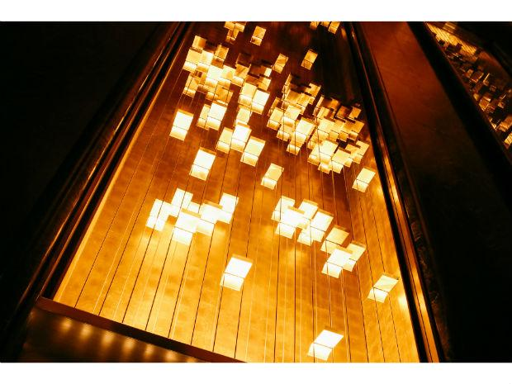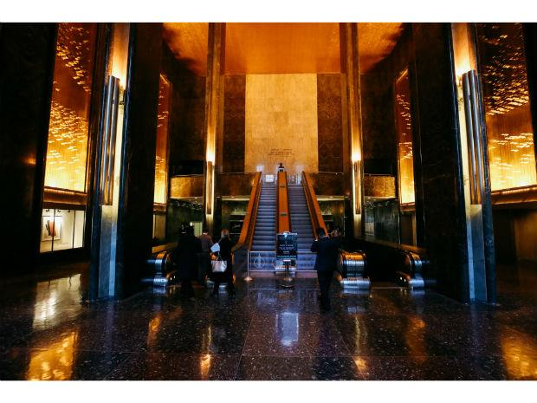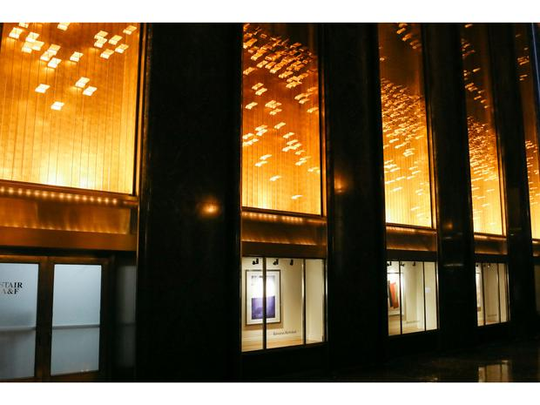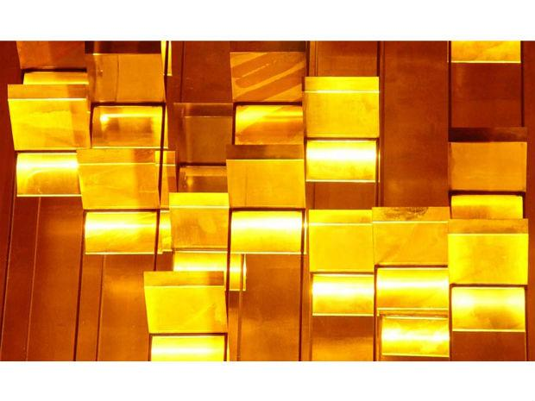
Light and Movement, Rockefeller Center, New York, 1978-Present
This permanent piece consists of lights, panels, metals, and installed architectural materials. The piece itself conveys a sense of spirituality in daily life as the reflections of light that bounce around the room creates a beautiful effect. The light panels are reminiscent of large office and apartment buildings when they light up New York City at night.

Questioning Strategies for Images:
- Day 1
  - What are the basic characteristics of this place? What does it look like? Is it natural? Is it industrial? Is it homey? Is it like a vacation?
  - How do these sculptures represent the places they’re located in?
  - What qualities parallel between each sculpture and each personal utopia?
- Day 2
  - What basic shapes can you see in the sculpture and do they parallel the place the sculpture is in?
  - How does each sculpture represent a utopia?

Lesson Procedure:
Day 1
- (5 minutes) Welcome students into the classroom as they enter and head to their regular seats. Tell students to take their sketchbooks out and have them open on a new page. Invite students to turn their chairs around to face the projector screen as needed.
- (5 minutes) Introduce Michio Ihara (artist/history, background, example artwork)
  - Referencing the artist information above, introduce Ihara and his work.
    - “Today we’re going to be taking inspiration from a sculptural artist named Michio Ihara.”
    - Share Ihara’s background written in Historical/Cultural/Artist Information.
  - Albright Miller Residences:
    - Describe the image as shown above. Emphasize the structure’s parallels with the landscape behind it; the mountains and hills are turned into a leveled pattern with the different metal rod rectangles and curves. The cubes moving in the wind might also reference trees moving in the wind. Introduce definitions: kinetic sculpture, industrial materials, natural materials.
  - In addition to images provided in this lesson, show students Ihara’s website. Taking a break from the PowerPoint and sharing the artist’s site gives students a chance to see a wider breadth of the artist’s work beyond the provided examples.
- (10 minutes) Introduce Personal Utopias project.
  - Share the following quote with students to transition into the project outline.
    - “...as in all my work, the conception evolves from the space and the way the space is used. I spend time in and observe the space before I begin to design the work...” - Michio Ihara
    - Lesson introduction: “For our next project we will be creating Personal Utopia sculptures using Ihara’s approach to observing a space and designing artwork based on that space. We’ll be taking time today to brainstorm and look for references of places you’ve been that you think of as your own utopia, which is a place where everything is ideal or perfect. Now, is anything ever perfect? (wait for response) No! Nothing is ever 100% perfect, but we can imagine it and visualize it through art.”
      - Refer to Day 1 Questioning Strategies for introductory questions.
        - What are the basic characteristics of this place? What does it look like? Is it natural? Is it industrial? Is it homey? Is it like a vacation?
        - How do these sculptures represent the places they’re located in?
        - What qualities parallel between each sculpture and each personal utopia?
- (30 minutes) Instruct students to take out their sketchbooks. Pass out copies of the rubric and the brainstorming worksheet shown below (also post this to your online classroom, if needed). Refer to additional Day 1 Questioning Strategies for discussion prompts to get the ideas rolling. Allow students to work through the brainstorming questions in their sketchbooks. Students will need to complete at least four brainstorm ideas for this section.
  - Allow students to talk with each other as long as they are focused and on task - otherwise, encourage students to work through their worksheets and ask for help if they need it.
  - Allow students to use additional drawing materials (colored pencils, crayons, markers, and whatever else available) for their thumbnail sketches and notes in response to the questionnaire.
  - Play music during class - depending on what students want, you can play calming music, popular but school-appropriate music, or a collaborative class playlist out loud in the classroom to a reasonable volume. This also can help keep volume low by making sure no one is talking too loud over the level of music.
- Before the end of class, introduce the prototyping stage of the project. Reassure students that it’s fine if they’re not done with their questions yet, and there will be time next class to brainstorm more and review this next prototyping step.
  - Call students to one demo table to begin the demo process. Begin by showing students your own notes and sketches of your Personal Utopia. Share the meaning, the shapes/forms/colors you’ve chosen, what draws you to that place, and how you might improve it or represent it in an ideal way.
    - Explain that prototypes need to be at least 5 inches tall and wide.
    - Be sure to have your chosen material based on your location ready in advance to incorporate into your demo process. Reassure students that the material itself doesn’t have to be directly from the place, just the same material.
    - Create a demo sculpture based on your chosen place. (For example, a piece based on playing volleyball at the beach might have sand and string to represent the volleyball court, or even pieces of a volleyball, or pieces of driftwood or seaweed.)
    - Explain that a prototype is an early model of an idea; a three-dimensional sketch. Complete your teacher example in the time allotted.
- Take the last five minutes of class for clean-up. Have students put all drawing materials back where they got them; otherwise all that’s left is putting their sketchbooks away.
  - Having prototype time before cleanup time helps get students away from their work and ready to clean up. Sometimes students get too invested in their work and want to work to the last minute - this is okay sometimes but if too many students do this then it’s troublesome. Feel free to adjust this as needed.
Day 2
- (5-10 mins) Invite students into the classroom and immediately come over to one table for demo time. Begin with a recap of the prototype demo from Day 1 at the start of class, reinforcing vocabulary and process of prototype creation. Briefly click through the three image examples to remind students about Ihara’s work and how each piece reflects the qualities of its location.
- (40 min) Work time. Have students begin prototype time. Students may either start with sketching designs for their sculpture (sketches should take up the whole page) or with 3D techniques such as wire, yarn, clay, and so on. Have Ihara’s website pulled up on the projector showcasing his sculptural work to provide a general reference for the pieces.
  - During work time, walk around and assist students as needed. Make suggestions based on their ideas and what they want to incorporate in their art. Refer to Questioning Strategies Day 2 to prompt student work.
- (5 min) Instruct students to find at least one material to incorporate into their sculpture to bring into the next class. They can find more than one if they’d like, and all materials don’t have to be directly from each place if they are unable to get there.
  - Allow students to drop items off in advance at the start of the day, during lunch, or whenever they can - allocate space in the classroom as needed. One idea is to use inexpensive large storage bins or shelves, label each one per class period, and have students bring in their materials in bags with their name and class period on them.
Day 3
- (5 minutes) Invite students into the classroom. As students enter and get settled, have them set their materials on their desks for a visual check to see who has brought in materials and who has not. At this stage, it’s fine if students do not have their materials yet as there will be additional work time. during the next class period.
- (~15 minutes, 5 min per material demo) Begin work time on full sculptures. Again, have Ihara’s work on display on the board for general reference. Depending on what materials students want to use, demonstrate:
  - Metal wire safety precautions. Show students how to safely use pliers and wire cutters to use metal wire in their sculpture. Use safety glasses and gloves when handling these materials. Have students cut the wire away from themselves. If cutting a small piece, have them cup their hand around the smaller side to prevent the wire from flying away when cut.
  - Air-dry clay. Students should be familiar with this material from earlier grades, but demonstrate how they can create new colors using white clay and Crayola markers, or simply mixing clay colors.
  - Remind students that they may also paint their sculptures later for added color. For now, start them off with focusing on structure and form.
- (~35-40 minutes) Workshop time. At the beginning, have students place a piece of paper down with their name on it. Students will build their sculptures on top of this piece of paper so they can keep track of it as they work.
  - Instruct students that their final sculptures must be at least 8 inches tall and wide. Adjustments can be made if it’s larger in one dimension than the other.
  - Walk around the classroom referencing Day 1 and 2 Questioning Strategies where needed, and provide individualized assistance for students beginning their projects. If you would like to also work on your own project, do so for 10 minutes or so to model the sculptural process and finish during each of your other classes.
- (~5-10 minutes) Cleanup time. Have students collect all unused materials, store them in the bags they brought their found materials in, and put the bags with their sculptures.
  - Dismiss students by table once they have fully cleaned up to go place their sculptures on the provided storage shelf. At the end of this class, use tape to mark and label where the class periods divide on the shelves.
Day 4
- Refer to above instructions for day 4 as this day will mostly be work time.
  - Have Ihara’s work up as reference.
  - Work on your teacher example for 10 minutes (divide however through class).
  - Questioning Strategies to assist in the sculpture process.
  - Ask anyone if they need another demo on a certain material or technique.
- 5 minutes introduction and review, 5 mins retrieval of work and materials (dismiss by table), 40 minutes of work time, and 10 minutes of clean up time.
  - Refer to procedures above in Day 3.
Day 5
- Depending on where students are at, adding one more day of work time may be necessary to complete projects. Additionally, as outlined in the Accommodations section below, provide students with out-of-class time during lunch or before/after school to come in and work (this however is not a requirement and only for additional assistance for students, as well as only if your schedule allows for it).
- Invite students to enter and remind them that we will be finishing up the sculptures for the first 30 minutes of class. At 25 minutes have students start to clean up and shift into a self-critique activity. At this stage it’s okay if students are not finished with their piece fully as there may be additional days built in with this lesson.
- This self-critique activity can be completed at the end or near the end of the student’s project. Have students clear their materials, place their sculptures on their desks, and respond to the questions below:
  - Provide a brief summary of your Personal Utopia and how it represents your own ideal place to be. Refer back to your sketchbook notes and write this in complete sentences.
  - What do you like about your sculpture so far? What do you not like? Why?
  - If you could go back and change a part of your sculpture during this process, what might you change? Why?
  - Do you think your piece conveys your idea successfully? Why or why not?
  - Referencing how Ihara uses parallels of form in his works and their location, how does your piece parallel your chosen place?
  - Imagine your Personal Utopia sculpture fully installed in the location you chose. Would it be indoors or outdoors? Larger-than-life, the same size as it is now, or smaller?
- Have students turn in their critique papers for grading. If additional time is given to the entire class to finish their projects, hand these papers back out after grading for students to refer to when finalizing their pieces. Allow students to resubmit their sculptures and critique papers after you grade them. Reevaluate their grades based on sculpture completion and resubmitted self-critique responses.
Further work time may be necessary to finish up these projects (refer to Accommodations below). In later projects, these sculptures could be used to teach photoshop skills where students superimpose their sculptures into the locations they chose.

Evaluation:
___/16 | 4 | 3 | 2 | 1
Brainstorm Sketches | Four or more locations chosen with detailed notes, ideas, and thumbnail sketches. | Three locations chosen with adequate notes and sketches. | Two locations with some notes and some notes and sketches. | One or fewer locations chosen with little to no effort in notes or sketches.
Prototype | Prototype is 5x5 inches or more wide and tall, sufficient detail provided to show structure and form of sculpture idea. | Prototype is close to proper dimensions (half an inch to an inch short) and a general form is provided for the idea. | Prototype is not large enough (smaller than 4x4 in) and lacks detail for later reference in sculpture work. | Prototype is too small, incomplete, or crudely made with little to no effort.
Personal Utopia Sculpture | Sculpture is complete (or nearly complete) and represents personal utopia successfully. At least one found material is used in construction, effort and detail present, excellent use of class time. | Sculpture needs additional work but overall represents the personal idea and found materials are incorporated. Acceptable use of class time. | Sculpture is incomplete, lacks required materials, and the message is unclear. Use of class time needs improvement. | Incomplete, poor use of class time, not on task, sculpture is rushed or messy.
Self-Critique | All questions are answered in full sentences. Each response is mindful, well thought-out, and refers to at least two art vocab terms. | Most questions are answered (5 or 4 out of 6). Responses are adequate but could use polishing for full credit (grammar, response content, see notes on response paper). | Some questions are answered (3 or 2 out of 6). Responses are incomplete, unclear, or not fully thought out or intentional. | No responses provided, or little to no responses written. Single-word responses.

Personal Utopia Sculpture Brainstorming Worksheet

Key Terms:
utopia - a perfect, ideal place that we create
kinetic sculpture - art that relies on motion for its effect
industrial materials - man-made materials, used in building and construction
natural materials - nature-made materials, found outside all around us

Answer the questions below in your sketchbook using bullet point notes and thumbnail sketches for each location you choose (you must choose at least 4 locations).
- Where are your favorite places to be? Why? What do they mean to you?
- For each favorite place you thought of, list qualities of the scenery, objects, and materials found in that place.
  - What colors, sounds, and shapes make up this place?
  - What kinds of materials are there? Are they industrial? Natural? Both?
  - What are some memories you have of this place?
  - Do you like to relax in the places you chose or do you prefer to be active? What do you do in each place?
  - Do you associate these places with any people close to you?
- Find any pictures you have of each location you chose and put them all in one folder on your phone, desktop, or online drive. If you don’t have any photos, list or draw parts of the places.

Materials and Preparation:
- adhesive materials
  - hot glue, Elmer’s glue, wood glue, metal wiring, string, yarn, twine, tape
- safety tools for sculptural construction (use with supervision)
  - scissors, Exacto knives, pliers, wire cutters, safety glasses, safety gloves
- found objects and materials (for students to gather or request depending on need)
  - wood, bark, fabric, natural items, etc.
- additional sculpture materials
  - air-dry clay
The following should be done in advance for demos and storage throughout this lesson:
- get inexpensive bins or shelves for material storage
- clear enough space in the classroom for sculpture storage; wheeled shelves would be best
- your own selected location for a Personal Utopia teacher example
- sketches and notes in preparation of the teacher example
- preselected found material from your chosen location (does not have to be from that place in case it’s too far away to go to, just the same material)
- create a demo prototype starting on Day 1 during demo to be completed outside of class to show during the rest of the student prototype process

Resources:
Chattyfeet, & Shovava. (2017, October 3). Art History: The Evolution of Hypnotic Kinetic
Sculptures. Retrieved March 26, 2020, from https://mymodernmet.com/
kinetic-sculpture-art-history/

Doi, Y. (Ed.). (n.d.). MICHIO IHARA. Retrieved March 24, 2020, from
http://www.michioihara.com/about/biography.html

Hudes, K. (2018, July 18). Q&A with Michio Ihara. Retrieved March 25, 2020, from
https://www.rockefellercenter.com/blog/2018/07/17/q-michio-ihara/

Special Populations: Gifted and Talented Students
Depending on each gifted and talented student, individual accommodations can be made to enrich their time in this lesson. If possible, invite these students to come into the classroom during lunch or after school for more individualized work time in a relaxed setting. These students could be given additional materials and instruction (depending on what materials are available) to use for their sculptures. However, offer additional work time to everyone in class. Students who don’t technically qualify as gifted and talented should still be rewarded for proactive behavior, such as coming to extra class time for help, asking questions in class, or focused in-class behavior.
It’s important to not simply assign more work to gifted and talented students, but providing an extension to enhance their artmaking experience is crucial as well. As GT/accelerated learning students usually finish early and seek more to do, additional accommodations can be made to extend the lesson theme in the following ways:
- Further research on each student’s location for a specific issue to improve upon: ecological, social, and personal issues present in each place.

Extra Materials:
- Additional presentations for more ideas for students to reference.
- Student-led research efforts to bring examples into the classroom to reference.
- Safety goggles, gloves, and other materials that could be borrowed from other classrooms or found at hardware stores.

Thoughts About Questioning Strategies:

 | Questions
Day 1 | - What are your favorite places to be? Why?  - In those places, what do you like to do? Relax? Be active? Be alone? Be with friends or family?  - What reminds you of this pace? Is it a smell, a sound, a taste, an object? Why does it remind you of that place?  - What are the basic characteristics of the place? What does it look like? Is it natural? Is it industrial? Is it homey? Is it like a vacation?  - Is your place from a fantasy world? Why or why not?  - Is your chosen location a true utopia? Why or why not? How could you make it more perfect?
Day 2 | - What basic shapes can you see in the place you chose? How could you incorporate that into your lesson?  - How can you use a sculpture to represent your personal utopia? Will you use realistic or abstract shapes and ideas?  - Will you represent your place with real objects, or abstract shapes?  - What qualities would you parallel between your sculpture and your chosen personal utopia?

