How to Search for Classes Based Upon Delivery Method

To search for classes by delivery method, once you arrive at the “Search for Classes” area of MyMadison please select “Additional Search Criteria”:

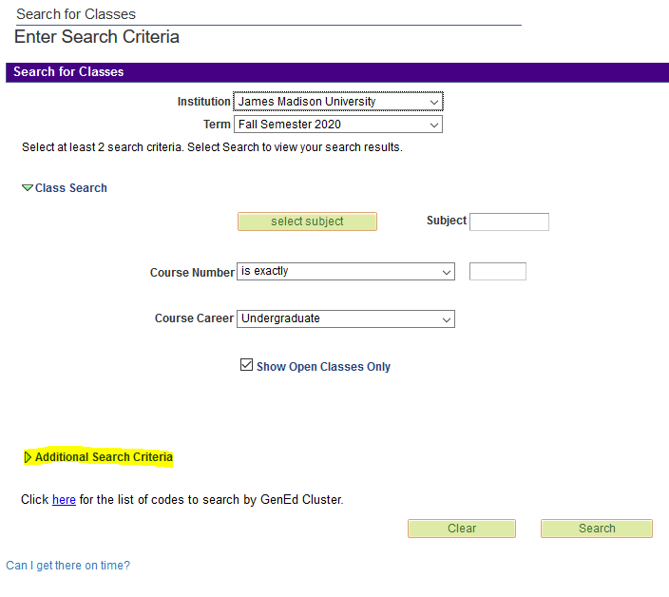

At the bottom of the additional search criteria page, use the location drop-down to select the type of delivery method you desire. To search for classes offered only online, use the “Online” selection in the dropdown. To search for all classes, including In-Person or Hybrid classes, use the “Main” selection in the dropdown.
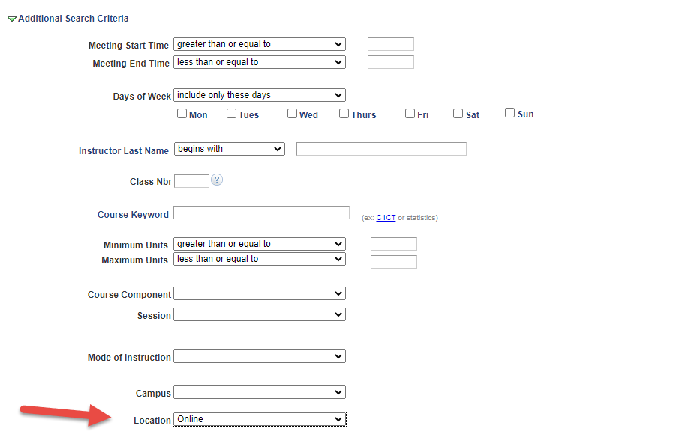

Classes offered completely online will list the room location as “Online”. Classes that meet in person or by hybrid method will list the building and room number in the room location area:

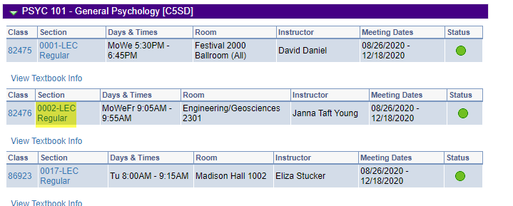
To determine the specifics of the meeting pattern, please review the “Notes” section of every class you are searching. In the instance below, the note alerts students that this class is a hybrid class thereby meeting partly in-person and partly remotely, per the instructor’s direction.

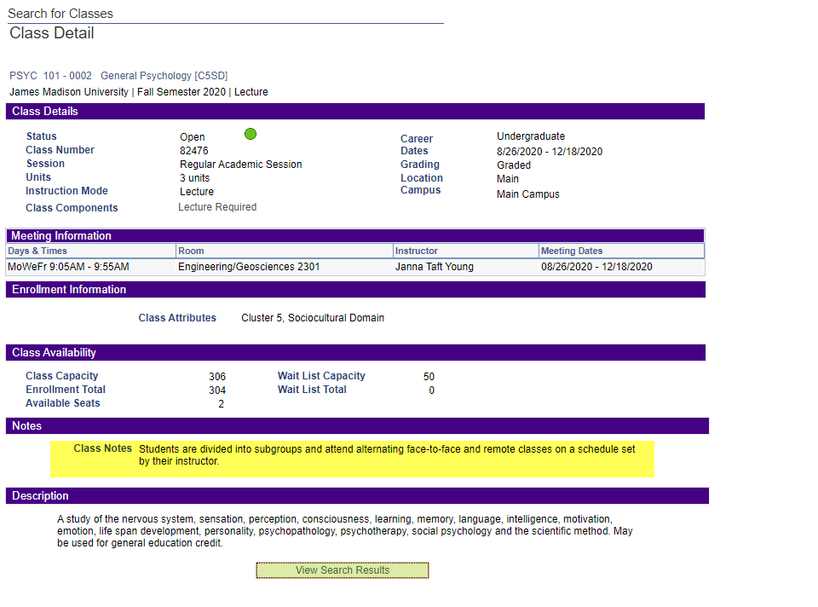

Online classes may meet synchronously or asynchronously. Synchronous online courses will meet during the specified times and days, but will do so remotely. Asynchronous online courses will not have a defined meeting pattern as it pertains to days of the week or times of the day and the instructor will determine the format of the online learning.

