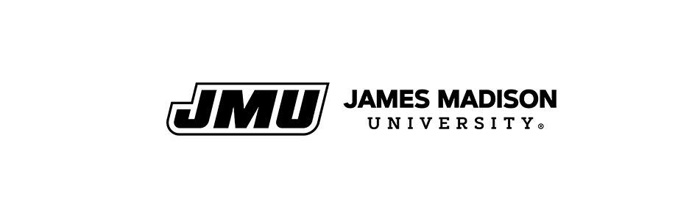

Post 9/11 GI Bill® Yellow Ribbon Application
James Madison University will accept a total of 3 out-of-state undergraduate students (not receiving the in-state rate under Section 702) into the Yellow Ribbon Program on a first come, first-serve basis. All other applicants will be placed on a waitlist.The total funds allocated by James Madison University for the academic year is up to $3,000.00 per student ($1,500.00 per semester). The Department of Veteran’s Administration will match the contribution made by James Madison University. The combined JMU and VA contribution cannot exceed the net tuition and fee semester charges. Yellow Ribbon is not available in summer terms.

Please submit this application to the Office of the Registrar. We must also have a copy of your Certificate of Eligibility (COE) or copy of the application confirmation page (if COE is not available yet). Return via email veteran@jmu.edu (no electronic signatures), fax 540-568-5615, mail (see website), or drop off (SSC Registrar’s Office 5th floor).

Last Name: _________________________________ First Name: _________________________________
Student ID:_________________________________ Email:______________________________________
Phone: ____________________________________ Parent’s Email: _______________________________
Mailing Address:_________________________________________________________________________
City: ___________________________________ State: ____________________ Zip: ____________________

Statement of Acknowledgment

▪ I am 100% eligible for the Post 9/11 GI Bill®.
▪ I acknowledge that Yellow Ribbon funds are distributed on a first-come, first-serve basis and limited in quantity.
▪ I understand that submitting this form does not guarantee my acceptance to the Yellow Ribbon Program.
▪ I understand that I must have submitted a copy of my Certificate of Eligibility (COE) and this application to be considered for the scholarship.
▪ I understand that I must be seeking an undergraduate degree in a VA approved academic program at James Madison University (major must be declared).
▪ I understand that James Madison University is not required to continue making Yellow Ribbon Program contributions if I am not in good academic standing, if I have a break in attendance (not including summer), or if JMU does not renew the Yellow Ribbon Program agreement with the VA for the following academic year.
▪ I understand that if I have any outstanding VA overpayments with previously attended institutions of higher learning (IHL) that I may be ineligible to receive Yellow Ribbon funding.
▪ I understand that I must promptly notify the Office of the Registrar of any changes in my enrollment or major and all courses must be counting toward graduation to be VA certified.

By signing my name below, I affirm that I have read the Statement of Acknowledgement and that the information contained on this form is true and correct to the best of my knowledge.

Signature: __________________________________________ Date: ____________________________

