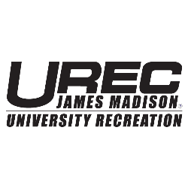
Sport Club of the Year 2021-2022
Letter of Intent Instructions

Sport Club Participant:
Sport Club of the Year is an award given to a team who exemplifies the values and mission that the Sport Club Council and UREC posses. Through this award, the Sport Club Council recognizes one team each year for their exceptional efforts in areas such as: team involvement and inclusiveness, community service, fundraising, recognition and/or awards, and impact in the JMU and Harrisonburg community. Please provide a Letter of Intent highlighting your team’s efforts in the areas listed above. Please limit your response to 750 words or less (3 pages double spaced). Please email all letters to JMUSCCPresident@gmail.com by Friday, March 18th.

*Note: We recognize that your seasons may not be completed by March 18th. If you have events (tournaments, shows, community service projects, and fundraising) that your team is planning to attend please include this in your letter.

