JMU-STAR Reporting Tool

User Guide

Contents
JMU Strategic Plan 2
Planning Cycles and Timeline 3
JMU Planning and Reporting Calendar 3
Timeline 3
Log in to JMU-STAR Tool 5
Create Objectives 6
1 Objective Name and Link to Plans 7
1.1 Steps to meet the objective 9
1.2 Support for Objective 10
1.3 Evaluation Methods 10
1.4 Budget Initiative 11
Copy Objectives 13
Copy Existing Objectives 13
Review and Update Copied Objective Information 14
Annual Report 16
Verify Current Cycle Objectives Are Linked 16
Update Current Cycle Objectives 17
1.6 Objective Accomplishments 17
1.7 Use of Results 17
Create a PDF of the Current Objectives (Optional) 18
Review/Update/Enter Next Cycle Objectives 18
Enter Annual Report Information 18
Create Annual Report PDF 19
Link Objectives 21
Link Objective to JMU Strategic Plan 21
Link Objective to Applicable Strategic Plans 21
Link Objective to Annual Report 22
Help 23
About this Manual 23
Using Document Navigation 23
Locating Specific Terms and Nomenclature 23
Maintenance of This Manual 24

JMU Strategic Plan
President Jim Schmidt, in partnership with the strategic plan co-chairs, is leading an eight-month process to create the next JMU strategic plan by April 2026. This aggressive schedule is anchored in wide-ranging listening sessions and idea forums with campus and community members; identification of focused action themes that will be developed into strategic initiatives by teams of faculty, staff, students, and friends; and opportunities for university-wide contributions to review and refine a future-focused and revolutionary vision for this institution.
You can learn more about the strategic planning process and keep updated on PAIR’s Strategic Planning website.

Planning Cycles and Timeline
Planning cycles align with the university’s academic and fiscal years (July 1 – June 30). Therefore, the Current Cycle will always be the current academic and fiscal year. (For example, when completing the End of Year Annual Report in July 2026, your Current Cycle will be the 2025-26 Planning Cycle.)

JMU Planning and Reporting Calendar

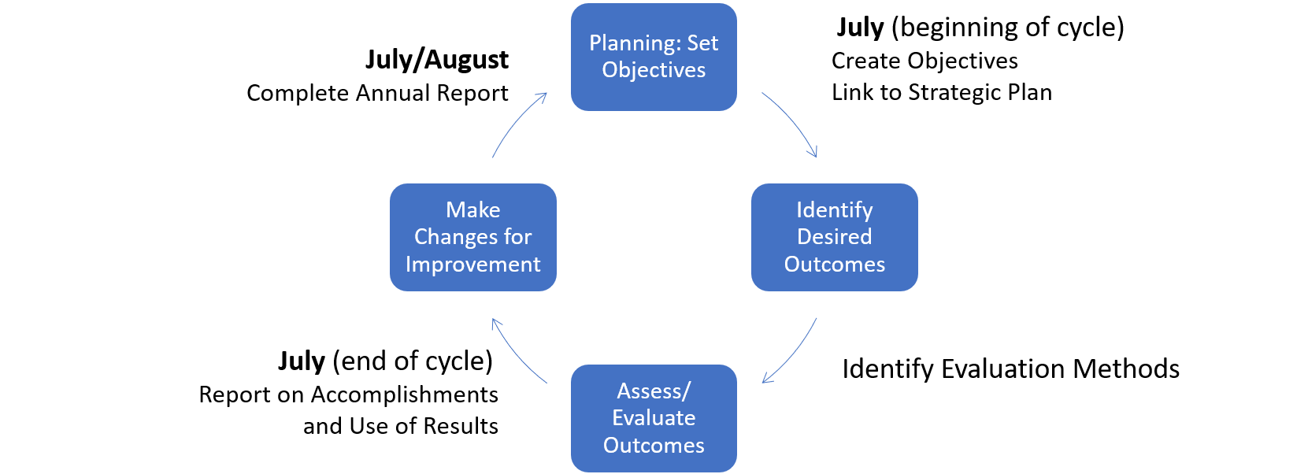

Timeline
July
- Directors/AUHs and AVP/Deans complete annual reporting in JMU-STAR.
- Directors/AUHs submit annual reports to respective AVP/Dean.
- AVP/Deans submit annual reports to respective VP.
- VP’s office communicates with AVP/Deans results of initiative requests.
- AVP/Deans report results of initiative requests to Directors.
August
- VPs review annual reports from AVP/dean units and create an annual report for the division.
- VPs, AVP/Deans send updated division/college strategic plans to PAIR (Cindy Chiarello grovecg@jmu.edu) for posting to the JMU-STAR tool so objectives can be written in alignment with JMU and division/college strategic plans.
- Directors/AUHs hold department planning retreat/meetings for the current year and update objectives in JMU-STAR based on these discussions.
October
- Office of Budget Management (OBM) begins the budget process for the following FY by issuing requests for cost-to-continue items, review of permanent budget revisions and reporting authority.
- OBM makes the forms for E&G initiative requests available to departments (if they are being accepted this year).
- PAIR (Cindy Chiarello grovecg@jmu.edu) makes initial contact with instructions for writing objectives requiring new funding into the JMU-STAR tool for the following FY (if Budget Initiatives are being accepted).

December
- All units enter objectives requiring new funding for the next FY into JMU-STAR.
- Units submit Budget Initiative forms to the respective AVP/Dean; an objective must be in JMU-STAR for each budget initiative submitted.
January
- Budget initiative requests, if accepted, are sent to the OBM by the VP's office.
February
- OBM meets with VP to discuss submitted budget initiatives.
- VP determines which objectives will become strategies on SCHEV six-year plan.
- Annual reporting fields in JMU-STAR open for the current year-end reporting.
May
- PAIR (Cindy Chiarello grovecg@jmu.edu) distributes end-of-year reporting information (objective outcomes and annual report).
- OBM meets with the VPs to communicate results of initiative funding requests.
June
- Directors/AUHs and AVP/Deans begin annual reporting in JMU-STAR based on instructions sent in April/May.
- Directors/AUHs and AVP/Deans complete year-end updates for each objective managed through the JMU-STAR Tool with a specific focus on accomplishments and use of results.
- Directors/AUHs/AVPs/Deans enter objectives for the next FY not requiring new funding into the JMU-STAR tool based on the following parameters:
  - Unit mission and major departmental or unit objectives
  - Continue objectives from prior year that include the evaluation of results
  - Action plan items resulting from Program Review
  - Other mutually agreed upon goals and objectives with supervisor
- Board of Visitors approves the university budget.

Log in to JMU-STAR Tool
- Navigate to https://www.jmu.edu/pair/strategic-planning/jmu-star-help.shtml on any browser.
- Click on the link for the JMU-STAR Portal under the header How can I access JMU-STAR?
- Log in:
  - Username is your full JMU email address
  - Your default password was set up prior to training

Note: Your JMU‑STAR password is not synced with your JMU eID and password; it will not change unless you change it manually. If you have forgotten or want to change your password, contact Cindy Chiarello (grovecg@jmu.edu) for assistance.

Create Objectives

Important Information
At the beginning of the planning year (July or by the Fall semester), you should use the JMU-STAR tool to create objectives for the upcoming year. Any objective is appropriate for tracking in the planning tool, but you should put emphasis on tracking high-level objectives from year-to-year – showing how you’re using results from the previous year to inform improvement for the next year. The JMU-STAR tool is the vehicle for reporting and tracking objectives so that they are seen and reviewed by university administration.

Effective communication is critical for our planning process to work optimally. Please talk to those you lead about their objectives; both the ones being worked on in the current year and the ones being planned for next year. Ask questions of your supervisor to learn their planning priorities. The plan hinges on the quality of the objectives being executed and their alignment with university, division and college strategic plans.
NOTE: If you are continuing an objective from a previous planning cycle, see instructions to Copy an Objective. Copying objectives should be done before creating new objectives, otherwise the new objective will be overwritten by the copy process. If you are creating new objectives, continue with the instructions in this section.
At the beginning of the planning cycle, for each objective enter information for sections 1 (Objective Name and Link to Plans) through 1.4 (Budget Initiative).
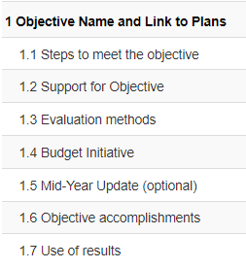
The last two fields (1.6 Objective Accomplishments and 1.7 Use of Results) should be completed at the end of the year. However, you can fill in information as it becomes available. We no longer use 1.5 Mid-Year Update.

Steps
- Log in to the JMU-STAR tool.
- From the Welcome Page, click on Programs.

- Click on your program/unit name.
- Choose the planning cycle you’re working on.
  - There are three cycles visible: Past Cycle, Current Cycle, Next Cycle.
  - Planning cycles align with the university’s academic and fiscal year (July 1 – June 30).
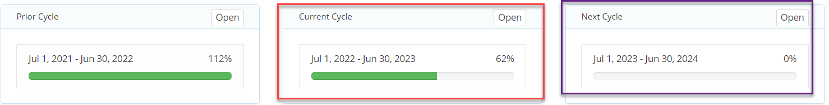
Note: The following steps are re-numbered to align with the objective numbering in the JMU-STAR tool:

1 Objective Name and Link to Plans
Several things happen in this first field of the objective field set:
- Name the objective: Objective Name - short and long description
- Link Objective to applicable strategic plans
- Link to Annual Report
- Add a new objective field set

Name the objective: Objective Name – short and long description
- Click on the first field (Objective Name and Link to Plans) to expand it.
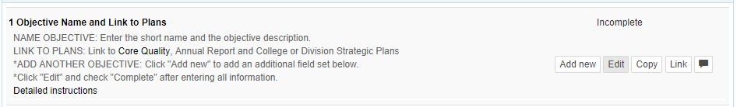

- Brief instructions are located in the opened box. Click Edit. A box will open in the current window.
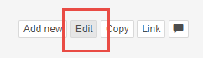
If you choose, you can develop your plan and objectives outside of the JMU-STAR Tool. You can then use copy and paste to enter your objective information. The Objective Template, located on the JMU-STAR Tool webpage, has been developed for this purpose.

- Enter the Short Name for the objective in the box at the top. Use division/college/department abbreviations before giving a short descriptive title to the objective—this short name is used on the Budget Initiative form. For example, OIR- Enrollment projections. (There is a maximum character count of 60 for this field.)

- Enter the long description for the objective in the large text space. Clearly and concisely describe the objective. Include criteria and make sure the objective specifically states a reason why it is important AND fully describes an outcome, product, deliverable, or result to be achieved.
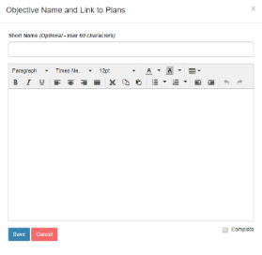
NOTE: Include learning/Use of Results from the prior year’s objective here or in the “Steps to meet the objective” field.

- Once you are done entering information, check the box to mark this field as complete.
- Click Save after entering the information.

Link Objective to JMU Strategic Plan and Division Plan
See instructions to Link to annual report and strategic plans.

Link Objective to be included in the Annual Report
See instructions to Link to annual report and strategic plans.
The Plan link icon shows the number of plans linked to this first objective. Click on it to see the linkage information.
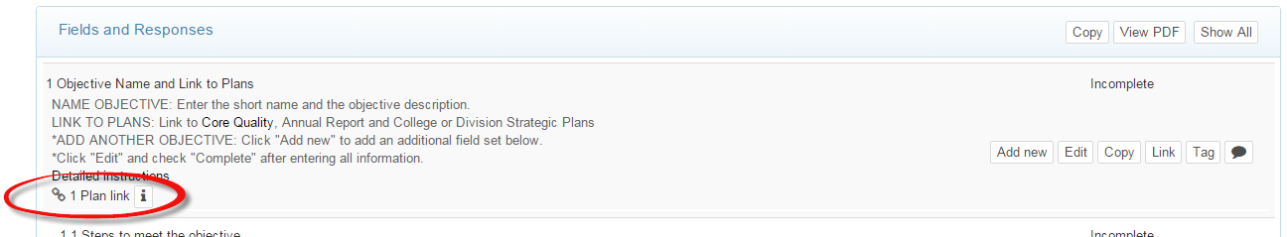

Add a new objective field set
When beginning a new Planning Cycle, the JMU-STAR Tool contains only one field set for an objective. To add more than one objective, you must open the first 1 Objective Name and Link to Plans to add a new objective field set.
- Click Add new to add one or more additional field sets
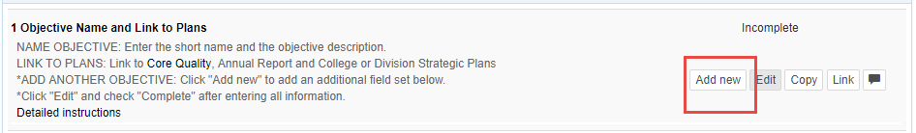

- Click OK to add a new field set.

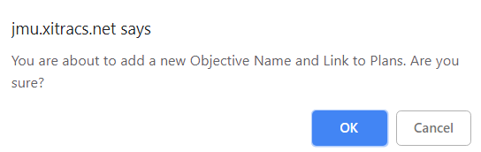
The new field set will be below the existing field set(s), i.e., it will appear as objective 2.

1.1 Steps to meet the objective
Describe the actions to be taken for the objective to be met. (You can attach supporting documents if appropriate.) NOTE: Include Use of Results from the prior cycle if you did not include them in the long description.
- Click on the Steps to meet the objective field. Brief instructions are located in the opened box.
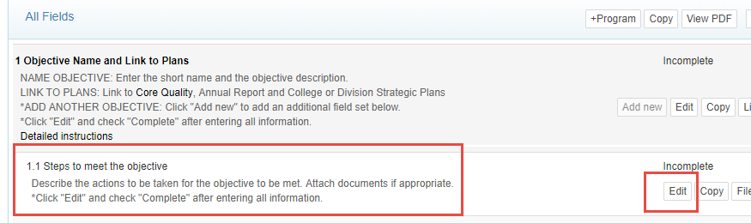

- Click Edit.
- Enter the steps the unit will take to achieve the objective.
Note: It is not necessary to enter information into the Short Name box for any of the subfields of an objective (i.e., 1.1-1.7).

  - Fully describe the key steps to reach the objective. Make sure all key steps include specific detail to be measurable and state a specific timeframe for completion.
  - Use the formatting tools to number the steps if needed.
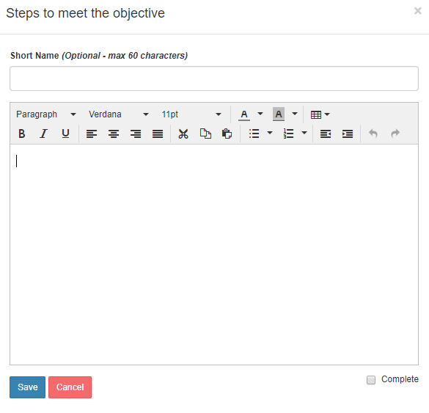

- Check the box to mark this as complete.
- Click Save after entering the information.

1.2 Support for Objective
This field indicates that you intend to contact another office at JMU for support with this objective. The other office(s) are not notified through this tool. This serves as a reminder that you need to contact them.
- Click on the Support for Objective field.
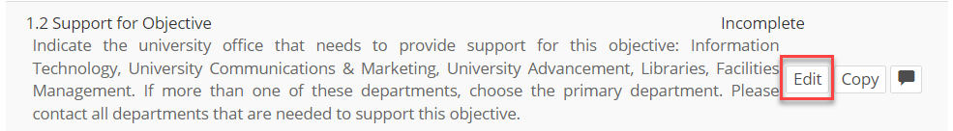

- Click Edit.
- Select the applicable choice from the list.
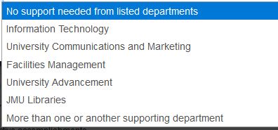

- Check the box to mark this as complete.
- Click Submit in the bottom left to save this information.

1.3 Evaluation Methods
  - Click on the Evaluation Methods field.
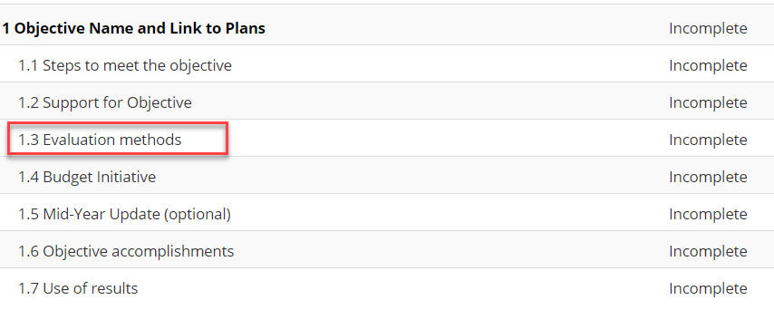

  - Click Edit.
- In the large text area, enter the methods you will use to evaluate the success of this objective.
- Describe the specific, systematic evaluation methods that will be used to measure change.
- Include how the objective will be evaluated/assessed using specific, systematic evaluation method(s) that are clearly linked to expected change/results.
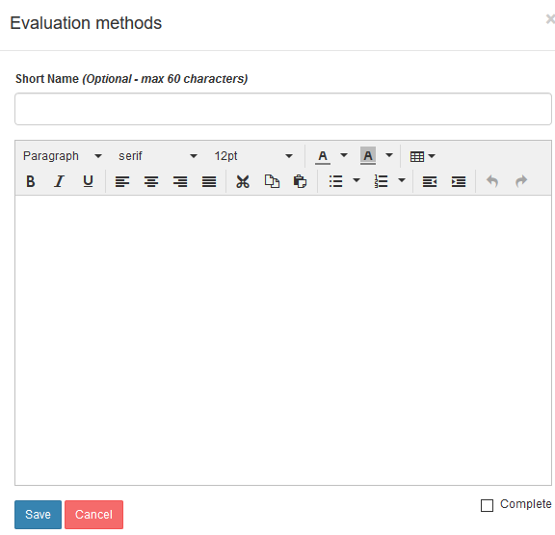
  - Check the box to mark this as complete.
  - Click Save after entering the information.

1.4 Budget Initiative
Use this field if your department is submitting a budget initiative. This is applicable for those new objectives that apply to the next cycle (not the current cycle).
- Click on the Budget Initiative field.
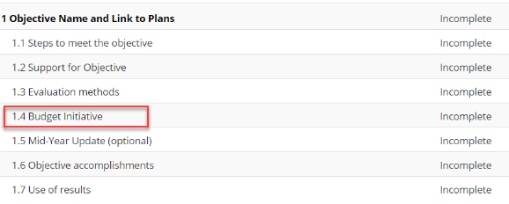

- Click Edit.

- Select Yes or No if you are submitting a budget initiative for this objective.
Note: You will still need to fill out the Budget Initiative form.
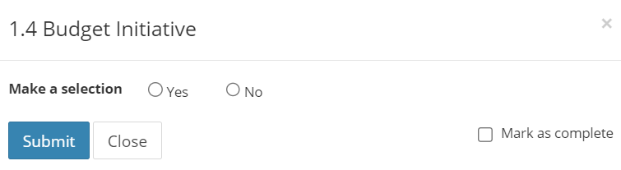
- Check the box to mark this as complete.
- Click Save after entering the information.

Copy Objectives
Objectives can be continued from a previous planning cycle. This process should be done before creating new objectives, otherwise the new objective will be overwritten by the copy process.
- Log in to the JMU-STAR tool.
- From the Welcome Page, click on Programs.
- Click on your program/unit name.
- Choose the planning cycle you’re working on.
  - There are three cycles visible: Past Cycle, Current Cycle, Next Cycle.
  - Planning cycles align with the university’s academic and fiscal year (July 1 – June 30).
  - See University planning and reporting calendar for more information, or contact Cindy Chiarello (grovecg@jmu.edu) for assistance.

Copy Existing Objectives
- Click Copy in the All Fields row. A pop-up window will open.
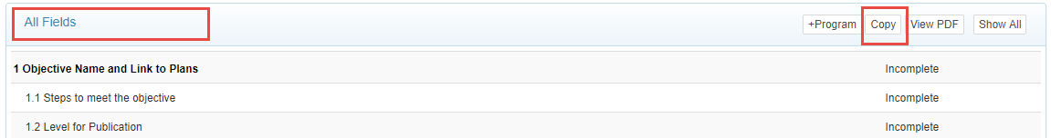

- From the Select a prior cycle dropdown, choose the year where your objectives are that you want to copy.
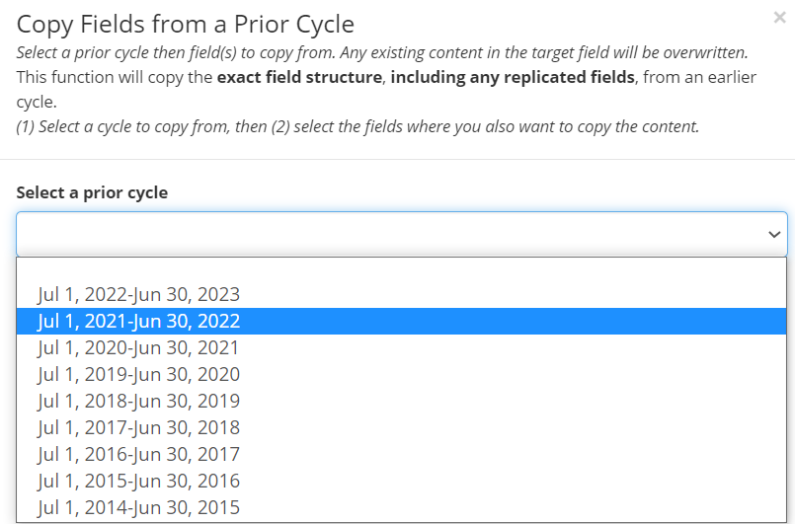

- Check all objective fields for the specific objectives that you want to copy.
  - NOTE – you should not copy Objective Accomplishments or Use of Results, these should be unique to each planning cycle.

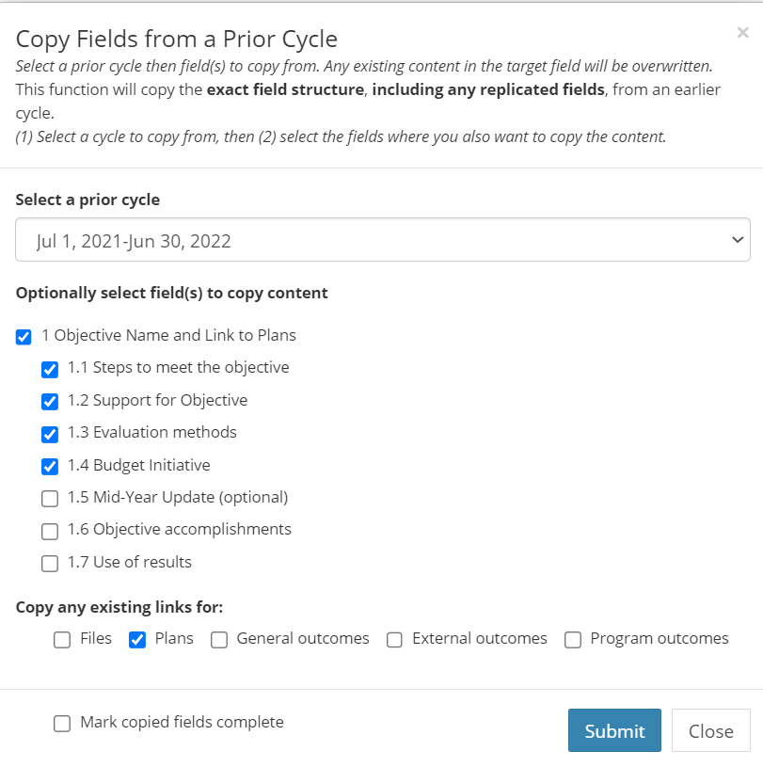
- Scroll to the bottom of the list. Click Plans to copy existing links from the previous cycle’s objective. Do not click Mark copied fields complete.
- Once you have made your selections, click Submit.

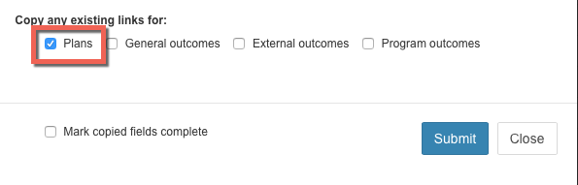
Your copied objectives should now be viewable in the planning cycle you are working on.

Review and Update Copied Objective Information
Review and update the information to reflect what the unit is doing in the current year (steps follow).
- If needed, update the objective Short Name. Update the objective long description. Click Edit.
Note: Include learning/use of results from the prior year’s objective here or in the Steps to meet objective field.

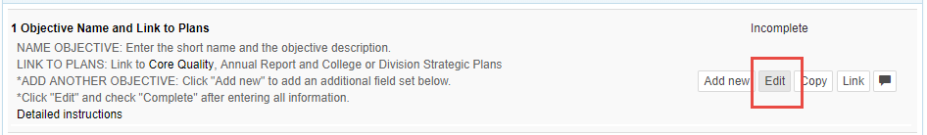

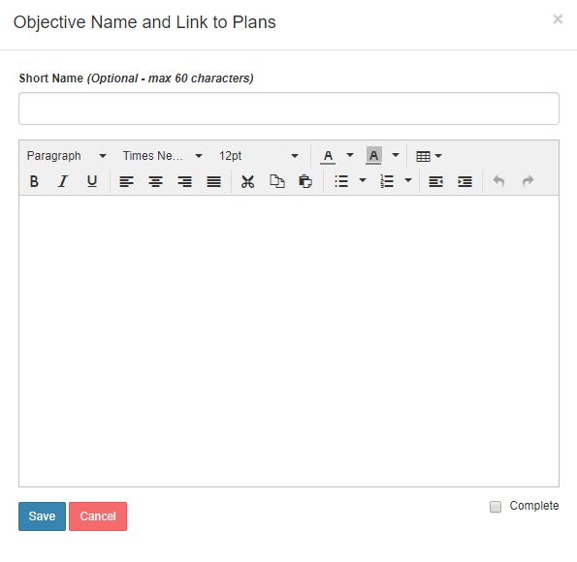

- Check the box to mark this as complete.
- After the information has been entered, Click Save.
- Repeat this process for updating other objective fields as necessary.
Note: 1.6 Objective Accomplishments and 1.7 Use of Results will not be completed until the end of the year.

Annual Year-End Reporting
The annual report highlights your accomplishments over the past year and includes categories that align with the university’s strategic plan or other areas of emphasis for JMU.
At the end of the academic and fiscal planning year (usually starting in April), you should use the JMU-STAR tool to report on your objective accomplishments and create your annual report. This has five steps:
- Verify Current Cycle Objectives Are Linked
- Update Current Cycle Objectives
- Review/Update/Enter Next Cycle Objectives
- Enter Annual Report Information
- Create Annual Report PDF

Verify Current Cycle Objectives Are Linked
Verify your Current Cycle Objectives are linked to both your annual report and any applicable strategic plans.
- From the Welcome Page, click on Programs.
- Select your program to open the drop-down menu.
- Choose the cycle that is ending (before June 30 this will be the Current Cycle, after June 30 the JMU-STAR Tool will automatically advance the cycles so the year that just ended will be the Prior Cycle).
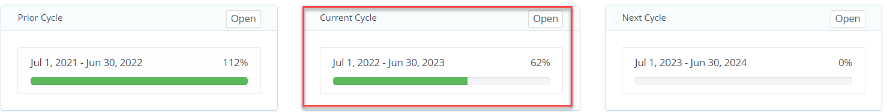
- For each objective, you will link it to multiple items. Click on Objective Name and Link to Plans to open the dialogue box.
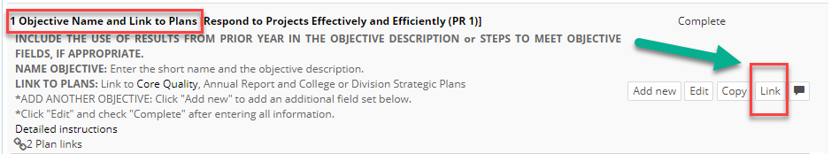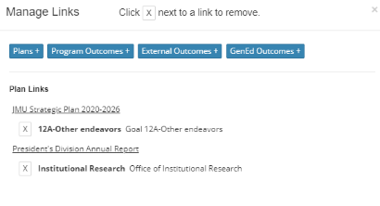

- Click Link to show the plans this objective is linked to.
  - If your objectives are already linked to all applicable strategic plans AND your Annual Report, you can skip this step and move to Update Current Cycle Objectives.
  - If your objectives are not linked to all applicable strategic plans AND your Annual Report, follow instructions in Link to annual report and strategic plans, then return here and continue.

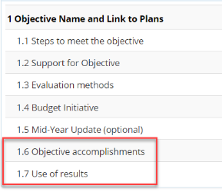
Update Current Cycle Objectives
Update your Current Cycle objectives with accomplishments and how you will use results.

1.6 Objective Accomplishments

- For each objective in the cycle that is ending, click on Objective Accomplishments.
- Click Edit.
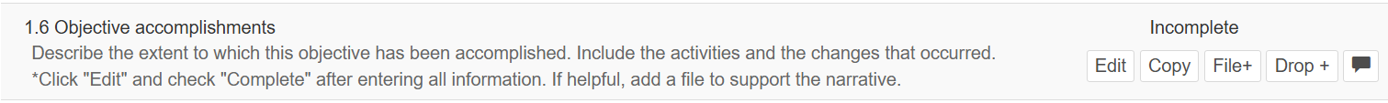
  - In the large text area, describe the extent to which this objective has been accomplished. The description should fully communicate the extent to which each of the specific activities outlined in Steps to Meet the Objective have been achieved and the changes that occurred. (If you choose to, you can copy the Steps to Meet the Objective, paste into this field, and respond to each one.) Include analysis of what happened.
- Check the box to mark this as complete.
- Click Save.
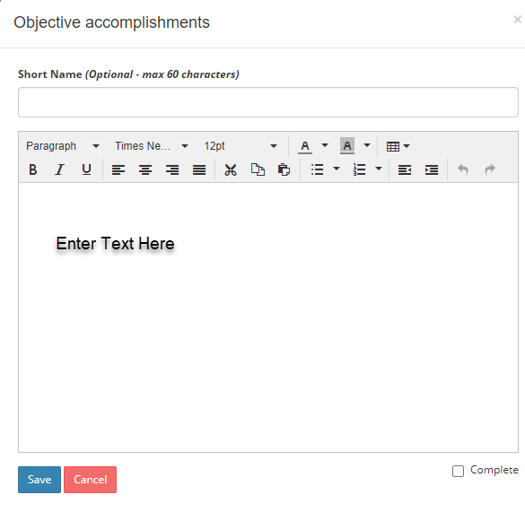

1.7 Use of Results
- For each objective, click on Use of Results.
- Click Edit.
  - In the large text area, reflect on how well the objective was accomplished during this year.
  - Describe how the Evaluation Methods results will be used to bring about future improvement or change.
  - Provide details of what will be changed in the next cycle to further enhance the results of this objective or move to the next step.
  - Fully and clearly connect current results with a specific future direction; set continued or new objective(s) for the following year.
- Check the box to mark this as complete.
- Click Save.

Create a PDF of the Current Objectives (Optional)
- In the All Fields bar above objective 1, click on View PDF.

- A pop-up window will open with PDF Report Options.
  - Select Include Field Numbers, Links, and designate the Planning Cycle.
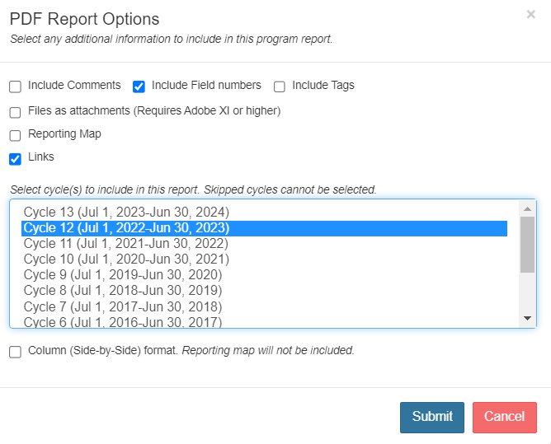
- Click Submit. A new tab will open in your browser with the PDF.
- Download/Save the file to your computer.

Review/Update/Enter Next Cycle Objectives
Prepare and finalize your objectives for next year.
- From the Welcome Page, click on Programs.
- Select your program to open the drop-down menu.
- Choose Next Cycle (before June 30 this will be the Next Cycle, after June 30 the JMU-STAR Tool will automatically advance the cycles so the upcoming year will be the Current Cycle).
- You may have entered some objectives with budget initiatives in January. You will see these here. Enter any remaining objectives now (use Create Objectives documentation for instructions). Return here to continue.

Enter Annual Report Information
- From the Welcome Page, click on Plans.
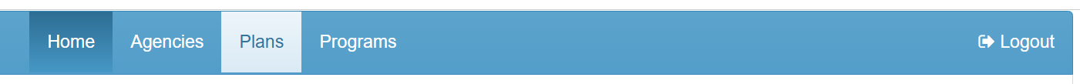
- Click your unit name to create/edit the annual report.
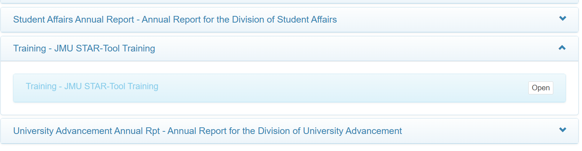
- For each field, click on the field to expand it, then click Edit to enter information in that field. A brief description of information to include in the field is in the expanded view. For more detailed information, view the Annual Report Template on the JMU-STAR Resource webpage.
  - Note: not every field may be applicable to your unit. If it is not applicable, leave it blank.
  - Required fields: Unit Head, Report Year, Unit Mission, Executive Summary. Complete the other fields as they apply to your unit. These fields align with the university’s strategic plan or other areas of emphasis for JMU.
  - The Addenda may include supplemental information, such as:
    - APR/Program Review Action Plan
    - APT assessment report

Create Annual Report PDF
From the Plans tab, you are able to create a PDF of your annual report that includes the objectives from the current and next academic years.
The annual report PDF combines:
- Annual Report (from the Plans section of the JMU-STAR tool)
- Current Objectives (from the Programs section of the JMU-STAR tool, current year plan cycle)
- Upcoming Objectives (from the Programs section of the JMU-STAR tool, next year plan cycle)
Note: the PDF will only include the objectives if you linked them (See Link Objectives for instructions).
- Once you have entered information for all applicable fields, click View PDF in the plan header.
- A pop-up window will open with PDF Plan Report Options.
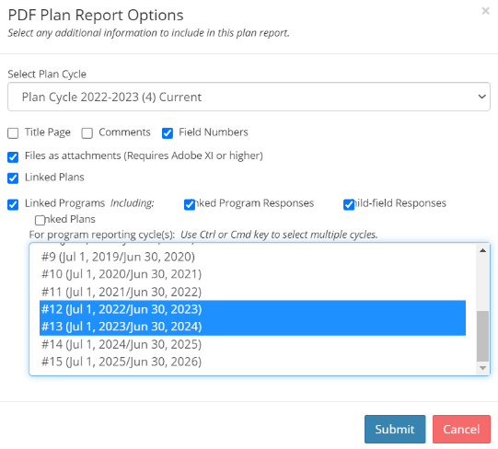
Select:
    - Plan Cycle Current (NOTE: this same process can be used to create previous years’ reports, simply select the year for which you want a report)
    - Title Page (optional)
    - Field Numbers (optional)
    - Files as attachments
    - Linked Programs (these are your objectives)
    - Program Reporting Cycles
  - Select the current cycle (year ending)
  - Select the next cycle (next year)
- Click Submit. A new tab will open in your browser with the PDF.
- Download/Save the file to your computer. The report can be easily shared in this format.

Link Objectives
How to link objectives at any point during the planning year.

Link Objective to JMU Strategic Plan
Note: for the 2025-26 year it is not necessary to link to the JMU Strategic Plan. We will resume this once the new 2026 plan is completed.

Link Objective to Applicable Strategic Plans
If your division or college has a strategic plan, follow your VP’s guidelines for linking to your division’s strategic plan.
- For each objective, click on Objective Name and Link to Plans to open.
- Click Link.
- Click Plans.
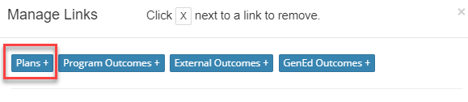
- Click the drop down to select a plan.
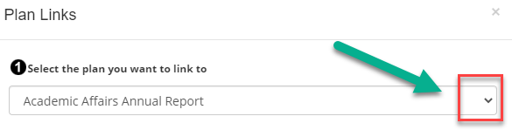
- Select your division’s strategic plan.
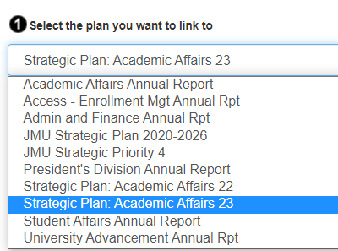
- Scroll to the bottom and click Save.

Link Objective to Annual Report
You must link objectives to the Annual Report Plan in order to include them in your annual report pdf.
- For each objective, click on Objective Name and Link to Plans to open.
- Click Link.
- Click Plans.
- Click on the drop-down menu and choose the Annual Report for your division.
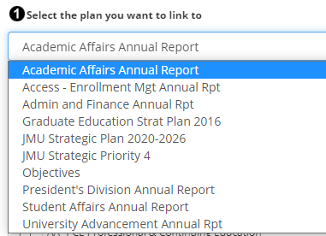
- Check the box next to your unit. (This will include the objective in your annual report.) The list is organized by AVP/Dean level.
Note: Follow guidelines from your AVP/Dean for instructions about linking to their annual report, some AVP/Deans do not use this function. Choose your AVP/Dean from the list to link to their annual report.

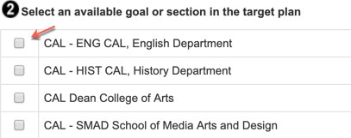
- Scroll to the bottom and click Save.
NOTE: VPs, AVPs, Deans and Department Heads—be sure to include in your annual report the activities and accomplishments of units that report to you that do not create objectives or annual reports in JMU-STAR.

Help
If you need assistance with the JMU-STAR tool or the planning process, please contact:
Cindy Chiarello grovecg@jmu.edu
Tina Grace gracetm@jmu.edu

About this Manual

Using Document Navigation
This document has been created using headings to allow for easy navigation to specific areas of interest.
- To use the navigation pane in Microsoft Word, choose the View ribbon (the top of the screen) and check the box next to Navigation Pane. The navigation pane will appear to the left.
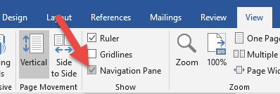
- To use the navigation in Adobe, click on the Bookmarks icon on the left. The navigation pane will appear to the left.
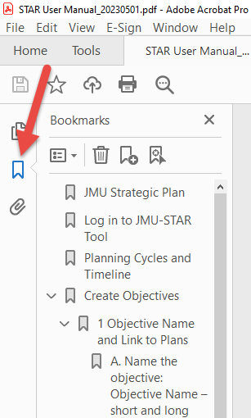
From here, you can click on a heading and the document will take you to that section.
Alternatively, you can click in the Table of Contents on the next pages to go directly to a desired section.

Locating Specific Terms and Nomenclature
Care has been taken in writing this manual to use consistent nomenclature with what you will find in the JMU-STAR reporting tool and in other information you receive from the Office of Planning, Analytics, and Institutional Research (PAIR). To quickly locate information on a specific topic, use Ctrl+F on your keyboard to open the Find box, then type the phrase you are searching for. For example, if you want to create a PDF of your objectives, use Ctrl+F, then type PDF. The finder will show you anywhere in the document that the letters “PDF” appear.
Words in bold indicate exact wording of an item within the JMU-STAR tool and specific sections of this manual. These bold terms are often used to guide you to specific links within the tool or to indicate which command to click on, or to direct you to another section of this manual for specific directions.

Maintenance of This Manual
This manual is intended to be a useful and easy resource for JMU-STAR users. Please send any corrections, updates, or suggestions for usability of this manual to Cindy Chiarello at grovecg@jmu.edu or Tina Grace at gracetm@jmu.edu.

If your unit has experienced changes in reporting, organization, or changed its name, please contact Cindy Chiarello (grovecg@jmu.edu) so that we can make the appropriate changes in the JMU-STAR tool.

