Quality Enhancement Plan (QEP) Progress Report

Institutional Data Team

**Executive Notes**

This report contains the work of three team members of the QEP committee:

Chris Patterson is a doctoral assistant in the Center for Assessment and Research Studies (CARS), and a 3rd-year student in the Assessment & Measurement program (PhD).

Linette Watkins is a Professor and the Department Head of Chemistry.

Jeff Souder is the Budget Director in the Office of Budget Management.

Section I: Relevant Data Analyses

**Data Collection**

Data collected for this report was collected from the Office of Institutional Research, as well as the Office of the Registrar. We would like to thank both offices in their work for providing us with the data needed to explore equity and retention on JMU’s campus.

**Sample**

The initial sample for this report consists of 28,556 students who attended JMU between Spring 2017 and Fall 2021. Data filtering was not performed on students with missing data. Rather, adjustments were made for analyses that will be discussed in the report. As a result, subsample numbers may not match perfectly. Table 1 breaks down the sample by race/ethnicity, gender, and first-generation status.

**Table 1**

*Breakdown of Sample by Identity*

|  |  |  |  |
| --- | --- | --- | --- |
| Group | Identity | n | % |
| Race | American Indian/Indigenous | 61 | 0.2 |
|  | Asian-/American | 1442 | 5.1 |
|  | Black/African American | 1443 | 5.1 |
|  | Hispanic/Latinx | 578 | 2.0 |
|  | Multiracial* | 2888 | 10.1 |
|  | Pacific Islander | 46 | 0.2 |
|  | White | 21387 | 74.9 |
|  |  |  |  |
| Gender | Female | 16443 | 57.6 |
|  | Male | 12057 | 42.2 |
|  | Other Gender Identity | 11 | 0.04 |
|  |  |  |  |
| Generation Status | Continuing-Gen | 23199 | 81.2 |
|  | First-Gen | 3684 | 12.9 |
|  | Unsure | 1673 | 5.9 |

**Question 1: What proportion of students leave JMU?**

Of the 28,556 students that have attended JMU between Spring 2017 and Fall 2021, 2,326 have left for various reasons Therefore, 8.2% of students who enrolled in the past 5 years have left JMU. Table 2 gives a more representative picture of this proportion by race, gender, and college generation status.

Pacific Islander and white students have the smallest proportion of departure with 6.5% and 7.8% of Pacific Islander and white students leaving JMU in the last five years, respectively. American Indian/Indigenous students have the highest proportion of leaving JMU (14.8%), followed by Black/African American students (9.0%). Female students have a lower departure rate from JMU in the past 5 years (7.5%) than male students (9.0%) and students who identify outside of the gender binary (0%). Finally, proportionally more first-generation students have left JMU in the past 5 years (9.4%) than students who have at least one guardian with a college degree (7.3%).

**Table 2**

*Proportion Leaving JMU by Identity Group*

|  |  |  |  |  |
| --- | --- | --- | --- | --- |
| Group | Identity | # Attended JMU | # left JMU | Proportion of attended that left |
| Race | American Indian/Indigenous | 61 | 9 | 14.8% |
|  | Asian-/American | 1442 | 119 | 8.3% |
|  | Black/African American | 1443 | 130 | 9.0% |
|  | Hispanic/Latinx | 578 | 48 | 8.3% |
|  | Multiracial* | 2888 | 251 | 8.7% |
|  | Pacific Islander | 46 | 3 | 6.5% |
|  | White | 21387 | 1670 | 7.8% |
|  |  |  |  |  |
| Gender | Female | 16443 | 1237 | 7.5% |
|  | Male | 12057 | 1086 | 9.0% |
|  | Other Gender Identity | 11 | 0 | 0% |
|  |  |  |  |  |
| Generation Status | Continuing-Gen | 23199 | 1684 | 7.3% |
|  | First-Gen | 3684 | 348 | 9.4% |
|  | Unsure | 1673 | 294 | 17.5% |

\**Note: We recognize that the multiracial student group is a highly diverse group, and should not be treated as monolithic. However, JMU recognizes students with multiple racial identities as “multiracial.”*

This information is mostly consistent with what to expect from higher education literature regarding retention at Historically White Institutions (HWIs). Knowing the proportion of students that have left JMU in the past 5 years, broken down by identity, helps the QEP group to identify retention as an equity issue. If retention was not an equity issue, then all groups, no matter how they were identified, would have the same retention rate as the overall rate (8.2%). We know this is not the case. More specifically, white students, a group that holds racial privilege, has a lower proportion than the overall rate, signifying that on average, a higher proportion of white students stay at JMU than almost any other racial group. First-generation students (students who are the first in their family to attend college) are historically known to leave institutions at a higher rate than peers who have a guardian with a college degree. The interesting piece for JMU is noting that proportionally more male students have left JMU than female students in the past 5 years. Although male students are slowly becoming more underrepresented on college campuses across the country, it is interesting to see that 1.5% more males than females have left JMU.

**Question 2: When are students leaving JMU?**

Students can leave JMU at any point in their academic career. Over the past 5 years, 1,896 students have left JMU between their first and fourth year on campus. Table 2 shows the time point in which students left JMU over the past five years. Most students leave in the first year, with over half of all students who leave JMU leaving in either their first or second semester on campus (n=1,044). This is in line with research in higher education retention; most students who leave an institution are most likely to do it within their first two semesters. Most early-alert systems are built around the first-year student experience for this reason.

There are still many students that leave in their second year (n=539), which still is in line with research. When a student stays at one institution through their second year and enrolls for their third, they are exponentially more likely to graduate from that same institution. In other words, a student is much more likely to leave the institution in their first two years than any other year on campus. JMU would benefit from creating a system that is suited for at least the first two years, but no evidence to our knowledge exists of the harms of having an early-alert system be used for students who are past their second year.

**Table 3**

*Number of students who left JMU by number of semesters and years attended*

|  |  |  |
| --- | --- | --- |
| Year | Semester | # who left JMU |
| 1 | 1 | 664 |
|  | 2 | 380 |
| 2 | 3 | 353 |
|  | 4 | 186 |
| 3 | 5 | 183 |
|  | 6 | 68 |
| 4 | 7 | 45 |
|  | 8 | 17 |
| **Total** |  | **1896** |

**Question 3: Why do students leave JMU?**

Students leave higher education for a variety of reasons. At JMU, it is no different. Data on the reason students leave is taken from student records. In the process, students either select a primary reason for leaving, or a reason is assigned to them upon meeting with the proper offices. Table 4 shows the reasons why students leave JMU. Tables 5-7 break down those reasons by select racial/ethnic and gender identities, as well as first-generation status. Overall, the top students leave are due to psychological reasons, transferring to a different institution, taking a leave of absence, and feeling a lack of fit and/or sense of belonging on campus. Not many students are marking academics or their major as the reason for leaving JMU, meaning that things like GPA and coursework may be less relevant to retention on campus.

**Table 5**

Count of Reasons Students Leave JMU by Racial/Ethnic Identity

|  |  |  |  |  |  |  |
| --- | --- | --- | --- | --- | --- | --- |
| Reason | Race | | | | | Total |
| Asian | Black | Hispanic/Latinx | Multiracial | White |
| Academic | 0 | 3 | 1 | 5 | 39 | 48 |
| COVID-19 | 2 | 4 | 1 | 9 | 74 | 90 |
| Extenuating Circumstances | 0 | 0 | 2 | 2 | 7 | 11 |
| Family | 8 | 1 | 3 | 12 | 42 | 66 |
| Finances | **10** | **10** | 1 | 14 | 84 | 119 |
| Fit/Sense of Belonging | 8 | **10** | 2 | **20** | **127** | 167 |
| Home | 6 | 1 | 0 | 12 | 61 | 80 |
| Health | 3 | **10** | 0 | 18 | **160** | 191 |
| Job | 4 | 1 | 0 | 6 | 28 | 39 |
| Leave of Absence | **10** | 9 | 3 | **23** | **152** | 197 |
| Major | 2 | 3 | 3 | 3 | 18 | 29 |
| Medical | 1 | 3 | 1 | 6 | 47 | 58 |
| Personal | 3 | **11** | **5** | 17 | 97 | 133 |
| Psychological | **9** | 8 | **5** | **26** | **216** | 264 |
| Transfer | **13** | **11** | **4** | **28** | **188** | 244 |
| Total | 79 | 85 | 31 | 201 | 1340 | 1736 |

*Note:***Bold** numbers indicate a top reason why that group leaves campus.

The top reasons Asian students leave campus are lack of financial security, transferring to a different institution, and taking a leave of absence. Black students note they are leaving JMU most prevalently because of finances, personal reasons, health concerns, and a lack of fit/sense of belonging. Hispanic/Latinx students are noting personal reasons and transferring as reasons to leave JMU. Finally, white students are leaving JMU primarily because of psychological reasons and transferring to another institution, but are also leaving due to health concerns and lack of fit/sense of belonging. All groups note that psychological/mental health is a prevalent reason for leaving JMU, while no group has a large proportion that notes academics as the primary reason for leaving.

**Table 6**

Count of Reasons Students Leave JMU by Gender

|  |  |  |  |
| --- | --- | --- | --- |
| Reason | Gender | | Total |
| Female | Male |
| Academic | 20 | 32 | 52 |
| COVID-19 | 54 | 40 | 94 |
| Extenuating Circumstances | 4 | 10 | 14 |
| Family | 38 | 32 | 70 |
| Finances | 75 | 52 | 127 |
| Fit/Sense of Belonging | **115** | 55 | 170 |
| Home | 62 | 18 | 80 |
| Health | **122** | 75 | 197 |
| Job | 9 | 30 | 39 |
| Leave of Absence | 101 | **107** | 208 |
| Major | 18 | 13 | 31 |
| Medical | 34 | 25 | 59 |
| Personal | 56 | **87** | 143 |
| Psychological | **141** | **128** | 269 |
| Transfer | **167** | **85** | 252 |
| Total | 1016 | 789 | 1805 |

Female students have left JMU mostly to transfer to another institution, but have also noted psychological health, lack of fit/sense of belonging, and choosing to take a leave of absence as reasons. Male students are slightly similar; they note transferring, psychological reasons, personal reasons, and taking a leave of absence as primary reasons for leaving JMU. Both groups note transferring and psychological reasons as top reasons for leaving JMU.

**Table 7**

Count of Reasons Students Leave JMU by First-Generation Status

|  |  |  |  |
| --- | --- | --- | --- |
| Reason | First-Generation Status | | Total |
| Continuing- Generation | First-Generation |
| Academic | 40 | 5 | 45 |
| COVID-19 | 71 | 13 | 94 |
| Extenuating Circumstances | 7 | 3 | 10 |
| Family | 35 | 16 | 51 |
| Finances | 79 | **23** | 102 |
| Fit/Sense of Belonging | **140** | 18 | 158 |
| Home | 71 | 11 | 82 |
| Health | **146** | **30** | 176 |
| Job | 24 | 4 | 28 |
| Leave of Absence | **153** | **24** | 177 |
| Major | 24 | 4 | 28 |
| Medical | 54 | 4 | 58 |
| Personal | 99 | 17 | 116 |
| Psychological | **231** | **27** | 258 |
| Transfer | **194** | **44** | 238 |
| Total | 1368 | 243 | 1611 |

Students who have at least one guardian with a college degree (continuing-generation students) note psychological concerns, transferring, taking a leave of absence, health concerns, and lack of belonging as the top reasons for leaving JMU. First-generation students list transferring, psychological reasons, health concerns, taking a leave of absence, and finances as the top reasons for leaving JMU. Both groups leave most often for psychological reasons, transferring, taking a leave of absence, and health concerns.

Together, Tables 5-8 show:

1. Mental health is a top concern for all students, regardless of identity.

2. Marginalized students are more affected (proportionally) by finances and sense of belonging than privileged students.

3. Academics are rarely a point of worry for students who choose to leave JMU.

Although these two points are significant to note, more research should be done on the student population to find points in students’ experiences that lead them to have mental health concerns or feel a lack of sense of belonging. Knowing students’ experiences from their point of view will help the QEP group better understand the need for and implementation of an early alert system.

**Conclusion**

Although relatively not many students leave James Madison University, there is insight to be gained on when and why students leave JMU. Overall, psychological reasons lead the most students to leave JMU every year, yet there are other concerning reasons. Many marginalized students leave JMU for reasons that can be linked to their identity, such as a lack of connection to campus and financial concerns. Given that noncognitive factors like the ones listed can lead to poor academic performance, we must find a way to target students when they first show struggle in noncognitive factors on campus. In order to know when and how to intervene, we must know what factors are important to student success according to research and evidence gathered at JMU.

Section II: Research on Undergraduate Retention

In order to know what to look for to ensure accurate intervention, we looked to literature to understand the ways students interact with their institution, and how those interactions affect a student’s decision to stay or leave the university. Here, we present the three competing student retention models in literature.

Model 1—The Undergraduate Dropout Process Model (Spady,1980; 1981)

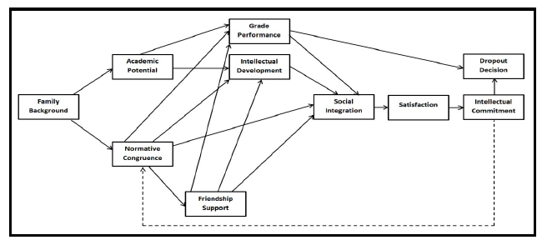

The undergraduate dropout process model is one of the first models that described how students navigated college. This model assumes that a decision to leave campus depends on 1) grades and intellectual development, 2) quality of friendships, and 3) a student’s norms blending in with campus. As this model was the first of it’s kind, there are more universal designs more commonly used in today’s research; this model is older and does not generalize to the campus experience today.

Model 2— The Institutional Departure Model (Tinto, 1975;1993)

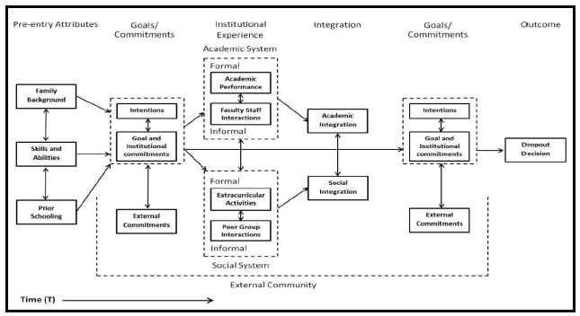

Tinto’s institutional departure model is the most widely applied and used model in higher education retention research, due to its integration of multiple disciplines and interpretability. Tinto argued that students’ experiences, primarily in the first year of college, are dependent upon their ability to disassociate from their old communities (e.g., high school community) and integrate into their new community (i.e., their college community). During integration, the student must navigate both their social and academic systems. Their interactions with these systems, primarily interactions with faculty and peers, will inform a student’s intentions on whether to stay at the university. This model is widely used in higher education, and validity studies have shown this model’s generalizability. The primary disadvantage to this model is that there is no consistent way to measure the constructs defined in this model.

Model 3 (Championed Model)- The Meta-Analytic Structural Equation Model for Persistence (Dolan, 2019)

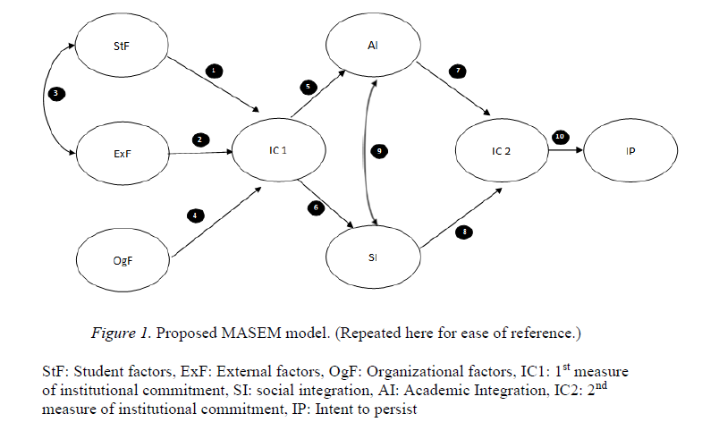

Dolan’s meta-analytic model is the newest retention model that combines previous models (including Tinto and Spady) to create a comprehensive model to represent the student experience. This meta-analytic model defines each factor via observed variables, and each observed variable has a measure associated with it. We have chosen to champion this model because of how well-defined each factor is.

Through our championed model (model 3), we gained insight on what things are important for students to know, think, or do in order to raise their intentions to stay at JMU. Instead of creating a statistical model with all of these variables and factors to predict retention at JMU, we first looked through literature to determine what groups may have preexisting differential rates in retention, given the context of JMU: A large, southeastern R2 primarily white institution located between multiple metropolitan areas.

After scanning literature, the initial statistical models to assess naturally occurring differences in retention rates are:

|  |  |  |
| --- | --- | --- |
| First-Order | Second-Order | Third-Order |
| Race | Race*Gender | Race*Gender*SES |
| Gender | Race*Socioeconomic Status | Race*Gender*First-Generation Status |
| Socioeconomic Status | Race*First Generation Status |  |
| First-Generation Status | Gender*Socioeconomic Status |  |
|  | Gender*First-Generation Status |  |
|  | SES*First-Generation Status |  |

Logistic Regression will be used to model the likelihood of retention past the first year on these variables. Nested model testing will be used to find the most parsimonious model that explains the most variance in retention rate after the first year of college. After the best statistical model is found, we will then add in ISSAQ factor scores as covariates to determine the best way to predict retention in the JMU body, based on social identities and ISSAQ scores.