“Stop the Spread

Community Impact Reflection”

Workbook

FOLLOW THESE INSTRUCTIONS

Failure to follow these instructions will result in a notification email requesting resubmission.

Failure to resubmit may result in an alleged policy violation of Failure to Comply with a Disciplinary Decision.

- Download this document, save it as a .doc file and submit as an attachment to an email to: osarp-educationalprograms@jmu.edu

Links to cloud documents will not be accepted.

- Use the email subject line: Stop the Spread Workbook

What Do You Value?

Using the values listed, and adding to the list if you like, rank the values by importance to you.

Using your own words, write a definition for your top 5 values.

RANK: | VALUES:
 | Accomplishment
 | Active Community Member
 | Compassionate
 | Ethical
 | Faith/Spirituality
 | Family Oriented
 | Financially Stable
 | Fun/Enjoyment
 | Good Partner
 | Happiness
 | Honesty
 | Independence/Freedom
 | Intelligent
 | Loyalty
 | Physically Healthy
 | Power/Influence
 | Respect
 | Other:
 | Other:
 | Other:

Guided Reflection

What values did you put as being the most important to you? How do you actively live out these values?

- How do each of these values influence your role as a community member and the responsibility we all have for the health, safety, and success of our community?

How are your values similar/different to your community’s values? How do you decide which values to follow? (JMU’s stated values are: Academic Quality, Community, Diversity, Innovation, Integrity, and Student Focus)

How do the values you identified as important to you play a role in adhering to the “Stop the Spread” Agreement?

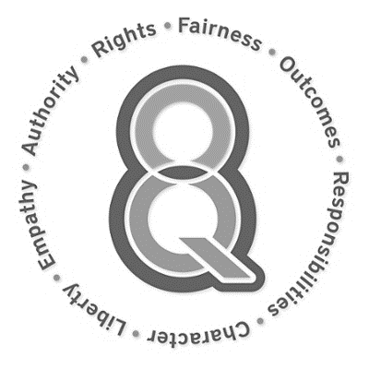

The Eight Key Questions

Fairness
How can I act equitably and balance legitimate interests?

Outcomes
What achieves the best short- and long-term outcomes for me and all others?

Responsibilities
What duties and/or obligations apply?

Character
What action best reflects who I am and the person I want to become?

Liberty
How does respect for freedom, personal autonomy, or consent apply?

Empathy
What would I do if I cared deeply about those involved?

Authority
What do legitimate authorities (e.g. experts, law, my religion/god) expect of me?

Rights
What rights (e.g. innate, legal, social) apply?

Ethical Dilemma Scenarios

You choose not to wear a mask because it goes against your values (you believe it is an infringement of your liberty). JMU, the Virginia Dept. of Health, and the Center for Disease Control claim that mask use is one of the ways we can prevent the spread of COVID-19; therefore, they have set forth regulations on mask use. Using the 8 Key Questions, how do you assess what you do?

Your roommates are hosting a large gathering of people and you are not comfortable with the large gathering. These are your friends and you don’t want to tell them to shut the gathering down and send everyone home, but you are uncomfortable with so many people being around with no mask/face covering or physical distancing. Using the 8 Key Questions and considering JMU’s expectations, how would you address this situation?

Reflection Questions about the Situation that led to your OSARP Sanction

- What were you thinking about at the time this situation occurred? What have you thought about since? What have you learned from this experience that will change your decision-making process in the future?

- How has this situation impacted (or could have impacted) you, your friends, your family, your residence hall/living space, JMU, Harrisonburg, etc.? What do you think they might think about your decisions and actions regarding this situation?

- When you think back to the Eight Key Questions, how might your current situation be different if you would’ve applied the 8KQ before acting? Choose three to write about.

- How do you plan to move forward from this? What do you want members of the JMU community to know? Is there anything you can do to make the situation right? What advice would you give them based on your experience?

