Using the Accommodate Student Portal for Exams:

Booking exams:
  - Log in to Accommodate Student Portal
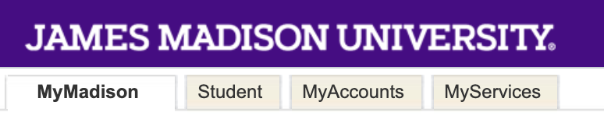
    - Log in to MyMadison
    - Click on “Student” tab at the top of the window
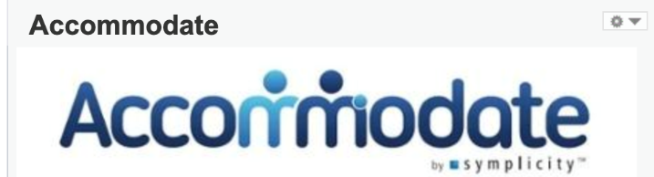
    - Click on blue Accommodate logo to access the Accommodate Student Portal
  - Click on “Testing Room” tab
    - If tab is not available, please a submit semester request for your courses. Click on the link to view a tutorial on how to submit a semester request.
  - On the bottom left corner, click on “New Booking Request”
    - Choose appropriate course, fill out information, and choose open booking slot on right side of screen
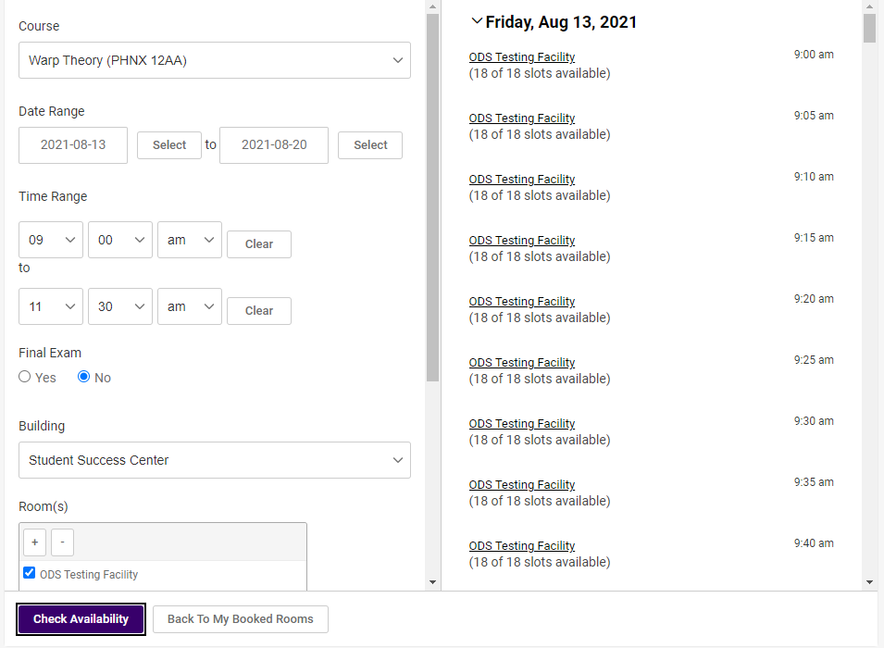
    - Fill out “Confirm Exam Booking” window and click “Submit Request”
    - Request will be under “Pending Booking Requests”
  - Request will then be reviewed by Professor then an ODS staff member
    - Once approved by both, student will receive an email confirmation
      - Request will now be under “Approved Booking Requests” in Portal
    - If the request requires different information, professor and ODS staff will be in contact.
  - Student can view all pending and approved requests in Accommodate Student Portal

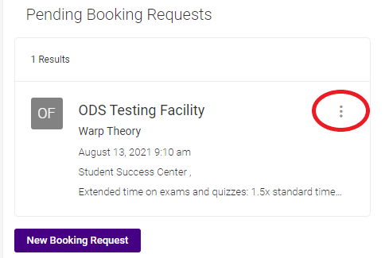
Canceling Exams:
  - Log in to Accommodate Student Portal
  - Click on “Testing Room” tab
  - Student finds exam they would like to cancel (both in “Pending” and “Approved”)
    - Click vertically lined three dots and click “cancel”

Rescheduling Exams:
  - Email odsexam@jmu.edu if you need to reschedule your exam.
    - ODS Exams requires written professor confirmation (via email) that it is okay to move your exam to a different day/time.

