(Descriptions of the images in the following page are included in the text)

Using the Accommodate Faculty Portal for Exams

Some Accommodate Tips
- If you are “stuck” on a page, try clicking the “Cancel” button.
- Navigating between courses/tabs
  - Instead of clicking the “Back” button to go back to the previous page, use the navigation links at the top of the page.
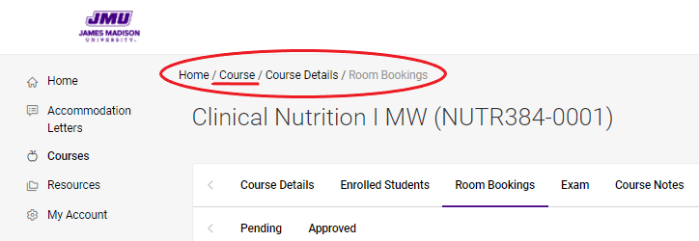

Add/upload Exam Information:
- Faculty can add exam information or exam documents at any point before the exam.
- This also applies to exams that are online or physically delivered.
- ODS Exams requires that professors provide the exam/exam information at least 24 business hours before the start of the exam.

- Log in to Accommodate Faculty Portal
  - Log in to MyMadison
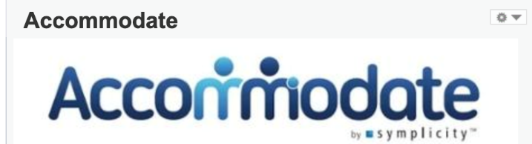
  - Select “Faculty” tab at the top of the window
  - Click on blue Accommodate logo to access the Accommodate Faculty Portal
- Click on “Courses” on the left side of the window
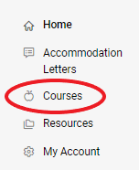
  - Select appropriate course
  - Click the “Exam” tab
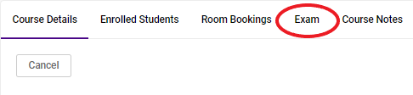
  - Click “Add New Exam”
    - Fill out form, upload exam (if necessary), and submit
  - Editing exams
    - All exam information can be edited by clicking on the exam title
    - Exam documents can be uploaded after submitting the exam information

Reviewing a Booking Request Made by Student:
- NOTE: Student’s exam lengths are automatically calculated by the system to add their class length with extended time accommodation. ODS staff will adjust the time to whatever is written on the faculty’s exam information.

- Faculty will receive email notification to view new booking request made by student
- Log into Accommodate Faculty Portal
  - Log in to MyMadison
  - Select “Faculty” tab at the top of the window
  - Click on blue Accommodate logo to access the Accommodate Faculty Portal
- Click on “Courses” on the left side of the window
  - Select appropriate course
  - Click the “Room Bookings” tab and select appropriate request
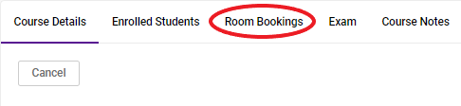
  - Read through exam request, fill in any necessary information, and “approve” if the requested date and time is appropriate
- Once approved, the request will be viewed and approved by ODS staff
  - Faculty will receive a confirmation email of ODS approval

Viewing a Completed Exam:
- Faculty will receive email notification that states a completed exam has been uploaded onto the Accommodate Faculty Portal
- Log into Accommodate Faculty Portal
  - Log in to MyMadison
  - Select “Faculty” tab at the top of the window
  - Click on blue Accommodate logo to access the Accommodate Faculty Portal
- Click on “Courses” on the left side of the window
  - Select appropriate course
  - Click the “Room Bookings” tab and select appropriate request
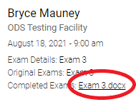
    - The completed exam file will be found on the student’s request.
      - Within the details under the student’s name, there will be a link to download the exam next to “Completed Exam”.

- If you are trying to view a completed exam from a previous course (after Final Exams Week):
  - Click on “Courses” Click on the “Past Courses” tab In the “Semester” filter, choose the semester you taught that course
  - Follow the directions listed above

