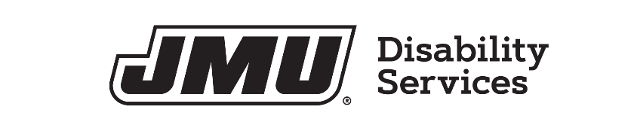
RELEASE OF INFORMATION

PERMISSION IS HEREBY GIVEN TO:
Office of Disability Services
James Madison University
Student Success Center, Suite 1202
MSC 1009
Harrisonburg, VA 22807
Voice/TDD: (540) 568-6705
Fax: (540) 568-7099

TO RELEASE INFORMATION TO AND EXCHANGE INFORMATION WITH:

(Name, Address, and Phone of individual or organization that will be receiving information)

REGARDING (Client/Student Information):

Name:
Date of Birth:
Address:

Phone Number:

NATURE OF THE INFORMATION TO BE DISCLOSED:

I understand that my consent to release this information will expire in 90 days or ( ), not to exceed one year. I understand that I may withdraw this consent in writing at any time.

Client’s/Student’s Signature:
Date:

Witness’ Signature:
Date:

Guardian’s Signature:
Date:

