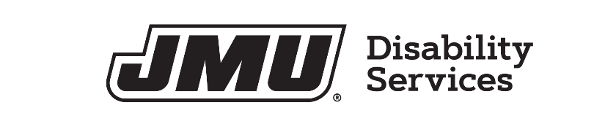

MEDIA RELEASE FORM FOR JAMES MADISON UNIVERSITY

I hereby give permission for the photographing/videotaping/filming of

(myself, my child’s name, my legal charge’s name)

By:
Disability Services

(photographer’s name/organization, if applicable)
Purpose:
Uses include, but are not limited to, inclusion in faculty workshops creation of faculty training materials such as VOD casts, student training sessions, and any other publications or programs, including via the Internet, authorized by James Madison University. I understand that such uses may disclose my disability to these audiences.

I release JMU from any and all responsibility for incidents arising from the use of the photography/videotape/film.

Signature of Person Consenting:
Date:

Printed Name of Person Consenting:

Signature of Witness:
Date:

Printed Name of Witness:
This permission allows JMU to use the media as specified above until such time as the permission is revoked. The permission may be revoked at any point.

