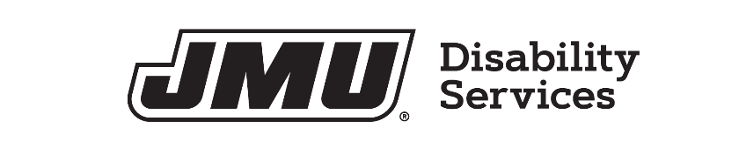

Copyright Awareness and Course Materials Agreement
The Office of Disability Services (ODS) and faculty members of James Madison University work with students to ensure the provision of auxiliary aids and services necessary for accessibility of lectures, books and other course materials for students with disabilities in keeping with the requirements of the Americans with Disabilities Act and Section 504 of the Rehabilitation Act. ODS, JMU faculty, and the student recognize that the content of published materials are protected by copyright. In providing materials in alternative, accessible formats, ODS and JMU faculty ask students to respect the rights of others associated with intellectual material and copyright limitations. Further copying and distributing of materials (including, but not limited to, texts in electronic formats and recordings of lectures) without express permission is not appropriate.
As indicated by the signature below, the student has registered with the Office of Disability Services for accommodations and requests access to materials in an alternative, accessible format. Further, the student agrees to use the materials provided for the purpose of study, to respect copyright and freedom of speech, and agrees not share or publish the materials to others without permission. Violation of this agreement may result in alleged policy violations through OSARP.
Student Name:

Signature:
Date:
Course Name:
Instructor’s Name:
Date Received:

Instructor Signature:
Date:

Reference: Auxiliary Aids and Services for Postsecondary Students with Disabilities
Retrieved August 31, 2010
Higher Education's Obligations Under Section 504 and Title II of the ADA
U.S. Department of Education
Office for Civil Rights
Washington, D.C.
Excerpt:
Q: What if an instructor objects to the use of an auxiliary or personal aid?
A: Sometimes postsecondary instructors may not be familiar with Section 504 or ADA requirements regarding the use of an auxiliary or personal aid in their classrooms. Most often, questions arise when a student uses a tape recorder. College teachers may believe recording lectures is an infringement upon their own or other students' academic freedom, or constitutes copyright violation.
The instructor may not forbid a student's use of an aid if that prohibition limits the student's participation in the school program. The Section 504 regulation states:
A recipient may not impose upon handicapped students other rules, such as the prohibition of tape recorders in classrooms or of dog guides in campus buildings, that have the effect of limiting the participation of handicapped students in the recipient's education program or activity.
In order to allow a student with a disability the use of an effective aid and, at the same time, protect the instructor, the institution may require the student to sign an agreement so as not to infringe on a potential copyright or to limit freedom of speech.
File: Copyright Awareness and Course Materials Agreement
Updated January 2022
Office of Disability Services
SSC Suite 1202
540-568-6705
disability-svcs@jmu.edu
jmu.edu/ods

