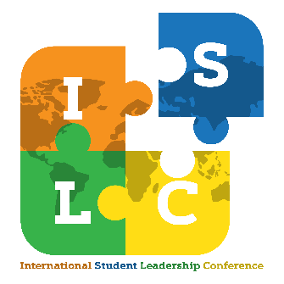
International Student Leadership Conference

March 26, 2022

Session Proposal

Presenter name: _______________________________ Country/ies of origin or expertise: _______________________

Title: ___________________________ Email: ___________________________ Phone: ___________________

Name of institution: __________________________________

Name of any co-presenter(s) and institution: _____________________________________________________________

Session title (limit 20 words): _________________________________________________________________________

Which category best describes your session? ___________________________

[Critical Skills] - these sessions are meant to provide participates with concrete leadership skills through scenarios, lessons, practices and discussions.
[Social Bonds] - these sessions are meant to work on areas which promote social connections with others that build leadership capabilities.
[Global Awareness] - these sessions are meant to discuss issues of importance to our global society and can be more informational and/or educational. The presenter(s) is a scholar or is very experienced in the field of the topic that he/she will be presenting. This type of sessions is meant for participants to take away concrete information, and/or to help them lead and advocate for changes in a particular topic.

Brief session description:

_______________________________________________________________________________________________________________________________________________________________________________________________________________________________________________________________________________________________________________________________________________________________________________________________________________________________________________________________________________________________________________________________________________________________________________________________________________________________________________________________________________________________________

Please submit to Marlee Meikrantz Sharp at meikramk@jmu.edu by February 15, 2022.

