COMMUNITY REPORT

Project REACH: Rural Engagement and
Capacity-building Hub

Abstract
Assets and challenges facing rural communities in the Shenandoah Valley before and during the
Coronavirus Pandemic 2020

Emily Akerson Kelly Atwood Melody Eaton Yvonne Frazier Maureen Molomba
Jenna Piersol
Naomi Rabago Margaret Sloan, PI Daniel Sullivan David Switzer
Tina Switzer Laura Trull



projectREACH@jmu.edu

Overview
In 2019, a core group of rural community representatives and James Madison University (JMU) faculty and staff began meeting and strategizing to develop a collaborative and asset-driven effort to meet the health and well-being needs of our surrounding rural communities. The Rural Engagement and Capacity-building Hub (REACH) was created to address rural, community-identified needs and improve quality of life by building on established projects and partnerships and serving as a connection point and resource for community organizations, universities and others across the state.

Community Conversations
After months of planning, REACH secured funding through JMU to launch Community Conversations in February 2020. These conversations, led by local community members in six rural communities, focused on identifying community needs, assets, projects, and action steps to support rural health and well-being in their areas.
Identified communities (pictured below) included: Broadway/Timberville, Elkton/Shenandoah, Luray, Mt. Jackson/Edinburg, New Market, Shenandoah, and Stanley. Meetings took place in Broadway/Timberville and Mt. Jackson/Edinburg before the remaining conversations were canceled due to COVID-19.

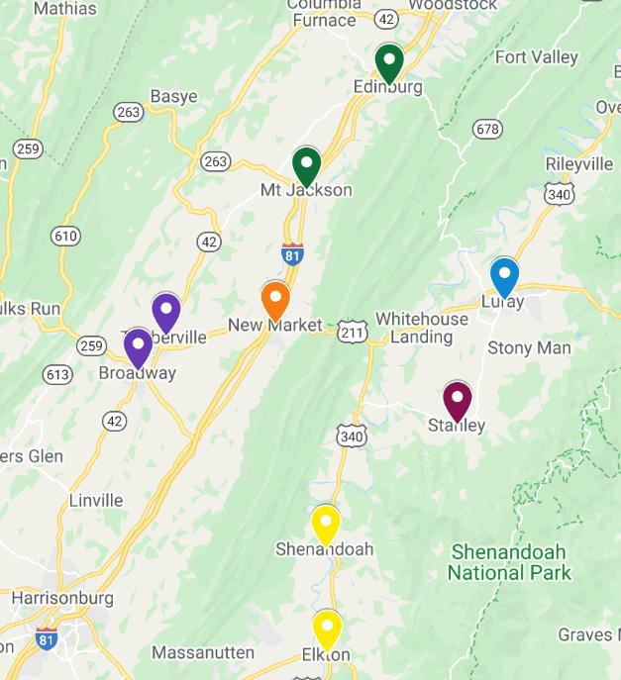
Top identified needs in Broadway/Timberville:
- transportation
- substance abuse
- childcare
- internet access
- services for seniors.

Top identified needs in Mt. Jackson/Edinburg:
- transportation
- employment
- affordable childcare
- substance abuse/behavioral health.

After the Coronavirus pandemic hit our area in March 2020, funding was frozen, and the REACH group decided to pivot from in-person meetings to online efforts. The Project REACH team developed and sent out an online survey to gauge how assets and needs may have shifted as a result of the pandemic, and how communities are rising to the challenge.

COVID-19 Needs and Strengths Survey
Just a few weeks into the pandemic, it became clear that this event would have a significant and dramatic impact on the needs of our rural communities. On June 12, 2020 REACH sent an anonymous survey to rural community members living and working in Page, Shenandoah, and Rockingham Counties to gather information about their experiences during COVID-19. Two hundred forty-eight rural adults responded to the survey. Nearly 74% said the needs in their communities had changed as a result of the pandemic.

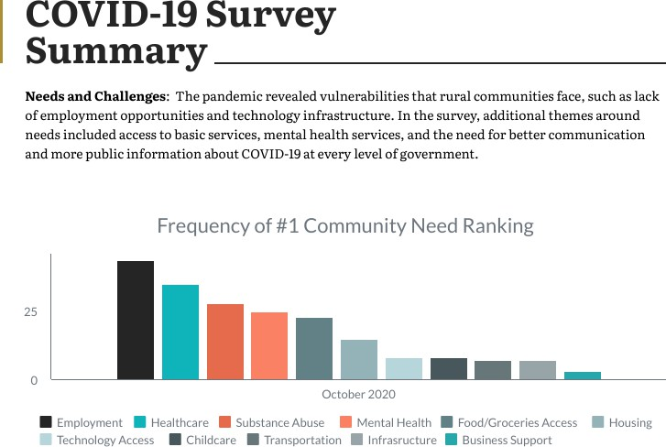

For more detail regarding each of the identified needs and challenges, click on the topics below:

Employment | Healthcare | Substance Abuse
Mental Health | Food/Groceries Access | Housing
Technology Access | Childcare Access | Transportation
Infrastructure | Business Support

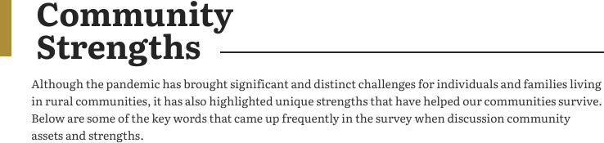
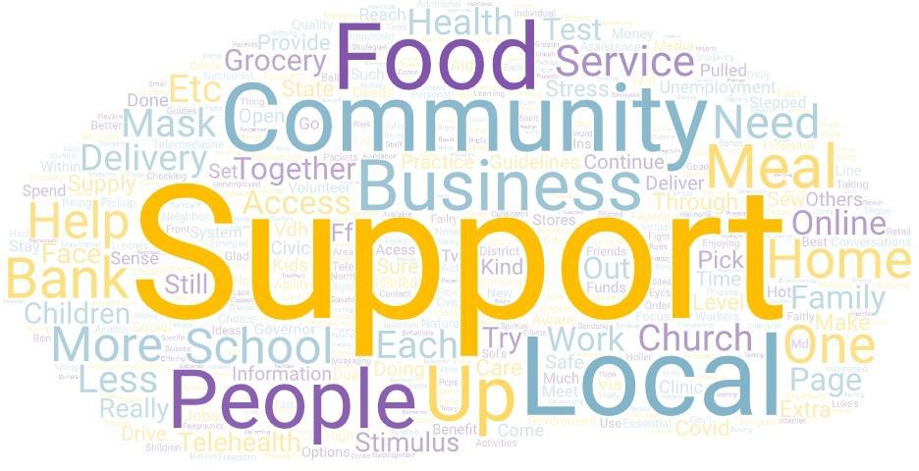

Themes: Our rural areas face unique challenges but are able to draw on their resilient character and community spirit in times of adversity. Frequent themes around community strengths included people reaching out to help others with grocery deliveries, mutual aid, and supporting local businesses. Community members highlighted neighbors helping neighbors, sewing masks and donating supplies to the local hospital, and people supporting each other and working together to meet needs. The local school systems’ responses and their work making sure children had continued access to food was cited numerous times as a community strength and asset.
People in general expressed feeling supported by government at all levels but desired more consistent communication from their elected officials regarding the pandemic.

Next Steps
As a follow up to the survey, the REACH team is connecting with organizational leaders from Rockingham, Shenandoah, and Page counties to hold in-depth interviews and gain a deeper understanding what services have been key during the pandemic and where there is a lack of services or barriers. Following this analysis, REACH will once again work with communities to identify projects that will improve health and well-being in our rural communities. At the same time, REACH will be actively applying for funding that would allow projects to launch in each of the six designated rural areas. Eventually, we hope to support a full-time Rural Hub Coordinator to facilitate development of new community projects, coordination of services, and link to resources and expert faculty at nearby universities and throughout the state. If you would like to be involved or learn more, please email projectREACH@jmu.edu or visit our website HERE.

Description of Community Needs and Challenges
Themes: Many of the needs and challenges were interconnected, for example, one respondent noted “residents need technology access to be able to access healthcare, mental health, and substance abuse services.” Themes that emerged around needs included: basic needs, access to services (a long-standing issue made worse by the pandemic), mental health and anxiety, breakdowns in communication, and lack of decisive leadership.

Employment
The need for higher paying jobs was rated as the top pressing challenge facing the community by survey respondents. People mentioned that the area was already experiencing chronic unemployment and underemployment due to the disappearance of manufacturing jobs over the last decade. Adding to the challenge, many existing jobs do not pay a living wage, require reliable transportation, and provide no options for childcare. Additionally, many jobs in the area rely on tourism, which has been severely affected by COVID-19. One participant noted that “having a good job may make meeting the other challenges/needs on the list easier to meet.”

Healthcare
Better access to healthcare, especially for seniors, was expressed as a major need. Some felt that better outreach was also needed, and that urgent care and clinics should extend their hours. Other barriers included not being able to access COVID-19 testing within the county and having to delay primary care and chronic care management. A few respondents mentioned the need for better healthcare coverage, and insurance that is not tied primarily to employment. The challenges faced by healthcare workers, in terms of risk and not being paid for their front-line work, was also cited.

Substance Abuse
The lack of access to substance abuse treatment and services was identified as an issue that existed previously and has been worsened by the pandemic. People expressed that mental health issues due to social isolation, lost jobs, loss of savings, and anxiety, fear, and depression could lead to substance abuse, and more mental health and substance abuse services are needed. One participant mentioned the need for “structured things for our youth to do” while parents are working and school is not in session, to prevent children and teens from engaging in alternative, potentially harmful behaviors.

Mental Health
Mental health services were frequently cited as a need in the community, and people said they had to travel outside of the county for affordable help. Fear, anxiety, lost jobs, social isolation, and the disappearance of in-person support systems like church, family, and friends also impacted mental health. Many respondents mentioned that the lack of support for mental health issues could lead to substance abuse, and that the community should be putting more emphasis into addressing mental health needs.
Food/Groceries Access
Food and groceries were major needs identified in the survey. Many people visited food pantries as they found themselves unemployed, underemployed or their children were home rather than utilizing school breakfast and lunch. Groceries became a need as supplies fluctuated in local stores and elderly and vulnerable community members were anxious about being exposed to COVID while shopping.

Housing
Affordable, accessible housing is often an issue in rural areas due to cost, low stock of housing, and aging housing stock which may not be accessible to adults with mobility limitations. Many people reported being crowded into homes with children attempting to attend virtual school, some adults trying to work from home and older adults who could not attend their regular community events was stressful and taxing for their housing situations.

Technology Access
Rural disparities in technology infrastructure, resources and access were common themes in the responses. Though technology was seen positively with telehealth, zoom meetings and church services,
consistent, reliable access to these was often described as a barrier. One respondent summarized the issues
simply by stating “This pandemic reveals the vulnerability of rural areas in terms of technology…” Limited access to internet (especially high speed), computers, and even phone service can impact all domains from healthcare (mental and physical), employment and school/ distance learning and were mentioned by many respondents.
One simply stated, “Need faster internet or internet access in general in rural areas. “

Childcare Access
Childcare access can affect many domains of need. Childcare resources were listed by many respondents as a current community need but not many commented specifically on this community gap. “Accessibility” and
“access” to childcare, as well as schooling options were mentioned. One participant reflected on local schools
by stating “With the uncertainty of schools, parents will need assistance with childcare.”

Transportation
Transportation is a frequently cited need in the area that existed prior to COVID-19 and continues to affect the community. Without transportation, one participant noted “it is difficult to keep employment.” Others mentioned that transportation affects many other areas including access to health services, employment centers, mental health services, and substance abuse supports. Transportation for seniors was also mentioned as a critical need during this time.
Infrastructure
Our rural communities continue to struggle with access to the internet, access to technology, and/or slow
internet speeds. The lack of technology infrastructure was cited as a critical need that has “severely impacted
the school division’s ability to respond to the need for remote learning.” Beyond the challenge of virtual school, respondents also mentioned that the lack of fast, reliable internet made it difficult to work remotely, apply for jobs, and access telehealth services online.

Business Support
Businesses were mentioned as both a need/challenge and asset to the community during this time. Many people expressed fear about local and small business closures and uncertainty about their ability to recover and re-open after the pandemic. Some felt businesses needed more support, especially around establishing safe practices in order to operate and be able to employ staff. Respondents described renewed awareness around buying local and supporting local businesses, although one respondent mentioned “it’s hard to support all the businesses that need help.”

