Harrisonburg Police Department
(540) 434-4436
Rockingham County Sheriff's Department
(540) 564-3800
Sentara RMH Medical Center
(540) 689-1000
Runaway Safeline
1-800-RUNAWAY (2929)
Emergency Shelter
Alcoholics Anonymous
(540) 432-7322
SAMHSA’s National Help line 1-800-662-HELP (4357)
Futuro Latino Coalition
(540) 568-5284
Community Services Board
(540) 434.1766
Patchwork Pantry
(540) 564-3800
Valley Mission
1-800-RUNAWAY (1-800-786-2929)
Hope Distributed
(540) 434-1092
LGBTQ+ Support

Poison Control
1-800-222-1222
Trans Lifeline Side By Side (877) 565-8860 (804) 644-4800

Virginia Child Abuse Hotline (804) 786-8536
Sexual Health
AVA Care
(540) 434-7528
VA Disease Prevention Hotline (800) 533-4148
First Step (domestic violence)
(540) 434-0295
- Mercy House
(540) 271-1701
- Salvation Army
(540) 434-4854
- New Directions (domestic violence)
(540) 886-6800
The Trevor Project
(212) 695-8650
VA 24/7 LGBTQ+ Help line (866) 356-6998
  - LGBT Youth Talkline (800) 246-7743
  - Shenandoah LGBTQ Youth Center
(540) 466-3320
Crisis Counseling and Suicide Prevention


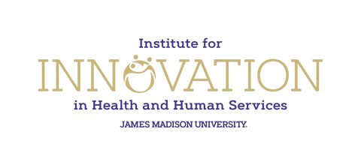
Harrisonburg/Rockingham Health Dept. 1-866-531-3068
Resource List
Emergency Services
Drug and Alcohol Info
Food Pantries
Harrisonburg Community Health Center
(540) 433-4913
Hand-in-Hand Resource Mothers Program
(540) 564-7151
Eating Disorders
Sentara RMH Behavioral Health
(540) 564-5100
ANAD
(888) 375-7767

Covenant House 9-Line (800) 999-9999
Suicide Prevention Lifeline 988
Rape/Sexual Assault/Violence

The Collins Center
(540) 432-6430
Department of Social Services
(804) 726-7000

Community Service Board
(540) 434-1766

Stop it Now, VA Dept. of Health 1-888-PREVENT (7738368)
National Domestic Violence Hotline (800) 799-7233

