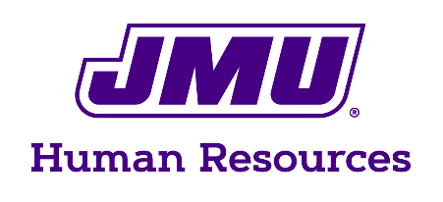
Human Resources
181 Patterson St.
MSC 7002
Harrisonburg, VA 22807
540/568-2992
Fax: 540/568-6454

Memorandum

To: (Employee/Applicant)

From: Jason Saunders, HR Consultant

Subject: Mandatory Drug and Alcohol Testing for Commercial Driver’s License Holders-Policy 1114

Date: (Date)
______________________________________________________________________________________

The purpose of this memorandum is to advise you that, in accordance with Policy 1114-Mandatory Drug and Alcohol Testing for Commercial Driver’s License Holders, “In order to promote campus and highway safety, the university will conduct mandatory drug and alcohol testing of all university employees who possess commercial driver’s licenses and use them in performance of their university jobs.”

A copy of JMU Policy 1114 is attached for your information. In general, it requires that employees in covered positions (positions, jobs or assignments in which an employee may be required or allowed to operate state-owned vehicles or equipment requiring a valid Commercial Driver’s License-CDL) be tested under the following circumstances:

- Prior to being initially assigned to a covered position
- Whenever an employee’s appearance or behavior causes a supervisor to question the employee’s ability to operate a vehicle safely
- When randomly selected
- When the employee has been in a job-related accident or has been cited for a moving vehicle violation
- Before an employee is allowed to return to a covered position after having tested positive to either alcohol or illegal drug use

Any employee who possesses commercial driver’s licenses and uses them in performance of their university jobs, and who refuses to participate in the test(s) or tests positive for alcohol or the use of illegal drugs, may be terminated from employment.

Covered employees will be given a minimum of 60 minutes of training annually on controlled substance abuse and alcohol misuse, how alcohol and drugs affect work performance, the alcohol and drug testing process, employee assistance programs, and possible corrective action in the event of a positive test. Your supervisor will notify you when these training sessions occur.

Please sign this memorandum to indicate that you have been advised as to the conditions of your employment and Policy 1114 and return to me at MSC 7002. Questions may be directed to Human Resources at 54/568-2992 or to your supervisor.

Received by: _______________________________________________ Date: __________________________

Copy to: HR
Department
Employee/Applicant

