Employee Instructions - Sign Up | 
After informing your supervisor or safety personnel of your work-related injury, and receiving clearance to obtain care via telemedicine, you are ready to start your visit with Concentra Telemed™. There are two ways you can access Concentra Telemed, using your web browser on your computer or with the Concentra Telemed app on Android and iPhone.

How to Access ConcentraTelemed.com
You’ll need a computer with a webcam and microphone. You can’t
access ConcentraTelemed.com using a tablet or smartphone.
- Make sure you have your photo ID ready.
- Go to your computer.
- Open your web browser and go to ConcentraTelemed.com.
- Sign up or log in. You’ll need to use your email address.
- Once signed into the system, please click on an available care coordinator to start the visit.

How to Use the Concentra Telemed App Please note:
To use the app, you’ll need a smartphone with a camera. The Concentra Telemed platform and Concentra
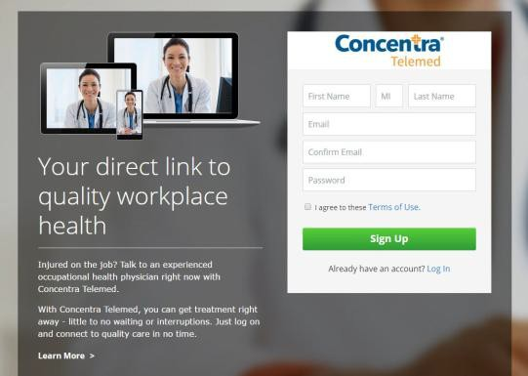
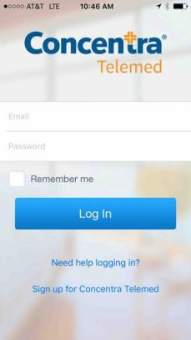
Telemed app are
- Make sure you have your driver’s license or state ID ready. exclusively for employers
- Go to the Apple app store or Google Play app. Search for “Concentra who have established
Telemed” and download the Concentra Telemed app. telemedicine accounts
- Open the app. with Concentra for their
- Sign up or log in. You’ll need to use your email address. employees.
- Once signed into the system, please click on an available care coordinator to start the visit.

Your Visit
After you’ve signed up:
  - Select the option to start a visit with an available care coordinator. Depending on their availability, you may be added to a virtual “waiting room” while you wait for them to connect.
  - The care coordinator will ask you some questions about your medical history and why you’re visiting.
  - You’ll be queued in a virtual waiting room to see a doctor. If you need to step away, remember to click the box that says TEXT ME so that you’ll be reminded when the clinician is ready.
  - Time for your appointment! Talk to the clinician as much as you need to.
  - When you’re done, you’ll check out with your care coordinator. They’ll help you get scheduled for another visit if you need it.

Need help? Having technical issues?
Call us at 1.855.835.6337.


About Concentra Telemed
Injury care when and where you need it.
Tired of the waiting room?
Can’t find time for the doctor?
With Concentra Telemed, you can use your computer or smartphone to see a clinician right away—minimal waiting, no interruptions. Within minutes of signing up, you’ll connect with a clinician who can help you get better, faster. Using video conferencing, they’ll diagnose, recommend treatment, and even prescribe medication if you need it.* It’s health care that works for you when you need it, where you need it.


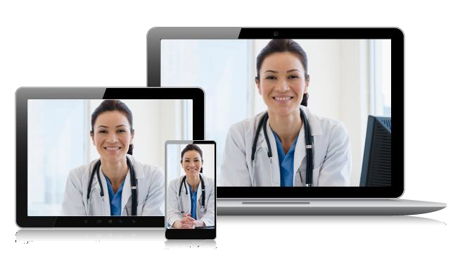
How you benefit
What we treat Talk to a clinician right when you need to. With Concentra Telemed can treat a lot of the things Concentra Telemed, you can see your clinician when it’s you normally visit a medical center for, such as: easiest for you—at work, at home, or on the go. And with
extended availability—seven days a week—chances are
- Minor functional movement injuries we’re here when you need us.
- Bruises
- Scrapes Get treatment right away—minimal waiting, no
- Sprains and strains interruptions. Instead of waiting in a waiting room, you
- Rashes and burns can do whatever you need to while you’re waiting for a
- Repetitive use injuries clinician. When they’re ready, you’ll get a text and you
- Contusions can see them immediately. It’s that easy.
- Bloodborne pathogen (BBP) exposures
Relax—you’re in good hands. Concentra Telemed
Concentra Telemed is primarily designed clinicians are trained in workforce health, so they
to provide immediate attention for minor understand the workers’ compensation system. You
medical issues. Serious injuries—or injuries don’t have to worry that they’ll know how to handle a
that need hands-on care, like stitches—will work injury—instead, you can focus on getting better.
still need to be seen in person by a clinician.
Depending upon the severity of your injury, Know your privacy is our priority. Concentra Telemed
your clinician may refer you to the closest uses advanced security software to protect your
Concentra medical center or emergency information and ensure your privacy, and your visit is not
room for further treatment. recorded.

*Where allowed by applicable law.

