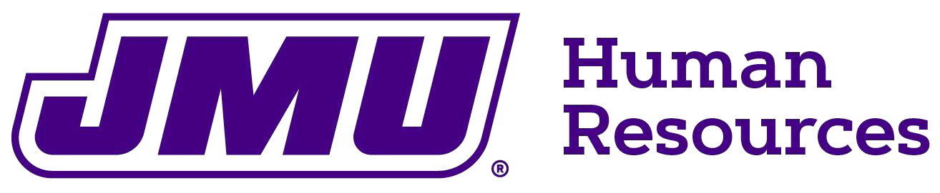

REQUEST FOR PAYOUT OF COMPENSATORY LEAVE
Requests for a payout of compensatory leave can be made twice annually, by June 1 (for a July 1 payment) or by December 1 (for a December 31 payment). Payouts are limited to 40 hours per request. Payout is limited to compensatory leave balances reflected at time of processing. No expired or pending leave is eligible for payout. Payouts are irrevocable.

Employee ID #: | Click or tap here to enter text.
Employee Name: | Click or tap here to enter text.
Date of Request:  (must be received prior to June 1 for July 1 payment or prior to December 1 for December 31 payment) | Click or tap here to enter text.
Amount of Request (hours):  (cannot exceed 40.00 hours) | Click or tap here to enter text.

I certify that the above information is correct, and I am eligible for a payout of compensatory leave. I understand that this request is irrevocable.

Click or tap here to enter text.
Signature of Employee Date
I certify that the above information is correct, and this employee is eligible for a payout of compensatory leave.
Click or tap here to enter text.
Signature of Authorizing Supervisor Date

Return form to Human Resources at MSC 7009 or email to benefits@jmu.edu

August 2025

