# James Madison University Health Center

724 S MASON ST, MSC 7901, HARRISONBURG VA 22807

540-568-6178 | [jmu.edu/healthcenter](http://www.jmu.edu/healthcenter)

# Health Information Receipt

*Please mail or bring this completed form with payment to the University Health Center at the address above. Do not fax this form to the University Health Center.*

Date: Student ID#: Date of Birth: / / Gender

Month Day Year

Name: Mailing Address:

Billing Address: (if different from mailing address)

Contact Telephone#: Email:

Check one: ( ) Visa ( ) MasterCard ( ) Check made payable to UHC ( ) Student JAC (Flex) card

Credit Card Number#: Signature: Expiration Date: CV2 Code Number#:

(What is this??): All credit cards now have a security code (CV2 or CVC number) on them. This can be found on the reverse of most issued credit cards on the signature line. We use the last 3 digits on the right hand side of the string of numbers.

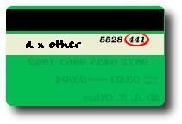

|  |  |  |
| --- | --- | --- |
| Description | Quantity | Price |
| Entire Medical Chart |  | $10.00 |
| **TOTAL** |  | **$10.00** |