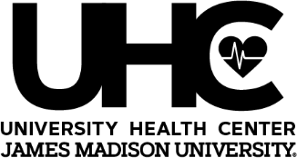

JAMES MADISON UNIVERSITY HEALTH CENTER

2nd Floor in Student Success Center

Phone: 540-568-6178 Fax: 540-568-6176

FIRST AID KIT REQUEST LOAN FORM

I understand I am responsible for the return of the borrowed first aid kits. Please promptly return within 7 days after return from trip. I understand that if I do not return the item/items by return date and in proper condition, I will be billed for the replacement or repair of the item.

* Please submit this completed form to UHC at least **48 hours** prior to picking up the First Aid Kits
* Forms are accepted by email at [healthctr@jmu.edu,](mailto:healthctr@jmu.edu) secure fax at 540-568-6176, or hand delivery to the University Health Center
* First Aid Kit Replacement Fee - $15.00 per kit for lost or severely damaged

Name requesting kits: (print)

JMU Department Name:

Department phone #: Number of kits requested:

Date to pick-up: Dates of travel:

Signature of staff/student requesting kits:

**----------------------------------------------------------------------------------------------------------------------------------------------------------------**

***(Information below to be completed at the time of pick-up)***

Name of staff/student designated to pick-up kits: (print)

Signature of staff/student designated to pick-up kits:

Kit numbers given:

**----------------------------------------------------------------------------------------------------------------------------------------------------------**

***(Information below to be completed by UHC staff upon return of kits)***

UHC staff signature receiving returned first aid kit/s:

Date kits returned:

# of kit/s not returned or damaged:

*11/11/2019*