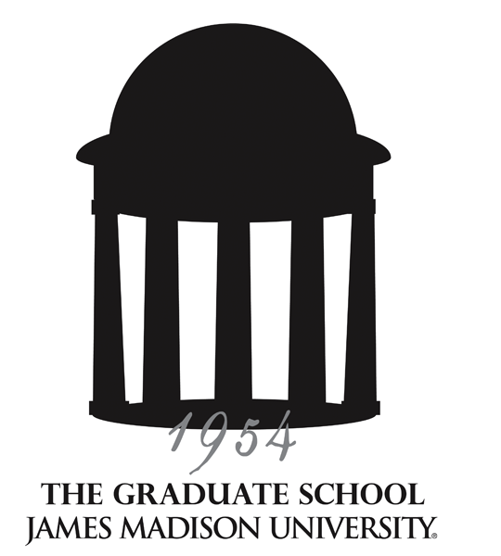
Graduate Council
Meeting Minutes
September 13, 2012 – Taylor 404

Supporting, facilitating and promoting excellence in lifelong education
through graduate programs of distinction, innovative outreach programs and a diverse student body.

ATTENDANCE

Members present: Reid Linn, Lynette Michael, Kathy Thompson, Melissa Aleman, Deborah Bandalos, Dabney Bankert, Mike Busing, Natasha DuMerville, Lennie Echterling, Tammy Gilligan, Janet Gloeckner, Teresa Gonzalez, Patty Hale, Michael Hall, Jim Hammond, Hossain Heydari, Ming Ivory, Michael Klein, Jeff Loveland, Holly McCartney, Susan Murphy, Nancy Nichols, Christian Davis for Steve Reich, Jason Rosenhouse, Ayasakanta Rout, John Scherpereel, Mary Jean Speare, Jennifer Taylor for Nicholas Swartz, Jane Thall, Kent Todd, Melissa Van Vuuren, Karin Tollefson for Cole Welter.
Guests: A.J. Morey (Cross Disciplinary Studies), Kristi Shackelford (Catalog), Peggy Shaeffer (COE), Janet Smith (Public Affairs), Rhonda Zingraff (CHBS).
Programs not represented: Clinical and School Psychology, Exceptional Education

ANNOUNCEMENTS

- Graduate Community Dinner: Friday, September 14, 4:30 – 6:30 p.m. in the Festival Ballroom.

- Northern Shenandoah Valley Regional Graduate & Law School Fair: Tuesday, September 25, 4:00–7:00 p.m. in the Festival Ballroom. Free registration for JMU graduate programs. Programs should notify Kathy Thompson (thompskb@jmu.edu) by September 14 to reserve a table.

- Graduate Viewbooks and inserts are available. (additional copies available upon request for recruiting purposes)

- All course/program requests to take effect summer or fall 2013 must be submitted by February 3. Catalog copy for each graduate program must be reviewed, revised, and submitted to Kristi Shackelford no later than February 28.

- JMU Communications and Marketing welcomes news items (including activities and projects) as well as stories about graduate programs or graduate (Masters, Ed.S, or Doctoral) students and faculty. You may submit story ideas to Janet Smith (smithjl@jmu.edu), who serves as the office’s liaison to the Graduate Council.

DISCUSSION

CFI Graduate Programming for 2012-2013– Trevor Smith, Faculty Associate
Trevor Smith announced that the CFI aims to develop authentic partners with offices and departments across campus. He provided an overview of CFI programming and explained that the CFI attributes increased participation of graduate students to better communication between graduate program administrators and CFI, as well as the support of CFI from The Graduate School administrators. Fall 2012 Graduate Workshop Series topics include Teaching Presentations in Job Interviews (10/19/12) and Developing Effective Conference Posters (11/30/12). Spring 2013 topics have yet to be determined. Members of the Graduate Council are encouraged to suggest workshop topics and/or possible presenters for the upcoming semester and to suggest improvements for the 2013 Graduate Student Colloquium. Nine students were selected as Fall 2012 Research Fellows. More information on the Graduate Research Fellows can be found at: http://www.jmu.edu/cfi/programs/grf/11-12/index.html. Trevor also discussed the Graduate Teaching Fellowship, a semester-long course design institute offered in the spring. In 2013, Teaching Fellows will focus more on assessment and activity development.

Study Group Update – Adam Copeland, Center Director, and Catherine Crummett, Assistant Dean, University Studies
Adam Copeland gave an overview of Study Group and the International Student Center and an update on the students who have progressed through the program and the four graduate students currently enrolled. Study Group’s future plans include: update marketing materials, clarify deadlines, work with referrals from individual programs, and increase the language requirement for both undergraduate and graduate students. Only a small number of JMU Study Group participants have been graduate students. Graduate students spend 1-2 semesters in the preparatory program. Study Group will meet with any additional programs interested in using Study Group for international student recruitment.

Overview of final approved program for M.A. in Communication & Advocacy – Melissa Aleman, School of Communication Studies
Melissa Aleman reviewed changes made to the master-level program. The revised program should come before the council for final approval soon (handouts attached).

GSA Report – Candace Avalos and Greg Brightbill, Graduate Students in College Student Personnel Administration
Candace Avalos shared new developments within the GSA and solicited feedback from the Council on areas of focus for the organization. The group is looking to establish a presence within the graduate community. In terms of organizational structure, the GSA intends to model itself after the Graduate Council by having graduate student representatives from across the various disciplines. The GSA plans to partner with CFI, graduate-level University programs, student service offices (for example, Community Service Learning), and local agencies to coordinate programs and experiences for graduate students.

GSA Representation
Reid announced that program directors will be asked to recommend students to serve as representatives to the GSA. Each graduate program will be represented (as defined by CIP codes) including programs with non-traditional graduate students. The GSA executive council plans to make every effort to understand the concerns of all graduate students, here and abroad.

Graduate Assistantship Strategies
Reid distributed a handout (attached) on options that can be used to distribute graduate assistant tuition funding and stipend. The document presented creative ways to preserve graduate funding to the benefit of the student, which could be a way to increase recruitment within programs.

Meetings with grad programs
Reid would like to meet with academic unit heads and graduate program directors within each of the college during the fall 2012 semester to discuss graduate education - solicit strengths and weaknesses, discuss vision, and listen to concerns. Kathy will contact units and departments accordingly to schedule these meetings.

CGS Resolution Regarding Graduate Scholars, Fellows, Trainees and Assistants
Reid reviewed the Council of Graduate Schools Resolution Regarding Graduate Scholars, Fellows, Trainees and Assistants (attached). The CGS, of which JMU is a member, agreed that students are to be under no obligation to respond to offers of financial support prior to April 15. Programs are encouraged to disseminate copies of the CGS form to potential students when extending offers of admission and funding.

ETD Update for academic year 2012-13
Kathy provided an update on embargos on electronic theses and dissertations:
- Embargos supported; beginning with fall 2012, options for no embargo, 1 year or 2 year; default is no embargo.
The JMU embargo/copyright document agreement is at http://www.jmu.edu/copyright/etds.shtml and includes an explanation about embargos. A link directly to the document is at: http://www.jmu.edu/copyright/wm_library/Document_Agreement.pdf
- The faculty advisor’s role is to explain ETD repository requirements and work flows, embargos etc. to students and to ensure that student work meets quality standards
- The library and the advisor share a role in advising students on copyright and use of copyrighted material in ETDs
- Future plans:
  - Work with ETDs within the larger context of scholarly communication
  - Acquire a platform that automates ETD work flows and allows for distributed review, approval and deposit processes
  - Improve exposure and discoverability beyond JMU; showcase JMU scholarship
  - Prepare for ETDs that represent new forms of scholarship

13. Appointments of representatives to Graduate Council, CAP and Honor Council
Kathy announced the following:
Student representatives to Graduate Council: Aimee Brasseur and Natasha DuMerville
Graduate Council representative to C&I Chairs: Kathy Thompson
Graduate Council representative to A-Team: Kathy Thompson
CAP Graduate Council student representative: Natasha DuMerville
CAP Graduate Council faculty representatives: Mike Busing and Karin Tollefson
Honor Council representative: Nancy Nichols

14. Graduate Fairs:
TGS will attend the following graduate recruitment fairs:
Monday, September 24 – VT - 10:30 a.m. – 2:00 p.m.
Monday, September 24 – Radford – 4:30 – 6:30 p.m.
Tuesday, September 25 – JMU – 4:00 – 7:00 p.m.
Thursday, September 27 – VCU – 10:00 a.m. – 1:30 p.m.
Thursday, September 27 – W&M – 3:30 – 6:30 p.m.
Friday, September 28 – ODU – 10:00 a.m. – 2:30 p.m.
Friday, November 2 – HBCU Career Development Marketplace, Alexandria, VA – 11:30 a.m.-6:00 p.m.

Remaining 2012-13 Meeting Dates:
Thursday, October 11, 2012 – Taylor 404, 2:00-3:30pm
Thursday, November 8, 2012- Taylor 306, 2:00-3:30pm
No meeting in December
Thursday, January 10, 2013 - Taylor 404, 2:00-3:30pm
Thursday, February 14, 2013 - Taylor 404, 2:00-3:30pm
Thursday, March 14, 2013 – Taylor 404, 2:00-3:30pm
Thursday, April 11, 2013 – Moody Conference Room, 2:00-3:30pm
Friday, May 17, 2013 (Retreat) – Montpelier Room, East Campus Dining Hall, 8:30 a.m. - 1:30 p.m.

