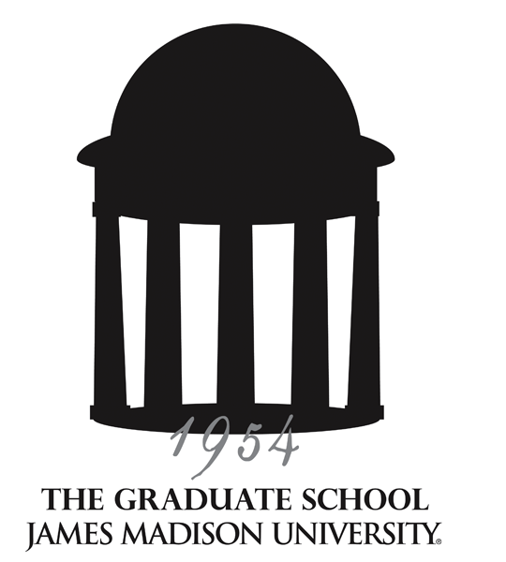
Graduate Council
Meeting Minutes
10/11/12 – Taylor 404

Supporting, facilitating and promoting excellence in lifelong education
through graduate programs of distinction, innovative outreach programs and a diverse student body.

ATTENDANCE

Members present: Reid Linn, Lynette Michael, Kathy Thompson, Dabney Bankert, Aimee Brasseur, Mike Busing, Janet Gloeckner, Patty Hale, Michael Hall, Hossain Heydari, Ming Ivory, Michael Klein, Holly McCartney, Susan Murphy, Nancy Nichols, Jason Rosenhouse, Ayasakanta Rout, Mary Jean Speare, Jane Thall, Melissa Van Vuuren, Karin Tollefson for Cole Welter, Roshna Wunderlich.
Guests: Michele Estes (Education), A.J. Morey (Cross Disciplinary Studies), Kristi Shackelford (Catalog), Janet Smith (Public Affairs), Rhonda Zingraff (CHBS).
Programs not represented: Assessment & Measurement, Communication and Advocacy, College Student Personnel Administration, Clinical and Mental Health Counseling, Combined-Integrated Psychology, Counseling and Supervision, Exceptional Education, History, Kinesiology, Physician Assistant Studies, Occupational Therapy,
Political Science, Public Administration, School Psychology.

ANNOUNCEMENTS

- Graduate Viewbooks and inserts are available upon request for recruiting purposes

- All course/program requests to take effect summer or fall 2013 must be submitted by February 3. Catalog copy for each graduate program must be reviewed, revised, and submitted to Kristi Shackelford no later than February 28.

- JMU Communications and Marketing welcomes news items (including activities and projects) as well as stories about graduate programs or graduate (Masters, Ed.S, or Doctoral) students and faculty. You may submit story ideas to Janet Smith (smithjl@jmu.edu), who serves as the office’s liaison to the Graduate Council.
REPORTS

Graduate Student Representatives/GSA: No report.
CAP: No report.
A-Team: Kathy reporteded that the meeting was informational: CFI’s January Symposium; implementation of online course evaluations; student grievance procedures policy; and restricted programs policy updates.
C&I: No September meeting; no report.
Honor Council: No report.

DISCUSSION

Dual Level Course Policy Revision
Kristi Shackelford reviewed the revised dual level course policy (attached). The course numbering system is outlined in the revised policy and clarification is included that courses offered at dual levels may be no more than one level apart, with the exception of performance courses in music. No undergraduate courses numbered below 400 may be taught as dual-level courses. The syllabi for dual level courses must show that higher quality and/or additional work is required of the students enrolled at the graduate level to ensure the additional rigor of graduate work as required by SACSCOC. The registrar has generated a list of dual-level courses offered for fall. This list will be sent to academic unit heads for verification that syllabi include the additional expectations for graduate students enrolled. Graduate program directors were requested to inform their academic unit heads about this requirement. This audit will be conducted for the spring semester as well.

GSA representation from graduate programs
Reid reminded the Graduate Council to nominate students to represent their programs on the Graduate Student Association. Programs that are still to nominate representatives include:
Biology
Communication Sciences and Disorders M.S./Ph.D. and Audiology
Computer Science
General Education
Health Sciences
Leadership Studies
Mathematics
Psychology - Clinical Mental Health Counseling
Psychology - Combined-Integrated Program
Psychology - Counseling and Supervision
Psychology - School Counseling

Meetings with graduate program directors and AUHs
The purpose of these meetings with the academic unit heads and graduate program directors within each college is to discuss graduate education, solicit perceived strengths and weaknesses, discuss vision, and listen to concerns. Information discussed in meetings may be addressed in the strategic plan.
CAL: Thursday, September 27, 3:00 p.m.
CVPA: Monday, October 15, 2:00 p.m.
CISE: Monday, October 22, 9:00 a.m.
COE: Thursday, October 25, 8:15 a.m.
CHBS: Thursday, October 25, 2:00 p.m.
COB: Monday, October 29, 10:00 a.m.
CSM: TBD

The issue of the competitiveness of GA/TA/Doc support comes up periodically. The following information represents current minimum levels of support. Program directors should adjust the tuition each year according to the percent of tuition increases and calculate tuition for the number of credit hours approved per assistantship for their program. It is hoped that these minimum levels of institutional support will serve as useful information when marketing programs or speaking with potential applicants.

Stipend | Tuition | Total Package
In-State  GA = $7,382  TA = $8,664  Doc = $14,500  _____  Out-of-State  GA = $7,382  TA = $8,664  Doc = $14,500  * some programs pay higher stipends | 18 cr hrs/acad yr = $7,038 ($391/cr hr)  * some programs cover more hours  ______  18 cr hrs/acad year = $18,972 ($1054/cr hr)  * some programs cover more hours | GA = $14,420  TA = $15,702  Doc = $21,538  * doctoral programs vary widely  _____  GA = $26,354  TA = $27,636  Doc = $33,472  * doctoral programs vary widely

Graduate Fairs:
TGS will attend the following upcoming graduate recruitment fairs:
Wednesday, October 31 – Hampton University – 10:00 a.m. – 2:00 p.m.
Friday, November 2 – HBCU Career Development Marketplace, Alexandria, VA – 11:30 a.m. – 6:00 p.m.
Graduate program directors are also welcome to attend any of these graduate fairs.

Remaining 2012-13 Meeting Dates:
Thursday, November 8, 2012- Taylor 306, 2:00-3:30pm
No meeting in December
Thursday, January 10, 2013 - Taylor 404, 2:00-3:30pm
Thursday, February 14, 2013 - Taylor 404, 2:00-3:30pm
Thursday, March 14, 2013 – Taylor 404, 2:00-3:30pm
Thursday, April 11, 2013 – Moody Conference Room, 2:00-3:30pm
Friday, May 17, 2013 (Retreat) – Montpelier Room, East Campus Dining Hall, 8:30 a.m. - 1:30 p.m.

