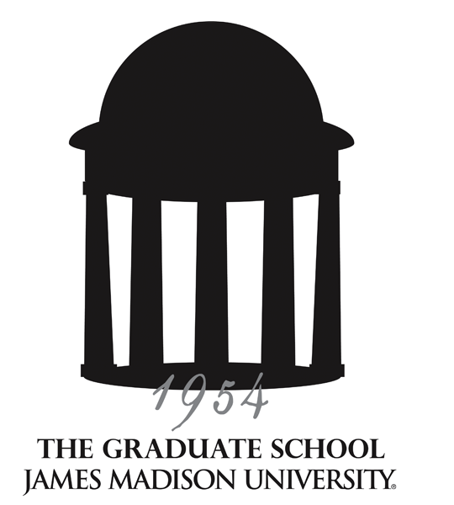
Graduate Council
Meeting Minutes
02/14/13 – Taylor 404

Supporting, facilitating and promoting excellence in lifelong education
through graduate programs of distinction, innovative outreach programs and a diverse student body.

Members present: Reid Linn, Lynette Michael, Kathy Thompson, Melissa Aleman (Communication and Advocacy), Robin Anderson (Graduate Psychology), Debbie Bandalos (Assessment and Measurement), Dabney Bankert (English), Aimee Brasseur (GA/GSA), Mike Busing (Business Administration), Lennie Echterling (Counseling & Supervision; Clinical Mental Health Counseling; School Counseling), Janet Gloeckner (Health Sciences), Teresa Gonzalez (Academic Affairs), Patty Hale (Nursing), Michael Hall (Psychological Sciences), Pamela Bailey (Physician Assistant Studies), Hossain Heydari (Computer Science), Ming Ivory (Integrated Science and Technology), Michael Klein (Writing, Rhetoric and Technical Communication), Dani Bronaugh for Allison Kretlow (Exceptional Education), Holly McCartney (Education), Susan Murphy (Strategic Leadership), Nancy Nichols (Accounting), David Dillard (History), Jason Rosenhouse (Mathematics Education), John Scherpereel (Political Science-EUPS), Mary Jean Speare (Music), Nicholas Swartz (Public Administration), Melissa VanVuuren (Library), Karin Tollefson (Art), Roshna Wunderlich (Biology).
Guests: Carol Fleming, Outreach & Engagement, A.J. Morey (Cross Disciplinary Studies), Kristi Shackelford (Catalog), Janet Smith (Public Affairs), Rhonda Zingraff (CHBS)
Programs not represented: College Student Personnel Administration, School Psychology, Combined-Integrated Psychology, Occupational Therapy, Communications Sciences and Disorders, Adult Human Resources Development, Kinesiology

APPROVAL OF MINUTES

The minutes of the November 8, 2012, meeting were approved by acclamation with no revisions.
ANNOUNCEMENTS

- All course/program requests to take effect summer or fall 2013 are due now. Catalog copy for each graduate program must be reviewed, revised, and submitted to Kristi Shackelford no later than February 28.

- JMU Communications and Marketing welcomes news items (including activities and projects) as well as stories about graduate programs or graduate (Masters, Ed.S, or Doctoral) students and faculty. You may submit story ideas to Janet Smith (smithjl@jmu.edu), who serves as the office’s liaison to the Graduate Council.

REPORTS

Graduate Student Representatives/GSA: Aimee Brasseur reported that the GSA has recently launched a blog. It has been live for only two weeks, and it has already received over 1,600 hits. The primary audience of the blog is graduate students, and many of the posts have been written by Graduate Student Association representatives. The blog is available here.

CAP: No report.

A-Team: Kathy Thompson reported discussion items included: an update from the Center for Faculty Innovation; the Libraries & Educational Technologies Scholarly Communication Initiative; and Turnitin, a plagiarism detection tool being considered for purchase by the library to replace SafeAssign.

C&I Chairs: Kathy reported that discussion items included: distance learning programs and a new preview form for existing programs that would like to move to a distance learning option; and an update on distance learning policies (Best Practices document at www.jmu.edu/dl).

Honor Council: Nancy Nichols reported on Council action regarding a student involved in two separate honor code violations on the same day during final exam week.

DISCUSSION

Graduate Certificate policy revision/update
Kristi Shackelford reviewed updates made to the Graduate Certificate policy:
- Nomenclature updates, replacing “graduate coordinator” with “graduate director”
- Proposals for graduate certificate programs must include a plan for assessment. Graduate program directors are responsible for the creation of the assessment plan, collection of data and final reporting of assessment results
- Clearer articulation that students may not earn a certificate program while enrolled as a degree-seeking student in the same program. (A good analogy is that a student may not minor in his/her major.) Degree-seeking students may enroll in a certificate program if it is not part of their master’s program.
- The graduate certificate program director is responsible for monitoring students’ completion of certificate programs.

Policy clarification on credits earned to complete a previous graduate degree
Credits earned to complete a previous graduate degree may not be applied to a second graduate program at JMU at the same degree level. Previously earned graduate credit earned as a part of a master’s degree program from an accredited institution may be counted toward the degree requirements of a higher level degree, such as the Master of Fine Arts, Educational Specialist and doctoral degrees if the earned master’s degree is not a requirement of admission. When a master’s degree is required for admission to a degree program, credits from the original degree program may not be used to meet the degree requirements of the new program.
Kristi and Reid explained that students will still need to take the minimum number of credits for the degree (i.e., 30 credit hours for a master’s), and no more than half the credits in a master’s program can be transferred (including 9 credits from outside of JMU).

GA/TA transcripts and evaluations
Teaching Assistants’ transcripts must be on file in the hiring department. The current assistantship contract states that the student must send his/her transcript to HR; this will be corrected on the contract. The transcript may be an unofficial transcript from JMU.

SACSCOC requires that GA/TAs be evaluated yearly. Sample evaluation forms are available if needed. Evaluations will be retained in the department according to the requirements of the Records Management Policy guidelines (see http://www.jmu.edu/JMUpolicy/1109.shtml).

Student Research Center at JMU
Reid reported that a subgroup of interested individuals from the Faculty Research Council and Academic Council have been meeting this year to discuss ways to support and highlight student research at JMU. The development of the Undergraduate Research Advisory Committee is currently underway and will include faculty representatives from each of the academic colleges as well as a graduate faculty representative. Dr. Melinda Adams will head the committee. This is viewed as the first step in a process that will eventually result in the establishment of a Student Research Center at JMU.

Update on Graduate Faculty policy revision
Kathy reviewed the changes made to the Academic Affairs policy regarding appointment to the Graduate Faculty as approved by the Graduate Council in January. The revised policy will be brought to the Academic Council for review and final approval. The changes in procedure were made as a result of feedback received during Reid’s “listening tour” last semester and will begin in the fall. The two primary changes are:

- Appointment of new faculty members upon hire: If new faculty members’ responsibilities will include graduate instruction and advising and/or supervision, and if they meet the criteria for graduate faculty status, the academic unit head of the hiring department will send a letter to the dean of The Graduate School requesting that the faculty member be appointed at the appropriate graduate faculty level. The college dean must also sign the letter, and a copy of the faculty member’s CV must be attached. The dean of the Graduate School will then send an appointment letter to the faculty member. The graduate program directors will receive a copy of the appointment letter.

- Annual Review Process: The timing of this process will take place in October instead of at the beginning of the academic year. Graduate program directors will also receive a copy of the annual review when it is sent to the academic unit heads.

Upcoming Graduate Fairs:
HBCU Career Development Marketplace, Washington, DC – February 1
Hampton University and Christopher Newport University – Tuesday, February 19
EMU Career & Service Fair – Bridgewater & Mary Baldwin Colleges – Wednesday, February 20
George Mason University – Wednesday, April 3

Remaining 2013 Meeting Dates:
Thursday, March 14, 2013 – Taylor 404, 2:00-3:30pm
Thursday, April 11, 2013 – Moody Conference Room, 2:00-3:30pm
Friday, May 17, 2013 (Retreat) – Montpelier Room, East Campus Dining Hall, 8:30 a.m. - 1:30 p.m.

