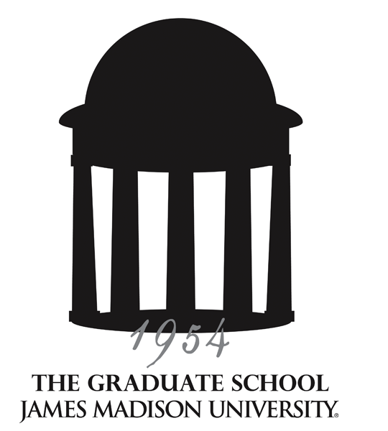
Graduate Council
Meeting Minutes
04/11/13 – Moody Conference Room

Supporting, facilitating and promoting excellence in lifelong education
through graduate programs of distinction, innovative outreach programs and a diverse student body.

Members present: Reid Linn, Lynette Michael, Kathy Thompson, Melissa Aleman (Communication and Advocacy), Josh Bacon (CSPA), Dabney Bankert (English), Aimee Brasseur (GA/GSA), Michael Busing (Business Administration), Natasha DuMerville (grad student rep), Lennie Echterling (Counseling & Supervision; Clinical Mental Health Counseling; School Counseling), Teresa Gonzalez (Academic Affairs), Michael Hall (Psychological Sciences), Pamela Bailey (Physician’s Assistant Studies), Hossain Heydari (Computer Science), Jim Zimmerman for Michael Klein (WRTC), Jeff Loveland (Occupational Therapy), Holly McCartney (Education), Nancy Nichols (Accounting), Ayasakanta Rout (Communication Sciences and Disorders), Mary Jean Speare (Music), Nicholas Swartz (Public Administration; also representing EUPS), Kent Todd (Kinesiology), Karin Tollefson (Art History),
Guests: Fletcher Linder (Interdisciplinary Liberal Studies Program), A.J. Morey (Cross Disciplinary Studies), Janet Smith (Public Affairs), Rhonda Zingraff (CHBS)
Programs not represented: Adult Ed/HRD; Assessment and Measurement, Biology, Exceptional Education, Health Sciences, History, Integrated Science & Technology, Leadership Studies, Mathematics Education, Nursing, School Psychology

APPROVAL OF MINUTES

The minutes of the February 14, 2013, meeting were approved by acclamation with no revisions (the March meeting was cancelled).
ANNOUNCEMENTS

- Grad Student Picnic: Friday, April 26, 4-6 p.m., Grace Street House lawn
- New Graduate Student Orientation: Monday, August 19, 2013, 9:00 – noon, HHS 1302
- Graduate Student Dinner: Friday, September 20, 4-6 p.m., Festival Ballroom
- JMU Communications and Marketing welcomes news items (including activities and projects) as well as stories about graduate programs or graduate (Masters, Ed.S, or Doctoral) students and faculty. You may submit story ideas to Janet Smith (smithjl@jmu.edu), who serves as the office’s liaison to the Graduate Council.

REPORTS

Graduate Student Representatives/GSA – Aimee Brasseur reported that the Graduate Student Association (GSA) is receiving nominations to recognize the impact of one outstanding graduate student and graduate faculty. Faculty or students may be nominated at http://jmugsa.blogspot.com/p/impact-awards.html. The blog is up to over 12,000 hits: http://jmugsa.blogspot.com

CAP: No report.

A-Team: No report.

C&I: No report.

Honor Council: Nancy Nichols reported that the Council will meet at the end of the month to discuss how to prevent students from avoiding honor code violations by withdrawing from a class.

DISCUSSION ITEMS

GSA President’s Report – Candace Avalos reported on activities of the GSA:
- Creating awards for outstanding faculty, students, staff; eventually hope to offer scholarships
- Writing a new constitution for the GSA
- Planning dinners (including fundraisers and the graduate community picnic) and other social events
- Marketing professional development workshops on campus
- Continuing to develop a social media presence (Facebook and Pinterest)
- Posting to the blog Monday through Friday; blog also contains information including an events calendar, award nominations form, and the Facebook page
- Selecting the executive board members for next year during April
- Sending out a flyer about the GSA in all new student acceptance packets

QEP Progress and Implementation – Josh Bacon and Fletcher Linder gave a presentation (see attached PowerPoint) on the progress of the QEP, required by SACSCOC. Although the QEP is designed to focus on undergraduate education with curricular and co-curricular activities, it can extend as appropriate to the graduate student population as well. The purpose of the JMU QEP is to teach ethical decision making skills that students will be able to apply across many personal, professional, and civic situations. There are eight Key Questions to help student evaluate the ethical dimensions of a problem:
- Outcomes – What are the short-term and long-term outcomes of possible actions?
- Fairness – How can I act equitably and balance all interests?
- Authority – What legitimate authorities (e.g. experts, law, my god or gods) expect of me?
- Liberty – What principles of freedom and personal autonomy apply?
- Rights – What rights (e.g. innate, legal social) apply?
- Responsibilities – What duties and obligations apply?
- Empathy – How would I respond if I cared deeply about those involved?
- Character – What actions will help me become my ideal self?

Module workshops will be offered for faculty during the May Symposium on how they might enrich what they already do in the classroom. Co-curricular activities planned will include freshmen orientation and residence halls activities. In the fall there will be a video series focusing on one question per month, with moderated online discussions. The QEP proposal will become the Madison Collaborative as it is implemented. www.jmu.edu/qep

Graduate Commencement Proposed Changes – Reid reported that there are 586 students walking during the May graduate commencement ceremony; 27 doctoral candidates and 2 MFA candidates. The length of the ceremony has become an issue given its growth over the last 5 years and these numbers. There is no speaker scheduled, other than President Alger. Reid indicated that two changes had been under consideration by the senior administration: (1) having only the doctoral and M.F.A. candidates and the dissertation directors process with the graduate faculty and the platform party while the master’s and Ed.S. students would be seated in their assigned seats before the ceremony begins; and (2) discontinuing the hooding for master’s and Ed.S. students though they would still be recognized as they cross the stage when their name is called. The Council members were near unanimous that the hooding should continue for this May and programs be given time to plan alternate activities/events for next year. Reid indicated that he would continue to advocate for the hooding this May but that in the event the hooding was discontinued, all candidates should process in as in the past. He will contact Donna Harper to convey the sentiments of the Council.

GA/TA/Doc assistant evaluations – Reid distributed a sample evaluation form that can be used or modified to evaluate GAs, TAs, and doctoral assistants (see attached). Any method of a documented yearly evaluation may be used. This was a potential compliance issue with the SACSCOC review.

Associate dean position – The announcement for the new Associate Dean position in The Graduate School has been posted on JobLink, recruiting JMU only. This position will be full-time in The Graduate School, with the expectation that the individual will continue teaching and conducting research in their discipline. This position replaces the Assistant Dean position, as Kathy is retiring effective July 1. She will continue some of her responsibilities part-time during the academic year as assistant to the dean. Members of the Executive Committee who will serve as the search committee for the Associate Dean position: Nancy Nichols, Jane Thall, Roshna Wunderlich, Lennie Echterling, Hossain Heydari, Cole Welter, and Reid Linn.

Revised graduate faculty policy – http://www.jmu.edu/acadaffairs/documents/AAPolicy5.pdf

Remaining 2013 Meeting Dates:
Friday, May 17th (Retreat) – Montpelier Room, East Campus Dining Hall, 8:30 a.m.-1:30 p.m.

2013-2014 Meeting Dates, 2:00 – 3:30 p.m.:
Thursday, September 12, 2013
Thursday, October 10, 2013
Thursday, November 14, 2013
Thursday, January 16, 2014
Thursday, February 13, 2014
Thursday, April 10, 2014
Retreat: TBD

