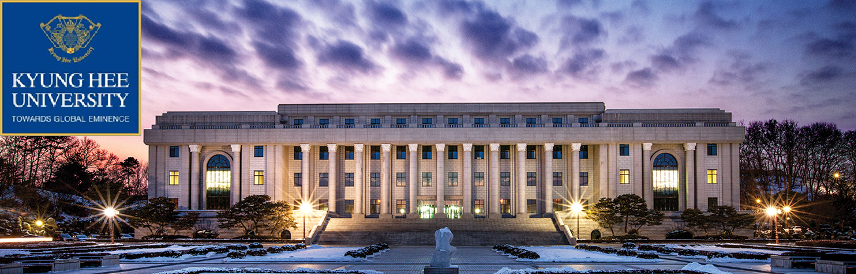

KYUNG HEE UNIVERSITY INFORMATION SHEET (Global Campus) 2019-2020

University Name | Kyung Hee University
Address | Room 103 College of Arts and Design, 1732 Deogyeong-daero,  Giheung-gu, Yongin-si, Gyeonggi-do, Korea
Website | http://www.khu.ac.kr/eng/  http://oiak.khu.ac.kr/eng/
Telephone / Facsimile | Tel: 82-31-201-3961  Fax: 82-31-201-3969
Contact Person  (International Program  Coordinator) | Seoul Campus:  Jiwon Yeom, Inbound Program Coordinator  exchange@khu.ac.kr  Global Campus:  Seohee Choi, Inbound Program Coordinator  exchange_gc@khu.ac.kr
Exchange Program Track &  Requirements | 1) Korean track  Department of Korean: TOPIK score is needed. Students who have TOPIK 3 or higher, will be exempt from the level test. Student who do not have TOPIK scores are required to take level tests before registering for any courses within the department.  Any student who wants to take a course in other majors or courses taught in Korean, should contact the coordinator at the Office of International Affairs, Kyung Hee University  2) English track  TOEFL IBT 82 / IELTS 6.5 / TOEIC 730  Any English test results equivalent to those scores can be accepted, and students from English-speaking country do not require to submit the English requirement certificate.
Term Dates for the Academic Year | Spring semester: March to June  Fall semester: September to December
Period of Exchange | 1 semester or 1 academic year (2 semesters)
Level of Study | Undergraduate  * If students at graduate level wish to study at Kyung Hee University with exchange program, please consult with us in advance.
Programme / Department(s)  (Available for  Incoming Exchange Students) | [Seoul Campus]  College of Humanities, College of Law, College of Politics and Economics, School of Management, College of Hotel and Tourism Management, College of Sciences, College of Human Ecology,  Humanitas College(General Education)  [Global Campus]  College of Engineering, College of Electronics and Information, College of Applied Science, College of Life Science, College of International Studies, College of Foreign Language and Literature, College of Art and Design
Course Catalogue URL | Please refer to the website.  http://sugang.khu.ac.kr
Recommended Credit Load | 3~5 (9~15 credits) courses per semester
Minimum-Maximum  workload | 3~6 (9~18 credits) courses per semester
Undergraduate Grading Scale | 4.3
Minimum GPA Requirement | It is up to our partner institution. However, we prefer those who have 3.0(out of 4.0) or above GPA.
Application Requirements | Students should be nominated officially by their home institution  and then send all the required documents before the deadline via Email.  1) Online Application Form or Application Form (paper)  2) Copy of Passport (Colour scanned, must be clear and legible)  3) Certificate of Enrolment (This can be any format, but it must state that you are enrolled in your home institution and have the official seal on it)  4) Copy of Official Transcript in English  5) Medical Assessment Form  6) Tuberculosis Test Result  7) 1 Coloured photo (white background and passport photo regulations apply)  8) Recommendation Letter (any format with an official seal)  9) Bank Statement (USD 3,800 or above for 1 exchange semester, USD 7,600 or above for 2 exchange semesters)  10) Dormitory Application  11) Dormitory Consent  12) Copy of Flight itinerary  13) Airport Pick-up Application  14) Copy of Medical Insurance Policy  (must cover the entire duration of your exchange period)
Application Deadlines | Spring semester: Nov. 15th (Nomination deadline: Oct. 31st)  Fall semester: May. 15th (Nomination deadline: Apr. 30th)  *Please send all the applications via Email. (PDF file)
Latest Arrival Date | They have to arrive before or on the orientation day.  On the same day, students will be able to check in at the dormitory.  Airport Pickup service will be provided.  (Mostly on the last Thursday of February / August.)  Exact date will be notified later.
Orientation | Spring semester: Usually last Friday of February  Fall semester: Usually last Friday of August  Exact date will be notified later.
Accommodation | On-campus dormitory (Woojungwon)  Off-campus housing
Cost of Rent  (in local currency) | KRW 1,054,000 per semester  *subject to change
Living / Prospective costs | Around $400~500 per month  It can be different depending on individual’s lifestyle
Medical Coverage | Students should obtain their medical insurance by themselves before they come to Korea.
Visa Requirements | Exchange students are to apply for Visa D-2-6 with the necessary documents at the Korean Embassy or consulate in their home countries  Visa type for Exchange students: D-2-6  Visa type for Dual degree students(undergraduate): D-2-2  Visa type for Dual degree students(master):D-2-3
Campus Facilities | Dormitory, Library, Cafeteria, Medical clinic & University medical center etc,.
Distance from City / Airport | It takes 1 ~ 1.5 hours by car from Incheon International Airport to Global campus.

Dormitory Information - Global Campus

Woojungwon

Built in September 1998, Woojungwon consists of residential and commercial areas that can accommodate up to 2,000 students. Each unit is furnished with a bathroom, beds, desks, cabinets and a phone. It is also supplied with a LAN cable for Internet access. Student cafeteria and other restaurants are located in the basement, and facilities such as a pharmacy, bookstore, laundry room, food court, etc. are placed on the first floor.

URL http://www.woojungwon.net/

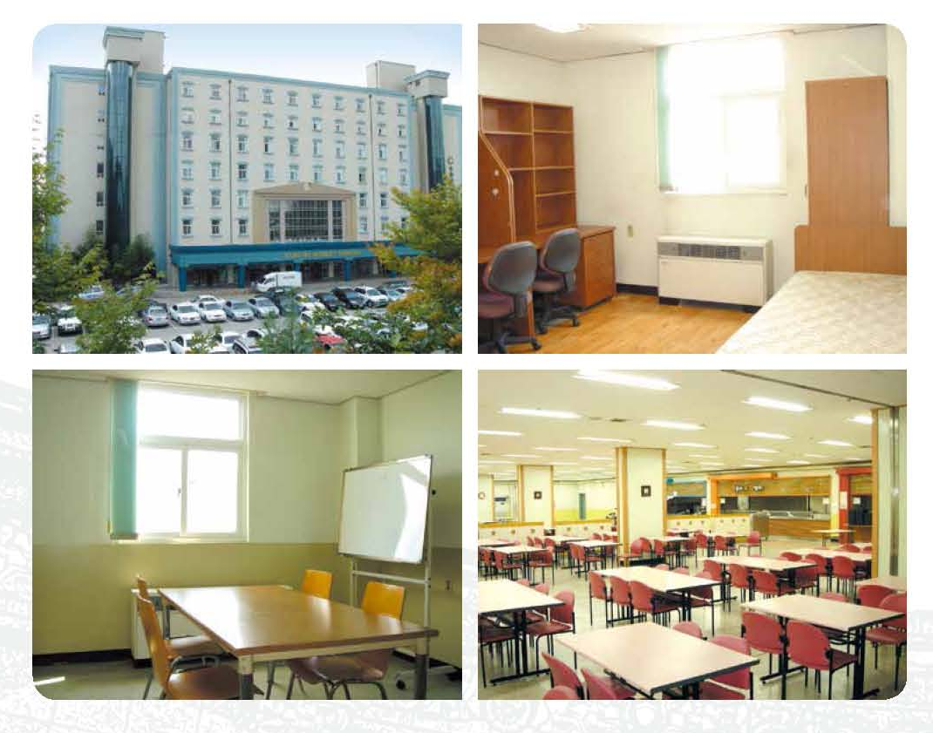

Seoul Campus map

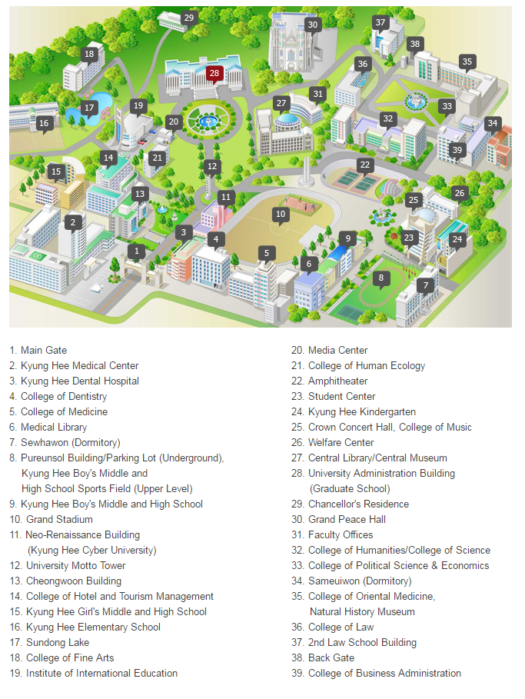

Global Campus map

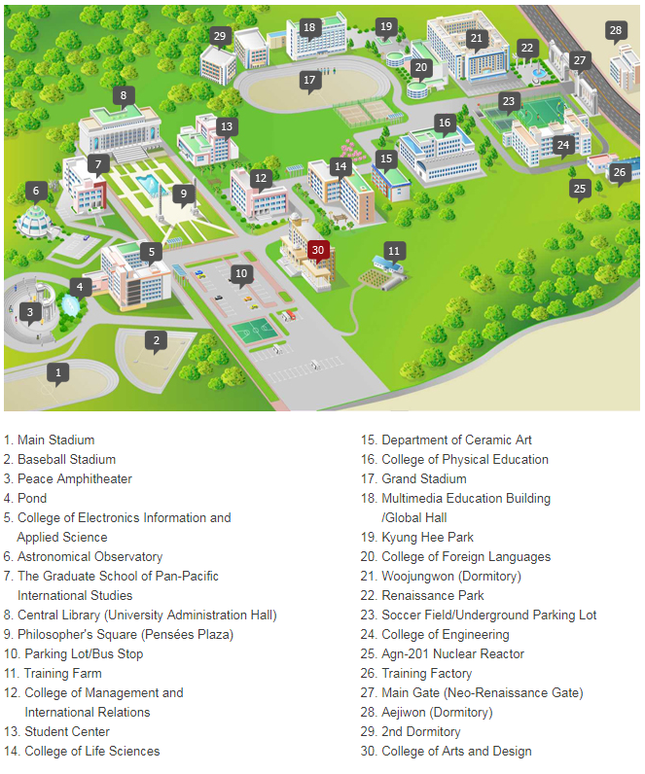

Department Information

Humanitas College
Office: 5th floor, Multimedia Education Building
Homepage: http://hc.khu.ac.kr/english/
E-mail: khwc5871@khu.ac.kr
Tel: +82-31-201-3401~4

College of Engineering
Office: Room 225, College of Engineering
Homepage: http://eng.khu.ac.kr/english
E-mail: khwc5770@khu.ac.kr
Tel: +82-31-201-2401~3

College of Electronics & Information
Office: Room 203, College of Electronics Information and Applied Science
Homepage: http://eni.khu.ac.kr/eng/index.html
E-mail: khwc5750@khu.ac.kr
Tel: +82-31-201-2501~2

College of Applied Sciences
Office: Room 203-2, College of Electronics Information and Applied Science
Homepage: http://applsci.khu.ac.kr/english/
E-mail: khwc3801@khu.ac.kr
Tel: +82-31-201-3801~2

College of Life Sciences
Office: Room 216, College of Life Sciences
Homepage: http://cls.khu.ac.kr/html_2018/ (Korean)
E-mail: khwc5790@khu.ac.kr
Tel: +82-31-201-2601~3

College of International Studies
Office: Room 302, College of International Studies
Homepage: http://kic.khu.ac.kr/
E-mail: kic@khu.ac.kr
Tel: +82-31-201-230~4

College of Foreign Language and Literature
Office: Room 203, College of Foreign Languages
Homepage: http://foreign.khu.ac.kr/ (Korean)
E-mail: khwc5830@khu.ac.kr
Tel: +82-31-2201~2

College of Art & Design
Office: 2nd floor, College of Arts and Design
Homepage: http://and.khu.ac.kr
E-mail: khwc5850@khu.ac.kr
Tel: +82-31-201-2672~4

College of Physical Education
Office: Room 210, College of Physical Education
Homepage: http://sports.khu.ac.kr/html_2017/# (Korean)
E-mail: khwc5870@khu.ac.kr
Tel: +82-31-201-2740~2
Four Seasons at Kyung Hee

Seoul Campus

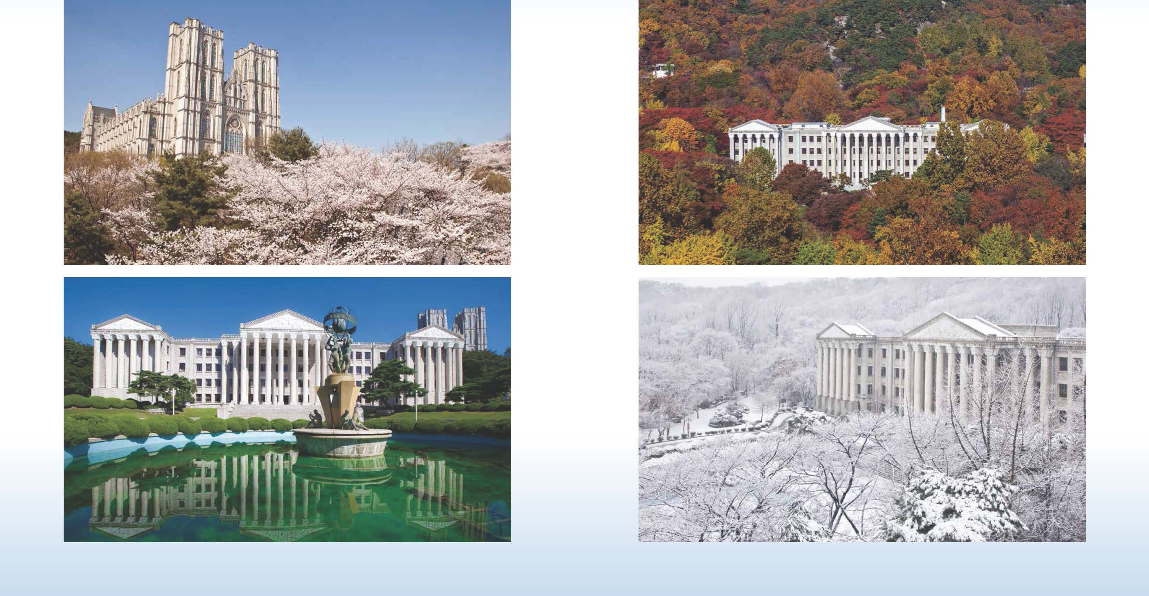

Global Campus

