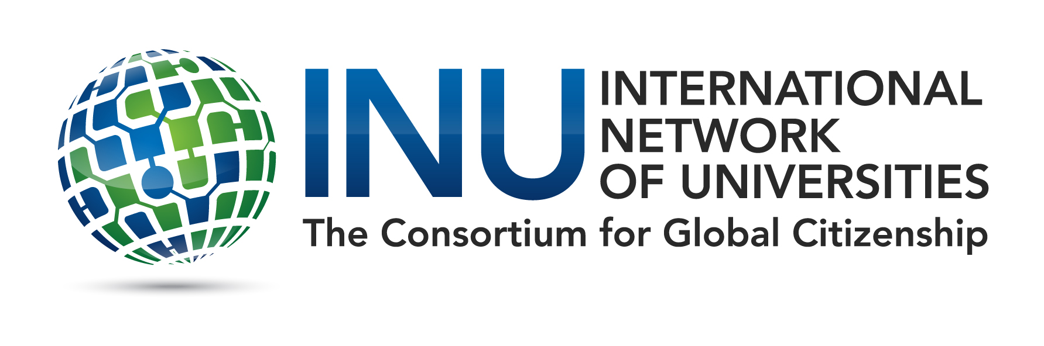

INU STUDENT SEMINAR

On Global Citizenship and Peace

JMU APPLICATION FORM 2019

DEADLINE: March 22, 2019

SUBMIT THIS FORM, ALONG WITH THE APPLICATION ESSAY, TO MS. EMILY WISHON IN JMU’S CENTER FOR GLOBAL ENGAGEMENT (wishonea@jmu.edu)

Name:
E-mail address:
Major(s)/Minor(s):
Class Year:
Cumulative GPA:
Expected Graduation Date:

Please discuss any international experiences that you have had (5 to 6 sentences):

The Center for Global Engagement expects students who participate in the seminar to “spread the word” about the seminar once they return to campus. If you were selected to represent JMU at the seminar, how would you spread the word about the seminar when you returned? (5-6 sentences):

