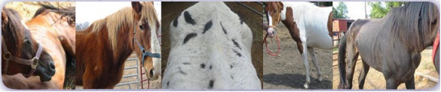
The Mahatma Gandhi Center for Global Nonviolence
presents…
A Day of Service at the Roanoke Valley Horse Rescue

Come join us April 9th while we prevent equine abuse, take care of abused horses, and provide much-needed support to the shelter.

Email: gatesdb@dukes.jmu.edu or visit the Gandhi Center at 500 Cardinal Drive to sign up.

ONLY $10 TO VOLUNTEER

