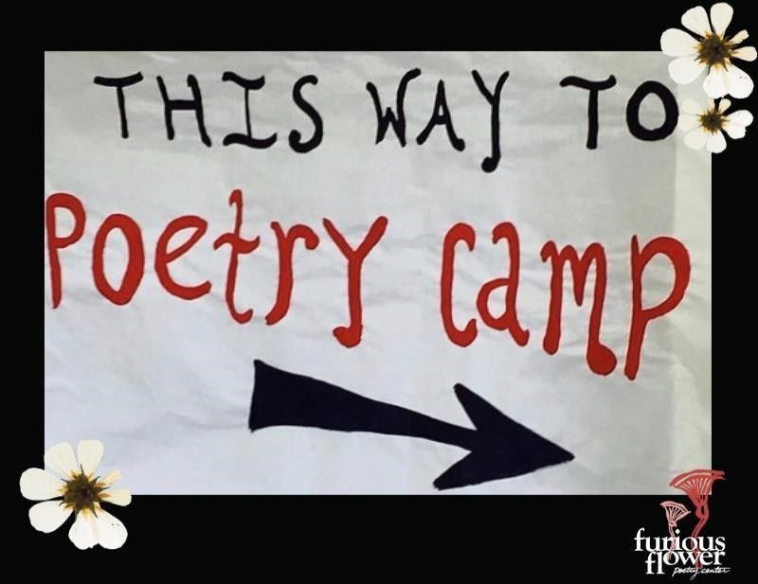

REGISTRATION PACKET
“Bloom On!”
July 27-31, 2020

Thank you for registering for the 2020 Furious Flower Children’s Creativity Camp (formerly known as Children’s Poetry Camp). The Furious Flower Creativity Camp is FREE for ages 7-13, and this summer’s camp theme is “Bloom On!” This registration packet has information regarding our new Creativity Camp structure for this summer, as well as the few forms you’ll need to submit no later than Friday, July 17, 2020.

Furious Flower is committed to the safety and well-being of our campers and their loved ones. This summer, we are shifting our Creativity Camp to a virtual setting that will include two, one-hour long workshops per day beginning the week of Monday, July 27th and ending Friday, July 31st. Each workshop will either be taught through the form of a: 1. Manual 2. Pre-recorded video 3. Real-time zoom video. All art supplies and other materials are provided. No particular experience or special skills are needed for any of these workshops. As much as is possible, children are grouped with others around their same age. Please read the descriptions of each workshop on the following page and then fill out and return all registration forms (see below checklist).

Forms Checklist for Creativity Camp:

❏ Workshop registration—complete one form per child
Classes are limited to 15 students each and will be filled in the order registrations are received.

❏ Parent/Guardian contact information—complete one form per child

❏ Parental acknowledgment of risk— complete one form per family (list all children who are participating)

❏ JMU photo release—complete one form per child (optional)

Workshop #1
Rhythm and Resilience
with Mr. Mike Deaton
This workshop features music-making with found sounds in your home, voice, the body drum, and more! You’ll learn “rhythm seeds” that can be played on any instrument…or none at all! You’ll learn patterns but also how to express yourself and make your own music. Then we’ll put rhythm together with movement, the breath, voice, and other tools that can help us be resilient against stress and anxiety. Your child will learn take-aways to put in their toolbox and use to help recognize and regulate how they are feeling. The focus is on FUN and anyone can do it! You do not need a musical instrument or any experience or special skills to participate and to enjoy this workshop.

Workshop#2

Nature as a Guide with Mr. Mike Deaton
This workshop features nature-themed language arts and visual arts games and activities. We’ll be looking at the world from different perspectives (like a bird or a bug), learning how to write poetry about different facets of nature, and mixing up animals in our literary laboratory. Each day features different themes and different activities. We’ll discover nature as a teacher and guide while exploring and creating lessons that might help humans deal with adversity and unexpected challenges. This is a very open-ended experience that allows campers to express themselves in any number of ways, all in the same workshop.

Workshop #3
Resilience, ResiliArt!

with Mrs. Celmali Jaime Okonji
No matter the challenge, we can get through it... creatively. In this series of visual art experiences you will explore colors, practice new techniques, and handle a variety of art tools, all while gaining important skills to become a more resilient person.

Workshop #4
Seeds of PoeTree

with Mrs. Celmali Jaime Okonji
Just like small seeds become a strong tree, your words can bloom into poetry. Discover the secret to growing your words into poems that tell your story and inspire others. Here is your chance to share your voice with the world.

Workshop #5
Tend, Till: your own business

With Ms. Kisha Hughes
When I was a kid, I was obsessed with the time. Whenever I asked my dad for the time, he would respond, "Ten til." And I would say "Ten til what?" And he would say "Tend til your own business."
This workshop will include activities to assist us in tending our own mental, emotional, and creative business. We will use mindfulness techniques to create stories, poems, and projects that remind us to pay attention to what is going on inside of us.

Workshop #6

Mindful movement

with Ms. Kisha Hughes
30 minute yoga asana class that will give students the opportunity to move their bodies, get out the wiggles and settle into a more peaceful space.

In case of emergency: If you need to reach us during the week of camp, please call the Camp Director, Talibah Aquil at (646) 734‐1609.
Our discipline policy: We believe that children learn best when they have the respect of others and the freedom to express themselves. With this in mind, we are committed to nonviolence in word and action among both the children and adults. Virtual Hazing and bullying are not tolerated. Minor behavioral issues will be dealt with on an individual basis; these are usually resolved, but if a child shows that he or she cannot participate in our virtual classes without significantly disrupting the experience of others, a parent/guardian, or other authorized adult will be contacted.

Please return all completed forms by Friday, July 17 via one of the methods below:
- Mail: Furious Flower Poetry Center
500 Cardinal Dr.
MSC 3802
Harrisonburg, Va. 22807

- Fax: 540‐568‐8888

- Email: aquilta@jmu.edu (attach scanned PDF)

Please feel free to call us with any questions at (646) 734‐1609.

Furious Flower Poetry Center’s 2020 Children’s Creativity Camp Workshop Registration | Submit by Friday, July 17, 2020.

Please complete one form per child.
Campers will be entered into workshops in the order that registrations are received.

Name: ________________________________ Age: ________

Elective Workshop

You’ll attend these workshops every day of camp.
Select FOUR Workshops and rate them in order of preference (i.e. 1 for your first choice, 2 for second choice, 3 for third choice and 4 for your last choice).
You will only attend TWO of these, but if your first and second choices in workshops are full, you will be placed in your other choices depending on availability.

____Rhythm and Resilience ____Nature as a Guide
____Resilience, ResiliArt! ____Seeds of PoeTree

____ Tend, Till: your own business ____ Mindful movement

Please return all completed forms by mail, fax or email to:
Furious Flower Poetry Center, 500 Cardinal Dr. MSC
3802, Harrisonburg, Va. 22807 or fax 540‐568‐8888
or email aquilta@jmu.edu (scan and attach PDF)

Parent/Guardian Contact Form
Child’s Name:
Home address:
_____________________________________________________________________
_____________________________________________________________________
Home phone: _________________Date of Birth: _
Name of authorized adult: ___________________________
_______________________________________________________________________
+ + + + +
Contact
Name: __________________________________
Relationship: ____________________________________
Cell phone: _____________________________
Home Phone: ___________________________________
Work phone: ____________________________
Email: __________________________________________
+ + + +

Parental Acknowledgment and Assumption of Risk

Required for all Children’s Creativity Camp participants

My child(ren) ____________________________________________________________is/are eligible to participate in Furious Flower’s virtual Children’s Creativity Camp held by the Furious Flower Poetry Center. I understand that participation in any activity is voluntary, and participants may withdraw from the activity at any time. In determining whether my child will participate in the activity, I am aware that James Madison University and the Furious Flower Poetry Center cannot undertake financial responsibility for my child in the event that he/she is injured or becomes ill while participating in the activity, nor can it assume any legal responsibility for harm my child may cause because of participation in the activity.

In consideration of the University permitting my child’s participation in the activity, I agree to assume the risks known to be inherent in the activity, as well as any unforeseeable risks. The known risks inherent in the activities are: injuries inherent in the physical activities of the workshops, communicable diseases and injury due to personal or third party actions.

I have read and understand the foregoing explanation of the risk inherent in allowing my child to participate in the activity. I hereby accept the risk of injury to my child as a result of participation in the activity, and, as further consideration for its permitting my child to participate in the activity, I hereby release James Madison University, the Furious Flower Poetry Center, and all its staff and volunteers from any and all claims which I or my child(ren) may have against it for loss or damage to property resulting from my child’s participation in the activity.

_____________________________________________________
Signature of Parent or Guardian

_____________________________________________________
Printed Name of Parent or Guardian

_____________________________________________________
Date

Photo Release / Permissions Agreement

I, ______________________________________________________ _________________ give permission to James Madison University to use photographs of myself and/or my child/children (enter their names)
________________________________________________
_________________________________________________________
for publication in official university communications (including print and web). I understand that names and other identifying information will not be used or provided. The images also may be published in Madison, the university magazine, and used to illustrate stories about students, faculty and alumni.

____________________________________________________________
SIGNATURE (PARENT OR GUARDIAN)

_______________________________________________________
PRINTED FULL NAME

____________________________________________________________
WITNESS

____________________________________________________________
DATE

