SPCC Cardholder Training PeopleSoft Electronic Forms-updated 1/15/2026
appa@jmu.edu
Cash and Investments Office
Contact: appa@jmu.edu
Peoplesoft finance electronic forms
SPCC Cardholder Training Guide

Contents
Overview 1
Form Location-PeopleSoft Finance 2
Form Examples 4
SPCC Application 4
Manage Reconcilers 7
Cancel SPCC 9
Monthly Credit Limit Increases 11
Single Transaction Increases 13
Exception Request 18
Approvals 21
My Madison Approvals 21
PeopleSoft Finance Approvals 31
Contact Information 34

Overview

Beginning August 1, 2021, the following forms for the Small Purchase Charge Card (SPCC) will be moved from paper or email format to electronic format within the PeopleSoft Finance System. All cardholders are expected, on this date, to use these forms for the following requests:
- SPCC New Cardholder Applications
- Managing SPCC Reconcilers
- Cancel SPCC
- Monthly Credit Limit Increases
- Single Transaction Increases
- Exception Requests
All forms will be electronically routed to your supervisor for approval then to the Cash and Investments Office or Accounting Technology for final approval and processing. All active cardholders will have access to PeopleSoft Finance to initiate these forms. Supervisors, who have access to PeopleSoft Finance, will be able to approve them within the system; those without access will have the approvals on their MyMadison dashboard. For each request, a cardholder will receive confirmation emails that should be printed and kept with their SPCC records for audit purposes.

Form Location-PeopleSoft Finance

PeopleSoft Finance can be reached from the Quick Login Access page on the JMU website: James Madison University - Quick Login Access (jmu.edu) . In the green shaded box, you will see Finance listed first. Click on this link.
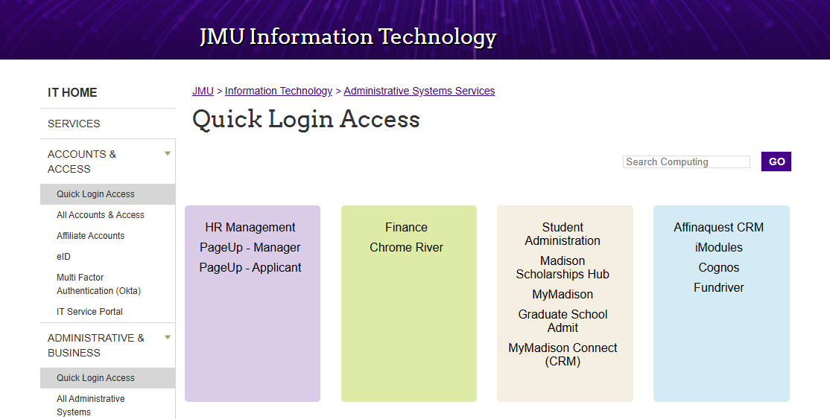
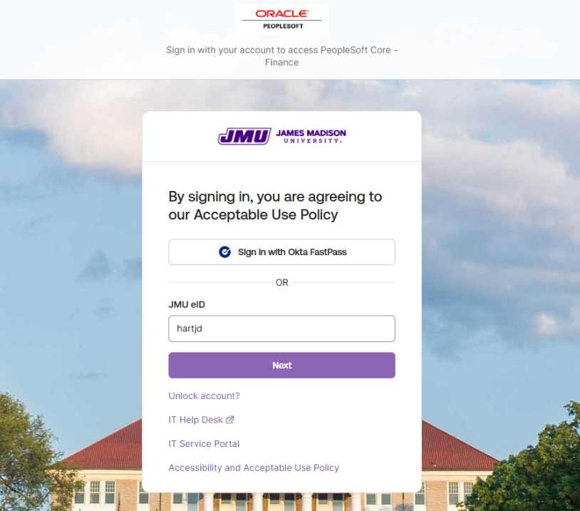
This will take you to the PeopleSoft Finance login page. You will use your e-id and password to log into this system. System access does require Okta verification.

- You will click on the navigation button in the upper right corner. 

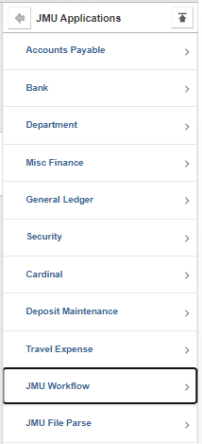
- Choose JMU Applications, then JMU Workflow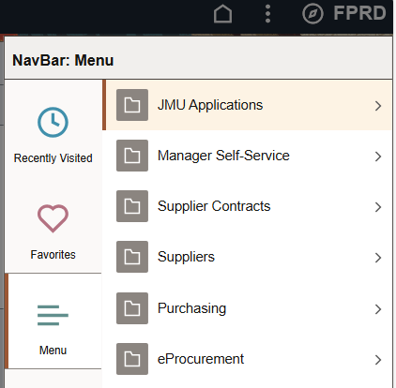

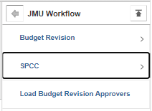
- Choose SPCC from the JMU Workflow menu

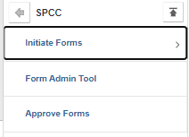
- Choose Initiate Forms from the SPCC menu

- From the Initiate Forms Menu these options are available:
SPCC Application
This form is to be used by any JMU Faculty, Classified or Wage Staff member who needs to request a Small Purchase Charge Card (SPCC).
Manage Reconcilers
This form is to be used by any current SPCC cardholder who needs to add or delete employees to reconcile their transactions in the Bank of America WORKS system
Cancel SPCC
This form is to be used by cardholders or their supervisors to cancel a current SPCC. Reasons to cancel a card include when an employee leaves employment with the university or changes positions.

Monthly Credit Limit Increases
This form is to be used by cardholders to request increases to their overall monthly credit limit on their SPCC either temporarily or permanently.
Single Transaction Increases
This form is to be used by cardholders to request increases to their single transaction credit limit on their SPCC either temporarily or permanently. Increases over $10,000 must include a copy of the invoice and eVA EP/PCO or Procurement written approval.
Exception Requests
This form is used by cardholders to request any exception to a Merchant Category Code (MCC) restriction on the SPCC. These restrictions can include the restaurant block or accommodation block.

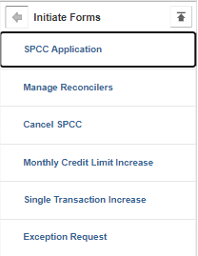

To begin initiation of a form, you will click on the appropriate form name and fill out the requested information.

Form Examples

SPCC Application
This form is to be used by any JMU Faculty, Classified or Wage Staff member who needs to request a Small Purchase Charge Card (SPCC). The following fields will be automatically filled in based on your e-id and password:
Applicant’s Eid
HR/Employee ID#
Application’s Name
Date of Birth
JMU Email Address

The new cardholder must fill in the following information:
Student? This is either Yes or No. If you are a student, you are not eligible for an SPCC.
JMU Physical Address: This is your JMU office address
JMU Phone Number: This is your JMU office phone number
Applicant’s MSC: This is your departmental MSC
Default Deptid: This is your departmental ID (org) number
Supervisor’s Name: This is your supervisor’s name
Supervisor’s Email: This is your supervisor’s JMU email address
Transaction Limit: This is the single transaction limit on your card. (typically $10,000)
Monthly Limit: This is your overall monthly credit limit. (typically between $10,000-$100,000)
Reconciler(s) for Card: These employees can reconcile your charges in the PeopleSoft Finance System. List their e-ids. If you want to reconcile your own card, you must list yourself as well.

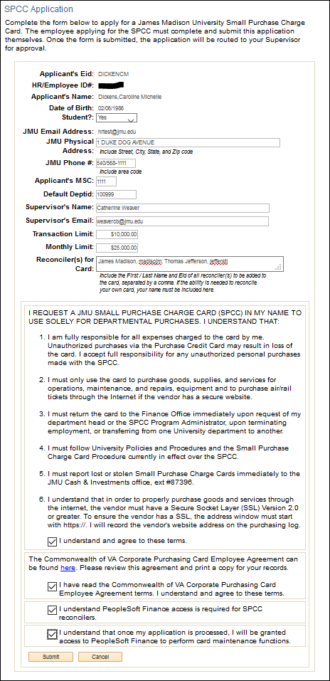

You must read and agree to all terms and conditions and then hit the submit button.

Once you submit, you will receive a request confirmation. This lets you know your form has been submitted successfully.
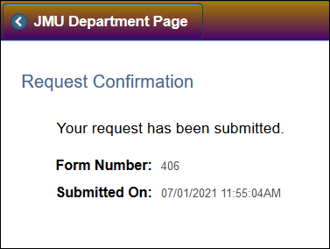

Once your application has been approved by your supervisor and Finance, you will receive an email letting you know the application has been approved.
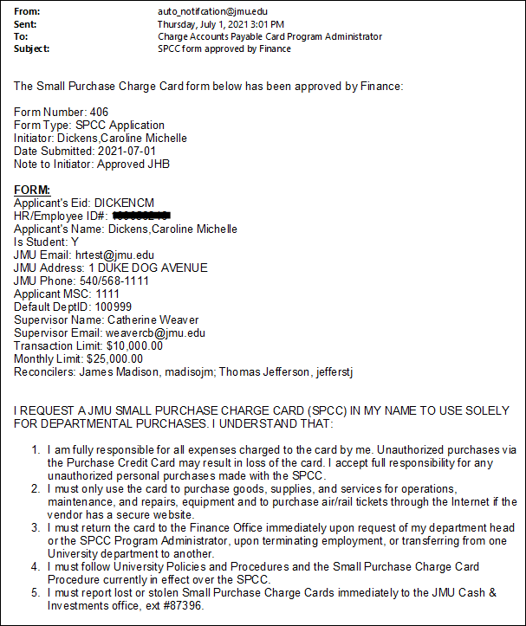

Manage Reconcilers
This form is to be used by any current SPCC cardholder who needs to add or delete employees to reconcile their monthly charges in the Bank of America WORKS system. The following fields will be automatically filled in based on your e-id and password:

Cardholder Name

The cardholder will fill out the last four digits of their card number and all other fields based on what they would like to do. If they want to add a reconciler, they will choose “add” and fill in the cardholder’s e-id. If they want to delete a reconciler, they will choose “remove” and fill in the cardholder’s e-id. Once complete, click the Submit button in the bottom left corner of the page.
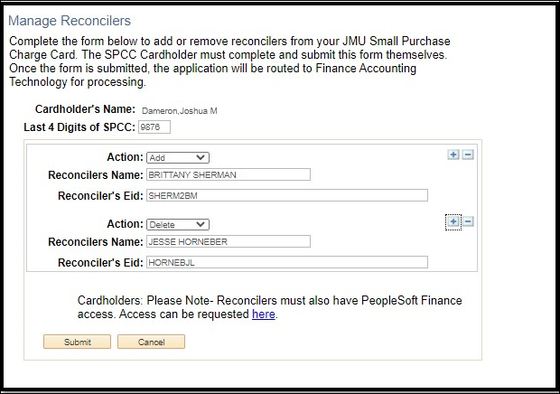

Once you submit, you will receive a request confirmation. This lets you know your form has been submitted successfully.
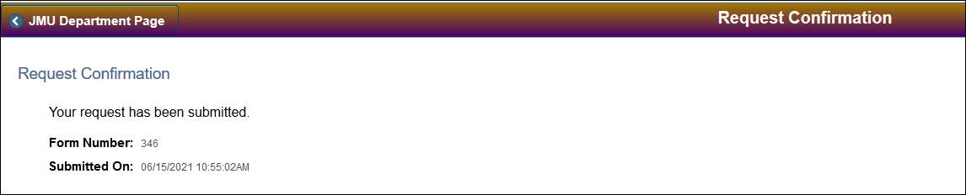

Once your form has been approved by Finance, you will receive an email confirmation.

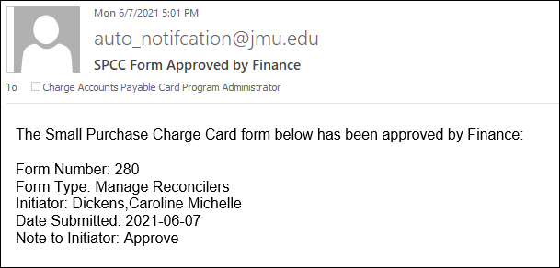

Note: If the reconciler is a new user to the Bank of America WORKS system, they will receive a welcome email once the Manager Reconcilers form has been completed from Bank of America to setup their profile in Bank of America WORKS.

Cancel SPCC
This form is to be used by cardholders or their supervisors to cancel a current SPCC. Reasons to cancel a card include when an employee leaves employment with the university or changes departments. The following field will be automatically filled in based on your e-id and password:
Requestor’s Name
The person filling out this form will need to fill in the following information:
Cardholder’s Name
Cardholder’s Eid
Cardholder’s Last 4 Digits of SPCC

Once complete, click the Submit button in the bottom left corner of the page.

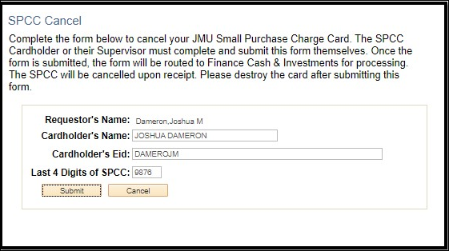

Once you submit, you will receive a request confirmation. This lets you know your form has been submitted successfully.

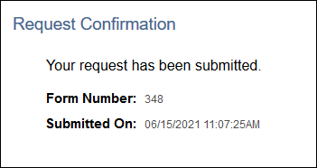

Once the form has been approved by Finance, you will receive an email to keep with your SPCC records.

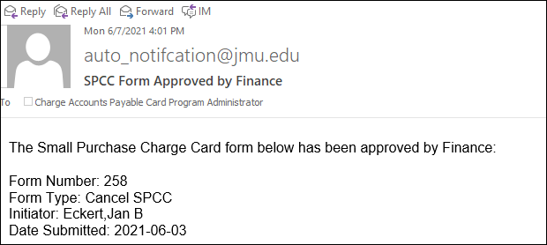

Monthly Credit Limit Increases
This form is to be used by cardholders to request increases to their overall monthly credit limit on their SPCC either temporarily or permanently. The following field will be automatically filled in based on your e-id and password:

Cardholder Name

The cardholder will need to fill in the following information:
Cardholder’s Last 4 Digits of SPCC
Duration: Permanent or Temporary. For temporary, you can put in a start and end date.
Request Limit: This is the new limit you are requesting.

Once complete, click the Submit button in the bottom left corner of the page.

Permanent Request
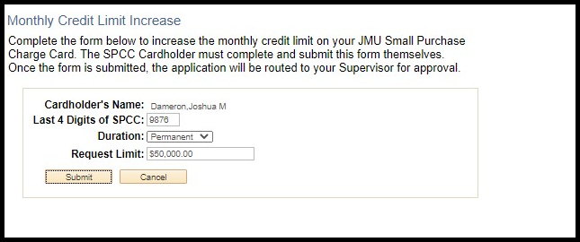
Temporary Request
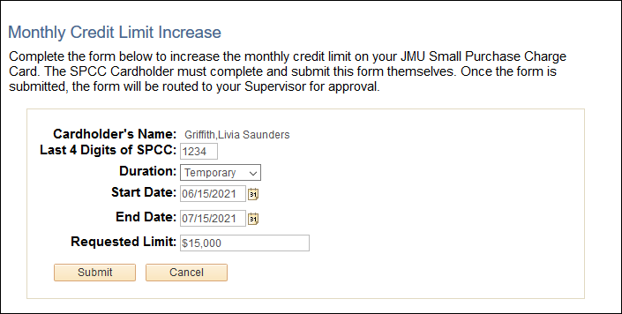

Once you submit, you will receive a request confirmation. This lets you know your form has been submitted successfully.

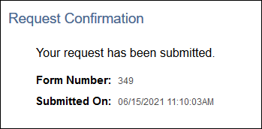

Once the form has been approved by Finance, you will receive an email to keep with your SPCC records.

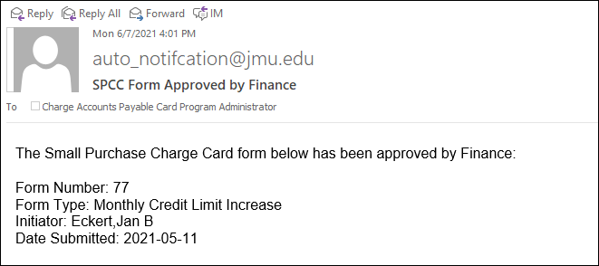

Single Transaction Increases
This form is to be used by cardholders to request increases to their single transaction credit limit on their SPCC either temporarily or permanently. Increases over $10,000 must include a copy of the invoice and eVA EP/PCO or Procurement written approval. The following field will be automatically filled in based on your e-id and password:

Cardholder Name

The cardholder will need to fill in the following information:
Cardholder’s Last 4 Digits of SPCC
End Date: This is the date the increase will expire.
Request Single Transaction Limit: This is the limit you are requesting.
eVA EP/PCO Number or Exclusion: You must enter an eVA order number or an appropriate exclusion. If you are entering an exclusion, you must attach written permission from the Procurement office before your limit will be increased.
Comment: Use this section to let Cash and Investments know any additional information on the request.
*NOTE: Once you submit the request, you will need to attach a copy of the invoice and any other important documentation related to the request.

Once complete, click the Submit button in the bottom left corner of the page.
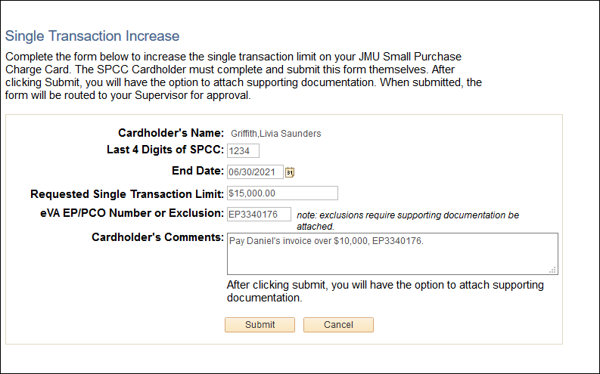

Once you click the Submit button, you will then be requested to add attachments. This would include copies of the invoices or any other relevant documentation. Click the Add Attachments button.
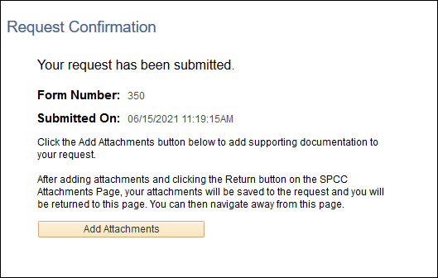

On the SPCC Attachments Page, you will choose “Add Attachment” to upload your relevant documentation.
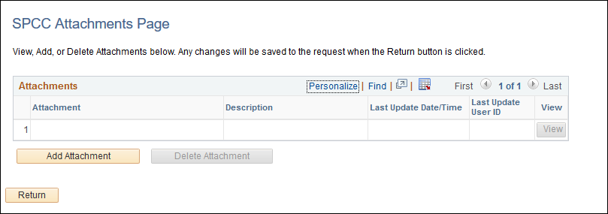

You will browse your computer to find the location of the documentation.
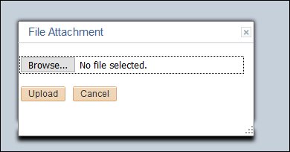

Once you find your document, you will add it, and hit the Upload button.

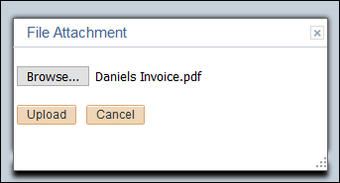

You will be prompted to add a description to your document (you do not have to add a description).

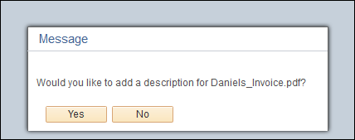

If you choose YES, you can add up to a 30-character description, then click the OK button

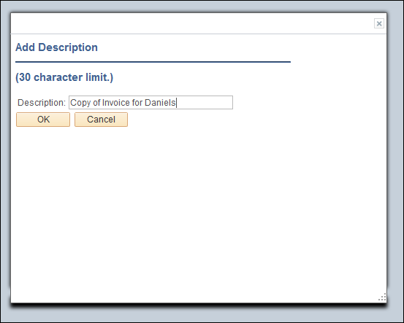

Your attachment will now appear on the SPCC Attachments Page. If it is correct, you can click the Return button. If you’d like to add more, you can click the Add Attachment button again, or you can delete the attachment.

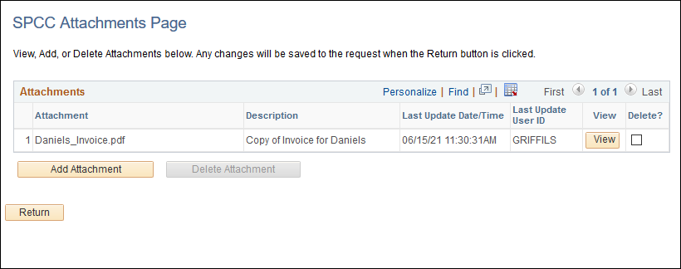

When you click the Return button, you will be taken back to the Request Confirmation page. This shows your request has been submitted.

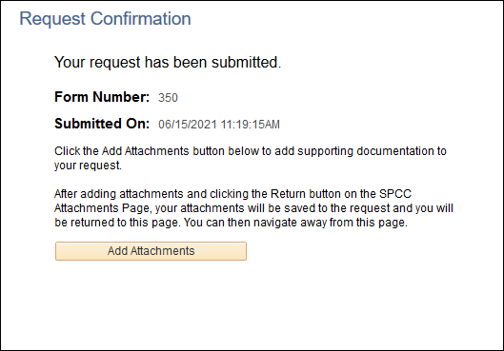

Once the form has been approved by Finance, you will receive an email to keep with your SPCC records.

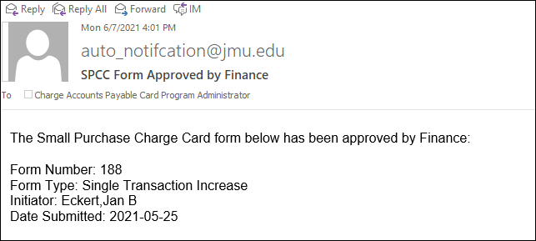

Exception Request
This form is used by cardholders to request any exception for a Merchant Category Code (MCC) restriction on the SPCC. The following field will be automatically filled in based on your e-id and password:

Cardholder Name

The cardholder will need to fill in the following information:
Cardholder’s Last 4 Digits of SPCC
Duration: Permanent or Temporary, for temporary, you will put in a start and end date.
Exception Type: This is the MCC Code you want lifted on the card.
Justification: Use this section to let Cash and Investments know any additional information on the request. You must have something in this field for approval.

Once complete, click the submit button in the bottom left corner of the page.

Temporary Request
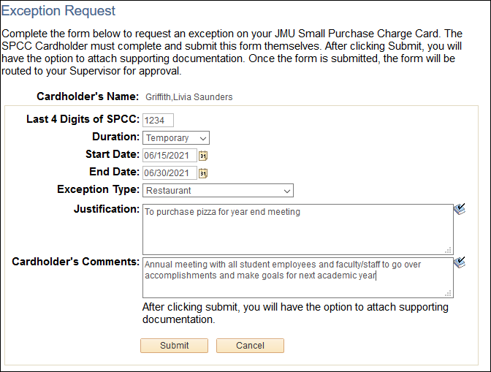

Permanent Request
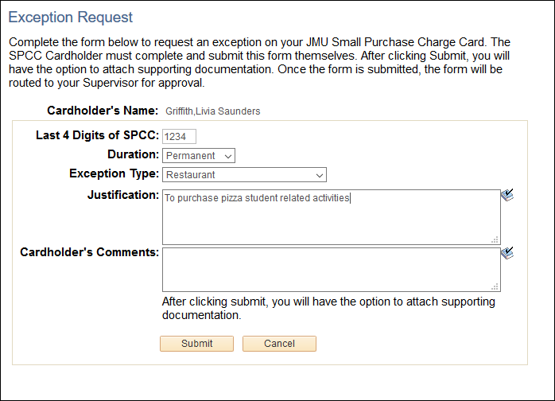

Once you click the Submit button, you will then be requested to add attachments. This would include copies of the invoices or any other relevant documentation. Click the Add Attachments button.

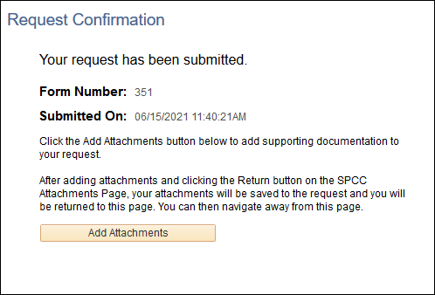

*The adding an attachment process is the same as for single transaction limit requests. See page 13 for detailed instructions. The request confirmation page shows your request has been submitted.

Once the form has been approved by Finance, you will receive an email to keep with your SPCC records.

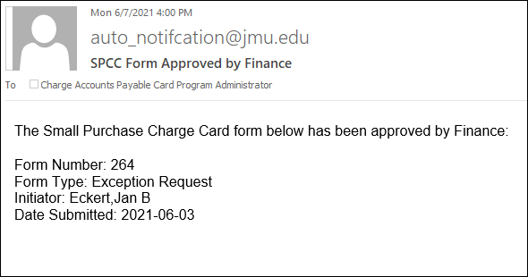
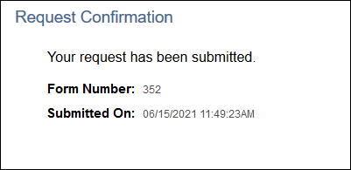

Approvals

My Madison Approvals

When a form has been submitted, supervisors will receive an email letting them know they have a form to approve.
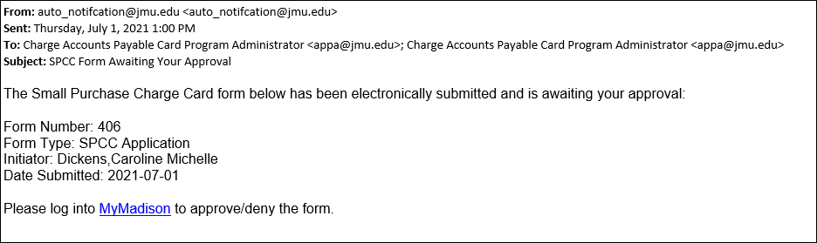
Supervisors will be able to approve all SPCC forms within MyMadison Approvals. MyMadison can be reached from the Faculty/Staff Main home page at: https://www.jmu.edu/gateway/faculty-staff.shtml On the left-hand side, there is a gray shaded box, and MyMadison is listed in that box.
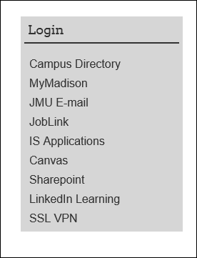
You will use your e-id and password to log in. System access does require Okta verification.
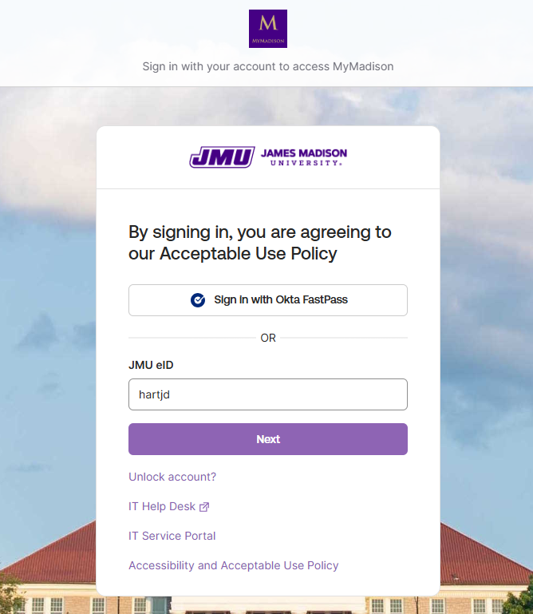

From the My Approvals tab in MyMadison, the supervisor will see how many SPCC forms are in their pending approvals, under Finance. Click on the blue hyper link SPCC Forms to be taken to the My Approvals-Finance.
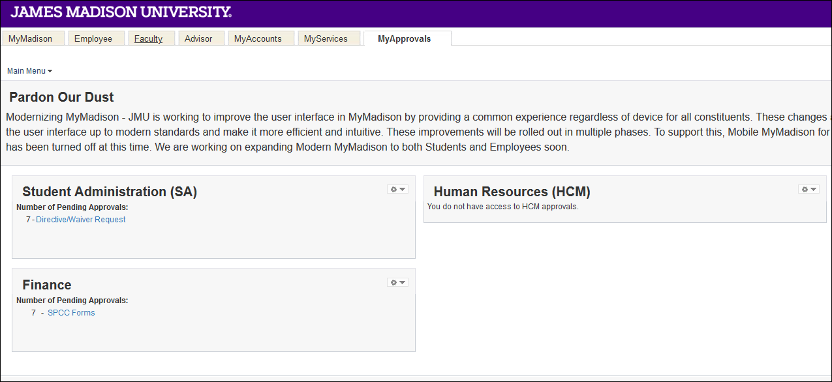
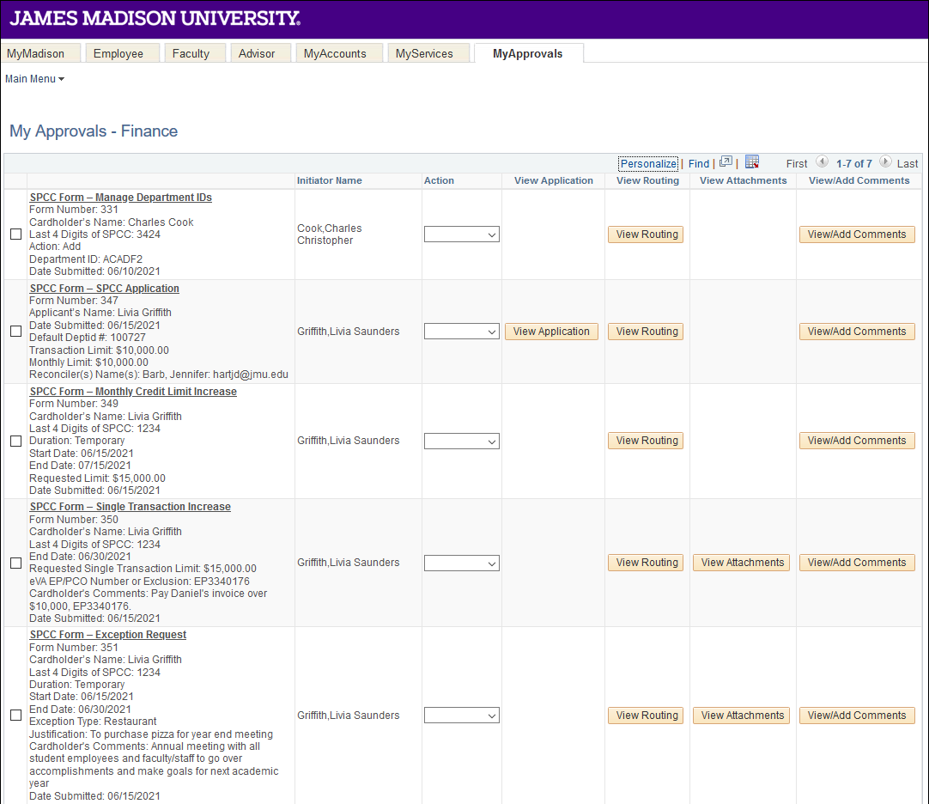
From the My Approvals Tab, the approver can do the following:
View Application - on any SPCC Application, the approver can view the form by clicking the View Application button.
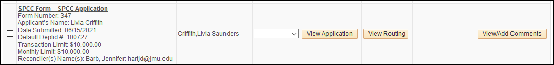
The application will come up for the approver to review. Once reviewed, click the Cancel button at the bottom of the application to return to the approvals page. 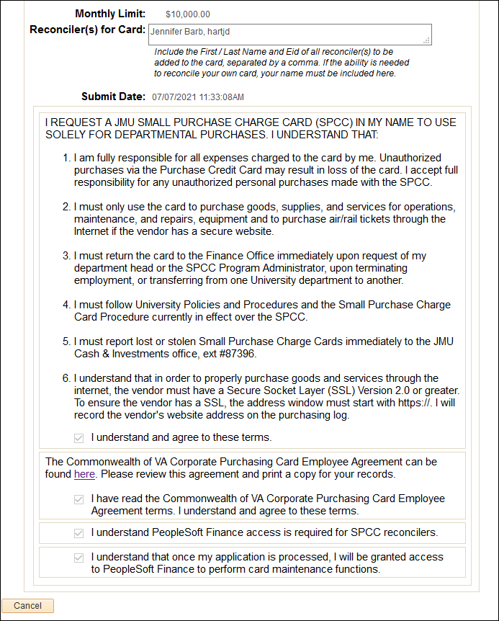

View Routing - this will show the approver the routing of the form. To view, click on the View Routing button.
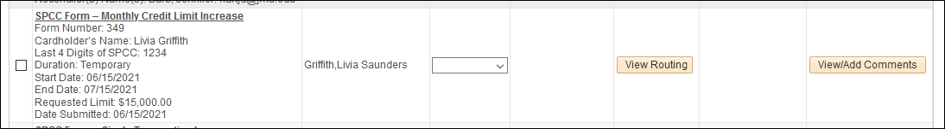
The forms approval routing will come up; once the approver has reviewed, they can click the Return button to go back to the My Approvals-Finance page.
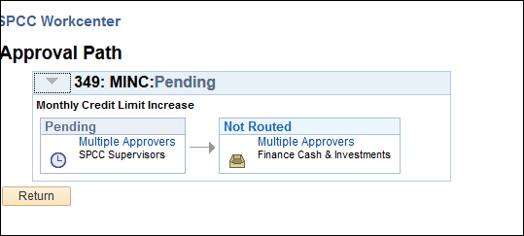
View Attachments - if a form has an attachment, the approver can view that attachment by clicking the View Attachments button.
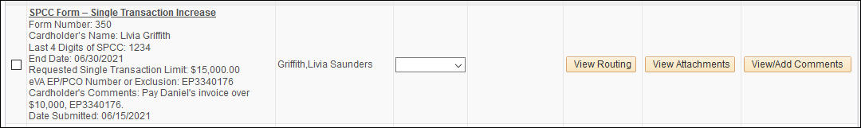
This will take the approver to the SPCC Attachments page. Click on the View button to pull up an image of the attachment. *Note you may need to enable pop-ups to see the attachment* After viewing the attachment, the approver would click the Return button to go back to the My Approvals-Finance Page.
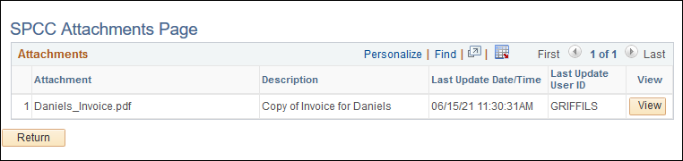
View/Add Comments - if any comments have been made about a submitted form, the approver could view them there as well as make comments.
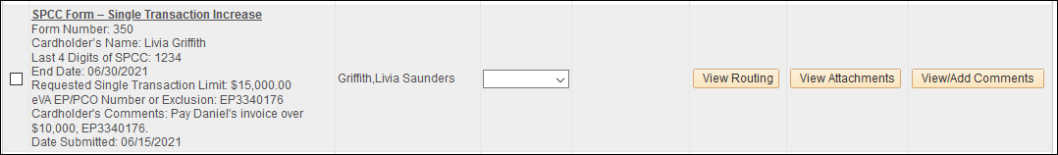
If the approver would like to make a comment here, they can do so by selecting the Add Comment button.
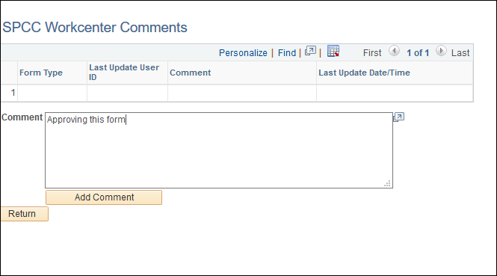
Once the approver adds the comment, you will see it added on the SPCC Workcenter comments. If complete, click the Return button to go back to the My Approvals-Finance page.
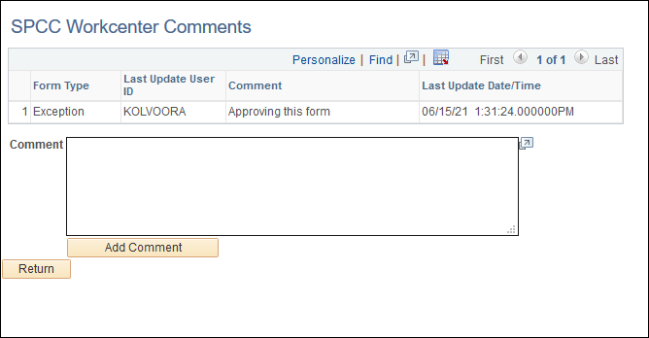
Once an approver has reviewed all documentation, they will either approve or deny the form. To do this, they will choose, under Action, either Approve or Deny. Make sure the check box on the far left is checked for the row you are working on.
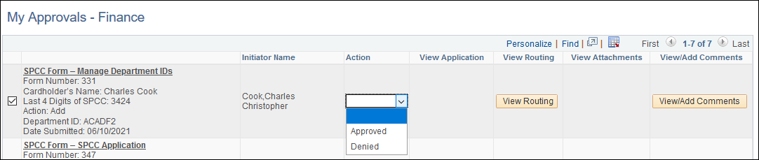
Once the correct status has been entered and the box on the left is checked, the approver will scroll to the bottom of the page and click the Submit button on the lower left corner.
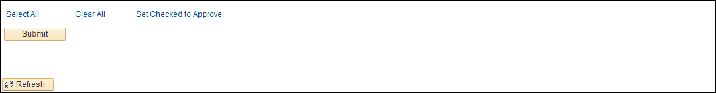
A message will pop up confirming the approver’s action. If correct, click the Yes button. If incorrect, click the No button.
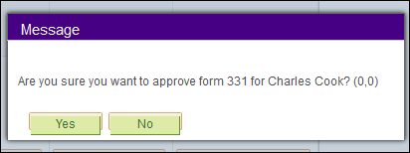
Once the approver has approved the form, it will be sent to Finance for final approval.
If the form is denied by the approver, the form will be rejected, and the cardholder would need to submit again if the request is still needed.

When an approver denies a form, they will be required to add a denial reason that will be sent back to the cardholder or initiator. Once complete, the approver will click the OK button.
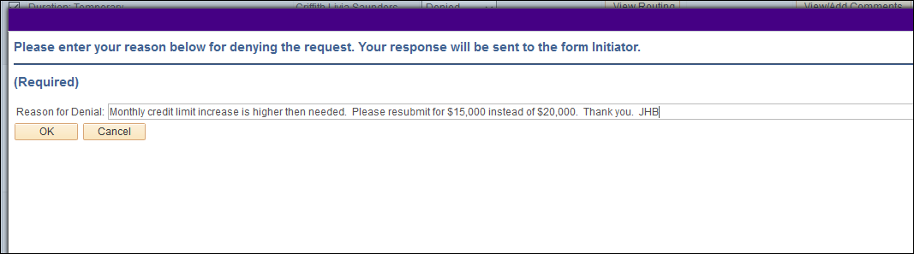
If the approver has several forms to approve and wants to approve them all at once, they would click the Select All hyperlink and the Set Checked to Approve hyperlink at the bottom of the page. This will set all lines to approve at once when the Submit button is clicked.
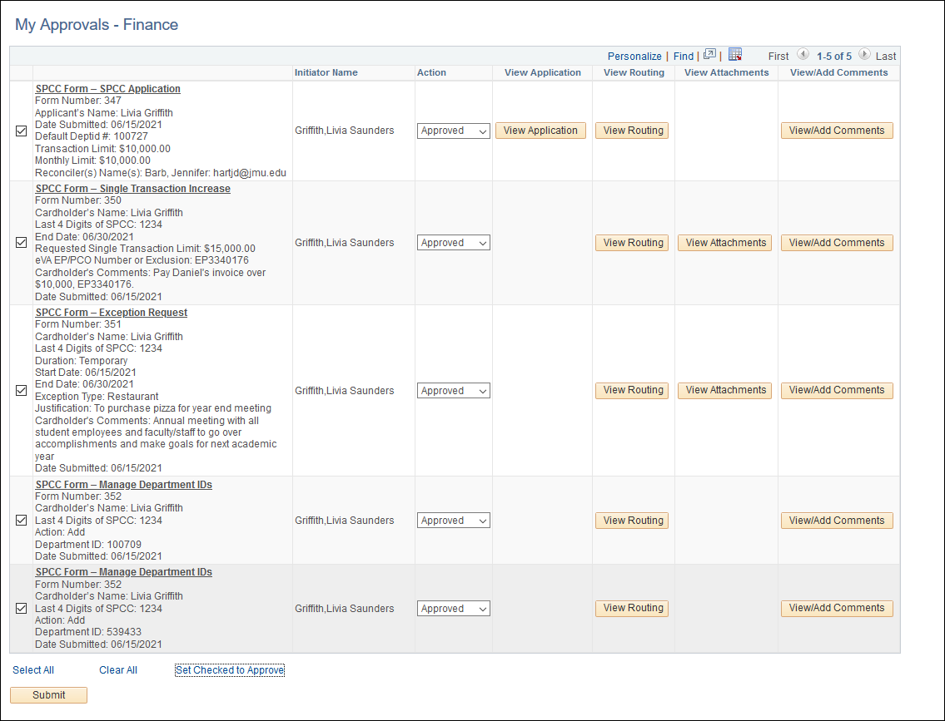

A pop up message will appear for each form confirming you want to approve all the forms (the number of forms you are approving will appear in the box). If everything is correct, the approver would click the Yes button.
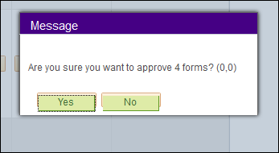

PeopleSoft Finance Approvals

Supervisors who have access to PeopleSoft Finance can also approve forms through PeopleSoft Finance JMU Workflow. Under the Navigator > JMU Applications > JMU Workflow > SPCC > Approve Forms
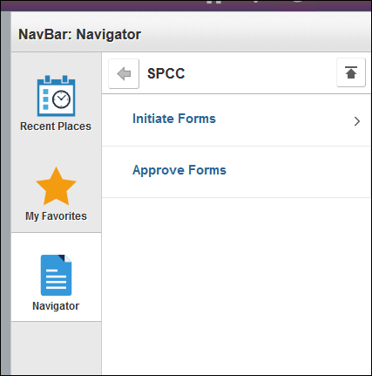

The Approve Forms Page will come up.
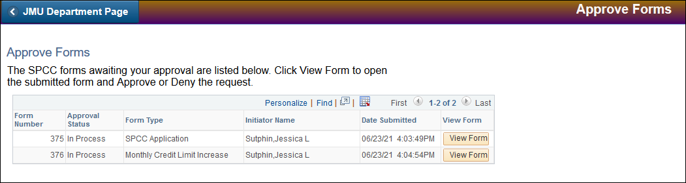
On each form, click the View Form button in order to view and approve.
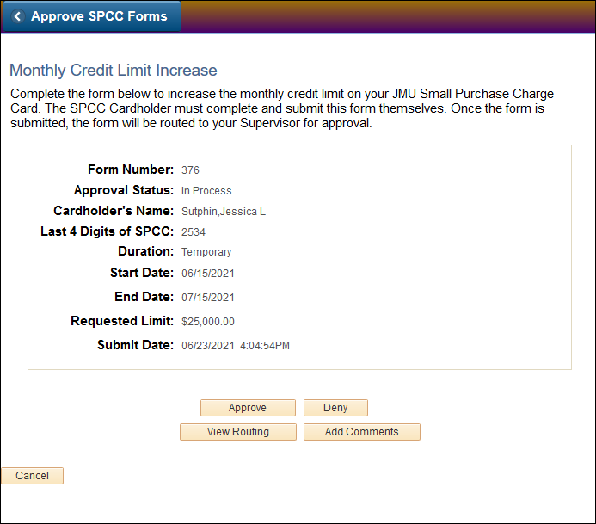
After reviewing the form, you can choose to approve or deny the form depending on your decision. You can also view the routing and add comments for the cardholder and Finance.

Approve
You will choose the Approve button. A pop-up box will come up to confirm you want to approve the form. If you choose yes, the form will be approved and moved to the next routing approval.
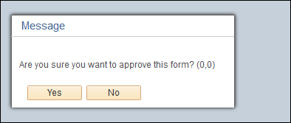
Deny
You will choose the Deny button. A pop-up box will come up to confirm you want to deny the form. If you choose yes, an additional box will come up requiring you to put in a reason for denial. You must type a reason and hit the OK button.
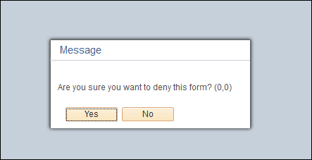
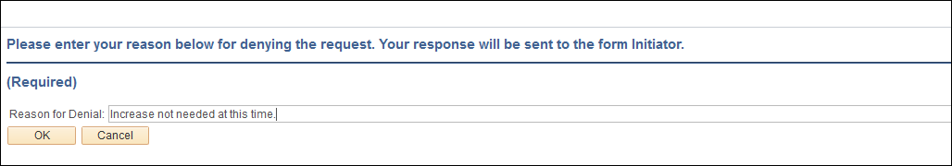

Contact Information

Cash & Investments: appa@jmu.edu (Departmental mailbox monitored during business hours)
SPCC Program Administrators:
Jennifer Hart Barb 568-7396 hartjd@jmu.edu
Racheal Estep 568-6771 esteprm@jmu.edu
Kristin Johnston 568-8061 john32km@jmu.edu
Tish Leeth 568-3205 leethtc@jmu.edu

