**Using Your SPCC on an Order:**

The Pcard/SPCC is not defaulted “on” and you cannot see it immediately on the Requisition.  This is not a bug, but a different way the new system is designed.

**How to add the SPCC to an eVa order:**

On every requisition you should navigate to the “Pcard” icon cid:image001.png@01D8EF98.54CA9660 on the left side navigation.  A new page will appear that includes a drop down to “select applicable Pcard”.

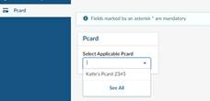

Select your Pcard.

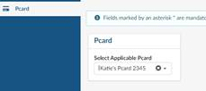

Pcard is now selected.  If the box is empty, you have not selected to use your Pcard.  Once you’ve selected your Pcard you can go back to complete the requisition process by clicking on the Purchase Requisition icon cid:image007.png@01D8EF99.82FDB750 on the left side navigation.  If you get into the habit of checking it each time it will help to ensure you don’t forget to use your Pcard as needed.

If your pcard is not submitted through eVa for a vendor who accepts the SPCC you can always call the vendor to pay for the order.  Please remember you are never permitted to fax, email or mail your card number to a vendor.  It is very important during this transition period you are reconciling your SPCC in a timely manner so you are aware if a vendor has not charged your SPCC and you expected them too.  If you would receive an email from Accounts Payable with an invoice you can pay by SPCC, please contact the vendor to pay by SPCC and reply to the email from Accounts Payable letting them know the invoice was paid by SPCC.

For SPCC questions please email [appa@jmu.edu](mailto:appa@jmu.edu) and for eVa questions please email [askeva@jmu.edu](mailto:askeva@jmu.edu)

# Managing your SPCC in eVA

This section covers the process of loading your SPCC, deleting your SPCC, updating your SPCC, and the workaround for associating your SPCC with other users. This section will also cover how to use your SPCC on requisitions. Please note that you can only load an SPCC assigned to you in your eVA account. Adding another card holder’s SPCC into your eVA account is a violation of policy.

## How to load your SPCC to eVA

1. Click the **YOUR NAME Icon** and in the dropdown menu, click **My Profile**

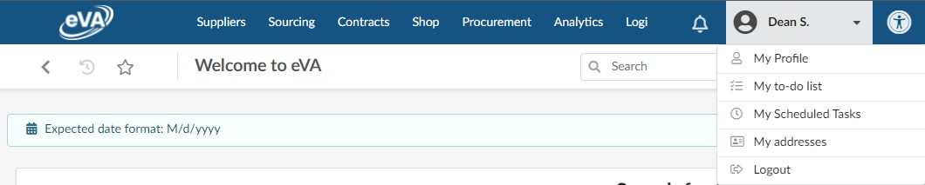

1. From the Profile Management page, scroll down the Pcard Info section, click **Add Pcard**

The PCard Manage pop-up window will display. Enter all the details as appropriate.

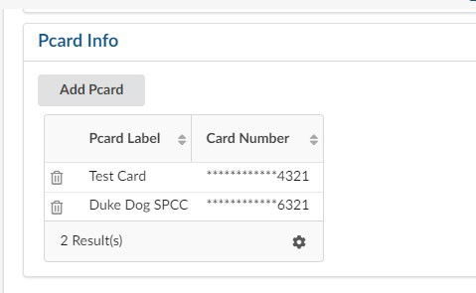

* + Pcard Label – This is how the SPCC will be displayed (*Formerly PCard Alias*)
  + Card Provider – Click in the field and select **Visa**
  + Name – Enter how your name appears on your SPCC
  + Card Number – Enter the card number as it appears on your SPCC (without any spaces)
  + Expiration Month – Enter the card’s expiration month
  + Expiration Year - Enter the card’s expiration year

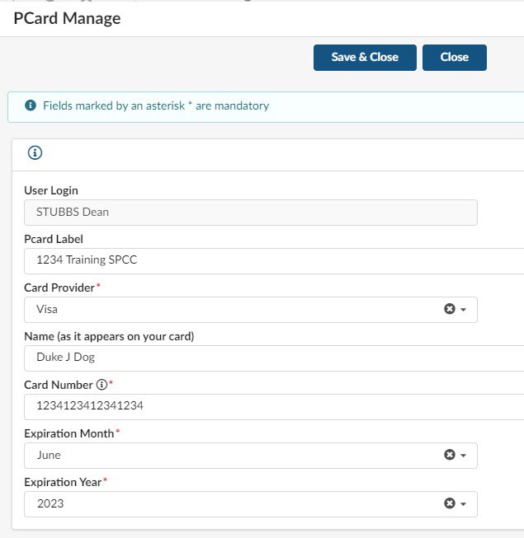

1. At the top of the Pcard Manage pop-up window, click **Save & Close**

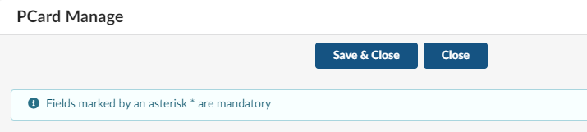

1. Your SPCC will now be available for use on requisitions immediately. You may need to refresh the Profile Management page to see the card you just added.

## How to update and remove your SPCC

After you have added your SPCC into eVA there is no longer a way to edit the information, such as the expiration date. You will need to delete the existing card and re-add it.

1. Click the **YOUR NAME Icon** and in the dropdown menu, click **My Profile**



1. From the Profile Management page, scroll down the Pcard Info section, click the **Trashcan icon** next to the Pcard label of the card you want to remove.



1. A confirmation pop-up window will display. Select **OK** to delete the card. The card will be deleted immediately.

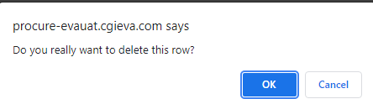

1. If you needed to update the card you just deleted, you can now re-add the card. See How to load your SPCC to eVA for the process.