**Financial Procedures for Short-Term Programs**



International Accounting

James Madison University

2026

# **Table of Contents**

1. **Introduction**

International Accounting (IA) 4

Center for Global Engagement (CGE) 4

**II. Operating Procedures**

Budget 5

Contracts & Leases 5

General Ledger (PeopleSoft) 5

Travel Pre-Approvals (PA) 6

Family Member/Travel Companion Expenses 6

Rental Vehicle 6

CISI Insurance 7

Pre-payments-

Bank of America Program VISA Card 7

Wire Transfer or ACH 7

Payments with Check 8

Credit Card Purchases 8

Airfare 8

Transportation to and from Airport 8

Lodging 8

Supplies, Books, Equipment 9

Pre-Departure/Post-Program Meals 9

Director Meal Allowance 9

International Phone Service 10

Payment of Expenses While Abroad-

Bank of America VISA Card 10

Dynamic Currency Conversion 11

Cash Advance 12

Retail Payments 12

Personal Credit Card 12

Non-Allowable Program Expenses 12

Receipt Details 12

Refunds/Reimbursements Collected While Abroad 13

Other Operating Procedures-

Cash Distribution to Students 13

Prepaid Debit Cards 13

Program vs. Personal Funds 13

Ending Program Cash-on-Hand 13

Program Surplus 14

Collection of Student Funds 14

Compensation-

Program Directors 14

Program Assistants & Support Persons 14

Financial Evaluation Form 14

1. **Expenses Abroad**

Excel Workbook Description 15

Expenses Abroad Detail - Instructions 15

Add a Row 16

Financial Report 17

ATM-Bank Fees 20

ATM Cash Withdrawals/Fees 21

Budget vs. Actual Comparison 22

Summary Financial Report Description 23

Summary Financial Report 25

1. **Forms**

Director Meal Allowance 27

Director Cash Distribution Form 29

Student Cash Disbursement Form 30

Budget 31

IAPCC Application 36

Wire Transfer Form 37

Commonwealth of Virginia Bank of America Employee Agreement 38

Request for Program Funds Advance 39

Bank of America WORKS Log-in Procedures 40

Check Available Spend (Balance) 41

Evaluation 42

# **I. Introduction**

The purpose of this handbook is to address the financial practices and procedures related to the financial planning of a successful short-term study abroad program.

The International Accounting (IA) Office and the Center for Global Engagement (CGE) work closely as a team to provide support for the short-term programs. They share the common goal of each short-term program being a successful and fulfilling experience for both the student and the director. See office contacts below**:**

**International Accounting (IA)**

Massanutten Hall, Suite 351, MSC 5705

 Liz Heavner, 8-3479, [heavneek@jmu.edu](mailto:heavneek@jmu.edu)

Beth Cave, 8-7338, caveex@jmu.edu

Ashley Dean, 8-8959, dean2ad@jmu.edu

Sharon Lorimer, 8-6357, lorimesb@jmu.edu

Alana Miller, 8-4517, [milleral@jmu.edu](mailto:milleral@jmu.edu)

Faith Sams, 8-3715, samsfe@jmu.edu

**CENTER FOR GLOBAL ENGAGEMENT (CGE)**

Madison Hall, 2nd floor, MSC 5731, 100 East Grace Street

JY Zhou, 8-7002, zhou9jx@jmu.edu

Katie Sensabaugh, 8-5209, sensabkb@jmu.edu

Angeline McMullin, 8-7599, mcmulja@jmu.edu

Salman Sheikh, 8-5446, [sheikhsx@jmu.edu](mailto:ander5al@jmu.edu)

Lindsey Shantz, 8-4507, shantzld@jmu.edu

Agnes Choi, 8-2662, [choiek@jmu.edu](mailto:choiek@jmu.edu)

The financial aspects of the programs are divided between the two offices. The IA staff supports the **abroad** financial aspects, which include pre-payments to overseas vendors via wire transfer, issuance of the Bank of America Program VISA cards, final budget revisions, and spreadsheet/financial report (excel) training. The CGE staff supports the **stateside** financial aspects, which include the preparation of the original program budget, pre-approvals, stateside purchases, payroll issues, PAR forms, assistance with director travel arrangements, and travel reimbursements. Out-of-pocket expenses should be avoided.

The Short-Term Program Director will oversee all aspects of the study abroad program. Student advising, recruitment, orientation, curriculum development, travel guide, ensuring the living environment is safe, being aware of student needs, student emergency response, financial management of budget and expenditures, and various duties necessary to provide an enjoyable educational experience abroad. It is recommended that the director have first-hand knowledge of the site location.

Who is permitted to lead a program?

Any JMU instructional, adjunct, and A&P faculty member is eligible to apply to lead a short-term study abroad program and be considered the program’s primary director. Program directors must be present on campus for entire prior academic year, attend all required meetings in preparation, and have experience and/or recent travel to site, or be working primarily with a recognized study abroad vendor. Prior to proposing a program, applicants must meet with the Director of Study Abroad to discuss feasibility, safety concerns, proposed courses, and other important logistical items. Please note: faculty who have retired from their full-time position at JMU cannot serve as the program’s primary director, but will still be eligible for co-director, instructional, or assistant positions as long as at least 26 weeks have passed since official retirement date.

# **II. Operating Procedures**

**BUDGET**

The Short-Term Program financial process begins with the creation of a program budget. The budget and all attachments must be presented in the **required format** and should be completed with adequate detail**.** CGE will provide you with the required budget template (**Forms, page 31**) and will assist you in establishing the preliminary program budget. Final budgets are due in CGE no later than the following:

* + - * Winter Term Programs: **November 11th**
      * Spring Break Programs: **February 4th**
      * Summer Programs: **March 24th**

The IA staff will handle budget revisions made after the due dates for the Winter and Spring Break Programs and after April 1st for the Summer Programs. The short-term programs are self-supporting and have limited funds generated by student revenues.

**CONTRACTS & LEASES**

Mark W. Angel, AVP for Finance, is the official JMU signatory for abroad vendor contracts, leases, and agreements. Such documents signed by individuals without authority to do so are invalid. Individuals signing contracts without the authority to do so may be held personally liable for payment to the contractor. Send documents requiring signature to International Accounting via email, campus mail, or hand deliver to Massanutten Hall, Suite 351.

**GENERAL LEDGER (PeopleSoft)**

International Accounting will establish a Local Dept. ID# (800XXX) on the PeopleSoft Finance System for each Short-Term International Program. Tuition and supplemental fees generated for program operation are deposited into the appropriate local dept. ID# and all program expenses will be booked to this specific department.

**TRAVEL PRE-APPROVALS (PA)**

CGE creates an **“umbrella” travel PA memo** in October which will include all programs (Semester Abroad, Winter and Spring Break, Summer Short-Term, and Lifelong Learning programs) traveling abroad. The memo will include the estimated budget amount.

CGE will create pre-approvals (PA’s) in Chrome River, one for each program (not for an individual traveler), based on the estimated expenses, by the end of January (November for Winter Break Programs).

**FAMILY MEMBER / TRAVEL COMPANION EXPENSES**

Short-Term Program Directors who have previously served as an FMIR in a semester length program should understand that there are **significant differences** in how the two types of programs are funded and how they operate. The Short-Term Programs are short in duration and the only funds supporting these programs are those derived from the current group of student participants. Directors and instructors are compensated according to the courses they teach.

The most significant difference relates to **allowable expenses**. Per the CGE S/T Faculty Handbook, family members/companions are responsible for all expenses occurring because of accompanying the program. This means that they are responsible for the payment of their own airfare, lodging, meals, admissions, class fees, and travel expenses. Such expenses are not paid with short-term program funds.

If JMU makes pre-payments that include family expenses, the program must be reimbursed for those costs **prior** to departure. Family expenses incurred while on location and paid for with program funds must be reimbursed immediately after the event has occurred.

The names and status of all non-students accompanying the program must be listed on the Employee Worksheet tab of the program budget. This should include all program assistants, family members, and guests.

**rental vehicle**

**Rental Vehicle Insurance Coverage**: Outside of the territorial USA, individuals are required to purchase LDW and CDW insurance. Plan for this expense in the program budget. Do not book the insurance through the rental car website. It should be purchased when picking up the vehicle in the foreign country.

**What to do if there is an accident or the rental vehicle is stolen?**

The driver must report any accident, fire damage, animal damage or any other damage to the police. This rule applies to minor damages or even to accidents without any involvement of a third party.

Get a copy of the police report – if the police in your country will not respond to the scene of the accident, you should go to the nearest police station to report the incident and obtain a report. This must also be reported, along with the police report, to the rental company. Be sure to get the rental company to provide a document acknowledging the damage.

Pictures of the damage to the vehicle should be submitted to International Accounting and/or CGE within 24 hours of the incident.

Contact the Bank of America Benefit Administrator at 1-800-992-6029 to report damages or theft of the vehicle, regardless of whether your liability has been established. If you are outside of the United States, call collect at 1-804-673-1675. The Benefit Administrator will answer any questions you or the auto rental company may have.

If you do not follow these procedures, you may be personally responsible for any damages that are not paid by the insurance.

**Note:** The rental car company’s LDW and CDW insurance is the primary insurance for damage or theft of the vehicle.

**Refer to Visa.com/business**

JMU has a contract with Enterprise (including National). It is preferred that all programs operating in the United States utilize one of these companies.

**CISI INSURANCE**

Student participants, program directors and instructional faculty, and paid non-teaching program assistants will be enrolled in an emergency medical and travel assistance plan. This is NOT travel insurance. CGE will initiate the enrollment. Directors may increase their insurance coverage and/or enroll accompanying family members at personal expense.

[](http://www.bing.com/images/search?q=money&qs=n&form=QBIRMH&pq=money&sc=8-5&sp=-1&sk=#view=detail&id=43BA2C730043163D1B0536A6ED00631135EE20B7&selectedIndex=341)**PRE-PAYMENTS**

Program directors should notify CGE or IA if deposits or pre-payments are needed. **The minimum required deposit will be sent.** Do not use personal funds for program expenses.

Deposits and pre-payments may be handled as follows:

**Bank of America PROGRAM VISA Card payment to Abroad Vendor (Contact IA)**

Pre-payments may be made to overseas vendors for lodging, meals, transportation, admissions, and other program expenses using the Program VISA Card. Program directors will need to complete the Bank of America card application form to obtain a card. Prior to using the card, the program director must submit a preliminary budget so that the funding limit on the card can be established to cover the amount of the budgeted pre-payments. IA requires an adequate number of student deposits before any pre-payments can be made. The program director will contact the vendor directly to make the payment. Invoices or receipts must be provided to IA to substantiate **all** pre-payments made with the VISA Card. **It is important that you** **know your vendor’s refund/cancellation policy.**

**Wire Transfer OR ACH to Overseas Vendors (Contact IA)**

Program funds may be wired directly from your program’s account (Dept. ID# 800XXX) to the specified overseas vendor. A preliminary budget, detailed **vendor invoice**, and written instructions from the program director are required before a transfer is initiated. The instructions must include **the beneficiary’s account name, IBAN or account number, address, bank name, branch bank address, amount to transfer, SWIFT and Sort Code**. Depending on the country, additional information may be needed. **(Wire Transfer Form, page 37).** Transfers can be made in US dollars or in foreign currency. The director is responsible for verification of invoice details. **It is important that you** k**now your vendor’s refund/cancellation policy.**

**Payments with a Check (Contact CGE)**

Stateside vendor payments can be made via a US dollar check. This method requires a request from the program director, a detailed vendor invoice, and any other information that adequately supports the request.

**Credit Card Purchases (Contact CGE)**

The program director may contact CGE to use a CGE VISA Small Purchase Charge Card (SPCC) to arrange for pre-payments to stateside vendors. Do not use personal credit cards for program expenses.

**Airfare**

Payments for flights cannot be made until CGE has approved the program budget and has confirmed the program will run. CGE will issue a pre-approval (PA) in Chrome River for each program before airfare can be purchased. Directors are required to make flight reservations with a travel agent, not directly with an airline. Once the least expensive round-trip economy class ticket has been selected, CGE will authorize payment. Upgrades to economy-class tickets, i.e. seating assignments, extra baggage, wifi, etc., will need to be paid with personal funds, including any date changes. If making flight arrangements for accompanying travel companions such as family members, the director will need to give personal payment authorization to the travel agent. If traveling before or after program for personal reasons, a cost comparison must be submitted to CGE for airfare. If the amount exceeds the cost for an economy round-trip ticket to the location of the program, the director must reimburse the surcharge. You may use your program VISA card for routine baggage fees. **CGE cannot guarantee reimbursement for flights paid with personal funds.**

**Transportation TO AND FROM AIRPORT**

A JMU vehicle and driver can be scheduled to take directors to and from the airport. Please complete the transportation worksheet and submit to CGE. If you plan to drive to the airport be sure to complete the Personal Vehicle Use Form with JMU Transportation.

**Lodging (including Alternative Lodging: AirBNB and VRBO)**

CGE is committed to developing programs that facilitate access and inclusion of all student groups, including providing access to students from all socioeconomic levels. An important priority is developing affordable programs that minimize the cost for students. Director lodging has a direct impact on cost for students, so CGE encourages faculty to select cost-effective lodging. While directors are allowed in some instances to book lodging up to the full per diem, this is only allowed in cases when a program’s budget can handle the larger expense and/or there are limited options in each location. In situations where lodging is over the per diem or does not meet the criteria listed previously; the program director will be responsible for reimbursing the program. In all cases, if there is an extra per-person expense for lodging for individuals who are not officially part of the program, the program director must reimburse this additional expense. This policy applies to all types of housing involved with study abroad programming.

The University has updated the policy on using alternative lodging such as Airbnb and VRBO. There is a mandatory form that must be completed, **“Alternative Lodging Request Form**”. A comparison of the cost of the alternative lodging versus the cost of a hotel needs to be attached showing the cost benefit to the University, along with the proposed method of payment. The request form should be submitted to International Accounting, along with the cost comparison, links to lodging selected and any back-up documentation, within 14 days prior to booking. IA will then submit the request to the Associate Controller for Accounting Operations and Disbursements for approval. Once approved by the AVP, Finance (or designee: Associate Controller for Accounting Operations and Disbursements) the lodging can be booked.

If you plan to use the program VISA card to book lodging, consult with International Accounting to determine the amount of funds needed on the card.

Directors can plan to travel 2 to 4 days before the program start date and 2 to 4 days after the program end date (based on the official dates provided on the budget worksheet) for a maximum of 8 days. Be sure to contact the owner of the property to ask questions and authenticate the property’s location and existence.

**Supplies, Books, Equipment**

CGE will order supplies, books, and/or equipment in compliance with standard procurement procedures. Items will need to be listed on the budget in the Equipment and Bookstore tab and approved by the Executive Director of CGE. Items like water test kits, flashlights, hand tools, art or craft supplies like paint, canvasses, or glue must be procured through an eVA vendor. Any Amazon purchases will need to go through CGE. **Amazon** is not an approved vendor, though CGE can go through JMU Procurement to request an exception.

Equipment (drones, cameras, and rarely laptops, etc.) purchased with program funds must be returned to CGE. If not JMU will withhold the Director’s pay until the item(s) are returned.

When purchasing souvenir type items for students with program funds, there is a $25/participant limit. Souvenir items include T-shirts, postcards, etc.

The “State-side Purchasing Request” form must be filled out prior to any purchase and submitted to CGE.

**Stateside out-of-pocket expenses for supplies, books, and equipment are NOT reimbursable.**

**Pre-departure/Post-Program Meals**

Contact CGE when planning orientation and/or post-program meals. The use of on-campus facilities is strongly encouraged. Only Aramark food is allowed on-campus. Contact CGE for the prior approval to bring in outside food. Pizza delivery is the exception. Tips must not exceed 20% of the amount before tax and the delivery fee; the total expense must be within the per diem. **Any out-of-pocket expenses without prior approval will not be reimbursed.**

Off-campus restaurant expenses need to be within the per diem per person, and tips should not exceed 20% of the amount before tax. Anything over will not be reimbursed.

Expenses for off-campus, non-restaurant functions, i.e. a barbecue or brunch at the director’s home, are reimbursable with an itemized receipt, up to the allowable per diem rates.

Reimbursement requests should be submitted to CGE within 2 weeks of the transactions or before departure, whichever comes first.

To ensure timely completion of financial reports including any balances, please plan any post-program meals by September 30.

**Program Director Meal Allowance**

Program directors will use the meal allowance budgeted under Director Meals as a meal stipend when they travel, as long as the daily meal allowance does not exceed 50% of the U.S. Department of State meal per diem. This percentage will allow the directors to plan one group meal per week with students and not exceed allowable amounts. With this procedure, directors can opt to receive the funds for meals by direct deposit or withdraw cash while abroad. If electing to have the funds direct deposited, International Accounting will prepare the documentation to have the funds deposited into the director’s bank account. The director will then use personal card or cash to purchase meals. No receipts will need to be kept or submitted. If electing to withdraw cash, the director will sign the meal allowance form rather than keeping each meal receipt. See **Short Term Program Director Meal Allowance, page 27 & Director Meal Allowance Distribution, page 29** for full policy and procedures.

**International Phone Service**

Telephone services are continuing to evolve. The current options are:

* Prepaid eSIM plan
* Purchasing a SIM card abroad
* International phone plan through current service provider

Talk to International Accounting prior to travel to review the best option.

Lengthy periods of roaming will not be reimbursed, roaming must be turned off. Pocket wi-fi devices are available through JMU Telecom.

**PAYMENT OF EXPENSES WHILE ABROAD**

Program funds needed for payment of expenses incurred while abroad may be obtained as follows:

1. **Bank of America Program VISA Card** - used for both point-of-sale and cash withdrawals
2. **Cash Advance** - for cash transactions
3. **Wire Transfers** – to pay large dollar amount invoices
4. **Western Union Retail Payment** – for cash on the ground
5. **Personal Credit Card** –for emergency use only

A detailed accounting of how the funds are spent abroad is the responsibility of the program director and such records must fulfill all **internal and external audit requirements**. Program directors are encouraged to pre-pay as many program expenses as possible to alleviate the need to carry large sums of cash during the program.

**Bank of America VISA Card**

A program VISA Card, issued by Bank of America, will be obtained for each program director and co-director.

The program VISA Card provides an increased level of safety for the program director and added security of program funds, while also giving JMU a viable method in which to deliver emergency financial assistance to the program while abroad. Using this card abroad makes the recordkeeping function more streamlined and efficient and diminishes the potential for co-mingling of personal funds with program funds.

The process to obtain a program VISA card is as follows:

* Every program director receiving a card will need to complete training and sign the application. The training is located at the following link **(Application, page 36)**:

<https://www.jmu.edu/computing/ittraining/e-training/IAPCC/>

* International Accounting will email the link and include program specific information (dept id, dept name, etc.) needed when completing the application after attending the financial procedures meetings.
* Once the application has been completed print, sign and send to International Accounting, by intercompany mail to MSC 5705 or scan as an email attachment.
* International Accounting will review the application, and the IA Manager will sign the application.
* IA will enter the application in BoA Works. Cash & Investments will set up the card and cardholder information in PeopleSoft.
  + Bank of America WORKS ([worksnoreply@works.com](mailto:worksnoreply@works.com)), will send a welcome email to cardholders to log in and create a password. This email will contain the cardholder’s name, email address, and the URL to finish setting up the account.
  + The “Username” will be the cardholder’s e-id and the associated email will be the @jmu.edu address.
  + BoA Works gives cardholders online access to view card activity.
* Cardholders will receive an email from IA when the card arrives and will set up a meeting to pick up the IAPCC card.
* Program Directors will need to call BOA to activate the card. The activation code is 216 followed by your nine-digit employee number. The PIN will also be set up at this time.
* Each program director will be required to sign (1) the Commonwealth of Virginia Purchasing Card Employee Agreement **(Agreement, page 38)** and (2) the JMU Request for Advance to acknowledge the credit limit available to them **(Advance, page 39)**.
* Use of the program VISA Card is restricted to making pre-payments to **overseas vendors** and payment of program expenses while abroad.
* **DO NOT** use this card for stateside program purchases or personal transactions. (Goods that are purchased stateside, such as books, equipment, reference items, and miscellaneous supplies **must** be coordinated with CGE).
* International Accounting will set the credit limit according to the program budget.
  + IA will plan with each director the funds needed abroad based on the “Expenses Abroad” category total from the budget.
* The available credit on the card declines as the funds are spent, cardholders will need to track their spending.
* Program cash abroad may be obtained by ATM withdrawal or by a cash advance inside the bank.
* **DO NOT** zero out the card at end of program. At least $50-$100 should be left for any transactions that still may need to be posted.
* International Accounting will reconcile the expenses to program’s local dept. ID# 800XXX once the program has concluded.

**Dynamic Currency Conversion (DCC)**

All charges on the program VISA card should be processed in each country’s local currency with conversion taking place at Bank of America. Merchants may offer to convert foreign transactions to US dollar values. This is very costly to your program. **When possible, avoid Dynamic Currency Conversion**.

ATMs are now using Dynamic Currency Conversion as well. If given the option, select to process the transaction in foreign currency. It is recommended to use ATMs attached to a bank rather than ATM kiosks. Kiosks target tourists. If a cash withdrawal is processed in USDs, be sure to get a receipt or record the amount of foreign currency withdrawn in your cash book.

**Cash Advance**

Programs requiring a US dollar cash advance must submit the request to International Accounting **at least 30 days** prior to departure. The advance funds will be deposited directly to the director’s bank account and the director will then withdraw the cash from their bank to take abroad.

Carrying large amounts of money presents many security concerns. Travelers are advised to limit the amount of cash on their person. Each country has an established limit of funds that can be transported abroad and those funds must be declared. Funds above the limit may be seized. In addition, you may face restrictions or taxes. The IA office will assist each program with obtaining any cash required up to the allowable limit of that country.

**Retail payments**

International Accounting has the ability to send cash via Western Union. IA can schedule cash to be sent to Western Union locations in various countries. The program director can then pick up cash in country.

**Personal Credit Card (Emergency use only, avoid if possible)**

**Do not use personal funds for program expenses.**

If an emergency arises, contact IA immediately. IA will work with directors to ensure funds are available as soon as possible. If needed, a personal credit card may be used on behalf of the program in emergency situations. CGE will submit the receipt(s) to JMU Accounts Payable through Chrome River. Reimbursement is not guaranteed.

**NON-ALLOWABLE PROGRAM EXPENSES**

**Additional improper/disallowed public funds expenditures are itemized in the JMU Financial Procedures Manual sections 4205.321 and 4215.372, and on the JMU Accounts Payable website. Program Directors will be required to reimburse the program for improper expenditures.**

* Do not purchase alcohol with program funds.
* Student or director medical expenses should be paid by the individual. If program funds are used for this purpose, the individual is responsible for full reimbursement to the program.
* Purchase of gifts and flowers is considered an improper use of public funds per State and University procedures.
* Items from the JMU Bookstore must be listed on the program’s budget “Equipment and Bookstore Items” tab and approved by the Executive Director of the Center for Global Engagement. There is a $50.00 cap per item. **(Budget, Equipment & Bookstore Items tab, page35).**
* Avoid making loans to students except in emergency situations.
* Do not purchase personal toiletries (i.e. shampoo, conditioner, toothpaste, deodorant, etc.).
* Amazon purchases.

**RECEIPT DETAILS**

* All expenses must be supported by adequate documentation. If submitted for reimbursement at JMU, would it meet the approval of the State of Virginia?
* Itemized receipts must be submitted with the completed Financial Report.
* Credit card receipts alone are not considered adequate documentation. Obtain actual receipt details.

**REFUNDS / REIMBURSEMENTS COLLECTED WHILE ABROAD**

All refunds/reimbursements collected while abroad must be recorded on the Financial Report worksheet. They should be recorded as a credit within the category from which the expense was originally made, the net effect on category expenses being zero. Refunds may be collected from vendors, students, non-student guests/visitors, etc. and become part of the program’s cash fund rather than a deposit into the bank account.

All program related payments should be made, and any account credits or refunds should be collected while abroad. It becomes very difficult to settle such matters once the program director has returned to JMU.

**OTHER OPERATING PROCEDURES**

**Cash Distribution to Students**

Cash disbursements are often made to students by program directors. This allows the students to pay for individual meals, city transportation, or cultural events/tickets during the program. Such disbursements require a **signature from the recipient**, disbursement date, amount distributed, and purpose. A cash disbursement template has been created to assist in recording this activity. For ease of use while abroad, the template may be prefilled with names of student participants prior to departure. Plan cash allowances in whole amounts (10-20) for ease of handing out funds. **(Student Cash Distribution Form, page 30).**

**PrePaid Debit Cards**

Vendors that accept cash as payment are decreasing, and fewer ATMs are available. To assist directors in giving students their meal allowances more effectively, International Accounting has been utilizing prepaid debit cards. In lieu of handing out cash to students for their allowances, those funds can be loaded on the cards. The funds can be scheduled in several increments during the program. Students will be able to use the prepaid cards abroad. This will reduce the need to visit ATMs multiple times.

**Program vs. Personal Funds**

**Do not co-mingle program and personal funds**. Do not use personal funds to pay for program expenses. If personal funds are utilized for program expenses, the Director/Assistant should be reimbursed immediately from program funds to maintain an accurate balance of available program monies. If program funds are utilized for personal expenses, the program should be reimbursed **immediately** after the event has occurred. Otherwise, those funds are no longer available for use on behalf of the program or students. Appropriate documentation is required in both instances. Use the Program VISA Card for program expenses abroad and not your personal credit card.

**Ending Program Cash-on-Hand**

All foreign currencies on-hand, other than British Pounds or Euros, should be spent on the students or exchanged for US dollars prior to your return. Otherwise, Program Directors will be **required** to purchase all other foreign currency. The number of coins returned should be limited as traveling with a large number of coins is difficult.

**program surplus**

Short-Term International Programs may carry forward a maximum balance of $2,000 from year to year. There will be no student refunds.

**Collection of Student Funds**

Directors should not collect cash from students for added program related activities. The budget should account for all activities.

**COMPENSATION**

**Program Directors**

Payroll for Short-Term Programs is handled by CGE. Two-thirds of the salary for Program Directors will be processed during the program, in up to four consecutive disbursements. The final one-third payment will be released upon satisfactory completion of the Director’s financial responsibilities. Such responsibilities include the timely and accurate submission of the Financial Report as well as the settlement of all financial obligations abroad. The holding of the remaining third of salary also applies to co-directors and/or program assistants who are assigned a program VISA card. (Inform CGE of any alternate compensation sources (i.e. departmental or grant funding).)

Directors and instructors are compensated according to the courses they teach, Short-Term Programs do not have an option for a Director’s fee.

**Program Assistants & Support Persons**

Compensation for all program support persons and assistants will be handled stateside through the **JMU Payroll** department. Program Directors will work with CGE to initiate the payment process prior to leaving the country.

Categories have been established to define the varied program support roles. This has been done to promote consistency in compensation throughout the programs and to be in compliance with IRS regulations. CGE will determine, with input from each Program Director, the proper classification of **all persons** traveling with their program. See details on **Budget, Employee Worksheet tab (page 34)** and in the CGE S/T Faculty Handbook.

Cash wages must not be paid to U.S. citizens abroad (this includes JMU students). All wages paid to U.S. citizens must be processed through **JMU Payroll**.

The Center for Global Engagement requires each program to have two program staff traveling with the program. If the program has one director and one non-teaching assistant, the one non-teaching assistant can have airfare, lodging, meals, excursions and any other program expenses covered. The non-teaching assistant will also receive a $500 stipend for the full duration of the program. If the program has multiple directors or instructors, the non-teaching assistant compensation will be as listed on the chart on the Compensation Reference tab of the budget and will be responsible for any additional expenses (including airfare, lodging, meals, etc.). If your program has one director and multiple non-teaching assistants, only one assistant may have all expenses included.

**FINANCIAL EVALUATION FORM**

Directors may receive a financial evaluation. This will provide a measure of performance for director’s handling of their program’s administrative and financial responsibilities. It will also provide directors with the opportunity to comment on the existing financial process and offer comments or suggestions for improvement. An electronic copy of the evaluation will be shared with the Program Director, the Executive Director of the Center for Global Engagement and the Director of Study Abroad. Directors will be provided an area to write their comments. The signed evaluation with any comments should be returned to International Accounting.

# **III. Expenses Abroad**

**Excel WORKBOOK Description**

The Excel workbook is a **required reporting format** created by International Accounting. The workbook is to be utilized by all Short-Term Program Directors to record all **cash and program VISA card** expenses. The Expenses Abroad Detail worksheet must be completed in the prescribed format and turned into International Accounting within **two weeks** of the program’s conclusion. The workbook is designed to be user friendly, and when completed correctly, provides the information necessary for inclusion in the University financial statements.

The workbook consists of six worksheets listed as follows: (1) Instructions, (2) ATM-Bank Fees **(page** **21)**, (3) Expenses Abroad Detail – ***Directors enter expenses on this worksheet only* (pages 17-19)**, (4) Budget vs. Actual Detail **(page 22)**, (5) Summary Financial Report **(pages 25-26)**, and (6) IA Use Only.

See pages 17-26 for samples of worksheets #2-5 and instructions for their completion.

All supporting documentation, itemized cash receipts, ATM and currency exchange receipts, credit card receipts with detailed vendor receipts, cash book, cash distribution sheets, and ending cash-on-hand must accompany the report when turned into International Accounting. These records must be legible and have sufficient detail to satisfy both University and State audit requirements. Copies of all completed reports will be maintained in IA. All original reports and supporting documentation will be forwarded to CGE for additional review and subsequent approval. CGE will maintain the original files as the official University record and will serve as a central location for audit purposes.

**Expenses Abroad Detail - Instructions**

This worksheet provides a method by which program expenses incurred abroad can be properly listed and categorized. If initial expense data is entered properly on the worksheet, all foreign currency amounts will be calculated automatically, and the results will update to the appropriate worksheets in the workbook. Cells have been formatted to accommodate foreign currencies, foreign exchange rates, the USD$$ value, USD$$ sub-totals and totals.

**To record expenses, complete the worksheet as follows:**

1. **Date:** Enter as mm/dd
2. **Expense Description:** Enter adequate expense detail. (i.e. vendor name, admission or excursion site, restaurant name, etc.). **Enter only one transaction per row**. To insert additional rows, see instructions on page 16.
3. **Credit Card Expense:** Enter the foreign amount spent on the **program VISA Card**, under the “Credit Card” column. Use the Bank of America bank statement or Bank of America on-line system to obtain the US dollar value of the charge and enter in the USD$$ column.
4. **Cash Expense:** Two columns are available. This allows for a separate accounting of cash spent by program co-directors and/or assistants. Enter the foreign amount in the appropriate column.
5. **Exchange Rate:** Column is used for cash expenses only. Enter the average exchange rate in this column for each cash expense. Weighted average exchange rates are computed on the ATM – Bank Fees worksheet. **(Instructions and worksheet on pages 20-21).**
6. **USD$$ Value:**
   1. **Cash Expenses** - Column contains a formula to automatically calculate the US dollar value of each cash expense when both a foreign amount & an exchange rate is entered on the worksheet.
   2. **VISA Card expenses** - Director must enter the exact US dollar amount as shown on the Bank of America on-line account activity or bank statement. (*This will overwrite existing formula in that cell*).
   3. **US dollar receipts** -Director must enter the exact US dollar amount as shown on the receipt. (*This will overwrite the existing formula in that cell*).
7. **USD$$ Sub–Total:** Calculates totals per category automatically. ***Do not enter data in this column.*** Values will automatically compute in this column and update to “Budget vs. Actual” worksheet **(page 22).**
8. **Category Totals:** Total expenses for Instruction, Auxiliary, and Academic Support categories automatically calculate using the USD$$ sub-totals from each individual expense category. ***Do not enter data on the total lines.***
9. **Total Expenditures Abroad:** (1) “USD$$ Value” total is calculated by adding all expenditures listed in the USD$$ Value column. (2) “USD$$ Sub-Totals” for Instruction, Auxiliary (student), and Academic Support are added together in the Total Expenses Abroad row in order to calculate the total abroad expenses. Totals from (1) and (2) will reflect the same amount if expense data has been entered correctly. ***Do not enter data on these total lines.***

**NEED TO ADD A ROW?**

To insert a new row, right-click on a row number, then click on “Insert” from the pop-up menu. A new row has now been inserted. Next, highlight a row within the same category, right click then click on “Copy” from the pop-up menu. Highlight the added row, right click and click on “Paste”, and hit the Enter key. This will add the formats/formulas to the new row. Enter expense data as usual.

IMPORTANT!

**Avoid inserting a row above the first row or below the last row in a category as this will alter the “total” formula for that category.**

**Expense report page 1**



**Expense REPORT Page 2**



**Expense REPORT Page 3**



**ATM – BANK FEES**

1. **Average Exchange Rate**: Using your Bank of America bank statements and on-line account activity, record all ATM cash withdrawn on the ATM Cash Withdrawals worksheet. List both the foreign amount and the US dollar value of each withdrawal. Complete a separate column for each cardholder. List withdrawals in date order.
2. The ATM Cash Withdrawals worksheet will automatically compute the total cash withdrawn for all cardholders and will calculate a *weighted average exchange rate* based on the amounts entered in the worksheets. Enter this calculated rate for each ***Cash Expense*** listed on the Expenses Abroad Detail tab **(pages 17-19).**
3. **ATM Fees**: Enter any ATM fees incurred per month, per card on the ATM Fees worksheet to calculate the monthly ATM fee totals. (**Page 21)**. Enter total fees calculated per month, per card, on Expenses Abroad Detail worksheet.

**ATM Cash Withdrawals/Fees**



**bUDGET vs. ACTUAL COMPARISON**

This worksheet will provide a comparison of **budget** numbers to **actual** program expenses abroad. This comparison, shown in both foreign currency denominations and in US dollars, provides a way to monitor the program’s financial status per category on an ongoing basis. The “Budget vs. Actual” worksheet will update automatically each time an entry is made to the “Financial Report” worksheet.

IA will enter all budget numbers once budget is finalized. For all other data, this worksheet is formatted, and formulas are established which allow all computations to occur automatically.

“Category Totals” and “Total Expenditures” should agree to those same totals reflected on the “Expenses Abroad Detail” worksheet.

Data contained in the **“USD$$ Actual”** column automatically updates to the Summary Financial Report “Abroad Expenses” column **(page 25)**.

***DO NOT ENTER EXPENSES ON THIS SHEET***



**SUMMARY FINANCIAL REPORT**

**Directors do not enter expenses on this sheet.**

The **Summary Financial Report** worksheet provides a comprehensive financial picture of each S/T Program upon conclusion. All financial activity during the program, including pre-payments and stateside expenses, is reported on this worksheet. (**Pages 25-26**).

1. **Page 1** reflects the **total financial activity** of each Short-Term International Program. The report is divided into multiple sections with the revenue and expenditure sections being presented in columnar format. Revenues are recorded as being collected stateside or abroad, while expenses are recorded based on where the monies are spent: Stateside Expenses (JMU PeopleSoft), Pre-paid Abroad Expenses (wire transfers or check), or Abroad Expenses (cash or credit card). Within those three columns, expenses are further categorized based on their purpose.
2. **Page 2** is where all program equipment is to be listed. The equipment information will be forwarded to JMU Plant Fund Accounting (Fixed Assets) for inventory and tagging purposes.
3. Explanation of the Form:

* **General Program Information**
* **Program Revenues**
* “Total Revenues Collected” refers to the amount of tuition and program supplemental fees paid to the University Business Office by the students.
* “Balance Forward Prior Year” refers to the program balance on hand at 7/1/XX.
* “Plus: Reimbursements/Other” refers to funds collected **stateside** other than student tuition and supplemental program fees.
* **Program Expenses**

Current expenditures must be included in this section for the report. All program expenditures should be classified as **Instructional**, **Auxiliary** (Student), or **Academic** **Support** (Administrative**)**. IA will enter the amounts for all Stateside and Prepaid Abroad Expenses.

* + - “Stateside Expenses “(JMU PeopleSoft) refers to those expenses that are both incurred and paid stateside.
    - “Prepaid Abroad Expenses” (Wire Transfers or Check) refers to those expenditures that have been prepaid by JMU on behalf of the program for goods/services to be delivered or performed abroad.
    - “Abroad Expenses” refers to expenses that are actually incurred and paid by cash or with credit card while on location abroad, as well as all pre-payments made using the program VISA card. **This is the section that details the expenditure of funds that have been advanced to the director for this purpose**. The accounting of the expenses reported here is the sole responsibility of the program director. Such records must contain adequate detail to conform to University and State audit requirements.
* **Net Surplus/(Deficit)**

“Net Surplus/ (Deficit)” is the ending program balance. This amount, plus/minus adjustments for cash-on-hand or out-of-pocket expenses to be reimbursed, should balance to the program’s general ledger account (JMU PeopleSoft). **Program Directors must provide a reasonable explanation of any deficit or excessive surplus. Any program cash-on-hand must be returned promptly to International Accounting.**

* **Equipment on Hand**

Section will list all equipment on hand at start of program giving a full description of item, date of purchase, purchase price, and current location.

* **Equipment Purchased**

Section will list all equipment purchased/to be purchased during the current program giving a full description of item, date of purchase, purchase price, and current location.

* **Review dates and signatures**

The Expenses Abroad Detail report is due to IA within **two weeks** of program conclusion. The Program Director will sign and date the Summary Financial Report after review and approval by IA.

**SUMMARY Financial Report PAGE 1**



**SUMMARY FINANCIAL REPORT PAGE 2**



# **IV. Forms**

**Director Meal Allowance**

**DIRECTOR CASH DISTRIBUTION FORM**



**Student Cash Distribution form**



**SAMPLE**

**Budget (page 1)**

**Budget (page 2)**

**Budget (page 3)**

**Budget (page 4)**

**Employee worksheet**

**Budget (page 5)**

**Equipment & BOOKSTORE ITEMS**

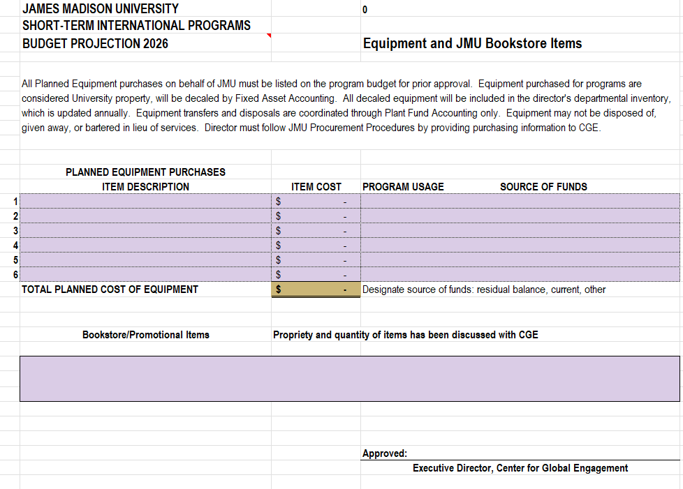

**IAPCC Application**

**Wire Template**



**Cardholder Agreement**

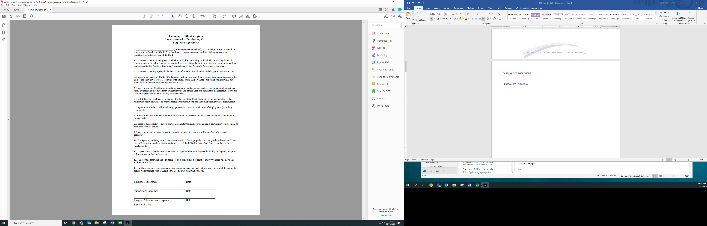

**Request for Advance**

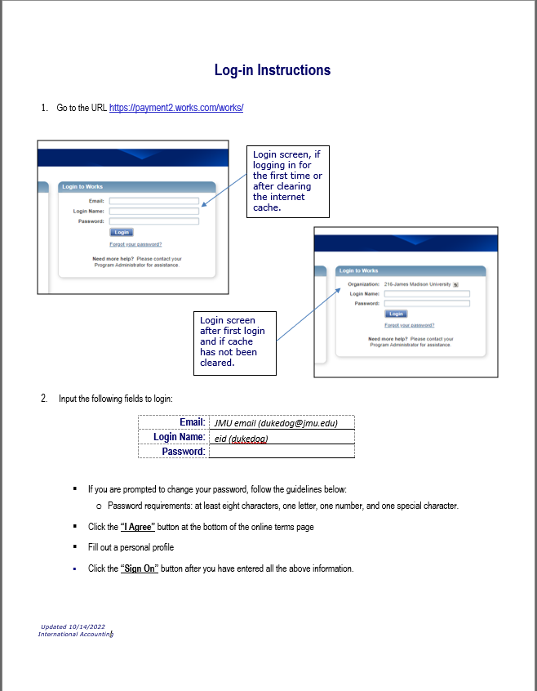**BOA LogIn Procedures**

**Financial Evaluation (page 1)**

**Available spend (Balance)**

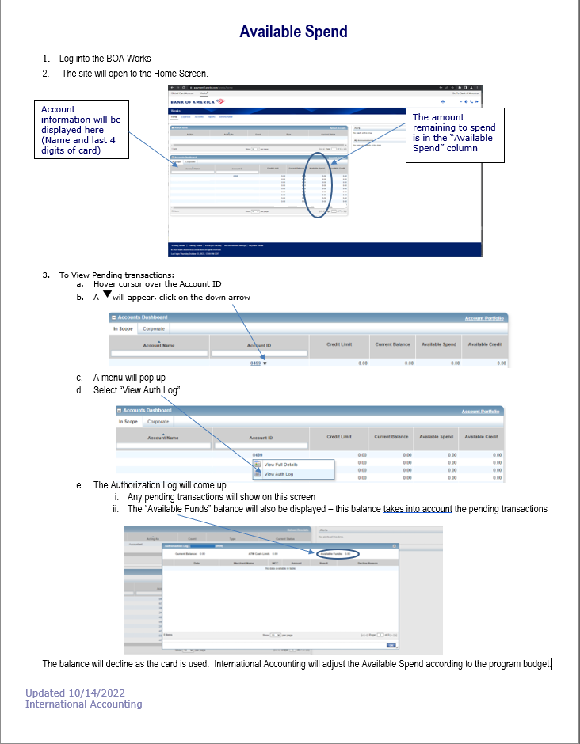

**Financial Evaluation (Page 1)**

**Financial Evaluation (page 2)**

**Financial Evaluation (Page 3)**

