SPCC Cardholder Training BOA WORKS Reconciliation
appa@jmu.edu
Updated: 8/26/2026
Cash and Investments Office
Contact: appa@jmu.edu
BANK of america
WORKS reconciliation
SPCC Cardholder Training Guide

Contents
Overview 2
Bank of America WORKS 2
Reconciliation 3
Reconciliation Dates 3
Home Page 3
Charging one department and account code 4
Charging Multiple Departments or Account Codes (Splitting the Line) 6
Split Coding Transactions that show tax charge 6
Splitting by Amount 7
Splitting by Percent 9
Uploading Receipt Images 9
Sign Off on Transactions 12
Flagged Transactions 14
Reconciling for multiple cardholders 17
Approvals 19
Information to review before approval 21
Approval of one transaction at a time 22
Approval of multiple transactions at a time 24
Flagging a transaction 25
Monthly Reconciliation Report 27
Running Report 27
Filtering Report by Card Holder 31
Filtering Report by Department ID 33
Monthly Budget Report-Batch Date Memo Statement 34
Running Report 35
Contact Information 39

Overview
Beginning January 3, 2022, Small Purchase Charge Card transactions will be reconciled in the Bank of America WORKS system. The reconciliation process will be completely electronic, allowing cardholders to allocate charges, upload receipts and approvers to approve transactions all within the Bank of America WORKS system. Charges will be available to reconcile as soon as the vendor posts the charges to the card. Cash and Investments will process a daily journal to post all transactions that have been reconciled and approved. Every cardholder will have access to WORKS and can assign a proxy reconciler to their card to reconcile charges on the cardholder’s behalf. All transactions will be required to be reconciled within Bank of America WORKS.

Bank of America WORKS

Bank of America’s WORKS system can be found at the following url is Works - Login (https://payment2.works.com/works/home) . For cardholders this assigned when you receive your Small Purchase Charge Card (SPCC). For approvers this is assigned during implementation or when new approver duties are assigned. Reconcilers will have this assigned during implementation or when a cardholder submits a manage reconciler form in PeopleSoft Finance to add a reconciler who has never had this duty before. The system can be accessed anywhere you have internet access.
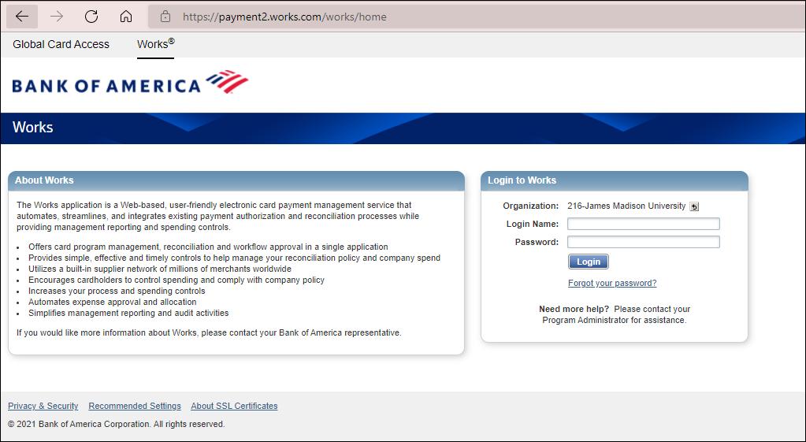

The user sets the password. If you need your password reset, you may contact the Cash and Investments Office at appa@jmu.edu

Reconciliation

Reconciliation Dates
Charges can be reconciled anytime during a billing cycle as soon as they are posted to the card. Any charges available to be reconciled will show under pending. Billing cycles will end around the 15th of each month and all charges need to be reconciled and approved by the 5th of the following month (example charges posted to the April 15th billing statement must be reconciled and approved by May 5th). Charges will be posted within 1-2 business days to departmental budgets once reconciled and approved.

Home Page
When a cardholder logs into WORKS, they will be on their home page. Under Action Items, the cardholder will see how many pending transactions they have to reconcile. Under Accounts Dashboard, the cardholder will see their basic card information including their Account Name (Cardholders Name), Account ID, Credit Limit (monthly), Current Balance, Available to Spend and Available Credit. If you are a reconciler who reconciles multiple cards see page 16, Reconciling for multiple cardholders for a screen shot on how your home page will look.
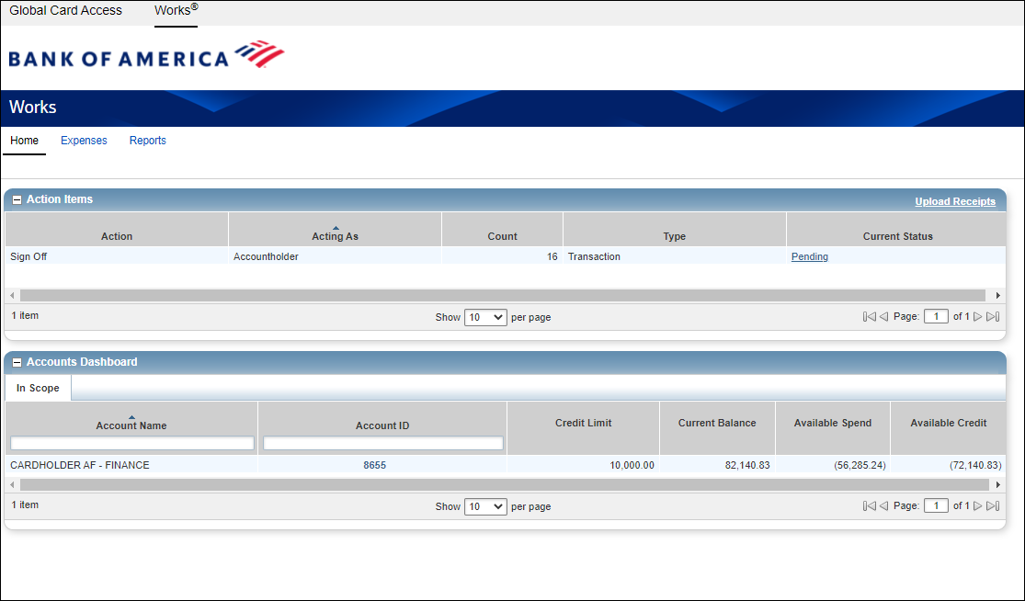

To begin the reconciliation, process the cardholder will click on the hyperlink under current status that says PENDING

Charging one department and account code
Once a cardholder clicks on the pending hyperlink, they will go to the Transactions-Accountholder page. This page will allow them to reconcile their charges.
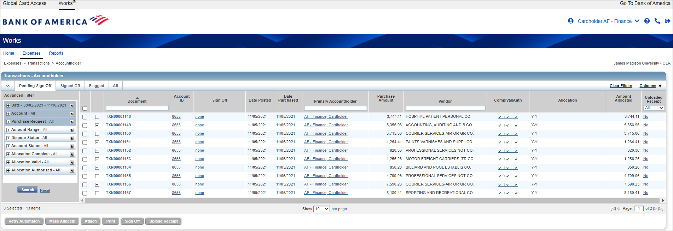
This page shows all the transactions ready for reconciliation. *note only 10 transactions per page is the default. You can change that by clicking on the bottom of the page Show XX per page. You can also scroll through the number of pages you have in the bottom right.
In the Document column, at the end of the document name click the arrow and choose Allocate/Edit. This is where you will enter eVA and expenditure accounting information.
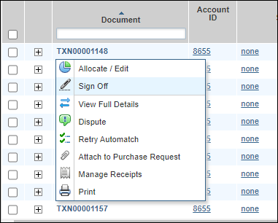
The Allocation Details box will pop up. If you are charging one department ID and one account code, you will complete the following steps:
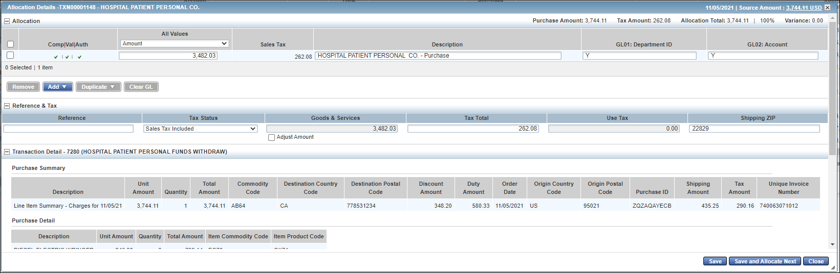
- Under the Description Column, you will need to delete the current description (which is the vendor name) and replace with your eVA information. You will either enter PO (formally EP) and the number, PCO and the number, Exclusion and the number (example for a Point of Sale transaction you will enter: Exclusion 01) or if you have no eVA information you will type in NONE. The line will not save without this information.
- Under GL01: Department ID you can keep your default department or replace with a different one. *All Department ID’s are available on all cards, please be careful to only choose Department ID’s you have approval to charge to.
- Under GL02: Account you will enter the correct expenditure account code.

Once the line is complete you will click the Save button then the Close button at the bottom of the box. If you choose Save and Allocate Next you will be taken to the next line to reconcile.
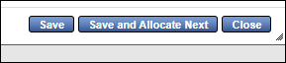

Charging Multiple Departments or Account Codes (Splitting the Line)

Split Coding Transactions that show tax charge
If you have a charge that shows sales tax charged, first make sure your receipt shows no sales tax charged. If the receipt shows no sales tax charged that means the vendor has not charged you sales tax but passed information to Bank of America in the sales tax line. This causes no issues unless you are split coding that line. To make sure your line splits as you intend it to you will need to do the following steps:
In the Document column of Transactions Pending Sign Off section, click the down arrow at the end of the document name and choose Allocate/Edit.
Under the Allocation Details page that pops up, you will see the Reference & Tax section. In the Tax Status field, it may say Sales Tax Included.
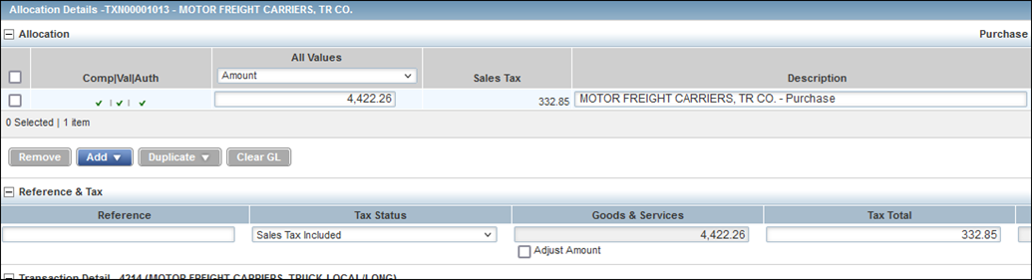

If the transaction shows this and no sales tax shows on your receipt you will need to change this so your charge splits correctly. Click on the down arrow and choose Non-taxable Purchase.
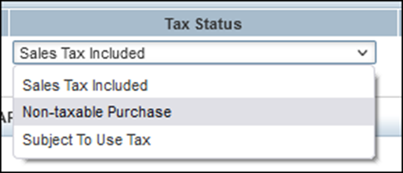
This will then take any information that was in the Tax Total Column and add it to the Total Amount column so you can split the charge correctly. You may now under the Allocation section split the charge however you need to.

Splitting by Amount
You will follow the same steps for resolving split coding to get to the Allocation Details box. If you are charging multiple department ID, Account codes or eVA information you will complete the following steps:
- Under the Description Column, you will need to delete the current description (which is the vendor name) and replace with your eVA information. You will either enter PO (formally EP) and the number, PCO and the number, Exclusion and the number (example for a Point of Sale transaction you will enter: Exclusion 01) or if you have no eVA information you will type in NONE. The line will not save without this information.

You will click on the Add button and choose the number of lines you would like to add. 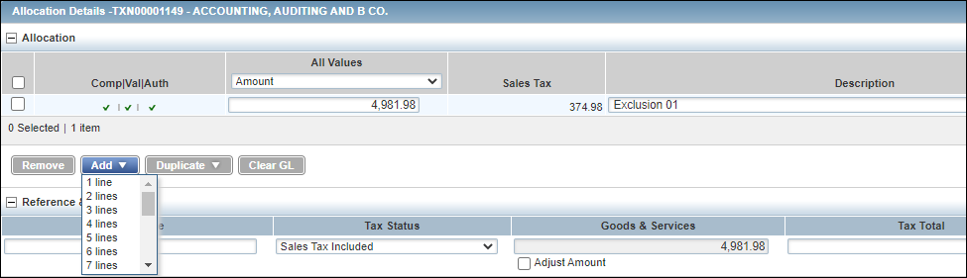

- The number of lines you indicated will be added. You will need to put the amount, description (eVA information), GL01 Department ID, and GL02 Account you want for each line. *note you will need to reduce the amount of the original line by the amount(s) on the new lines. You will see the following error if you try to save the line and the amount does not match the amount of the original transaction.

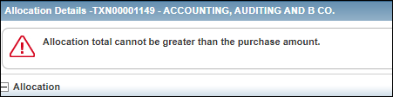

- Under GL01: Department ID you can keep your default department or replace with a different one.
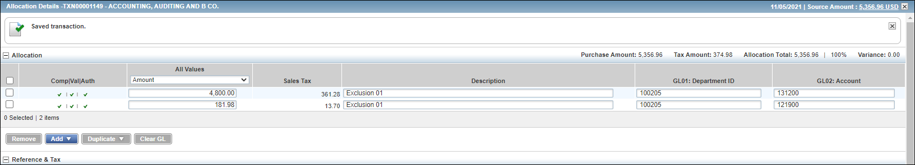
- Under GL02: Account you will enter the correct expenditure account code.

Once the line is complete you will click the Save button then the Close button at the bottom of the box. If you choose Save and Allocate Next you will be taken to the next line to reconcile.

Splitting by Percent
You will follow all the same steps as you did for Spilling by Amount except on the Allocation tab, under All Values columns you will change from Amount to Percent and put the percent in each line you would like to split by. Note the percent amount must add up to 100%.
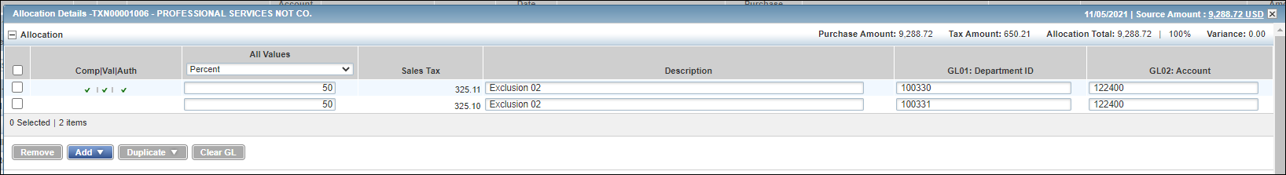
Once the line is complete you will click the Save button then the Close button at the bottom of the box. If you choose Save and Allocate Next you will be taken to the next line to reconcile.

Uploading Receipt Images
Before a cardholder or reconciler can sign off on a transaction to send to the approver you must upload an image of your receipt.
From the Transactions-Accountholder page, click on the No hyperlink under the Uploaded Receipt column.
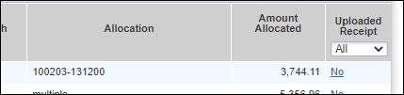

A Receipts Box will pop up, click the Add button and New Receipt
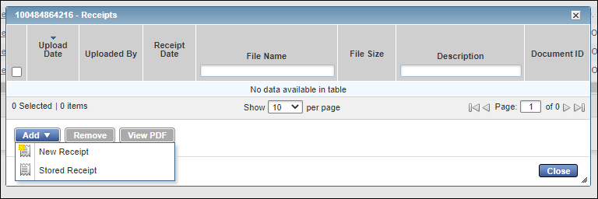
The Add Receipt Box will come up. Under File to Add, you will click the Choose File and navigate to the location on your computer where you have the image saved.
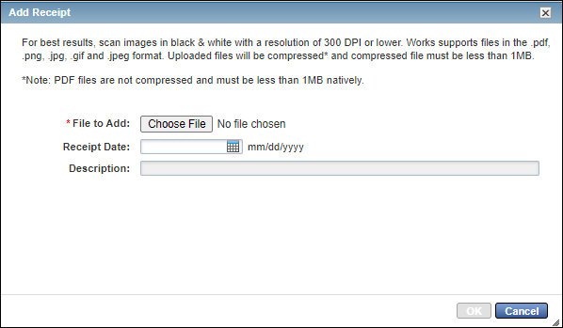
Double Click on the receipt for the transaction
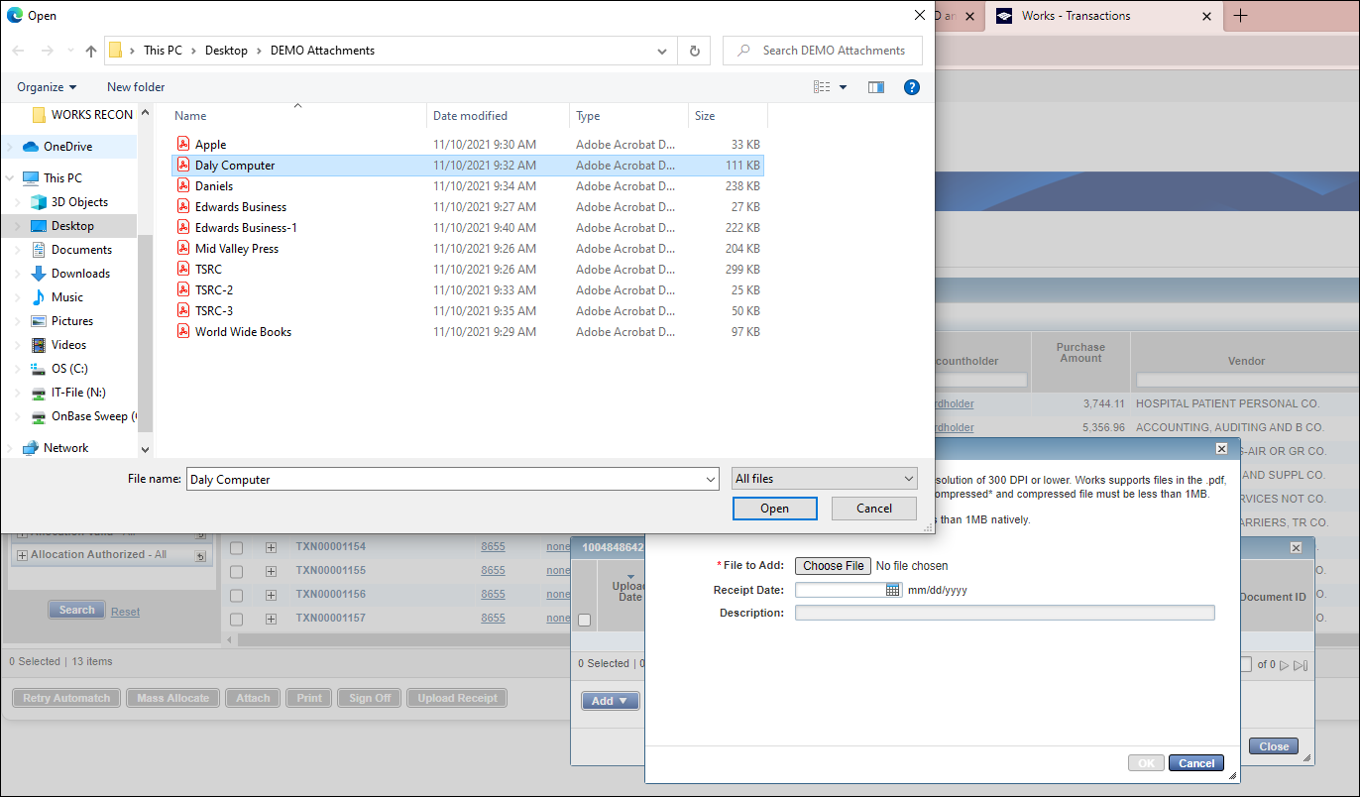
The file will now be added on the File to Add
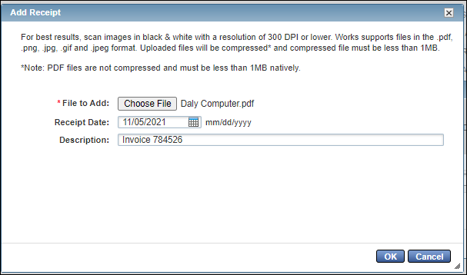
You are not required to add a receipt date or description but you may. Once complete you will click the OK button.
On the Add Receipts Box you will now see the receipt has been added. If you would like to view the image, you may click on the View PDF. 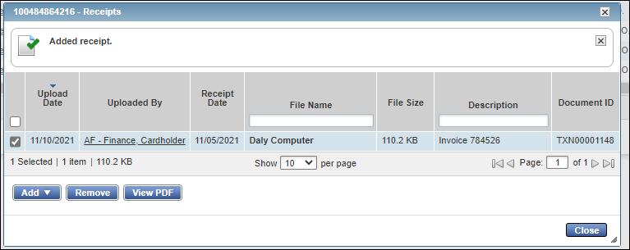
If you have more then one image to add you can click the add button again and go through the same process. Once you are done adding images you will click the close button.
Once an image is succesfully added to a transaction the Uploaded Recipt Column will change to YES.

Sign Off on Transactions
Once you have completed all the lines you will be reconciling at that time you will click on the check box beside the transaction(s).
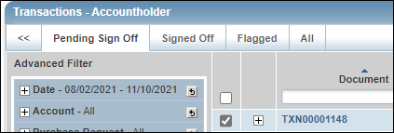
You may sign off on one transaction at a time or do multiple lines at once by clicking on those check boxes.
You will click the Sign Off button at the bottom of the page 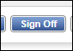

A Confirm Sign Off box will come up, you may enter a comment for the approver if you would like but it is not required, and then click the OK button.
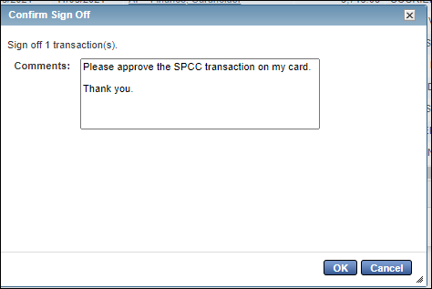
A message will appear at the top of your page letting you know how many transactions you have signed off on. Once signed off these transactions will move to your approver’s WORKS page for them to review and approve. All approvals are completed electronically through WORKS.

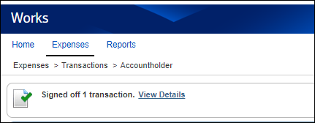

This process can be done at any time during the cycle period once a charge has posted to your card. If a charge is completely reconciled and approved, Cash and Investments will review all documentation before emailing audit requests. If the documentation is complete Cash and Investments will not need to contact the cardholder unless there is a question on the transaction.

Flagged Transactions
If your approver reviews a transaction and finds an error, they can flag that transaction. By flagging the transaction, it sends it back to the Action Items for the cardholder/reconciler to correct. From the homepage of the cardholder or reconciler under Action Items at the top of the page, you will see the Flagged Item. In the Action Column, you will see Resolve and under Current Status, you will see a hyperlink titled Flagged. Click on the Flagged hyperlink to see the transactions.
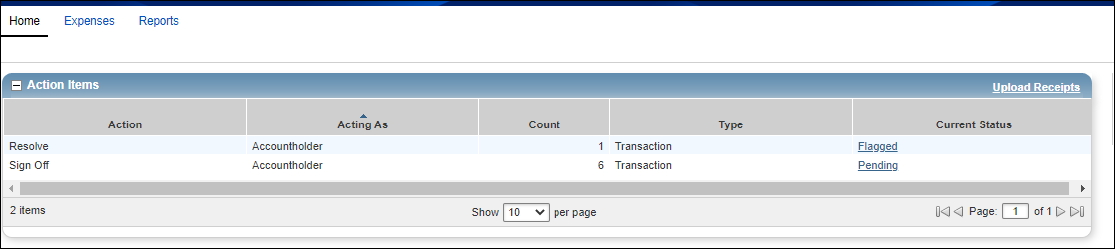
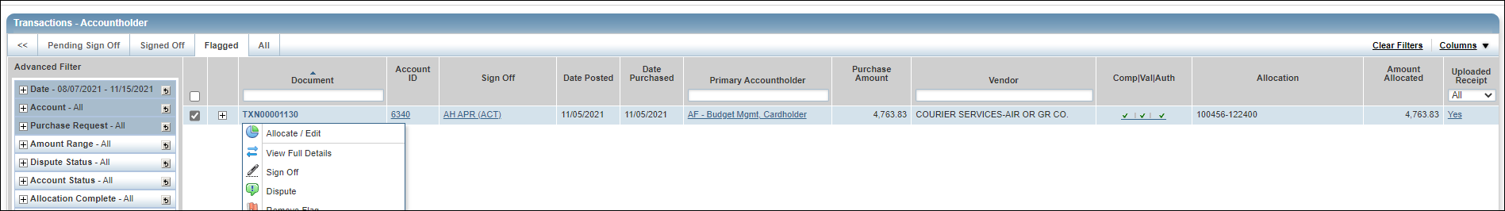
This will take you to the Transactions-Accountholder page and the Flagged tab. In the Document column, at the end of the document name click the arrow and choose Allocate/Edit.
This will bring up the Allocation Details. At the bottom of the page you will see the comment from the approver. 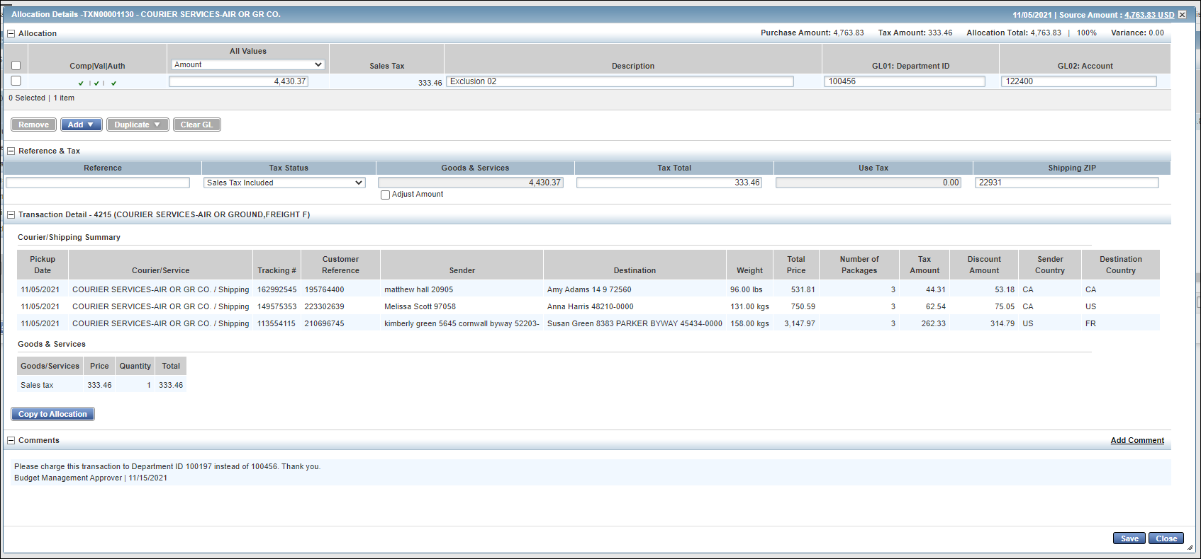

In this case the cardholder or reconciled allocated the charge to the wrong Department ID
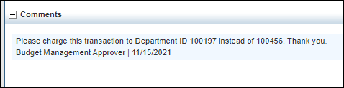
The cardholder or reconciler would correct the issue(s) found by the approver and then hit the save and then close button in the bottom right corner. *Make sure to hit save first so your changes are saved
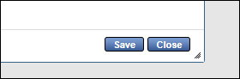
This will take you back to the Transactions-Accountholder page and the Flagged tab. If all items have been corrected you can click the Remove Flag button at the bottom left corner of the page.
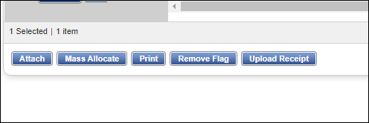
A comment box will come up; it is highly recommended the cardholder/reconciler make a comment letting the approver know of the corrections made then hit the OK button. 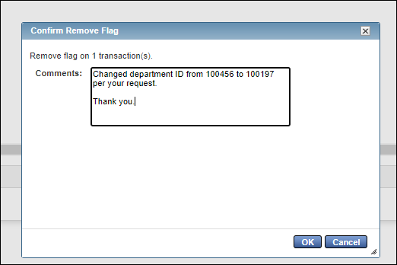
On the top of the page you will see a message box indicating the flag has been removed. This means the transaction has now been routed back to the approver for approval.
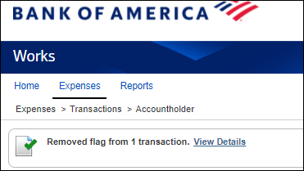

Reconciling for multiple cardholders
If a reconciler has access to more than one card when they log into WORKS they will see all those cards listed under the Accounts Dashboard, these are all the cards the reconciler has access to. If a card is not listed that you need to reconcile, the cardholder will need to complete the Manage Reconcilers form in PeopleSoft Finance.
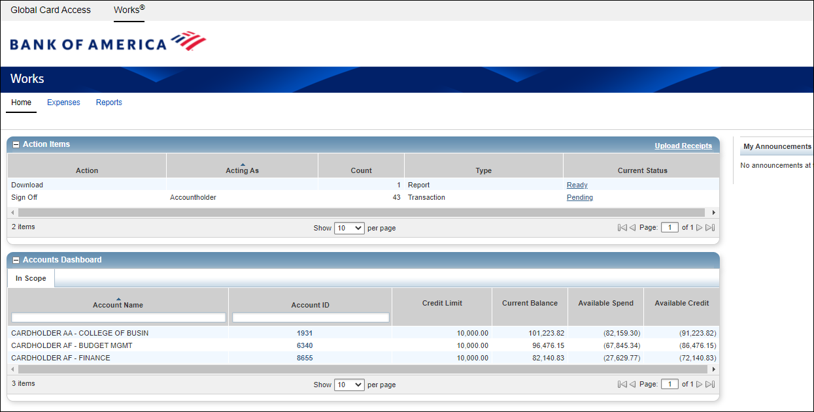
Under Action Items on the WORKS homepage you will see how many Pending Tractions there are to Reconcile and Sign Off on. If you click the hyperlink under Current Status that says Pending, you will see all the pending transactions for all the cards you reconcile for.
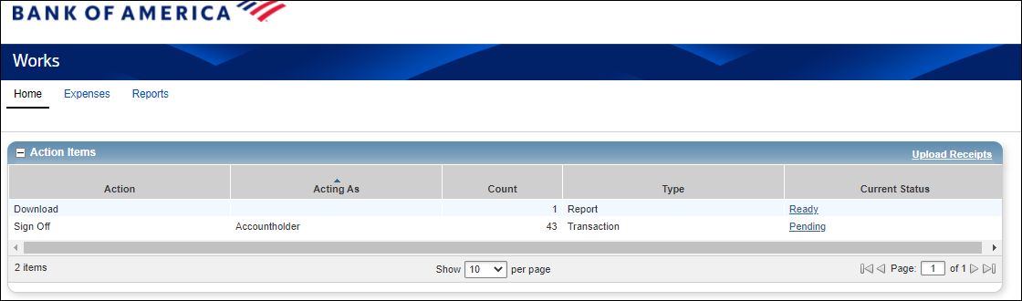

All the charges for all the cards will come in. Each column can be sorted.
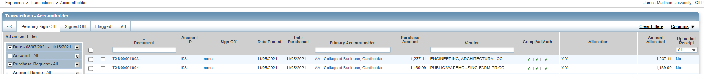
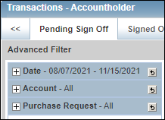
If you would just like to look at one card at a time under Advanced Filters on the left hand side click the + button by Account (it defaults to ALL)

When you click the + button under account there will be a magnifying glass. Click that for a list of all cards you have access to. Click the button beside the card you would like to work with and click the OK button. You will now only see the transactions for the card you indicated.
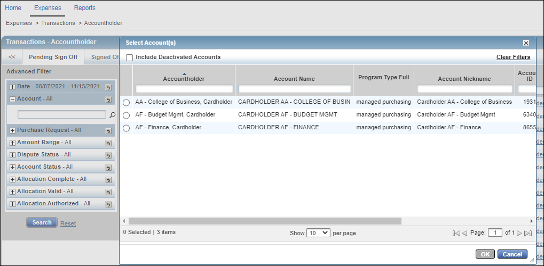

You will now follow the reconciliation process that starts on page 3 for each transaction.

Approvals

Each transaction will need to be approved in WORKS by the person(s) designated during implementation to be the approver on each cardholder’s card. Typically, approvers will be at the administrative level of Dean, Director, AVP, Vice Provost, or higher. In most cases, each cardholder has two approvers assigned to their card. Either has the ability to approve transactions.
Approvers will receive a WORKS user account during implementation or when needed. Daily, approvers will receive an email if they have transactions ready for their approval. Approvers may not proxy other employees to approve transactions on their behalf. If an approver will be out on extended leave please contact the Cash and Investments Office so an additional approver maybe added during the approvers leave.
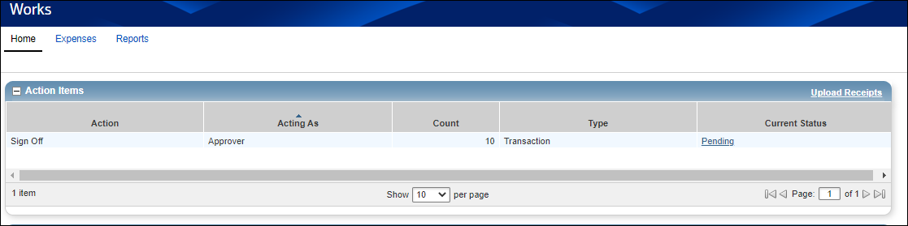
When the Approver logs into WORKS on their home page under Action Items, they will see there are charges waiting for approval. To view the transactions they will click on the Pending hyperlink under the Current Status column.
The Transactions-Approver tab will come up. On this page, the approver will see all transactions awaiting their approval. Each column can be sorted or if an approver would just like to look at one card at a time under Advanced Filters on the left-hand side click the + button by Account (it defaults to ALL) and choose the account they would like to look at.
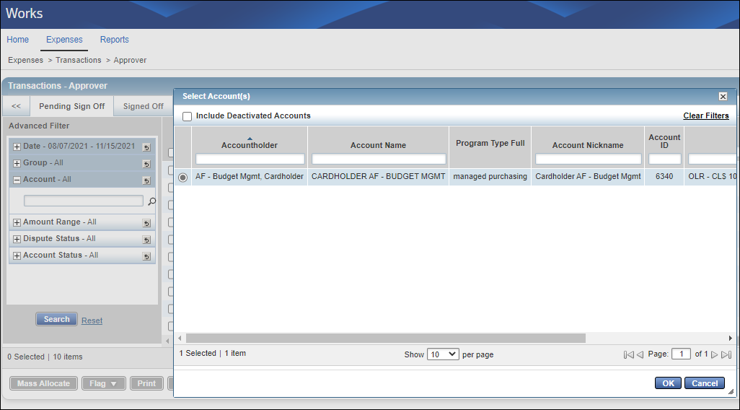
When you click the + button under account there will be a magnifying glass. Click the magnifying glass for a list of all cards you have access to. Click the button beside the card you would like to work with and click the OK button. You will now only see the transactions for the card you indicated.

Information to review before approval
From the Transactions-Approver page the approver can see most of the items needed for approval.
7Your text here
3Your text here
2Your text here
6Your text here
5Your text here
4Your text here
1Your text here

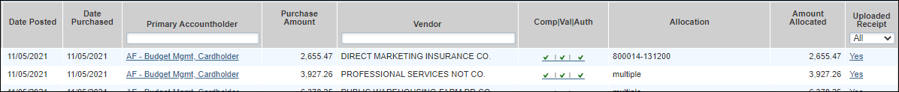
1 | Date Posted | This is the date the transaction posted to the cardholder’s card. It is also the first date the transaction was eligible to be reconciled in WORKS
2 | Date Purchased | Date the transaction was made
3 | Primary Accountholder | Cardholder name
4 | Purchase Amount | The amount of the transaction
5 | Vendor | The name of the vendor where the purchase was made
6 | Allocation | Department Number (first number) and Expenditure Account Code (second number) the charge as been allocated to. If the description says multiple that means more than one department number or expenditure account code was used during reconciliation. You will need to click into the transaction or more details. Instructions on this will begin on page: *Make sure the allocation is correct, department numbers are not restricted by cardholder.
7 | Uploaded Receipt | The hyperlink should also say Yes, click on the hyperlink to view a copy of the documentation submitted with the charge. The approver should assure the documentation matches the charge.

To view additional detail on each charge in the Document column, at the end of the document name click the arrow and choose View Full Details.
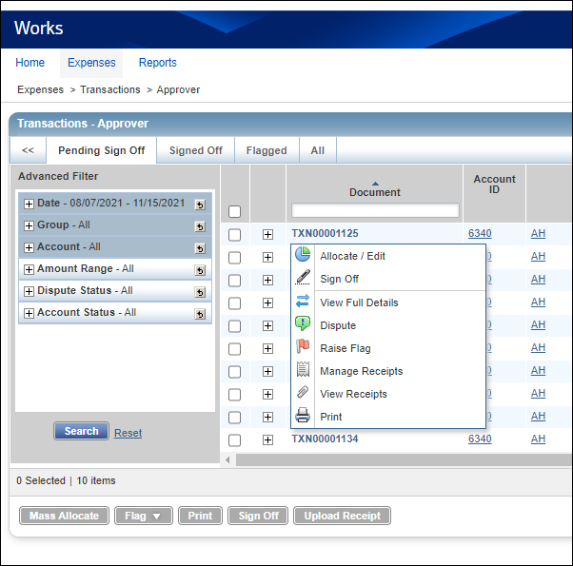
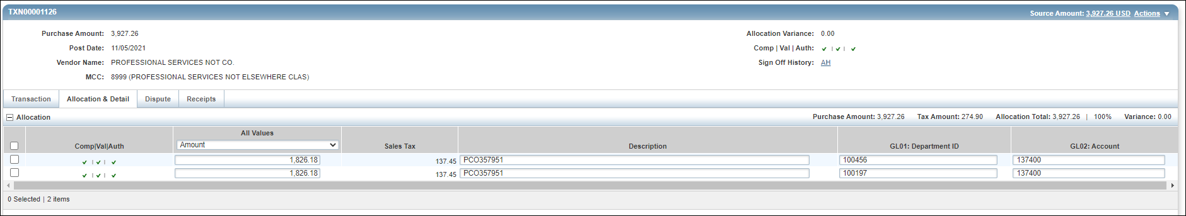
The Transaction Detail page will come up. This page will show the allocation details if more than one Department ID or Expenditure Account Code was allocated to as well as the eVA information in the Description Box. A cardholder must put in the description column either the PCO/PO number or eVA exclusion number. Failure to do this will result in your department being charge a 2% non-compliance fee.
Charges can either be flagged from this page to send back to the cardholder/reconciler to correct information or signed off on (approved). Approvers can also do a mass approval from the Transactions-Approver page.

Approval of one transaction at a time

From the Transaction Details page at the bottom of the page is a Save and Sign Off button in the lower right corner of the page
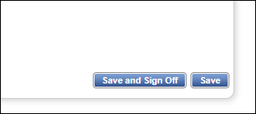
A pop up box will appear, you may add a comment but one is not required. Once you have reviewed and written your comment, you will click the OK button. This will approve the transaction and it will be a transaction that will post to your department budget during the next journal load (typically 1-2 business days). The transaction will be date and time stamped electronically that you have approved.
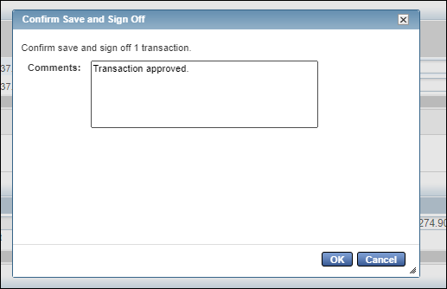
At the top of the page, you will see a note that says the transaction was saved and signed off on.
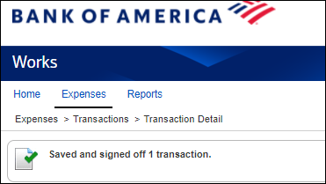

Approval of multiple transactions at a time
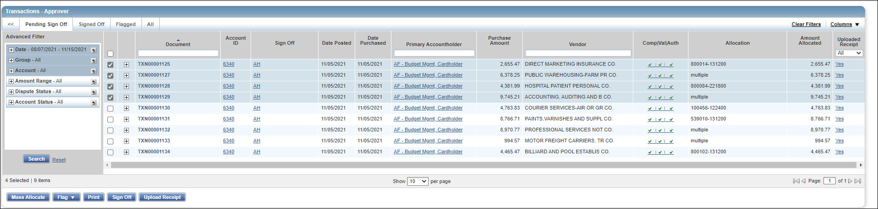
An approver may choose to review the transactions and approve all at one time. From the Transactions-Approver page and the Pending Sign Off tab, the approver will click on the boxes of the charges they want to approve (note if you’d like to approve all at once click the box at the top of the column and it will select all transactions) .
Once you have selected all the transactions you want to approve click the Sign Off button in the lower left corner.
A pop up box will appear, you may add a comment but one is not required. Once you have reviewed and written your comment, you will click the OK button. This will approve the transactions and it will be a transaction that will post to your department budget during the next journal load (typically 1-2 business days). The transactions will be date and time stamped electronically that you have approved.
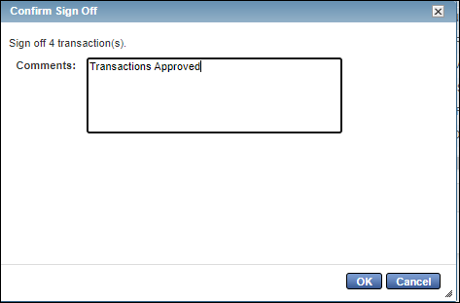

At the top of the page, you will see a note that says the number transaction signed off on.
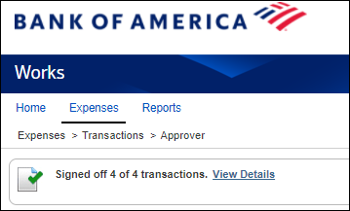

Flagging a transaction
If a transaction you review is missing information or has incorrect information, you may flag that transaction. By flagging the transaction, it sends it back to the cardholder/reconcile to correct the information with a note from the approver. Once the information has been corrected, the cardholder/reconciler may then sign off on it again to send it back to the approver to review and either approve or flag again.
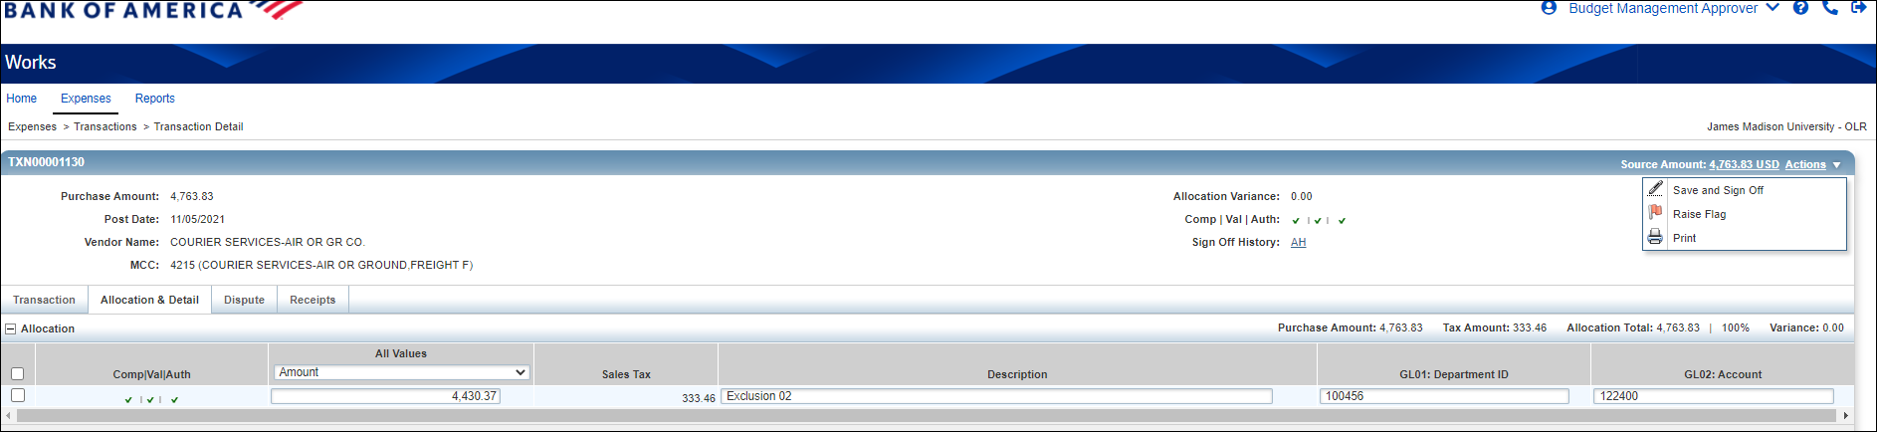
From the Transaction Detail page (see page 16 on how to navigate to this page) in the upper right corner under Actions you would choose the Raise Flag action.

A pop up box to confirm the raised flag will appear. Make a comment letting the cardholder/reconciler know why you are sending the transaction back to them for correction and click the OK button.
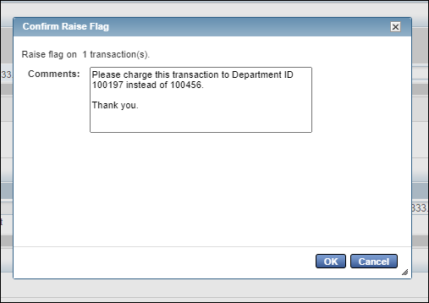
At the top of the page, you will see a note that says you have flagged the transaction.
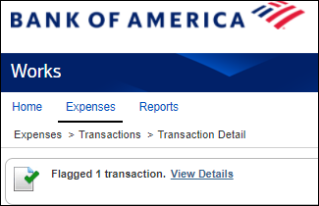

Monthly Reconciliation Report

Monthly, the cardholder/reconciler will run the Memo Statement to keep with your SPCC records. This report must be run after all charges are reconciled for the billing cycle and all charges have been approved. It is required that the report be kept with your SPCC records the for current and past fiscal year. This report will show you the Department ID and Account Number Charged, approval date and eVA information. In the header of the page, you will see the total transactions for the statement billing date. The report is separated by changes in Department ID and Account Code.
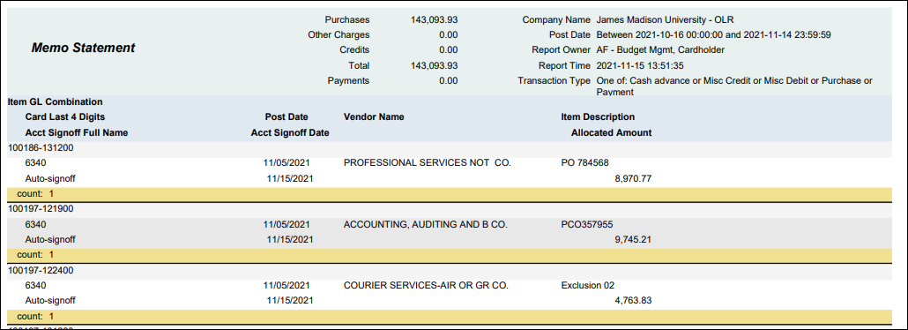

Running Report
From the WORKS report page, you will choose Reports and Create. Category will be Spend and Template is the Memo Statement (not the GL Memo Statement formally used)
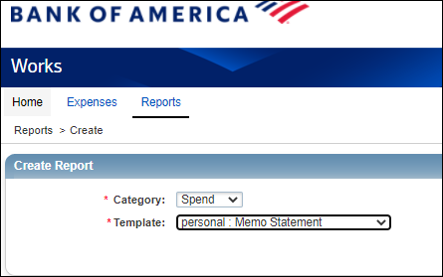

Make sure on Report Options the Advanced button is selected
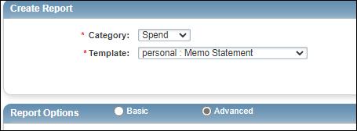
Under filters you will click on the calendar beside Post Date
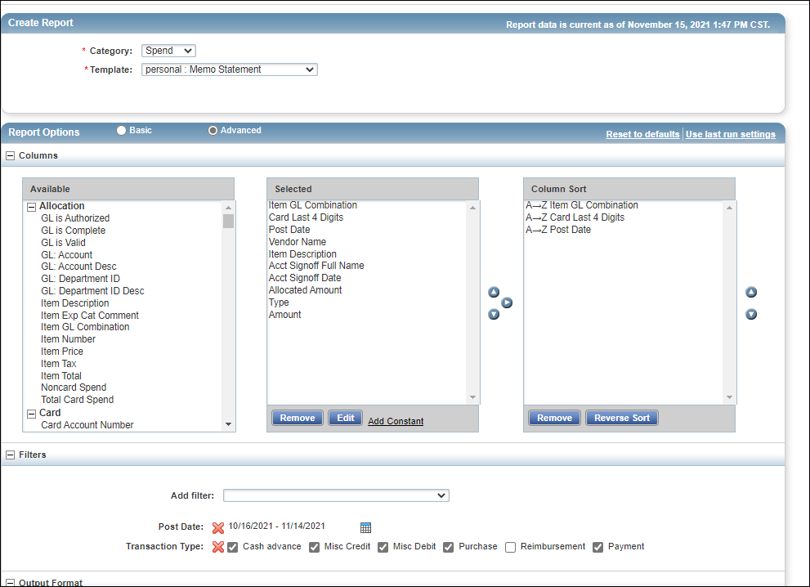

A pop up box will appear. Make sure the bullet beside Previous Cycle is selected and click OK button
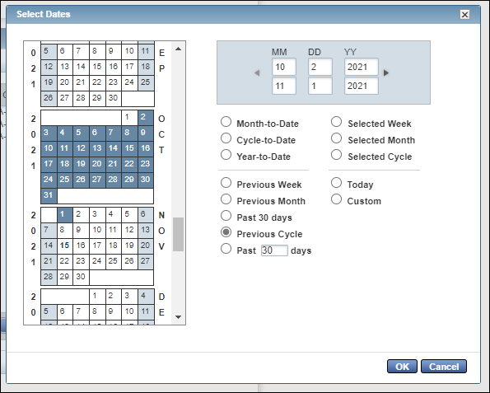
Make sure Output Format is PDF and Full Details (you can choose other outputs but the only output that is considered the official document type is PDF) Scroll to the bottom of the page and click the Submit Report button
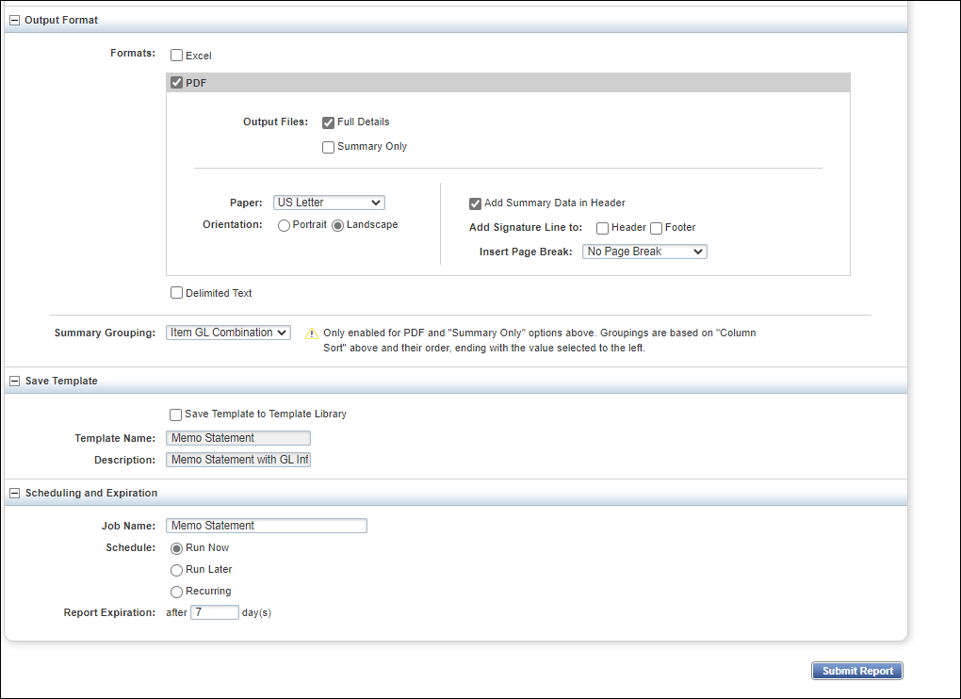
This will take you to the Complete Reports page. When you arrive on this page, the Status will be Awaiting Processing. Once complete the Status will change to Ready (takes about a minute). Click on the PDF hyperlink under Output Type(s) column.
The report will pop up, and you will need to print this report to keep with your SPCC documentation.
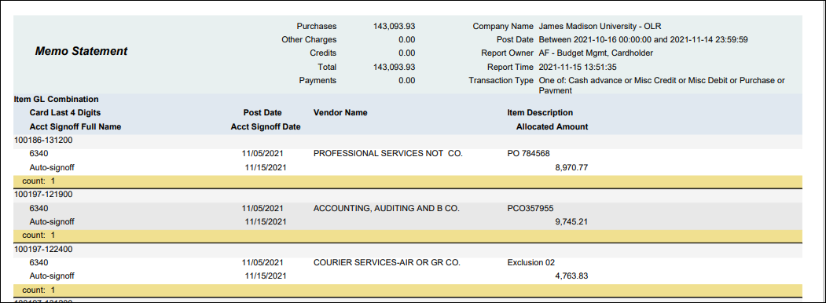
This report needs to be run once all charges are approved for the billing cycle.

Filtering Report by Card Holder

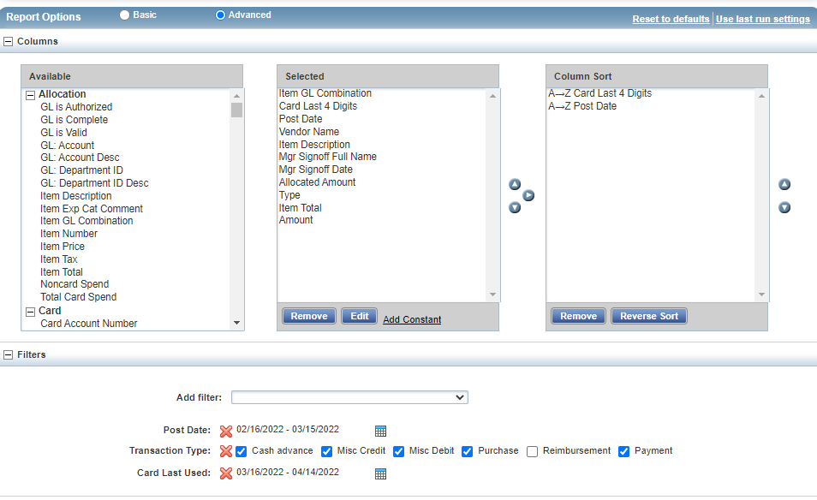
If reconciling for multiple card holders, it may be necessary to run the report by user. Navigate to the Report Options. Click the down arrow beside the Add filter field. This offers multiple options

Select CH Email.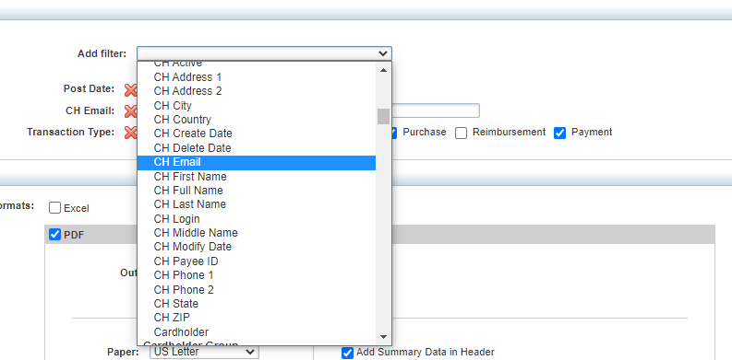
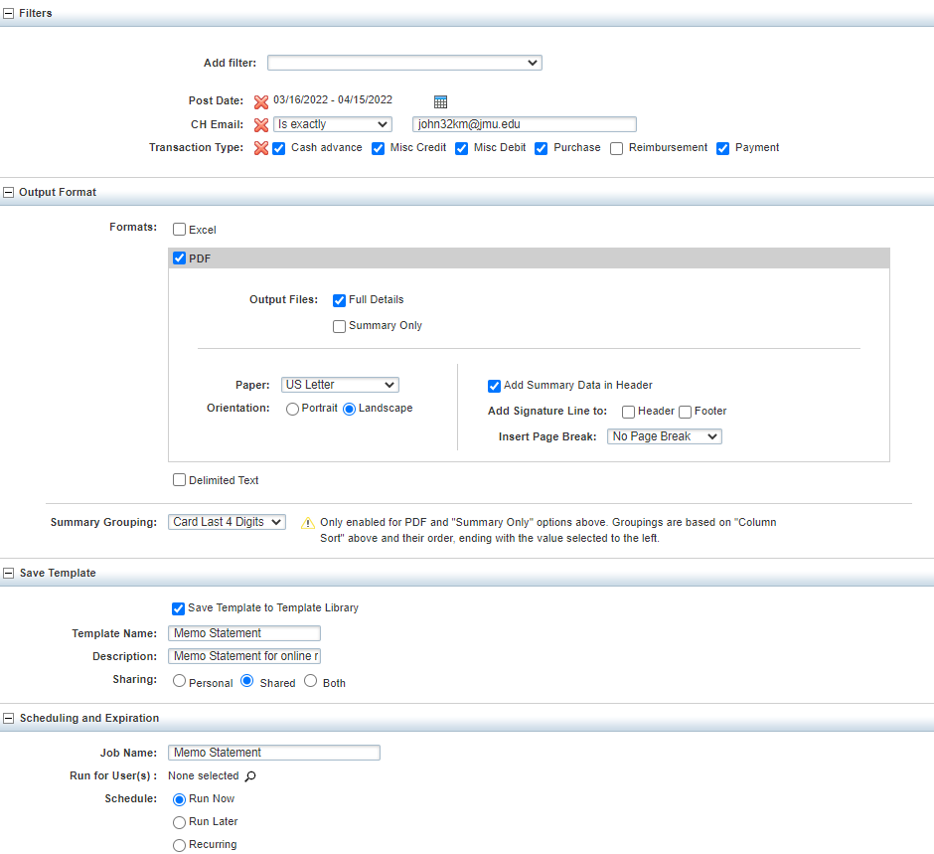
Enter the email of the cardholder in the field. If you would like to save this template so the filter is in place for future report requests, check the box beside Save Template to Template Library and add a name to the end of “Memo Statement” in the Template Name field.

Then select Submit Report to run the report.


If you saved the template, it can be found by selecting it in the Template Library under the Reports tab. Select the template name you chose under the Personal section. This will select your monthly report with the filters that you saved always in place.
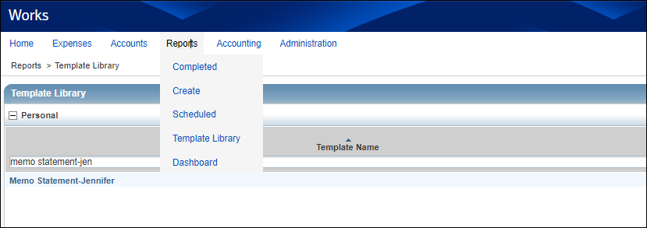

Filtering Report by Department ID
Just like filtering a report by user, Works has the ability to add numerous filters. One that may be helpful is filtering by Department ID. This can be accomplished by selecting GL: Department ID in the Add filter field and entering the ID number in the filter field.
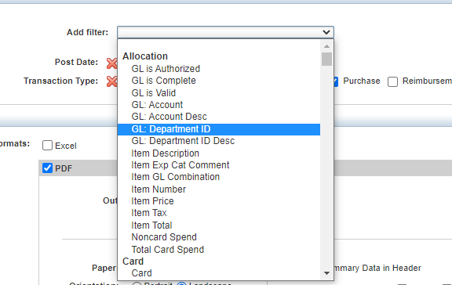

Monthly Budget Report-Batch Date Memo Statement

Monthly, the batch date memo statement can be run to keep with your departmental budget reports. This report will show all transactions posted a department budget by month as long as the person running the report is a reconciler on all cards that may charge the departmental budget. This report can be kept with departmental monthly budget information as the backup for SPCC charges. It is still required that each cardholder keep with their Memo Statement (which is by billing cycle) with their SPCC records.

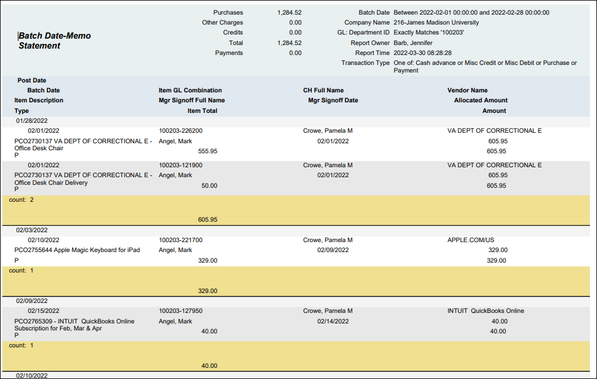

Running Report
From the WORKS report page, you will choose Reports and Create. Category will be Spend and Template is the Batch Date-Memo Statement. Note the first time you run it you must choose in the drop-down box for template “choose from all available templates” then find the Batch Date-Memo Statement in the list.
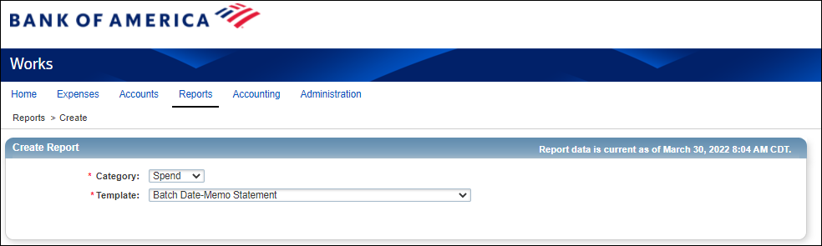

Make sure on Report Options the Advanced button is selected
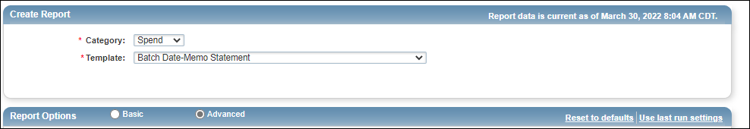

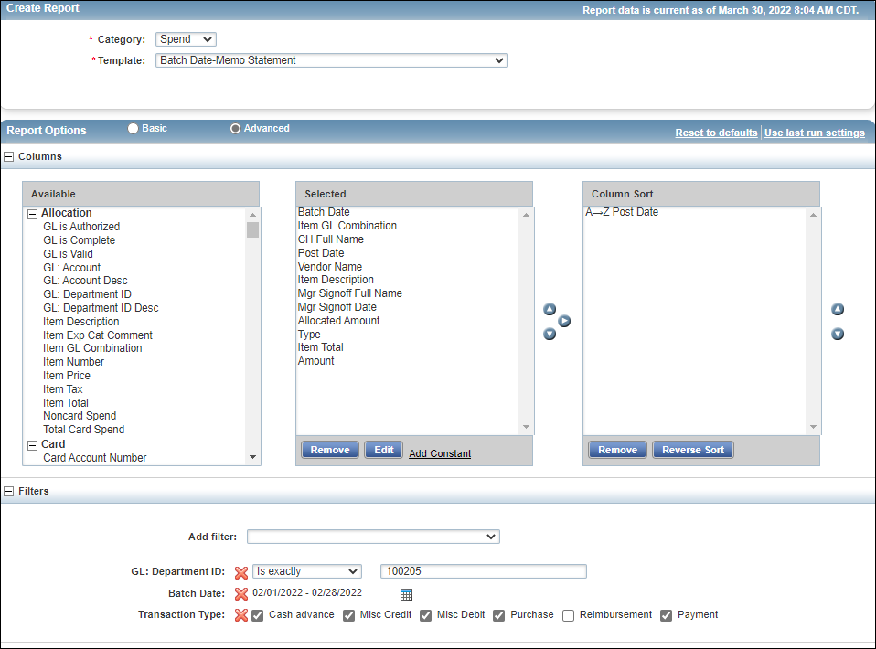
For the department under filters: GL: Department ID: put in the department number for the department you are working with
Under filters you will click on the calendar beside Batch Date

A pop-up box will appear. Make sure to choose custom dates and the dates from the calendar for the month you are working on and click OK button
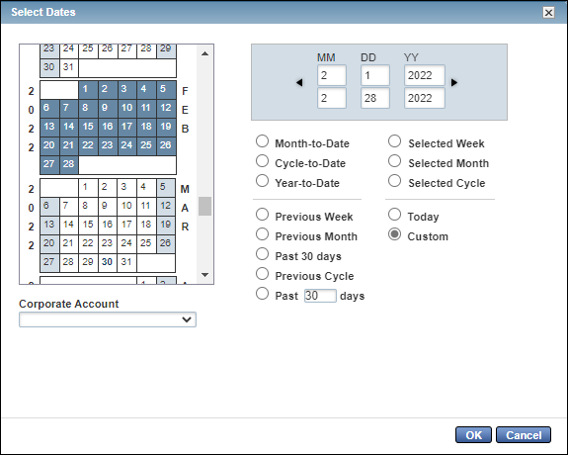
Make sure Output Format is PDF and Full Details (you can choose other outputs but the only output that is considered the official document type is PDF) Scroll to the bottom of the page and click the Submit Report.
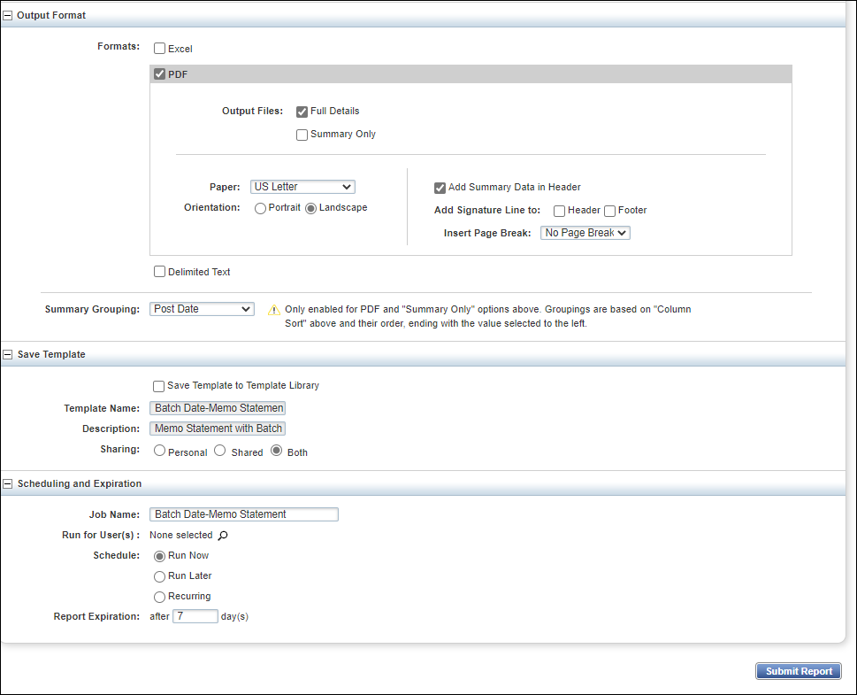
*for budget reconciliation purposes it maybe helpful to run to Excel as well to review transactions*
This will take you to the Complete Reports page. When you arrive on this page, the Status will be Awaiting Processing. Once complete the Status will change to Ready (takes about a minute). Click on the PDF hyperlink under Output Type(s) column.
The report will pop up, and you will need to print this report to keep with your monthly budget documentation.

Contact Information

Cash & Investments: appa@jmu.edu (Departmental mailbox monitored during business hours)

SPCC Program Administrators:
Jennifer Hart Barb 568-7396 hartjd@jmu.edu
Racheal Estep 568-6771 esteprm@jmu.edu
Kristin Johnston 568-8061 john32km@jmu.edu
Tish Leeth 568-3205 leethtc@jmu.edu

