HOW TO GIVE APPROVAL DELEGATION TO ANOTHER PERSON

What is an Approval (Vacation) Delegate? This is a person you give authority to temporarily approve expense and pre-approvals on your behalf while you are on vacation or otherwise unable to fulfill your Chrome River approval obligations. Approval delegation must be granted to an Approving Authority. An email will be sent to you and your approval delegate with notification of this designation. This email notification will include the date range of the approval delegation. You may only have one active approval delegate at a time. All expenses and pre-approvals normally assigned to you will automatically queue up for the delegate to approve. In addition, all approval emails will be sent to the approval delegate.

Note: This will be monitored. No one will be allowed to “permanently” delegate his or her approval authority. Please reference the Financial Procedure Manual (FPM) for additional information regarding Approving Authority’s.

Log into the Chrome River (Emburse Enterprise) application an any web browser by going to the JMU webpage ([www.jmu.edu](http://www.jmu.edu)). Choose Faculty/Staff and IS Applications. Choose Chrome River.

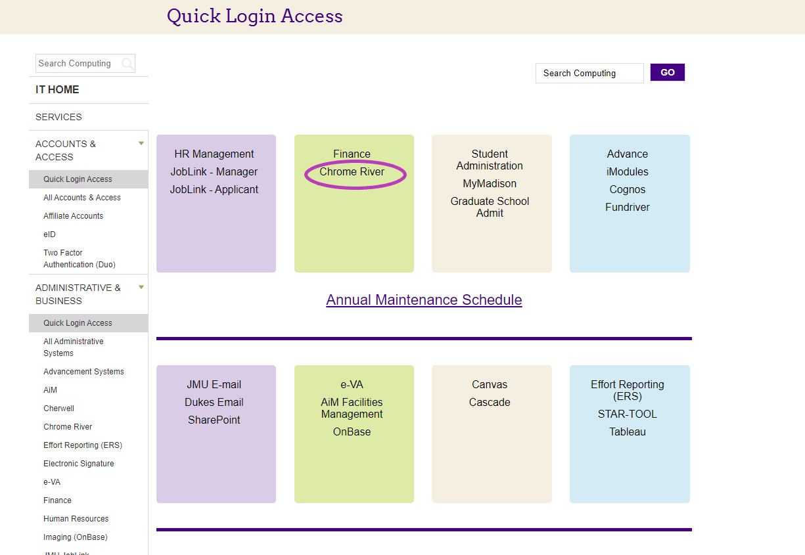

Sign in with your eID and password.

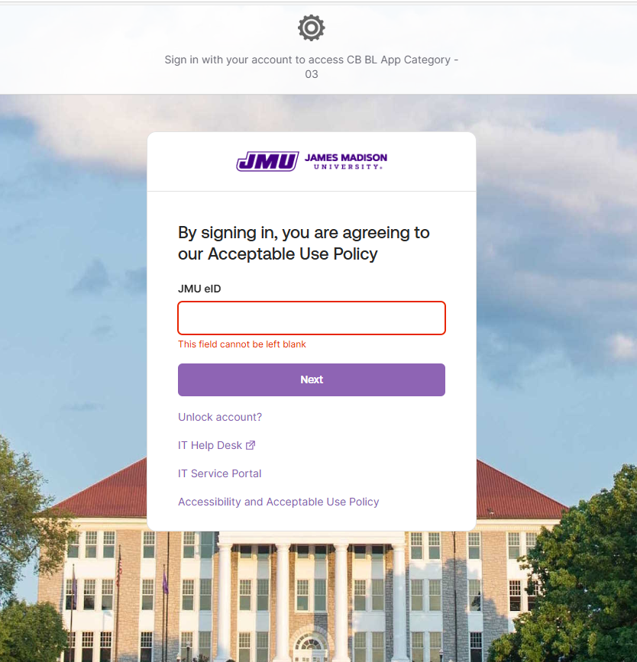

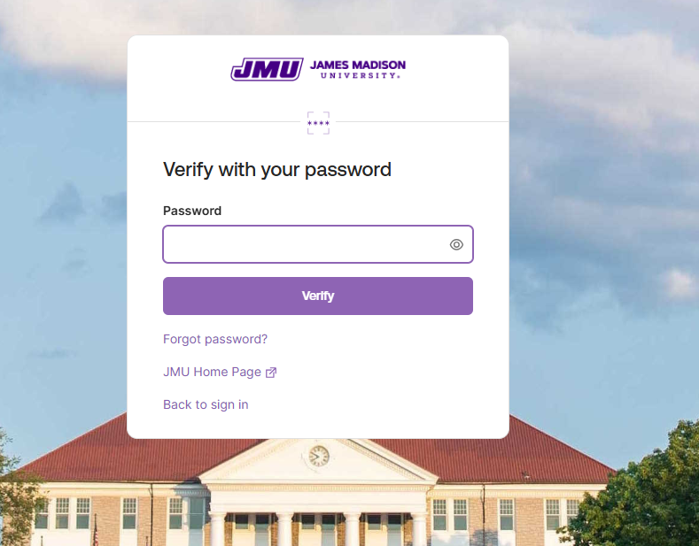

You can also access the Chrome River application from the Accounts Payable webpage.

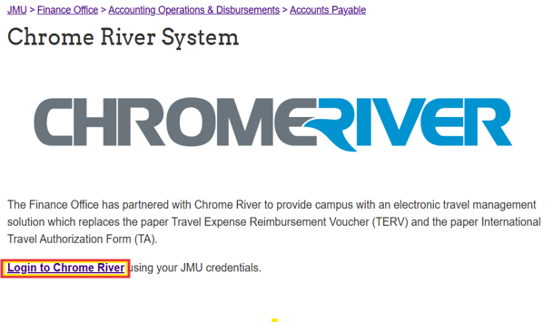

This is the Welcome or Home Screen

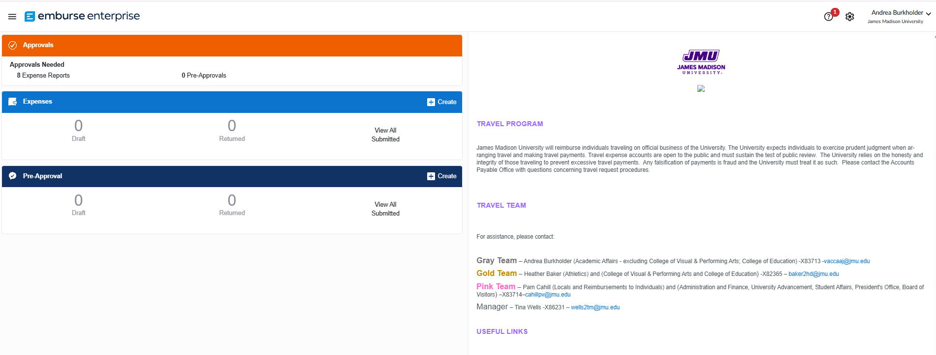

In the upper right-hand corner of the Welcome Screen, Click on your name and then Click “Account Settings”

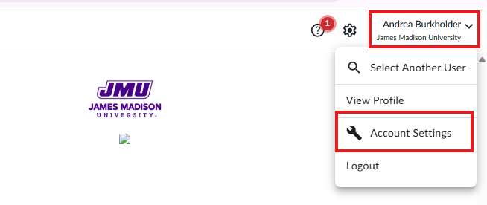

You will see this screen. Click “Delegate Settings” on the left hand

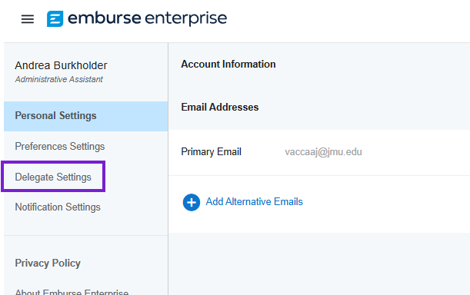

At this point, you have two options: “My Delegates” and “My Approval Delegate”. To assign an Approval Delegate to your account, click “Add Approval Delegate”

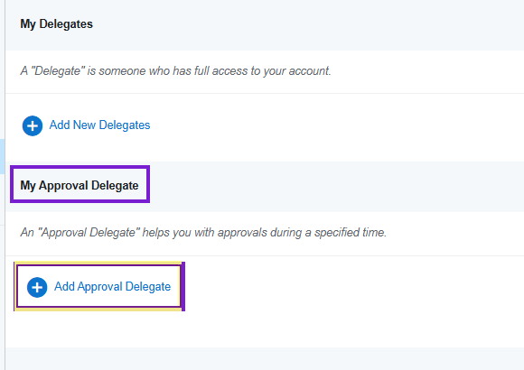

Click in the field “Select a User” and a drop-down list of names will appear. Type in the name of the person you want to give Approval authority to and then click on their name. Add a Start Date and an End Date and click save.

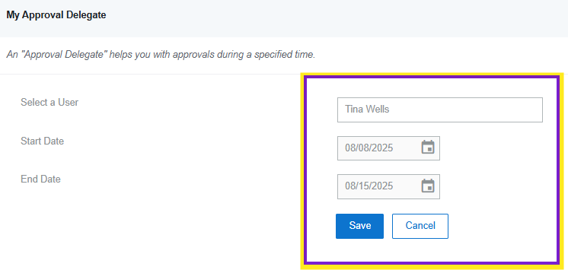

This person now has “Vacation Delegation” for approving reports on your behalf during your specified time. Any Expense Reports submitted between the dates you set will be sent to the Vacation Delegate you selected.

If you made a mistake and do not wish to give Approval authority, you can click on the cancel button, and it will delete your selection.