HOW TO GIVE DELEGATION AUTHORITY

What is a delegate? A delegate is a person you assign to have full access to your account to create expense reports, access your Setting Menu, Home Screen, and Reports. However, they **will not** have access or authority to approve expense reports on your behalf. You and your delegate will receive email notifications regarding approval, rejection or other adjustments to any reports created by your delegate. You can set up as many delegates as you would like in your account.

Log into the Chrome River (Emburse Enterprise) application an any web browser by going to the JMU webpage ([www.jmu.edu](http://www.jmu.edu)). Choose Faculty/Staff and IS Applications. Choose Chrome River.

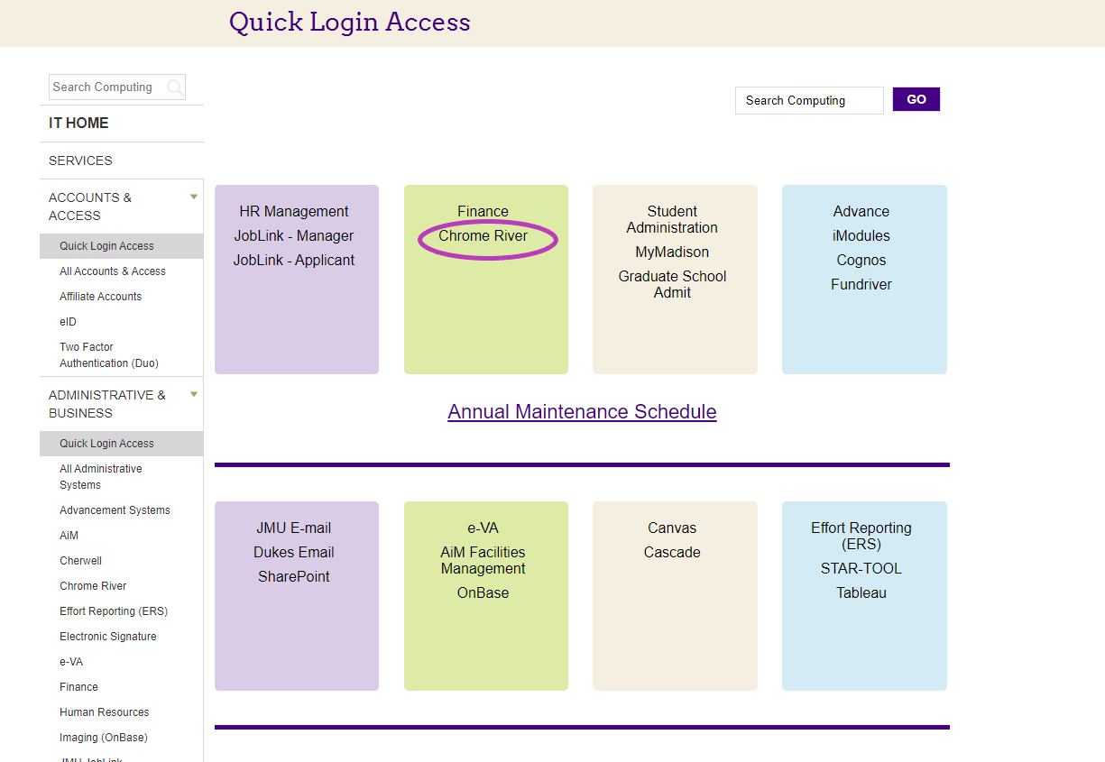

Sign in with your JMU eID, and password

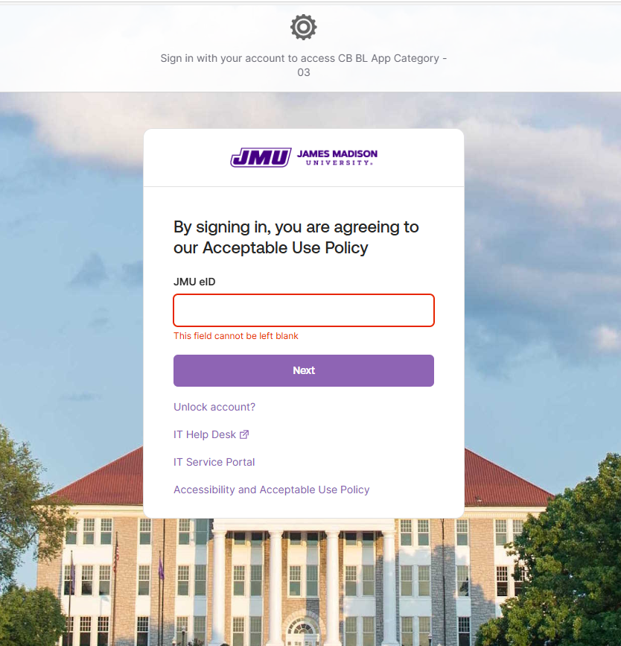

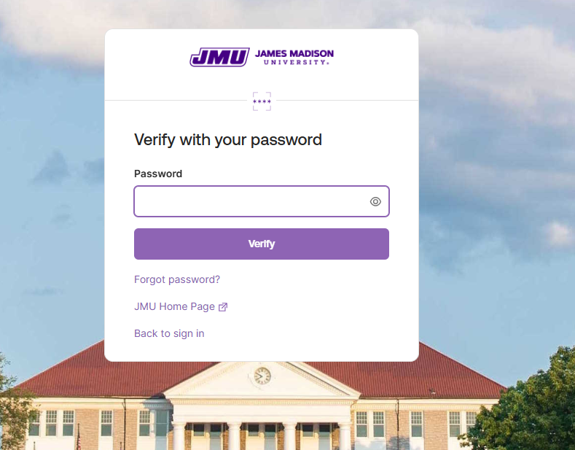

You can also access the Chrome River application from the Accounts Payable webpage.

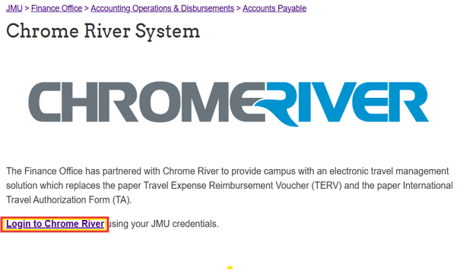

This is the Welcome or Home Screen

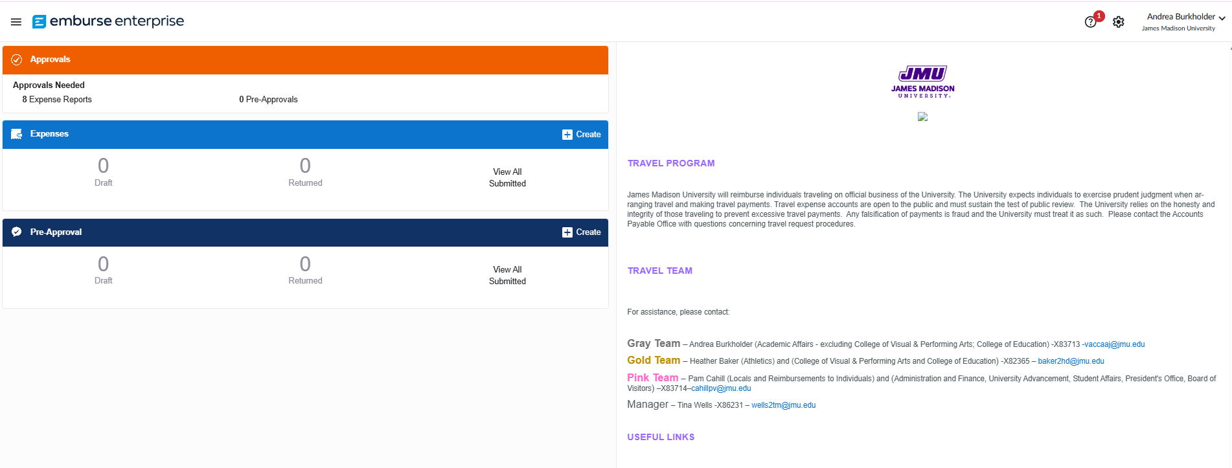

In the upper right-hand corner of the Welcome Screen, Click on your name and then Click “Account Settings”

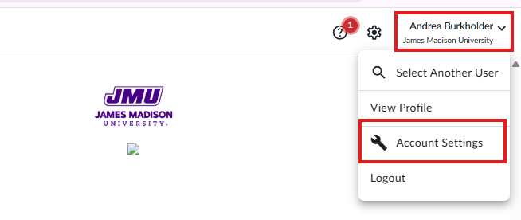

You will see this screen. Click “Delegate Settings” on the left hand

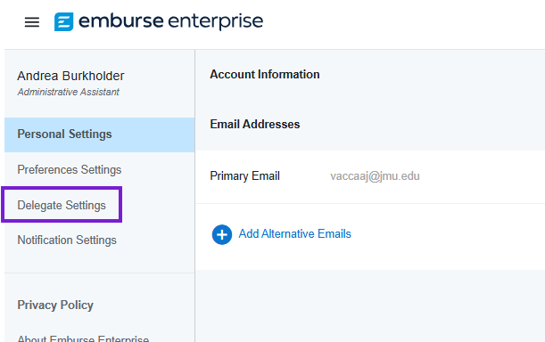

At this point, you have two options: “My Delegates” and “My Approval Delegate”. To assign a Delegate for your account, directly under “My Delegate” is “Add New Delegates”, click the blue plus button.

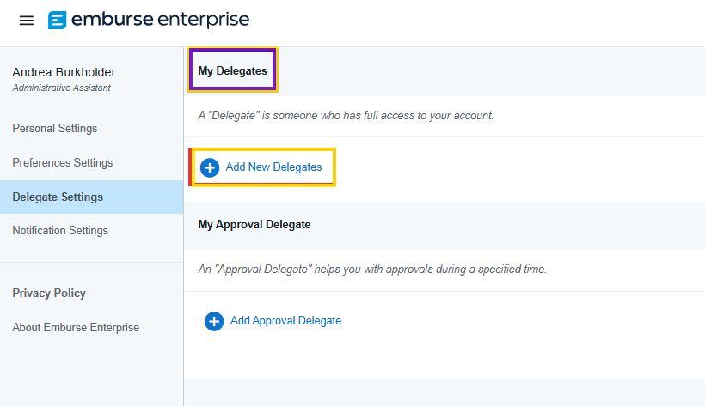

Click in the drop-down menu and a list of names will appear. Type the name of the person you want to give access to your account and select their name.

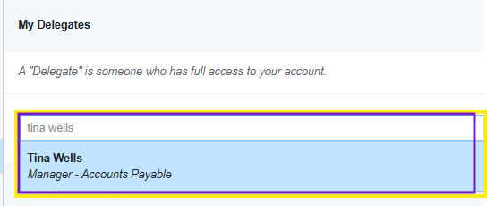

Once you choose their name, this person will have able to “delegate” into your account and process expense reports on your behalf. They **WILL NOT** be able to Approve on your behalf.

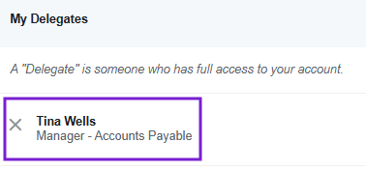

Now, Tina Wells is able to choose Andrea Burkholder and process an expense report on her behalf.

Note: This person is a Delegate as long as your leave them a Delegate. If you no longer want this person as your Delegate, go into your Delegate Settings and click the “X” next to their name and it will delete them.