Chrome River Training Guide

acctspayable@jmu.edu

10/30/2024

Accounts Payable

Contact: acctspayable@jmu.edu

Emburse Enterprise   
Training Guide

User Guide to Entering & Approving Expenses

# Table of Contents

Overview:………………………………………………………………………………………………………………………………………………………… 2

Accessing Chrome River:……………………………………………………………………………………………………………………………………2

Pre-Approval:……………………………………………………………………………………………………………………………………………………3

Per Diem Wizard:………………………………………………………………………………………………………………………………………………9

Submitting a Pre-Approval:………………………………………………………………………………………………………………………………11

Entering an Expense Report:…………………………………………………………………………………………………………………………….12

Allocation:………………………………………………………………………….…………………………………………………………………………….13

Charging Multiple Departments or Account Codes:…………………………………………………………………………………………….13

Uploading Receipt Images:………………………………………………………………………………………………………………………………..15

Non-Travel Individual Expense Report:……………………………………………………………………………………………………………..16

Entering an Expense Report for Travel:……………………………………………………………………………………………………………..19

Building the Report:………………………………………………………………………………………………………………………………………….21

Airfare:…………………………………………………………………………………………………………………………………………………………….22

Ground Transportation:……………………………………………………………………………………………………………………………………24

Rental Car:……………………………………………………………………………………………………………………………………………………….25

Entering Mileage:……………………………………………………………………………………………………………………………………………..27

Taxi:……………………………………………………………………………………………………………………………………………………………….. 29

Parking, Car Rental Fuel, State Vehicle Fuel, Public Transit (Bus, Metro) and Tolls:……………………………………………. 29

Entering a Hotel Expense:…………………………………………………………………………………………………………………………………30

Hotel Personal Non-Reimbursable:……………………………………………………………………………………………………………………34

Entering Conference/Registration and Membership Fees:………………………………………………………………………………….36

International Travel:…………………………………………………………………………………………………………………………………………37

Currency Converter:…………………………………………………………………………………………………………………………………………37

Reimbursing an External Person:………………………………………………………………………………………………………………………39

Submitting an Expense Report and Attaching a Pre-Approval:…………………………………………………………………………....41

Business Meals:………………………………………………………………………………………………………………………………………………...42

Adding an External Guest:…………………………………………………………………………………………………………………………………46

Chrome River Reminders:…………………………………………………………………………………………………………………………………47

Chrome River Helpful Links:……………………………………………………………………………………………………………………………..47

Contact Information:………………………………………………………………………………………………………………………………………...47

# Overview

Chrome River is an electronic travel management solution used for entering and approving travel and individual expense reimbursements.

# Chrome River

Login into Chrome River by going to the Quick Login Access page, clicking on Chrome River, and logging in with your JMU EID and Password. The system can be accessed anywhere you have internet access.

This is a screenshot of the Quick Access Login Page as it appears on the JMU website. Click the words "Chrome River"


After you log in with your JMU credentials, you will be taken to the Emburse Expense Enterprise home page. Your name will appear in the upper right-hand corner, with a drop-down menu.

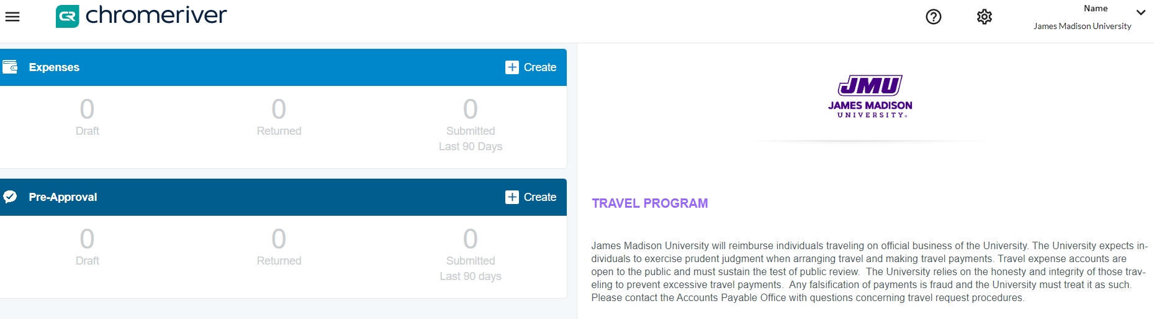

**Pre-Approval**

## When is a Pre-Approval Needed?

Pre-approvals are necessary in Academic Affairs for any expense report that is anticipated to be $500 or more. Remember, this is the total cost of the trip and not just what the traveler is being reimbursed. In addition, a pre-approval **must** be done for all international travel, as well as bringing a foreign national visitor to campus.

### Entering a Pre-Approval

A pre-approval is simply *an estimation* of costs associated with an upcoming trip. To get started, click the **+Create** button on the corner of the Pre-Approval.

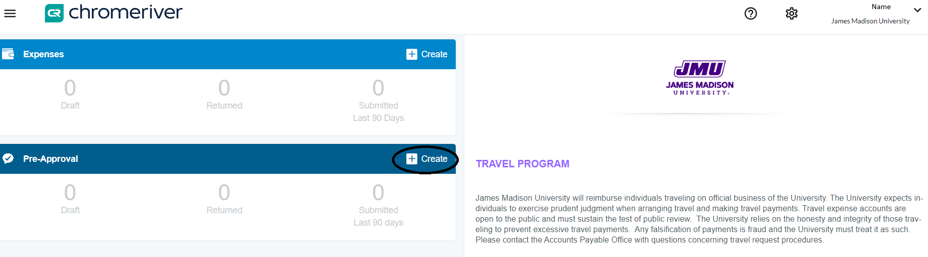

Once you click “create” you will enter a Report Name, start date, and end date (these should be future dates for when the travel is occurring). The business purpose should clearly explain the purpose of the travel. Select the Report type: Domestic or International. Report Purpose: Conference, Other, or Recruitment. Type of Traveler: Employee or Outside Party (such as student or candidate). Allocation: The org code these expenses will be charged to. After these fields are filled out, click “Save” in the upper right-hand corner.

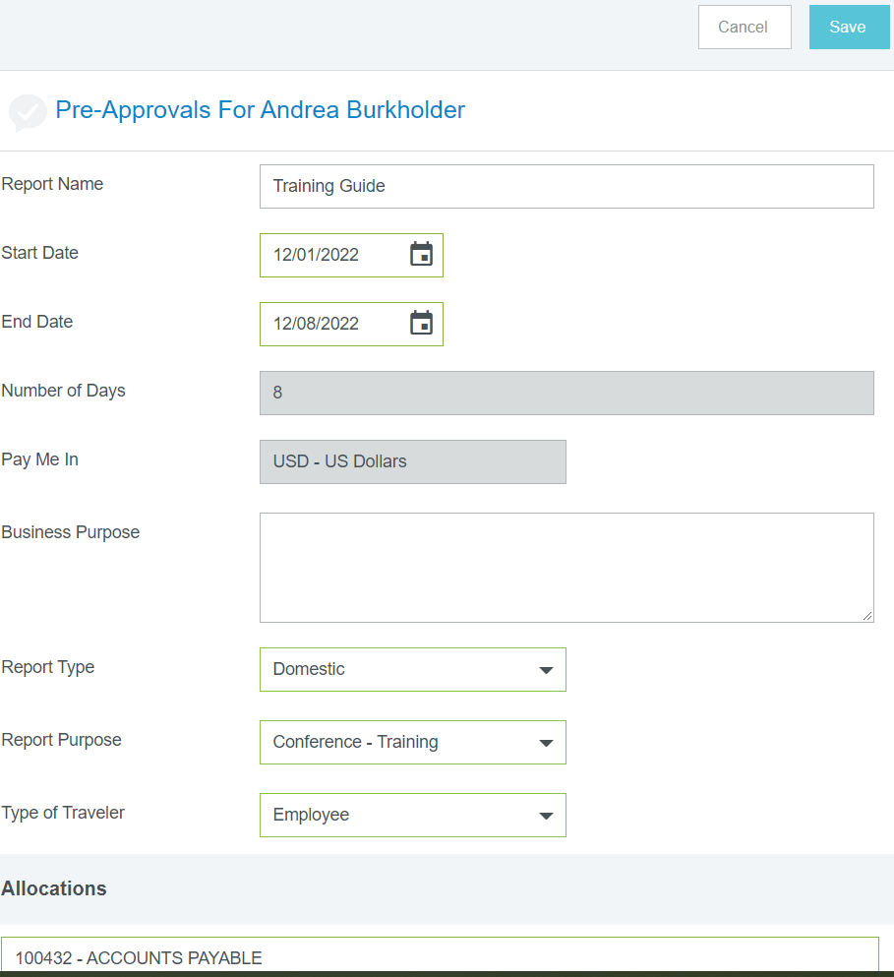

Once the header is created, you can start adding expenses by selecting the various tiles. Click on the “plus” sign at the top on the dark blue band and the tiles will show up. From here you can decide what to add to the report; airfare, ground transportation (which includes sub-categories), lodging, conference/registration, meals using the per diem wizard, or misc./other.

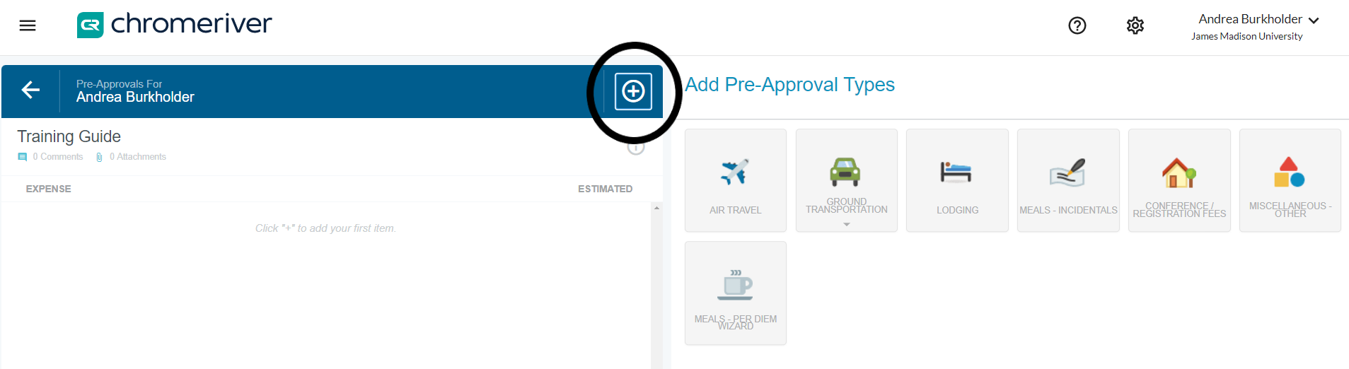

**Airfare:** Enter the estimated amount that the flight will cost. If airfare will be purchased with a departmental SPCC, check the “University Paid” box. If airfare will be processed as a personal reimbursement, leave the box unchecked.

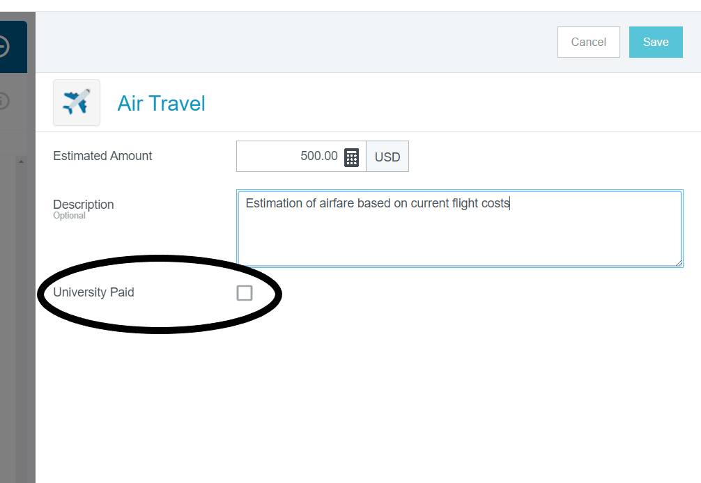

**Ground Transportation** allows for three options in a Pre-Approval, Train, Mileage, or Car rental.

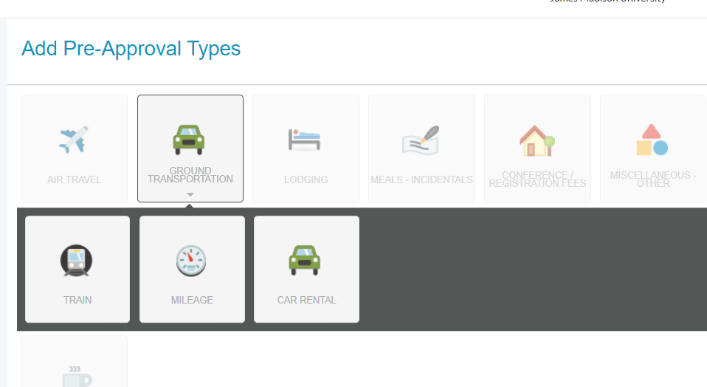

**Train:** These tiles are identical to Airfare. Check the “University Paid” box if it will be paid with a departmental SPCC. Then click “Save”.

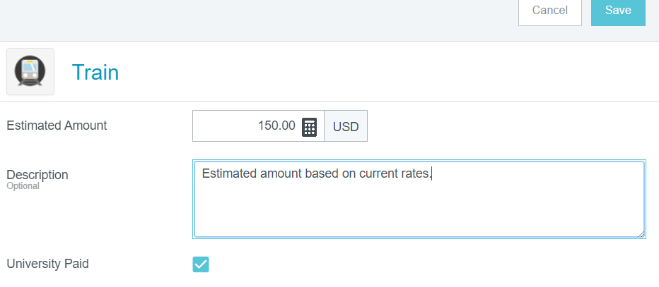

**Mileage:** To estimate the mileage on a pre-approval look at the current IRS/Fleet rates and multiply the appropriate amount by the amount of miles expected to travel. IRS rate may be used for anything under 280 miles driven per day of the trip. The Fleet rate must be used for anything driven more than 280 miles per day of the trip. <https://www.irs.gov/tax-professionals/standard-mileage-rates>

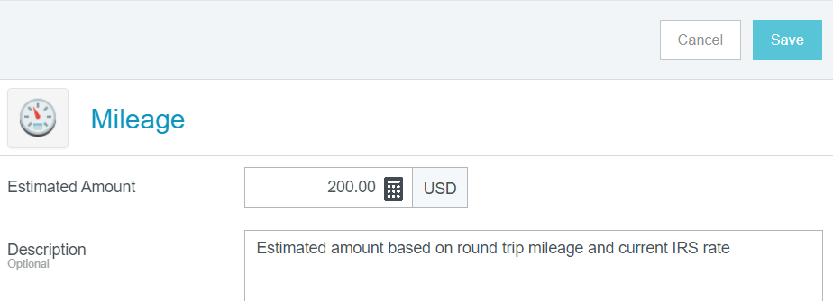

**Car Rental:** Rental cars should be based on the economy car rate. Rental cars should be secured through MotorPool when possible. Although you cannot put these expenses on an SPCC, you can secure a rental through our corporate contract with Enterprise as a direct bill to your department. To estimate the amount, look at the daily rate of an economy vehicle at the location of travel, and multiply the amount by the number of days it will be used. 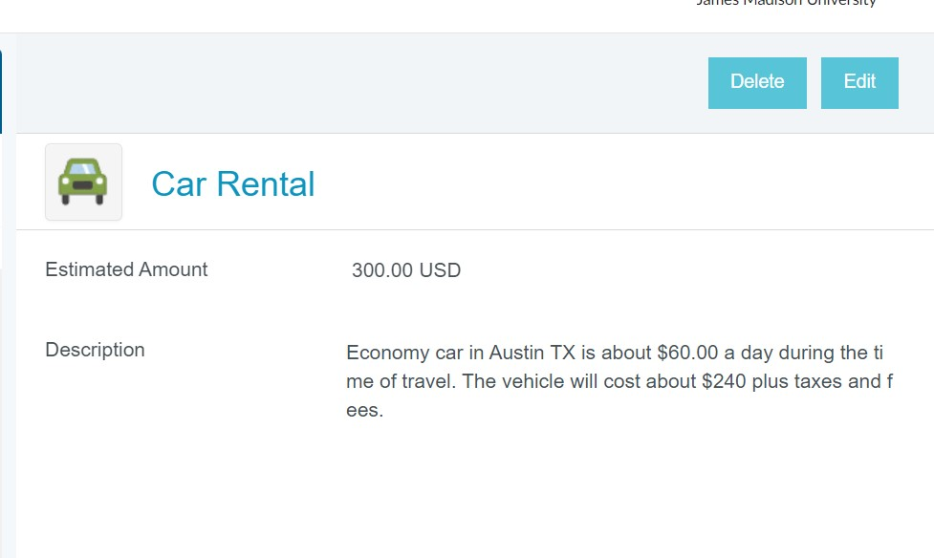

**Lodging:** To estimate the cost of lodging enter the number of days of travel, the number of rooms, and the current Per Deim Rate for the area. The Estimated Amount will auto-populate. <https://www.gsa.gov/travel/plan-book/per-diem-rates>

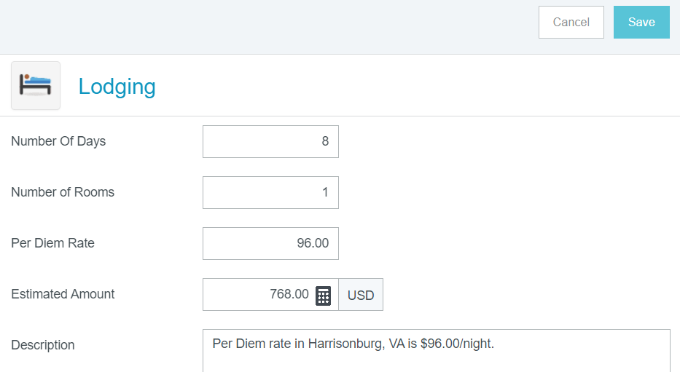

Conference/Registration Fees**:** Any fees associated with the conference can go into this tile, including membership fees. If these fees are paid in advance with a departmental SPCC, click the “University Paid” box. If this will be processed as a personal reimbursement to the traveler, leave the box unchecked.

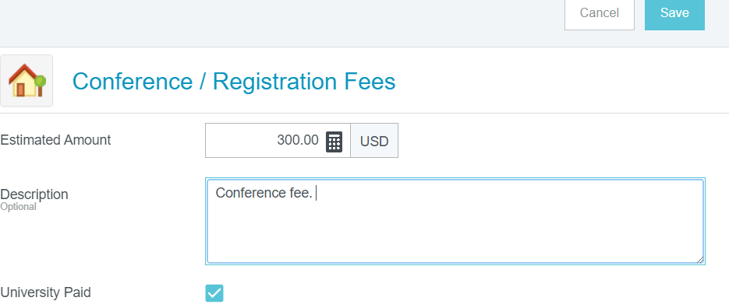

**Miscellaneous – Other:** This tile is for anything that is anticipated to come up during the trip that the other tiles have not accounted for. This can include taxis, baggage fees, rental car fuel, and so on.

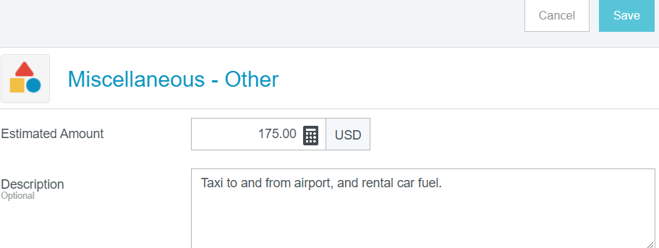

**Per Diem Wizard:** This tile will prompt you to enter the start date of travel, the end date of travel, and the location. Then, click “Add Entries”. *Please note the per diem wizard works the same way in a preapproval and an expense report*.

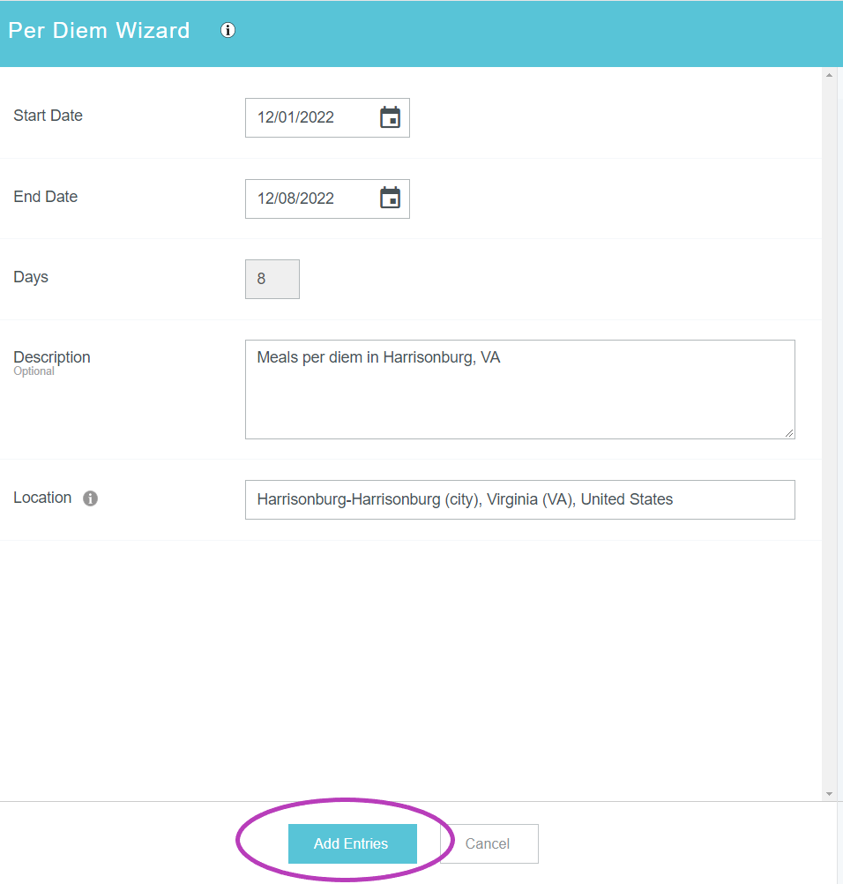

At this point, all of the meals for the entire trip are put on the righthand side of the report. When you click on a date it will give you the option to make “deductions” for any meals the conference will provide. The first and last day of travel will always need to be marked as “Travel Days”. This gives the traveler 75% of the per diem rate. After all deductions and travel days have been checked, click “Add to Report”

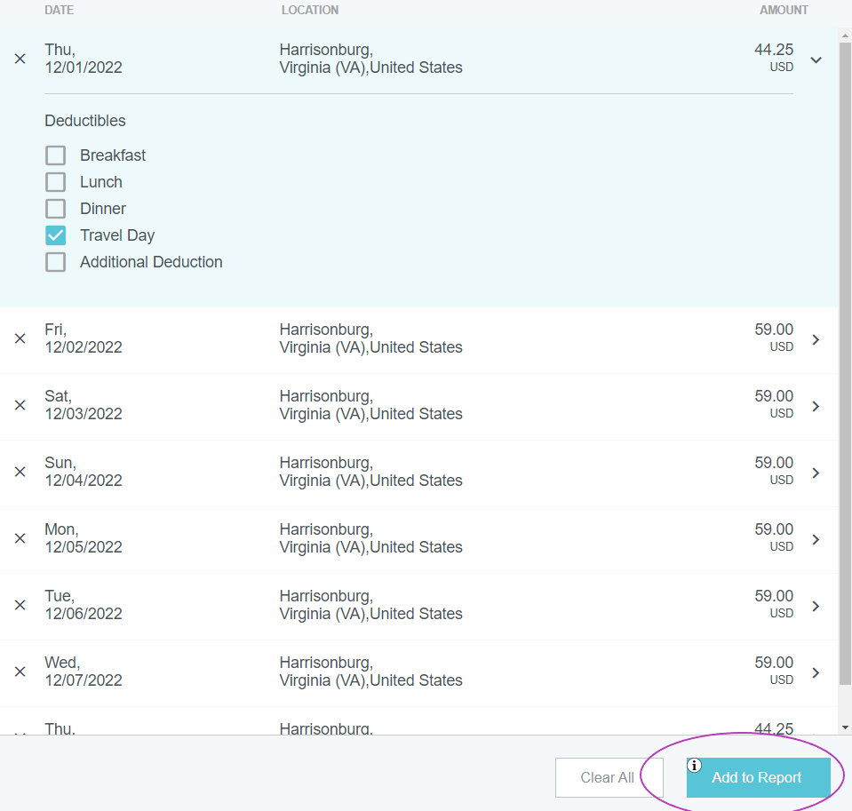

# Submitting A Pre-Approval:

After all of the anticipated expenses for the trip accounted for on the report, click the green “Submit” button at the bottom of the page. The Pre-Approval will funnel through the appropriate approvers.

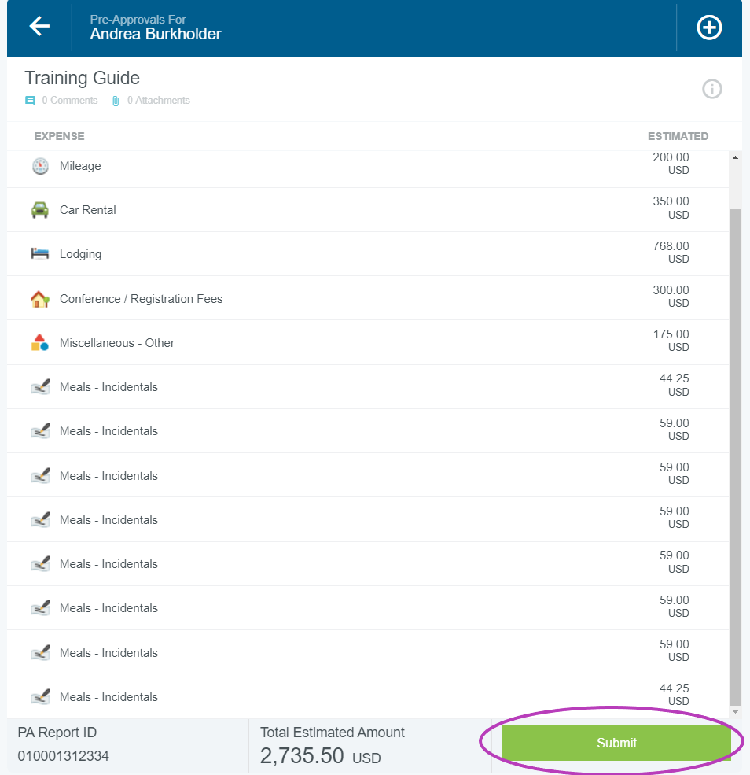

# Entering an Expense Report:

Expense reports can be started at any time and saved as a draft; however, the report cannot be submitted until the travel is completed and all the expenses associated with the business trip are accounted for. When entering an expense, the date on the tile should always be the date of purchase as shown on the receipt.

**Report Header**

Expense headers are an introduction to the report. The “Header” cannot be edited once saved.

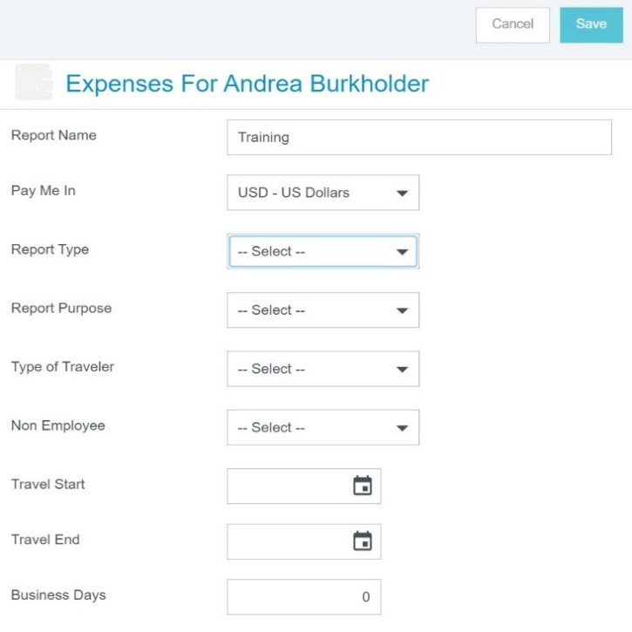

## **Report Name:**

## The name should include information about what the report is about, “CAPS Conference June 1-3”

Pay Me In:

The only option is USD. International receipts will also be reimbursed in USD.

Report Type:

The drop down includes Athletics, Domestic, International, Non-Travel Individual Reimbursement, and Student Teacher Evaluation. Most commonly, the report type will be Domestic or International.

Report Purpose:

The drop down includes Conference-Training, Non-Travel Individual Reimbursement, Other, Recruitment, Student Teacher Evaluation and Team Travel.

Type of Traveler:

This is either Employee, Outside Party, or Student

Travel Start & End Dates:

Enter the full date range of travel i.e.: June 2, 2023 – June 7, 2023

Business Days:

We count the first day as “Day 1” – if travel is from June 1-June 2nd it is two business days.

Business purpose:

Each report must include a detailed description or business purpose. Give as much information and detail as you can to create a clear picture for the audit.

Description:

Each line item gives the option of posting a description of that expense. For example, a taxi description should indicate why the taxi was used: “Taxi taken from the airport to the hotel.”

# Allocation:

The allocation is the org code that will pay for the expense. Multiple org codes, including grants, can be used on a single line item. The Allocation can be split by percentages or dollar amounts. As many org codes that are needed can be added to line items by clicking “Add Allocation”.

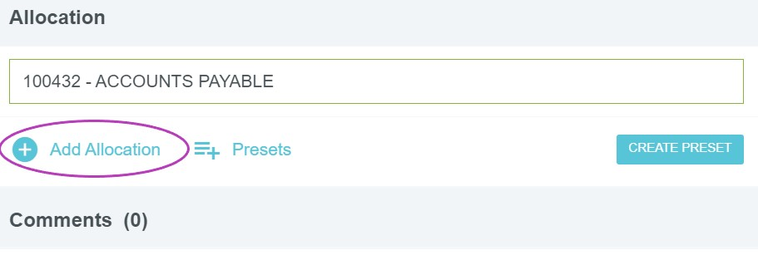

**Example of a split allocation (charging more than one department or org code)**

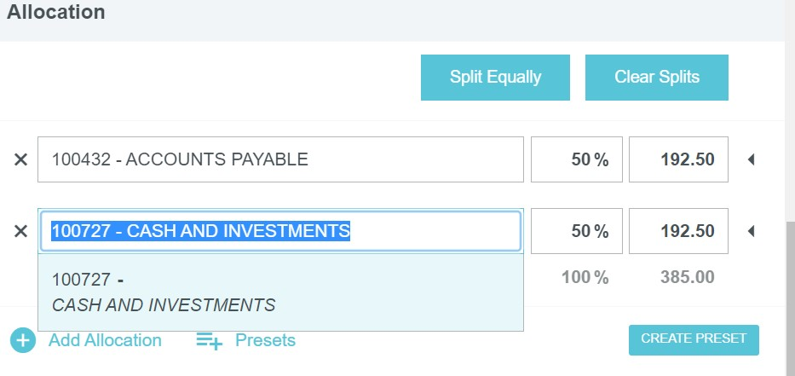

**Non-Reimbursable expenses should be allocated to 9900.**

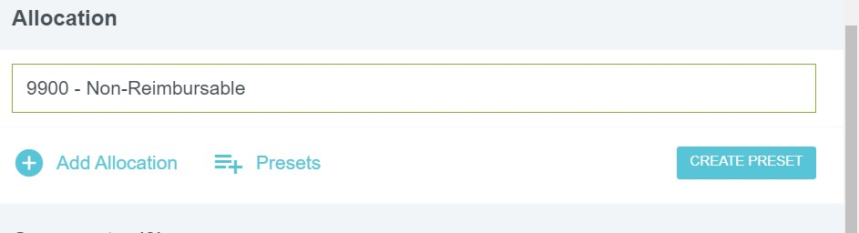

**University Paid expenses (SPCC payments) should be allocated to 9800.**

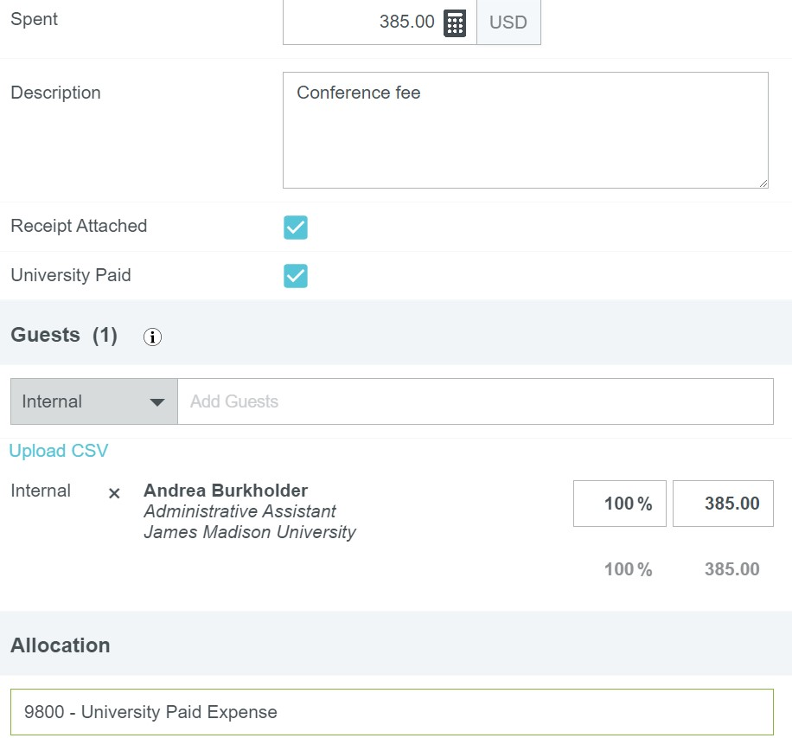

# Uploading Receipt Images

Scan all the receipts to yourself as a PDF, you can “drag & drop” the file into Chrome River on the header page or click “Add attachment” and upload from your desktop.

Once uploaded, each receipt must be moved to the expense line it is associated with. To do this, simply drag the receipt from the gallery and drop it on the appropriate line.

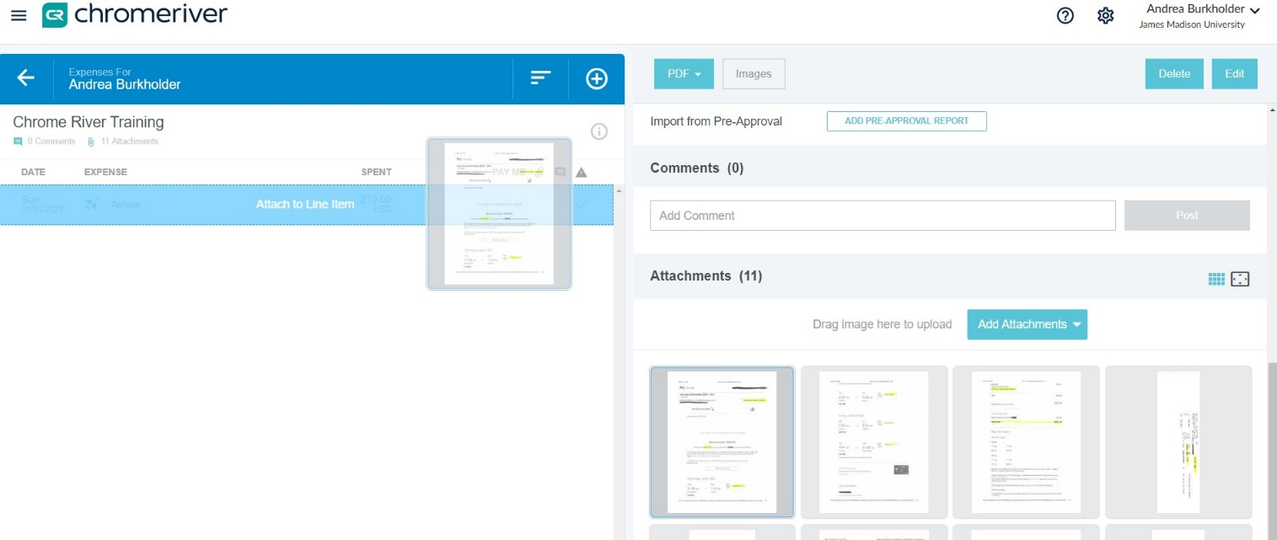

# Non-Travel Individual Expense Report

A non-travel reimbursement is used when the expense owner does not travel for business but rather is seeking reimbursement for a JMU business-related expense where the departmental SPCC is not used. Examples of this can be tuition reimbursement, lab supplies, fieldwork supplies, equipment rentals, reference materials, shipping, educational supplies, etc. ***To create a Non-Travel Individual Reimbursement, the “Report Type” and “Report Purpose” must both say “Non-Travel Individual Reimbursement”.***

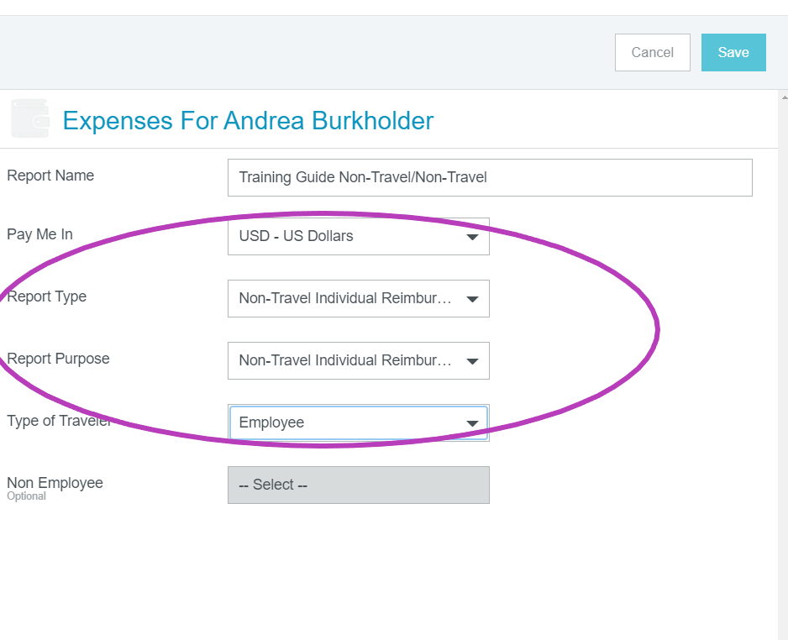

After the Non-Travel Header is created, click “save” and select the tile that best describes the reimbursement. An itemized receipt is required for all reimbursements, showing proof of payment.

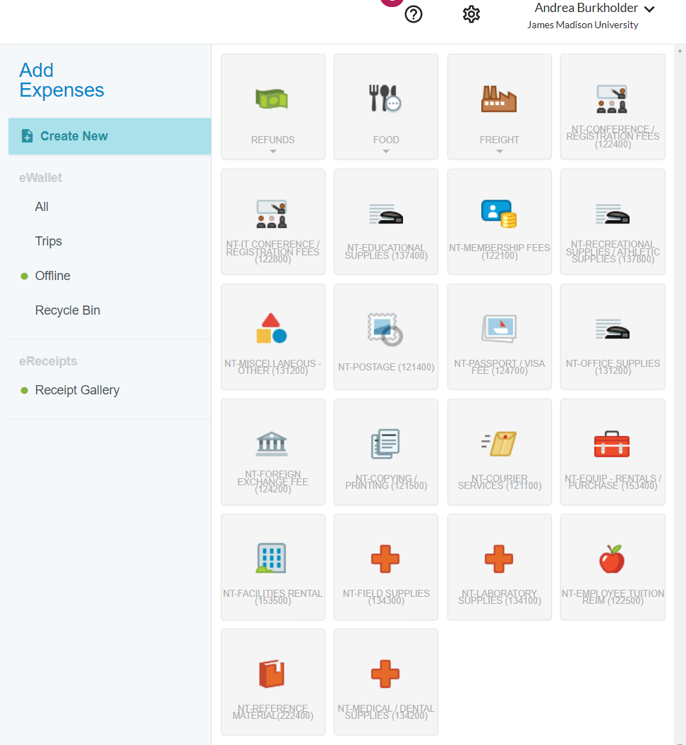

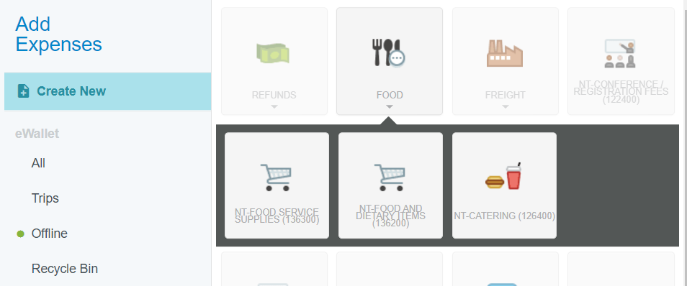

**Food:** The “Food” tile breaks down into three sub-categories: “Non-Travel food service supplies”, “Non-Travel Food and Dietary Items” and “Non-Travel Catering”. For all food service supplies, catering, and food and dietary reimbursements, an uploaded list of attendees as well as a detailed agenda of the event is required.

**Non-Travel Food Service Supplies:** This tile is used to reimburse items such as plates, napkins, cups, etc. Please specify a reason for not using the departmental small purchase credit to purchase the items.

**Non-Travel Food and Dietary Items:** This tile is used to reimburse food items purchased at the store for an event. Please note if items are being brought back to campus and they are over $250 you must have an Aramark Approval form attached to your report. This includes ice. Please leave a comment explaining why the departmental small purchase credit card was not used to purchase the items.

**Non-Travel Catering:** If an event is held on campus and a meal is being provided from an outside source, you may use this tile to reimburse.

Other types of Non-Travel Reimbursements*:* Non-Travel (NT) Conference/Registration fees and Non-Travel (NT) Membership fees, may only be reimbursed under “non-travel” if the employee does not have any physical travel related to these expenses. If the person is traveling, then they must be reimbursed after their trip is complete on a regular expense report.

Non-Travel Employee Tuition Reimbursement can be submitted for reimbursement after the employee has completed the coursework and proof of a passing grade or certificate of completion must be uploaded with proof of payment.

# Entering an Expense Report for Travel

## Create the Header

## **Report Name:**

## The name should include information about what the report is about, “CAPS Conference June 1-3”

Pay Me In:

The only option is USD. International receipts will also be reimbursed in USD.

Report Type:

The drop down includes Athletics, Domestic, International, Non-Travel Individual Reimbursement, and Student Teacher Evaluation. Most commonly, the report type will be Domestic or International.

Report Purpose:

The drop down includes Conference-Training, Non-Travel Individual Reimbursement, Other, Recruitment, Student Teacher Evaluation and Team Travel.

Type of Traveler:

This is either Employee, Outside Party, or Student

Travel Start & End Dates:

Enter the full date range of travel i.e.: June 2, 2023 – June 7, 2023

Business Days:

We count the first day as “Day 1” – if travel is from June 1-June 2nd it is two business days.

Business purpose:

Each report must include a detailed description or business purpose. Give as much information and detail as you can to create a clear picture for the audit.

Description:

Each line item gives the option of posting a description of that expense. For example, a taxi description should indicate why the taxi was used: “Taxi taken from the airport to the hotel.”

## This is an example of an Expense Report Header for Travel. The boxes should be filled in with the appropriate details. Report Name Pay Me In USD Report Type (select) Report Purpose (select) Type of Traveler (select) Travel Start Travel End Business Days (Enter the number of business days)

**Building the Report:**

At this point, you should have all the details of the trip and receipts to begin building your expense report. Click on

the circled “plus” sign to get the tiles to pop up and select the expense you need to add.



**Airfare:** The State will reimburse economy seating; and will not pay for seat selection, change ticket fees, or internet/telephone charges. If any of these charges were to appear on the flight receipt, put in the full amount of the ticket in the “spent” and use allocation 9900 to remove the non-reimbursable charge.

To enter airfare, click on “Air Travel” and “Airfare”. The date should be the date of purchase. Spent is the total spent. Business purpose should be as much information as you can give to explain where they went and why. Select the airline, class, and receipt attached”. If it was pre-paid on an SPCC, click “University Paid” and use allocation 9800.

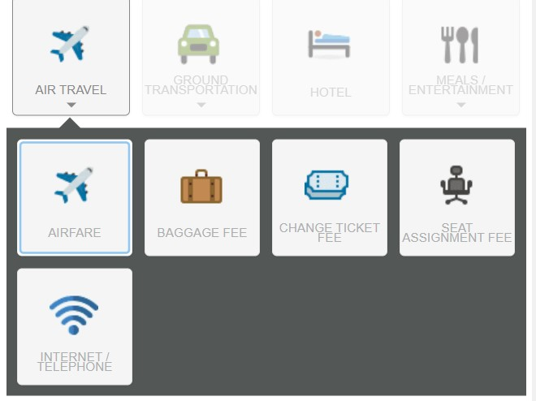

This is the Airfare tile. Enter the date of purchase, amount spent, a description, Airline and Seat Class. 
Check "Receipt Attached Box"
Check the University Paid Box if it was paid with an SPCC. 

Check Receipt Attached after the receipt is uploaded. 
Check "University Paid" if it was paid with an SPCC. 
Select the Allocation. 

**Baggage Fee:** To add Baggage Fees to the report, click on “Airfare” and “Baggage Fee”. Enter the date of purchase and the total amount spent. The state will reimburse checked luggage. The state will not reimburse any baggage costs that were not due to the traveler (examples include traveling with family members who may have traveled but not for JMU)

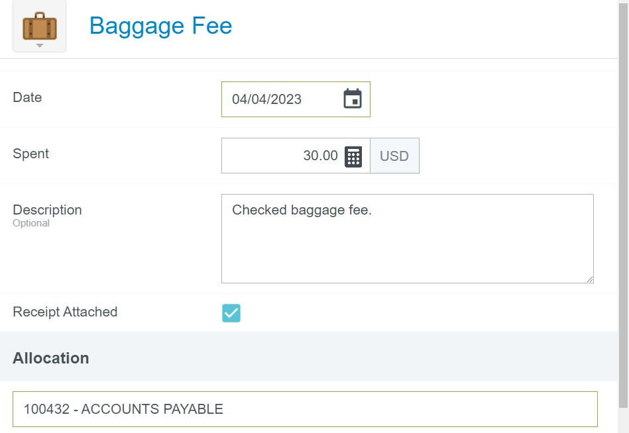

# Ground Transportation:

Ground Transportation Tile:
Subcategories are
Car Rental
Car Rental Fuel
State Vehicle Fuel
Mileage
Parking
Public Transit
Train
Taxi/Shuttle
Tolls

## 

## Rental Car: The State will only pay for economy vehicles. The state cannot pay add-ons such as advance toll options, advance fuel options, or insurance. If the traveler is abroad, they can get the additional insurance, as they are only covered under JMU’s liability insurance for domestic travel. Outside parties can also select to be reimbursed for insurance as they are not covered under JMU’s liability insurance.

Car Rental Tile
Enter the Date
Enter the Spent
A text box for the Description of the expense
Rental Agency
Location of the rental
Were there additional car add-ons to the bill (check the box if yes)
Receipt attached check box. 

## Train: Trains follow the same rules as airfare. The state can pay for standard travel only. Whenever possible, Trains should be paid in advance using a JMU SPCC. Train Tile Date Enter the amount spent Rail Class (Standard, Business - select from drop-down menu) Description of the expense.

**Mileage:** Mileage should have a consistent “base point”; the location where the traveler starts and ends. Usually, this is their JMU work address. However, if a person is traveling somewhere and their destination is *closer* to their home address, then we would enter their home address instead of JMU. Mileage rates: The IRS rate is the higher rate and can be used for distances that are 280 miles *or less* per day of travel. If the traveler exceeds 280 miles per day of travel, then you must use the fleet rate.

Enter the date of travel, select the rate, and click on “Calculate Mileage”

Mileage: 
Enter the Date
Business Purpose
Select the Rate for mileage to be reimbursed
Click "Calculate Mileage"

Enter the starting location, and the destination, and then click “Return to start”. You can enter up to 10 entries on one mileage line if there are multiple business-related stops. Click “Save Trip” and “Add to report”

Entering Mileage 
The Start address should be their JMU work address, unless their home address is closer to the destination
Enter the address of where they went
Click "return to stat" 
Use the "Add Destination" button to add up to 10 mileage entries on one line. 
Click "Save trip" in the upper righthand corner. 

### Deduction in Mileage

In the mileage tile, we cannot use account code 9900 if it is necessary to manipulate the reimbursement amount. Instead, where it says “Deduction” click on “None” and a drop-down will appear. Here you can decide to deduct a specific amount or a distance from the mileage report. However, this cannot be used to circumvent the IRS rate of 280 miles per day. If the report exceeds 280 miles per day the fleet rate must be selected.

Deduction in Mileage: 
Next to "Deduction" where it says "None" click and enter either a distance or an amount to deduct from mileage, if necessary 

# Taxi: The state will only pay for transportation to/from official business – examples of this include the airport, conference, and hotel. Put in the date of purchase, the amount spent (this should include the fare plus tip), and then the tip amount.

We can tip 20% of the total (this includes taxes & fees because there are not any per diems associated with a taxi). Your description should include details of where they went and why.

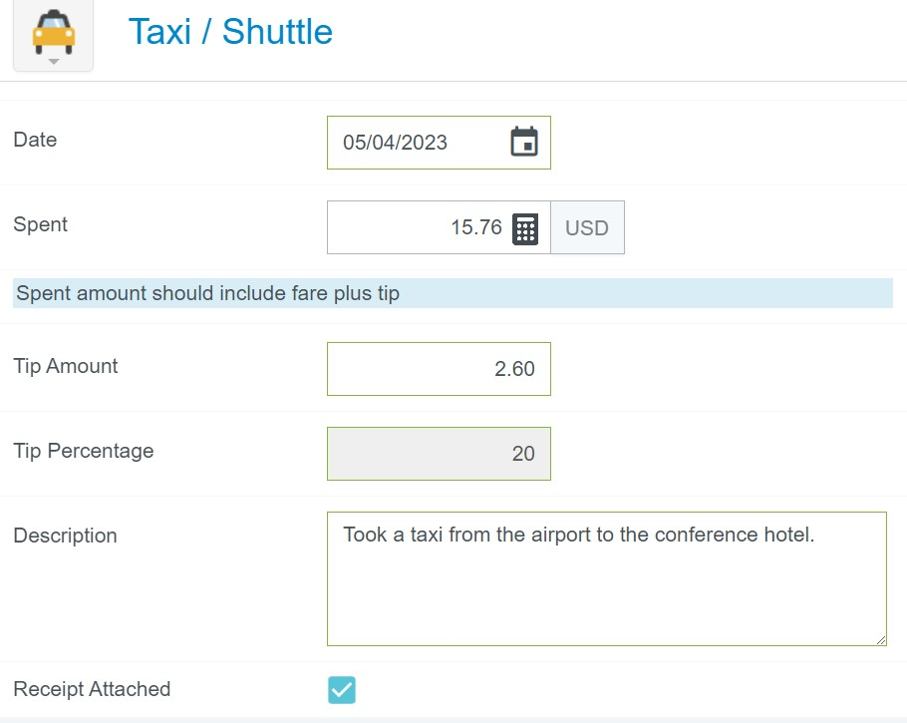

Helpful Hints: if the person tips over 20%, you must ***reduce the tip, and the amount spent*** by the same amount.

# Parking, Car Rental Fuel, State Vehicle Fuel, Public Transit (bus, metro) and tolls:

Enter the date, the amount spent, and a description, and include the receipt.

# Entering a Hotel Expense

#### ***JMU can only reimburse the traveler whose name appears on the hotel bill***

The travelers must pay for their hotel bill to be reimbursed. Travelers may not claim the reimbursement if anyone other than themselves pays for the hotel. This includes partners, parents, colleagues, and so forth.

To be considered for reimbursement the hotel bill must be fully itemized and show proof of payment.

## Hotel Header: When you click on “hotel” you will be prompted to create the header

* Date = of checkout
* Spent = The total amount spent (even if we are not able to reimburse everything).
* Business Purpose
* Receipt attached.
* Allocation

## Itemize

After you create your header, you need to itemize the entire bill.

This is the Hotel Header Screen
Enter the date of checkout
Enter the total amount spent
Write a business purpose
Write a description
Check the receipt attached box. 

## The Hotel Tiles will populate for itemizing.

Hotel Itemization Tiles
Hotel Lodging/Per Diem for room rates
Hotel Room Taxes/Fees
Hotel Parking
Hotel Internet/Telephone
Hotel Business Meals
Hotel Meeting Room
Hotel Transportation
Hotel - Other
Hotel Equipment Rental
Personal Non-Reimbursable. 

## Hotel Lodging/Per Diem

The hotel lodging/ Per Diem tile is used to itemize the room rates. If the room rates are the same for one or more consecutive nights in a row you may combine them. If they are different, you must itemize them separately.

The “Date should be the date of checkout. “Spent” is the total amount spent on the room(s). Click on “Calculate”

Hotel Lodging/Per Diem
Enter the Date
Spent (nightly rate)
Click "Calculate"

* Enter the check-in date, the check-out date, the location (this should be on the hotel’s address), and number of rooms.
* “Rooms” also refers to “occupants”. If two people travel together on JMU business and share a room, they would each be entitled to a per diem, and you should enter “2” next to rooms.
* Click “Save”

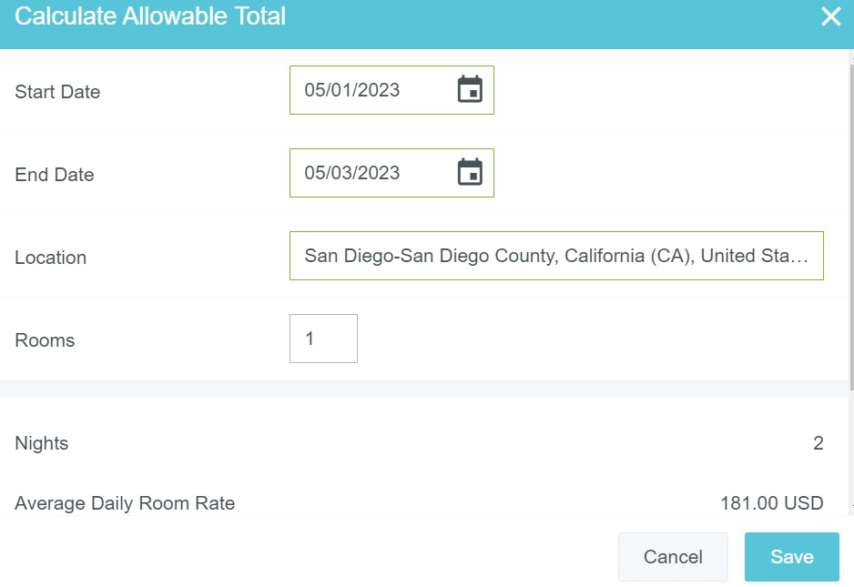

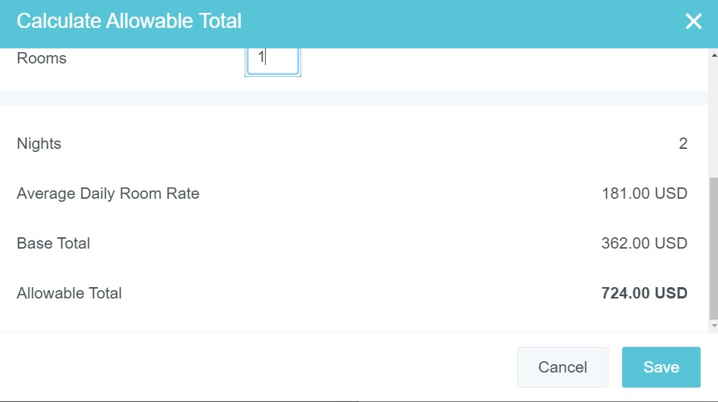

**Note:** The “Calculate Allowable Total” screen gives information about what the state will reimburse; these are for the room rates only (not including taxes). Entering the correct location is imperative for the system to calculate the correct per diem which is what the State will pay for lodging in a specific area.

In the example above, the location is San Diego, May 2023. Per diems are based on the date and location, it is important to be precise with these details. This is for a two-night stay as indicated on the screenshot. The “Average Daily Room Rate” is the *base per diem*; the state allows us to reimburse up to 200% of this amount with justification The “base total” is simply the base per diem multiplied by the number of nights ($181.00*2 = $362.00). The “Allowable Total” is 200% of the base total and is the *maximum* the state will reimburse. Anything over this amount cannot be reimbursed with state funds.

## Hotel Room Taxes/Fees: Taxes and fees can be combined, even if the room rates are itemized separately.

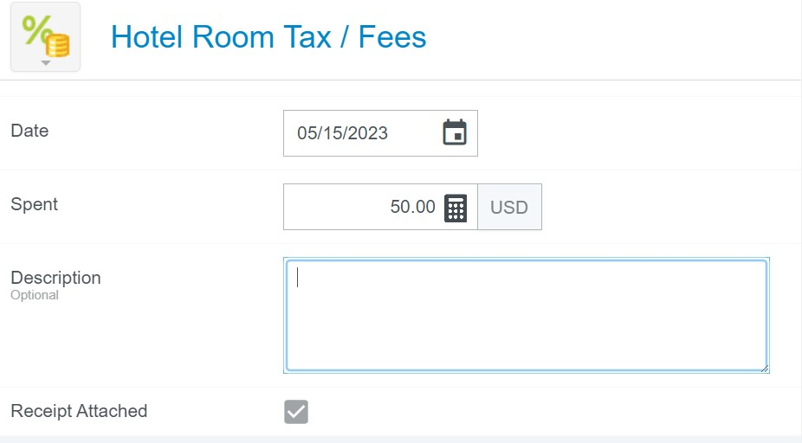

## Hotel Parking

Hotel parking should go into the appropriate tile. The state can reimburse self-parking fees. If self-parking is not offered at a hotel, then valet parking can be reimbursed. A screenshot from the hotel’s website should be uploaded for auditing purposes.

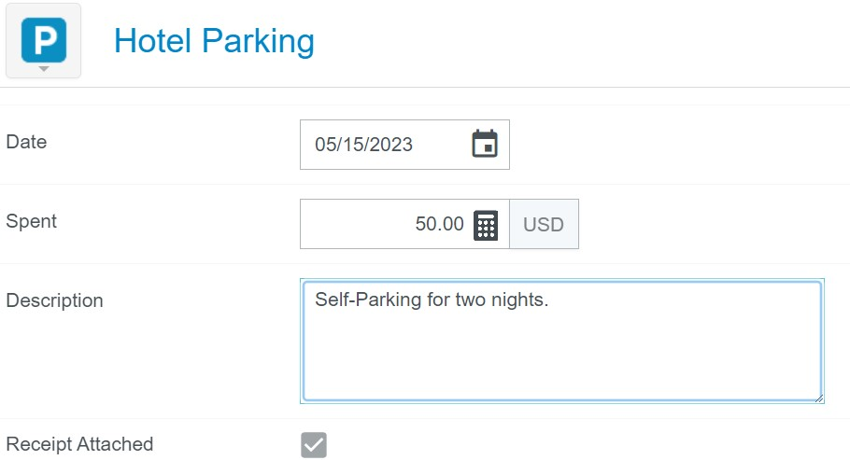

## Hotel Personal Non-Reimbursable

The state will not reimburse personal expenses on a hotel bill. These must be itemized in the personal non-reimbursable” tile. These expenses include but are not limited to, fees for early check-in or late check-out, room service, internet fees, laundry services, and movies/entertainment. 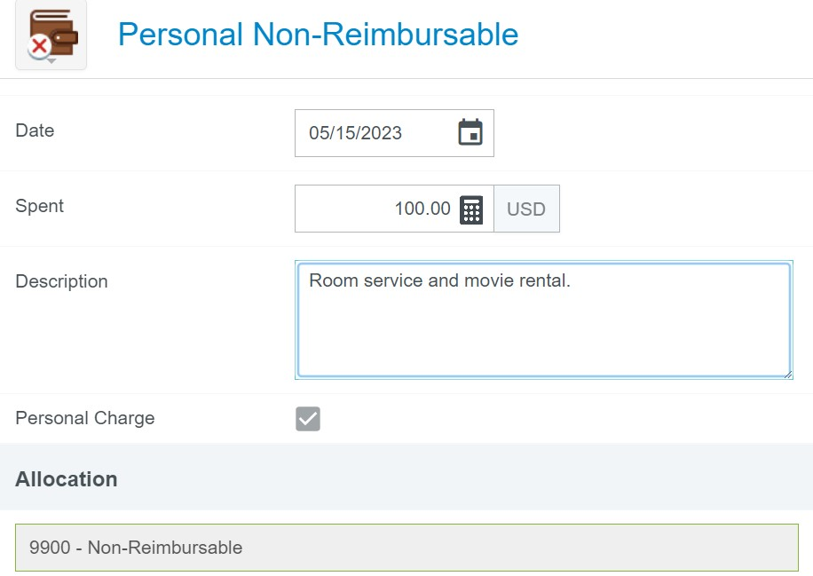

## NOTE: Split Allocation: Hotel Lodging Per Diem & Split Taxes

## If a hotel’s lodging per diem exceeds the allowable total, or if there is no justification for going over the base per diem, then the reimbursement amount must be reduced to the allowable total and the taxes for those nights must be pro-

## rated by the same percentage.

To do this, enter the “Spent” amount as usual, scroll down to “Allocation” and click “Add Allocation” and enter 9900 for personal, non-reimbursable. In the example below, the “Allowable” total is $428.00, and the amount spent is $500.

In the allocations, put $428.00 into the org code that is paying for the expense, and the remaining in 9900. Write down the percentage splits to apply to the tax line that corresponds with the lodging that went over the allowable total.

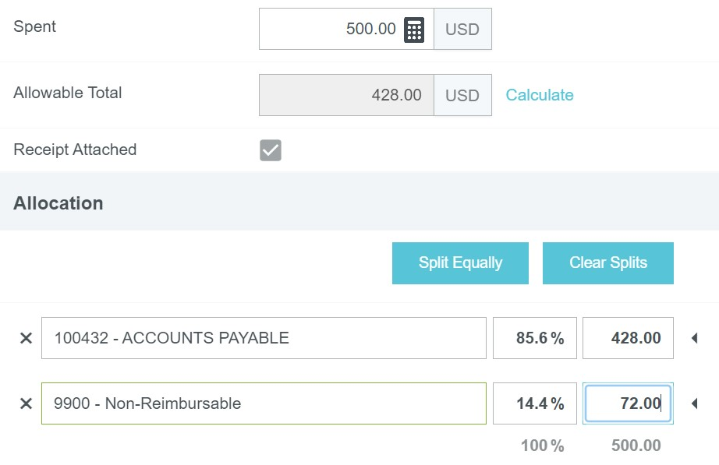

Save this line item and click “Itemize” then “Taxes and Fees”. Enter the taxes for the specific night, scroll down, click “add allocation” and add the 9900 allocations; instead of entering a dollar amount, insert the percentage that the org code can pay, and the percentage that is non-reimbursable from the previous screen.

## A screenshot of a hotel account

# Entering Conference/Registration and Membership Fees.

Conference and Membership fees must be included on the expense report and cannot be reimbursed until after the conference has concluded. Please note that the “date” will always be the date of purchase.

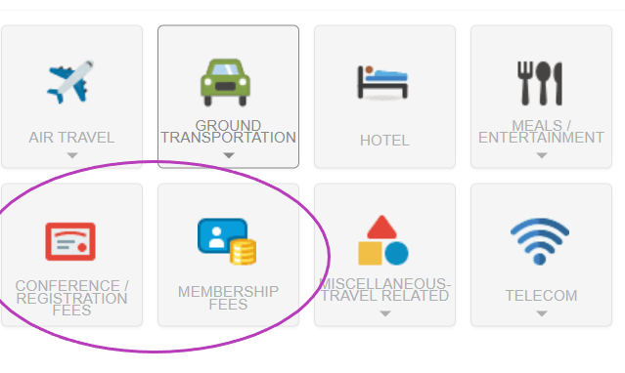

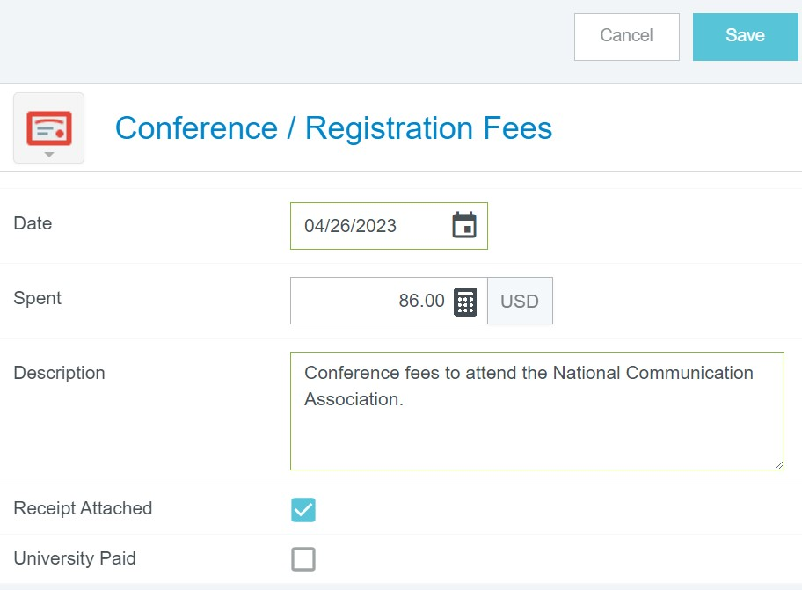

# International Travel

## All international travel *must* have a Pre-Approval attached to it.

### Currency Converter

Creating an international expense report involves the same steps as a domestic expense report. However, you must enter receipts into the system in the currency the purchase was in.

Click on the “USD” next to the amount and a drop-down will appear with all the currencies. Select the appropriate one and Chrome River will convert the currency into USD. The system is live and will convert based on real-time currency rates from the date of purchase.

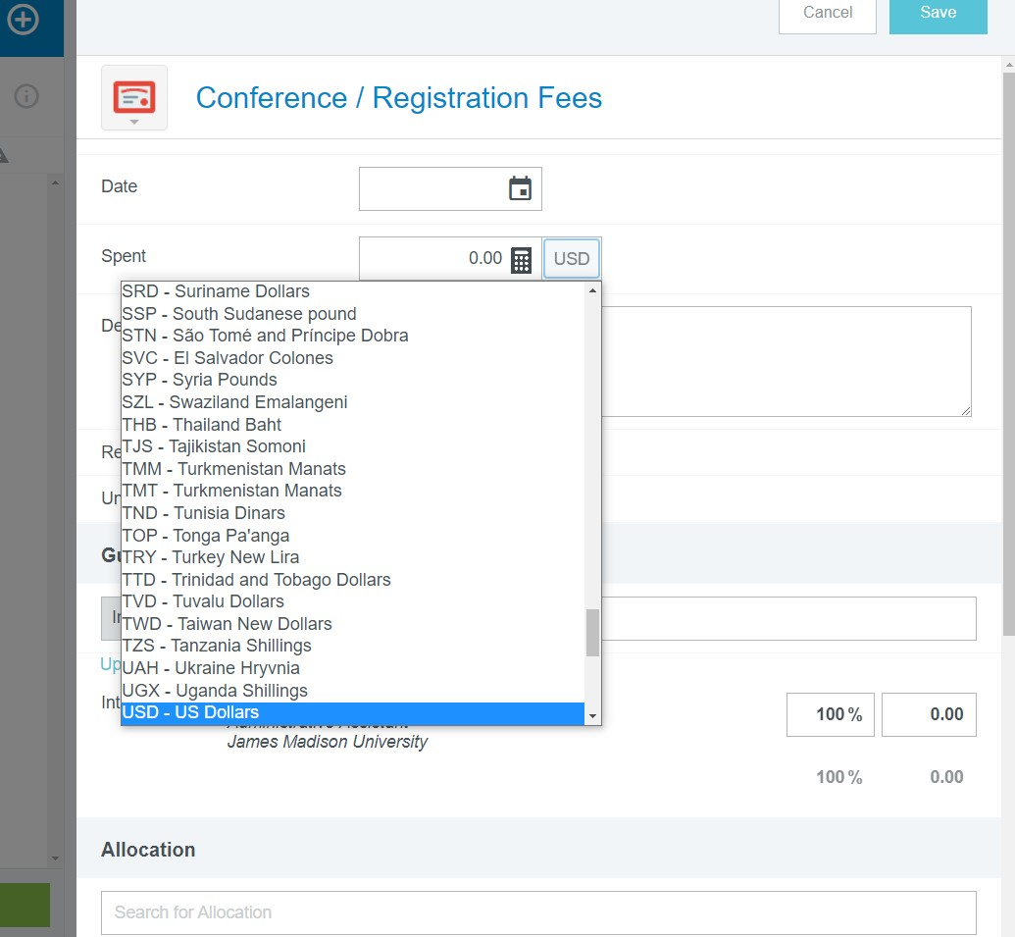

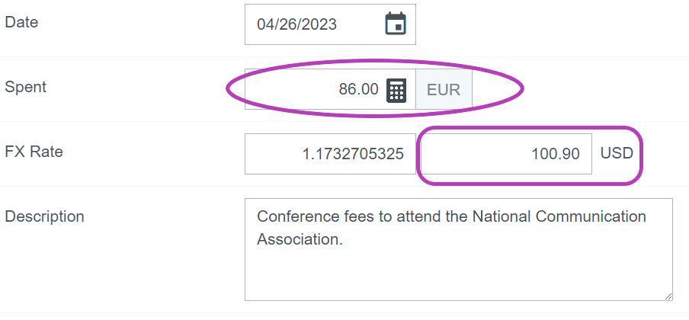

# Telecom: The telecom tile is primarily used for long-distance telephone fees which might occur while a JMU employee is on official business abroad and needs to conduct business/communicate with JMU.

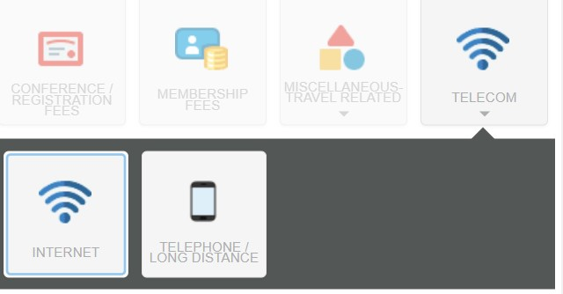**Miscellaneous Travel Related:** Any other reimbursable expenses that occur while the person is on travel status will be found in this tile.

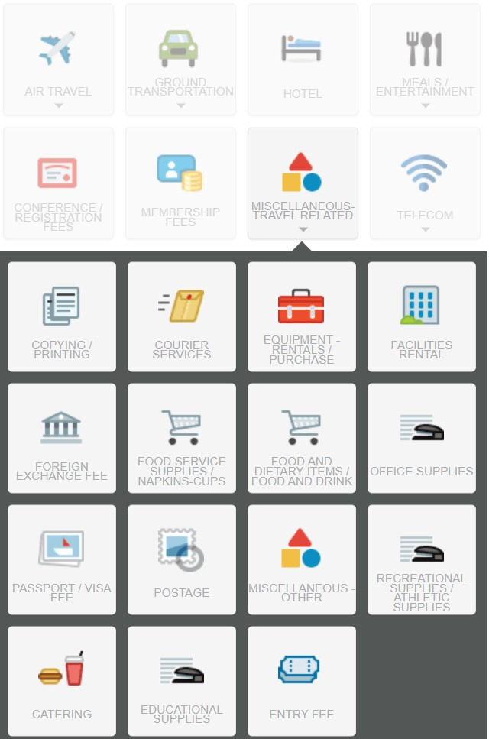

# Reimbursing an External Person

* If an external person travels on behalf of the University, they are entitled to payment for their expenses. Most commonly, this is candidates for a faculty position, and we bring them to campus for an interview.
* Occasionally, students will also travel on behalf of the university (to conferences)
* The same travel reimbursement rules apply to non-employees. Itemized receipts are needed for reimbursement.

## To enter a non-employee into the system they must fill out the “non-employee vendor enrollment form” and email it to [chromerivervendors@jmu.edu](mailto:chromerivervendors@jmu.edu)

* Students should fill out the form using their SA (Jaccard number), outside parties must use their SSN.
* You will get a confirmation email when they are in the system.
* Create your report as usual, but “Type of Traveler” will either be “Outside Party” or “Student” (pick accordingly)
* Click on the “non-employee” drop-down and select the traveler's name from the list.

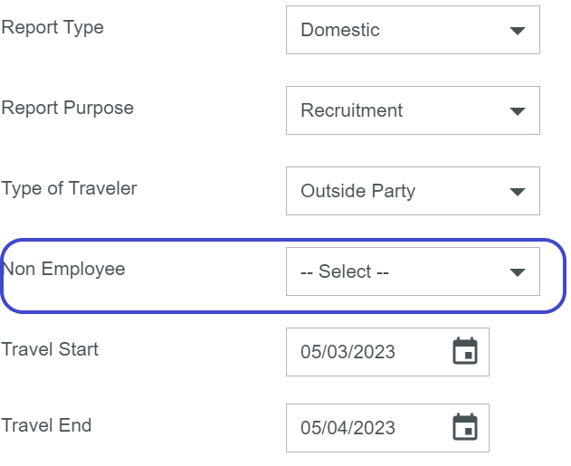

## Before submitting an Expense Report for an external person, they must sign the Cover Page and upload it as you would a receipt.

* Click on “PDF”
* “Cover Page”

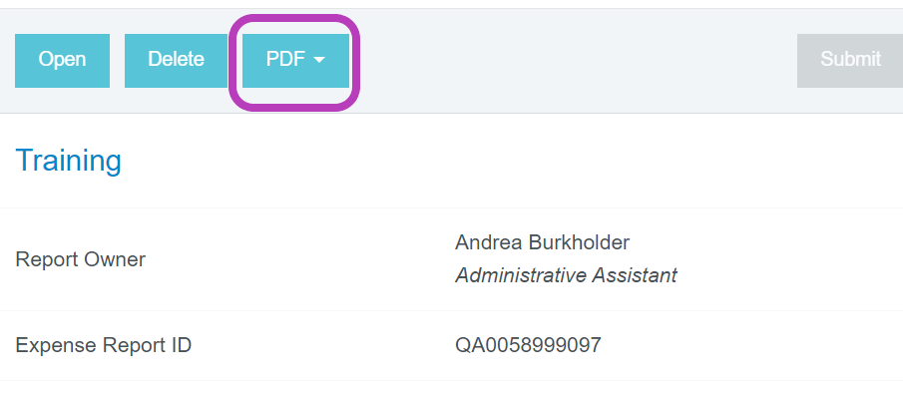

### Ask them to review the charges on the first page and sign the second page.

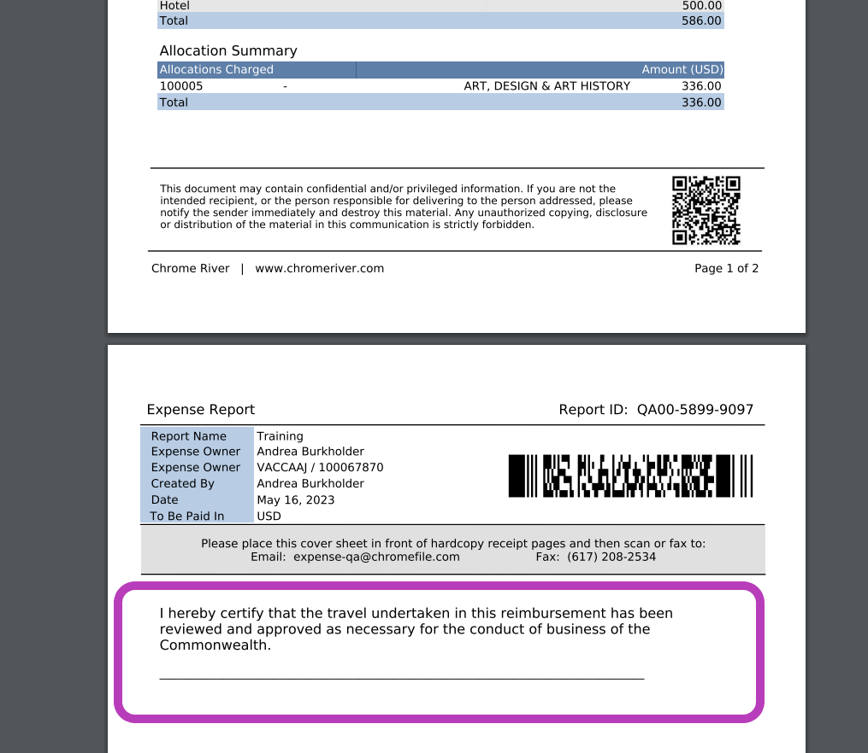

# Submitting an Expense Report & Attaching a Pre-approval

* When you’ve completed your report click “submit” at the bottom of the report.
* Submit Confirmation will pop up in the upper right-hand corner.
* If the report requires a pre-approval, click on “pre-approval” and select the correlating pre-approval that was created prior to travel. Then click “submit.”

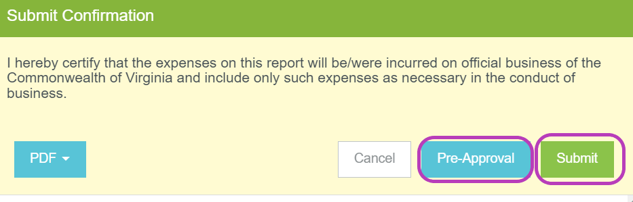

# Business Meals

* Meals while on official business must involve a substantive and bona fide business discussion with a non-University employee.
* A University employee should pay for the entire business meal and submit the receipt for reimbursement.
* An original, itemized receipt is required for reimbursement of all business meals.
* Tips for official business meals are limited to 20% of the food/drink before taxes.
* An approving authority may authorize a meal reimbursement of up to 50% over the applicable per diem rates with sufficient justification.
* Alcohol is not reimbursable.

### To get started, create a header for the report.

1. The date the meal took place
2. The Report type
3. The Report Purpose
4. Type of Traveler
5. Travel Start & End Date
6. Number of Business Days
7. Save

### Click on the “Meals and Entertainment” tile & “Business Meal.

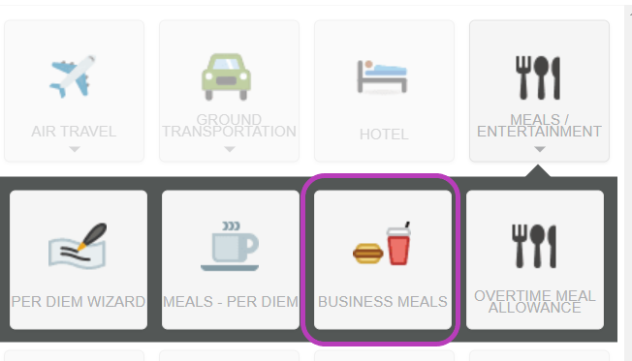

### Create your Business Meal Header

***Enter the date of the meal, and click on “Calculate” 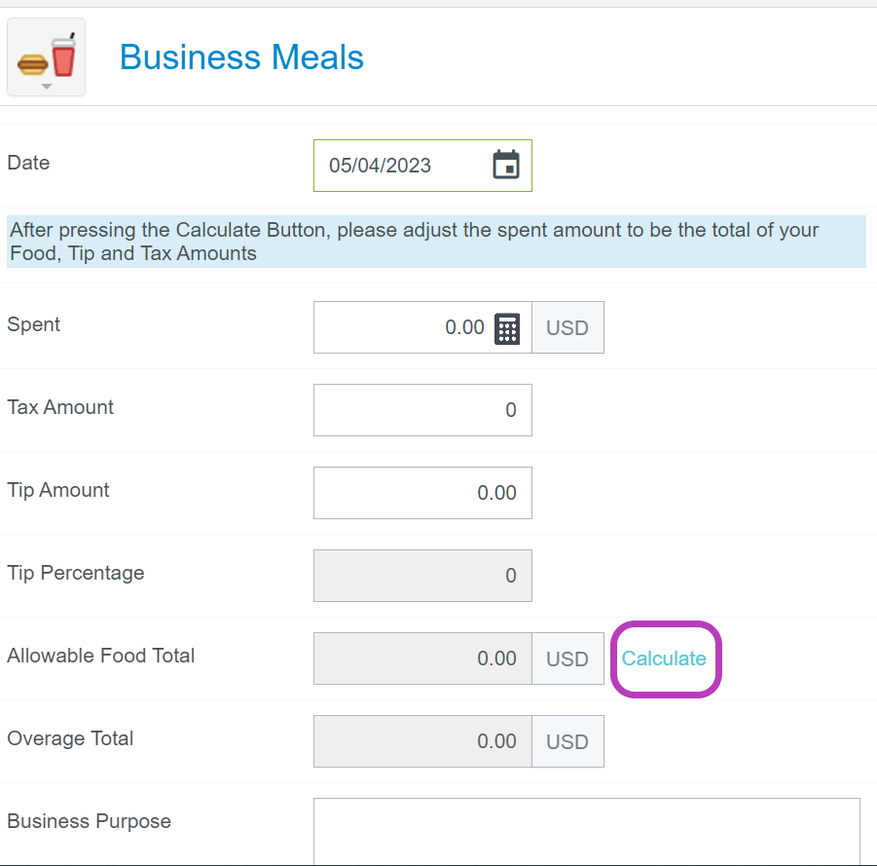

### Business Meal Calculate:

* Location – based on the receipt where the meal took place
* Meal Type – Breakfast, Lunch, or Dinner.
* Attendees – Enter the number of people who attended the business meal.
* Based on this information the system will calculate the following:
  + “Per Attendee” allowance
  + “Base Total (which is the per diem for the entire meal)
  + “Allowable Food Total” which is 50% over the per diem that can be given with proper justification.

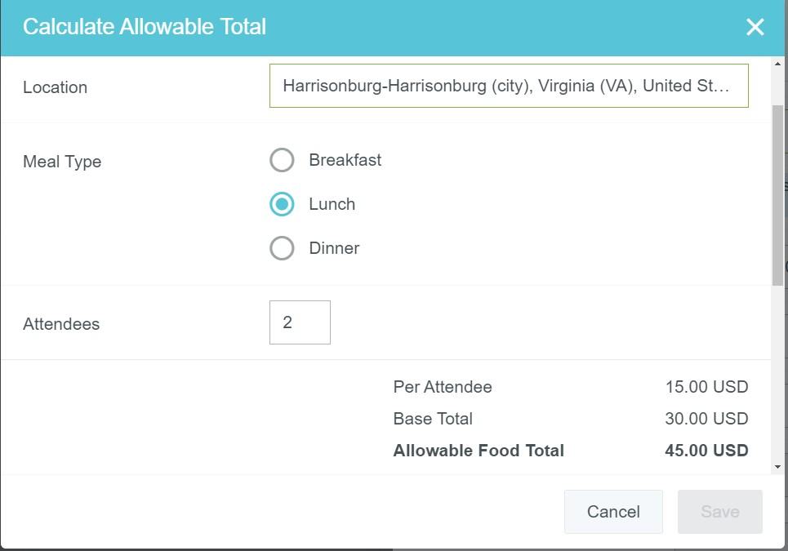

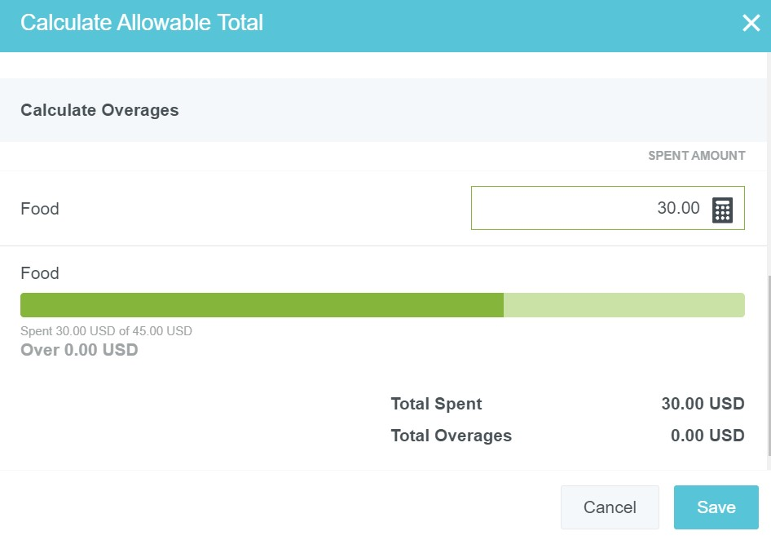

* Enter the “Food” total – this is the *subtotal* of the food purchased (without tax)
  + Click Save

This will take you back to the “Business Meal Header” screen.

* Enter the tax amount
* Enter the tip – tip cannot exceed 20% of the subtotal
* Please note – the subtotal from the “calculate” is automatically put into the “spent” field. This WILL make the tip percentage higher than it is.

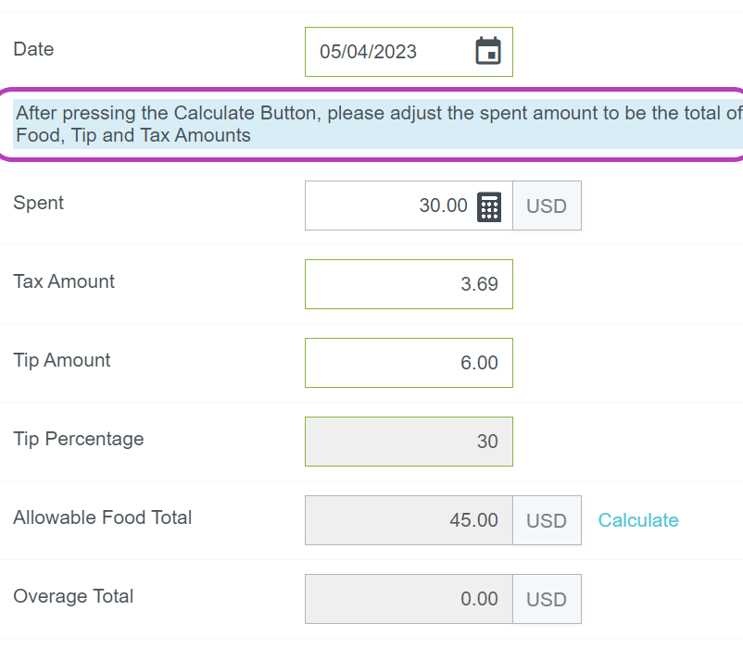

At this point, adjust the “Spent” to be the total of the food, tip, and tax amounts. The tip percentage will be adjusted accordingly to reflect the true percentage.

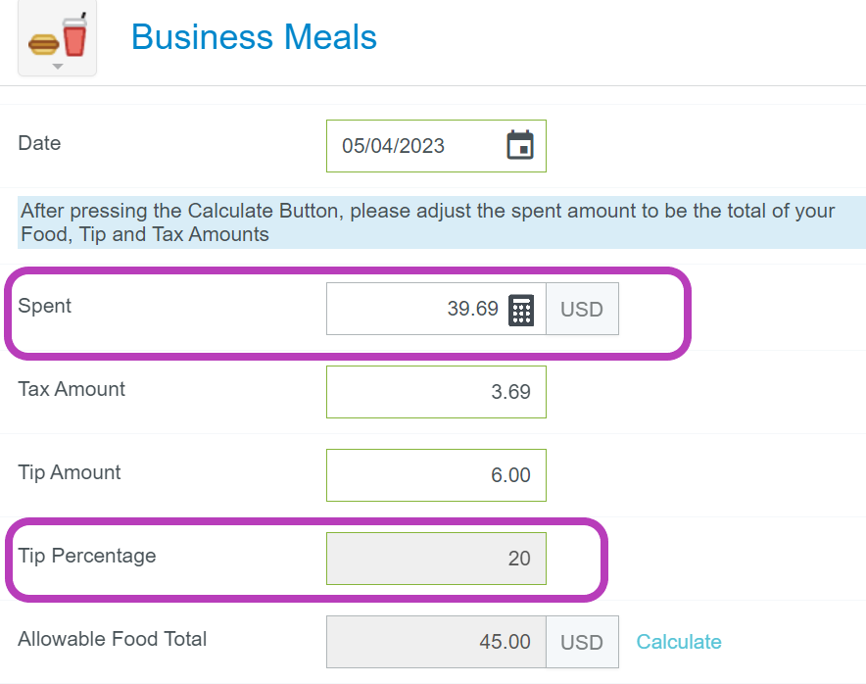

## Adding External Guest

A business meal must have at least one external guest.

* Scroll down to where it says “Guests”
* Select “External”
* Add New External Guest
* **Please note** this is also how you would add an external guest to any expense that required one (hotel, non-travel catering, etc.)

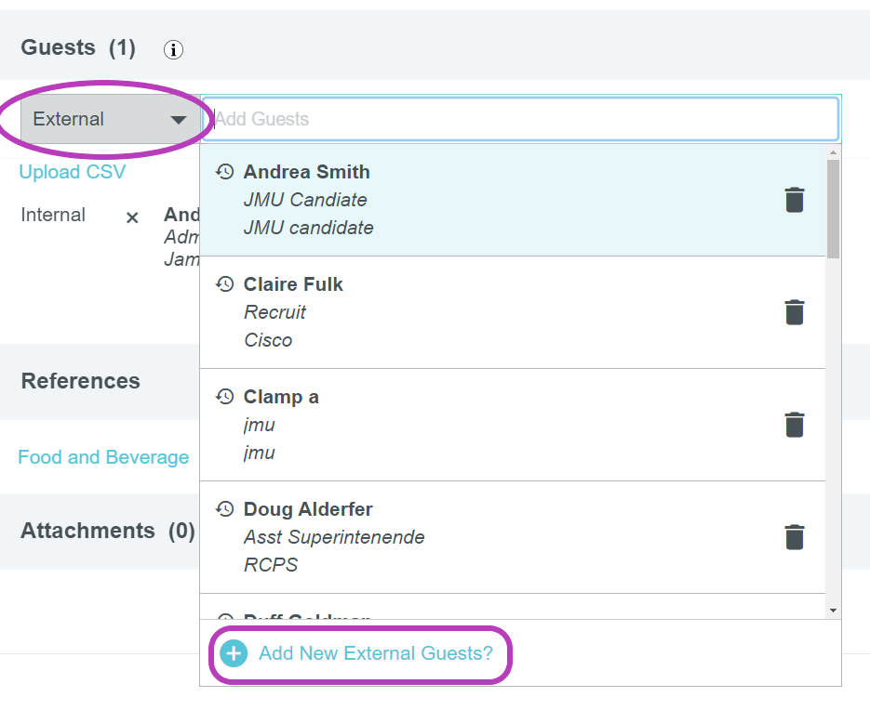

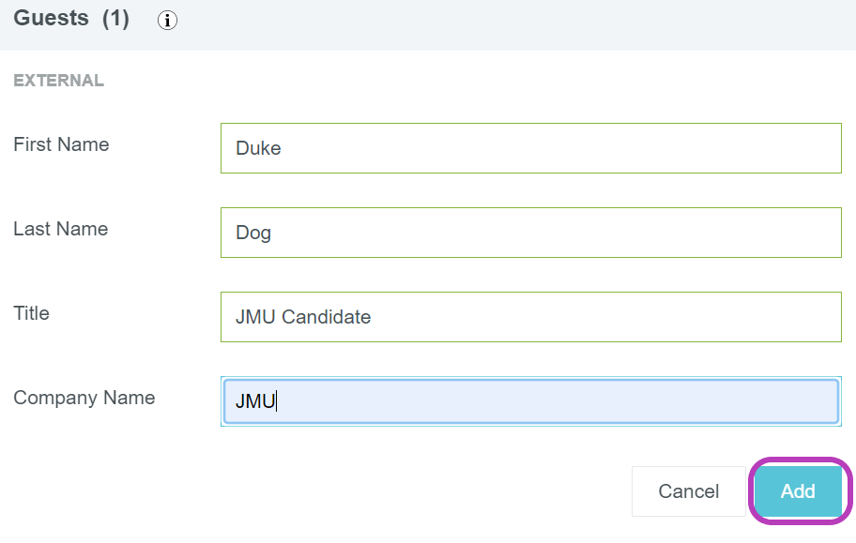

## Chrome River Reminders:

* Meals per diem are determined from where lodging occurred, and where the person laid their head at night. If a person travels to multiple locations during travel status, the per diem must change as well.
* To enter a report on behalf of another user, the primary user must first make you a delegate for their account
* All expenses must have an itemized receipt showing proof of payment.
* Receipts should be attached to the line items they correlate with (See pg. 15)
* All expenses must be in the user’s name for reimbursement. A spouse/parent, etc. cannot pay for a hotel, or airfare on behalf of someone traveling for JMU and it be reimbursed to a JMU employee.
* Employees cannot pay for other employee expenses and seek reimbursement (Hotel, Airfare, Conference fees)
* All expenses should include the full amount, if something is not reimbursable allocate the non-reimbursable portion to 9900, except for taxis and business meals.
* Hotel services or purchases that aren’t reimbursable should be itemized in the Personal Non-Reimbursable tile.
* The state cannot reimburse alcohol.
* The state will not reimburse personal expenses including transportation costs to or from personal meals, sightseeing, etc.
* Public transportation policy states that travelers must select economy vehicles when securing rental cars, and select coach/economy seating on trains, and planes. Luxury cars, limousines, XL taxis, and optional add-ons such as “Priority Pickup” are not reimbursable with state funds.
* Parking is included in the Public Transportation policy, and travelers must park in the lowest economy lot at airports, train and bus stations.
* Travelers must opt for self-parking when available at hotels.
* Mileage: The area within a 25-mile radius is the employee-designated base point, and mileage is not reimbursable if traveling within 25 miles of their base point.

## Chrome River Helpful Links

* Chrome River Training Materials: <https://www.jmu.edu/financeoffice/accounting-operations-disbursements/accounts-payable/chrome-river-training.shtml>
* Assigning a delegate <https://www.jmu.edu/financeoffice/_files/ap-files/how_to_become_a_delegate.pdf>
* Entering a Business Meal <https://www.jmu.edu/financeoffice/_files/ap-files/how_to_enter_business_meals.pdf>
* Entering a Hotel Expense <https://www.jmu.edu/financeoffice/_files/ap-files/How_To_Enter_Hotel_Expenses.pdf>

# Contact Information

**Accounts Payable: acctspayable@jmu.edu** (Departmental mailbox monitored during business hours)

## Chrome River

Tina Wells Manager 568-6231

Andrea Burkholder Academic Affairs 568-3713

Pam Cahill Student Affairs & Local Funds. 568-3714

Heather Baker Athletics, School of Music, & College of Education 568-2365