Project Name
Stormwater Pollution Prevention Plan (SWPPP)

Estimated Project Dates:
Start DATE
Completion DATE

Table of Contents
Section 1: Introduction 1
Plan Purpose 1
Section 2: Contact information 2
2.1 Responsible Parties 2
2.2 SWPPP Team 3
Section 3: Site evaluation, assessment and planning 4
3.1 Project/Site Information 4
3.2 Discharge Information 5
3.3 Nature of the Construction Activity 5
3.4 Sequence of Construction Activities 5
3.5 Allowable Non-Stormwater Discharges 6
Section 4: Erosion and Sediment Control Plan 6
Section 5: Stormwater Management Plan 7
Section 6: Pollution Prevention Plan 9
6.1 Contractor Training 10
6.2 Good Housekeeping 11
6.3 Hazardous Products 11
6.4 Petroleum Products 11
6.5 Miscellaneous Products 12
6.6 Spill Control Procedures 12
6.7 Portable Toilets 13
6.8 Washout BMPs for Concrete and Other Activities 13
6.9 Waste Management 14
Section 7: Inspections and Maintenance 14
7.1 Inspections 14
7.2 Maintenance 14
References 15

Appendices
Appendix A: CERTIFICATIONS
Operator Certification
Delegation of Authority Certification
Subcontractor Certification
RLD or Other Qualification Certification
Appendix B: CONSTRUCTION GENERAL PERMIT
Signed Copy of Registration Statement
Construction General Permit Coverage Letter
Construction General Permit
Transfer of Ownership Agreement
Notice of Termination Form
Appendix C: Records of Land Disturbance
Appendix D: Daily Precipitation Log
Inspection Reports
Appendix E: SWPPP Map
Site Plan
Land-Disturbing Permit and/or CGP Coverage Letter for Spoils/Borrow Sites
Appendix F: SWPPP Modifications Log

Section 1: Introduction

Plan Purpose
This Stormwater Pollution Prevention Plan (SWPPP) has been developed in accordance with the requirements of the Virginia Stormwater Management Program (VSMP) General Permit for Discharges of Stormwater from Construction Activities (Permit), as defined in General Permit No. VAR10 Effective Date: July 1, 2014 Expiration Date: June 30, 2019. The purpose of this SWPPP is to:
- Identify potential sources of pollution that may reasonably be expected to affect the quality of stormwater discharges from the construction site, and;
- To describe and ensure the implementation of practices that will be used to reduce pollutants in stormwater discharges from the construction site and to assure compliance with the conditions of the Permit.
Implementation of the components of this SWPPP is required as a condition of the Permit (Appendix B). James Madison University has been granted authority to administer the VSMP program through the use of annual standards and specifications by the Virginia Department of Environmental Quality (DEQ).
Coverage under the Permit will be deemed terminated at midnight on the date the Notice of Termination is submitted.

Section 2: Contact information

2.1 Responsible Parties
Construction Site Operator
Company:
Name, Position:
Address:
Phone:
email:
Registered Land Disturber (RLD)
Company:
Name, Position:
Certification #:
Address:
Phone:
email:
JMU Project Manager
Name:
Address:
Phone:
email:
JMU Project Engineer
Name:
Address:
Phone:
email:
JMU Stormwater Coordinator
Name: Dale Chestnut
Address: 181 Patterson St., Harrisonburg, VA 22807
Phone: (540) 568-7606
email: chestndl@jmu.edu

2.2 SWPPP Team
SWPPP Coordinator
Company:
Name:
Address:
Phone:
email:
Responsibilities: Create a SWPPP Team to aid in the implementation of the SWPPP and ensure SWPPP measures are adequately implemented. Oversee day-to-day activities, operation and maintenance of BMPs, provide subcontractor training, conduct or provide for required inspections and reports, identify site and SWPPP deficiencies and correct as needed, ensure project site map is kept up to date as project progresses, and ensure any changes in operation from the SWPPP or approved plan are addressed in the SWPPP.
SWPPP Team Member
Company:
Name:
Address:
Phone:
email:
Responsibilities:
SWPPP Team Member
Company:
Name:
Address:
Phone:
email:
Responsibilities:

(See Appendix A for additional personnel and certification forms.)

Section 3: Site evaluation, assessment and planning

3.1 Project/Site Information
Project Name and Address
Project/Site Name: Project Name
Project Street/Location: Project Street
City, State, Zip Code Harrisonburg, VA 22807
Project Latitude/Longitude
38°26’29.81” N 78°52’40.76” W (Lat/Long)
Method for determining latitude/longitude: Google Earth
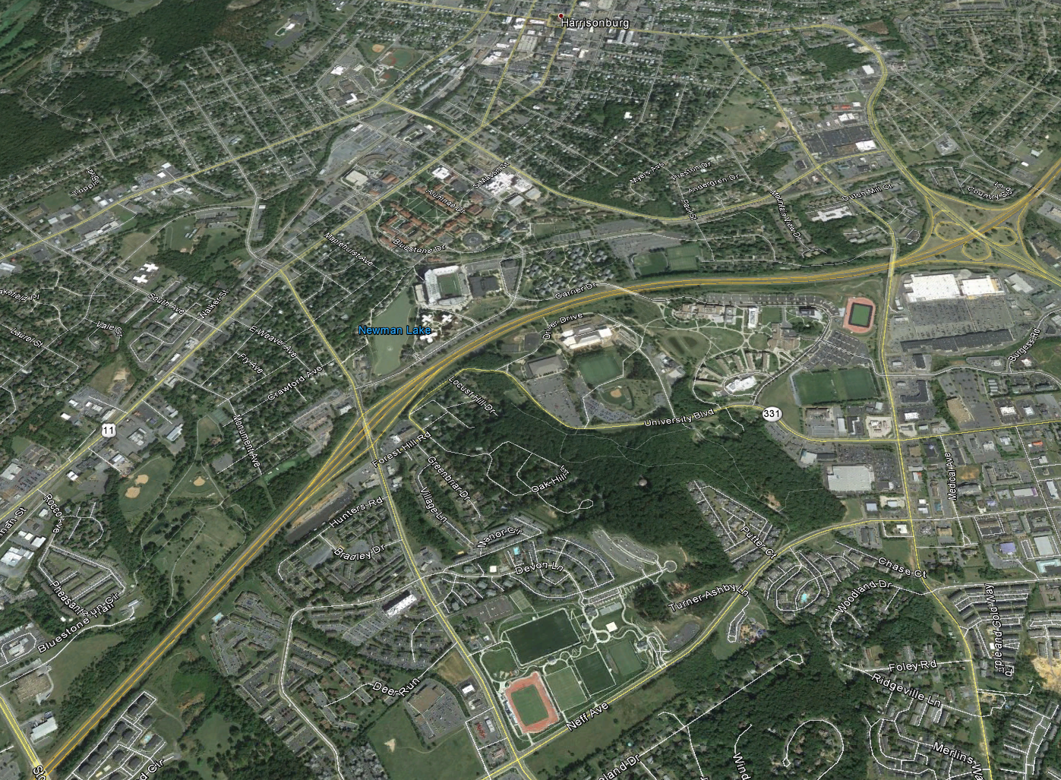
Precipitation data will be gathered from a rain gauge located on-site or by using the Weather Underground website (www.wunderground.com) using a nearby location in Harrisonburg, Virginia. Precipitation data will be documented on the Daily Precipitation Log in Appendix D or in daily construction reports.

3.2 Discharge Information
This project discharges to James Madison University’s Municipal Separate Storm Sewer System (MS4) which is within the Blacks Run (HUC PS22) tributary of the Potomac River watershed and is also part of the larger Chesapeake Bay watershed. Blacks Run flows into Cooks Creek, then the North River, then into the South Fork of the Shenandoah River, then the Potomac River, and eventually into the Chesapeake Bay. Blacks Run is several hundred miles inland of the Chesapeake Bay and hundreds of feet above in elevation, and is therefore not tidally influenced.
The approximate 12,000 acre Blacks Run watershed is characterized by mostly built-up lands (approximately 8,000 acres) with the remaining lands being mostly pasture and croplands. The rate of urbanization within the Blacks Run watershed has, thus far, outpaced efforts to mitigate its environmental impacts. As a result, Blacks Run is included on the state’s 305(b)/303(d) Water Quality Assessment Integrated Report as a Category 4A water body. Category 4A waters are those that are impaired (i.e. do not attain their intended/desired use) and have been assigned a TMDL to address the impairments. Blacks Run was deemed to be impaired due to elevated levels of fecal coliform and e. coli bacteria, as well as benthic-macroinvertebrate bioassessments. A waste load allocation (WLA) has not been assigned.
As such, this project will need to implement the additional required measures as outlined in Part I B 4 and Part II A 5 of the Construction General Permit:
- Permanent or temporary soil stabilization shall be applied to denuded areas within seven days after final grade is reached on any portion of the site;
- Nutrients shall be applied in accordance with manufacturer’s recommendations or an approved nutrient management plan and shall not be applied during rainfall events: and
- The required SWPPP inspection schedule shall be amended as follows:
  - Inspections shall be conducted at a frequency of (i) at least once every four business days or (ii) at least once every five business days and no later than 48 hours following a measurable storm event. In the event that a measurable storm event occurs when there are more than 48 hours between business days, the inspection shall be conducted on the next business day.

3.3 Nature of the Construction Activity
PROJECT DESCRIPTION …

3.4 Sequence of Construction Activities
Following is a basic sequence for construction activities of this project.
- Site preparation.
  - Installation of ESC measures according to approved site plan. (See referenced site plan)
- Install utilities.
- Building Construction.
- Final grading and stabilization.
  - Prepare ground for permanent stabilization.
  - Await establishment of permanent stabilization.
- Removal of ESC measures.
  - Remove ESC measures and re-stabilize any areas disturbed in this process.

3.5 Allowable Non-Stormwater Discharges
Type of Allowable Non-Stormwater Discharge | Likely to be Present at Site
Discharges from firefighting activities. | Yes No
Fire hydrant flushing. | Yes No
Waters used to wash vehicles or equipment where soaps, solvents, or detergents have not been used and the wash water has been filtered, settled, or similarly treated prior to discharge. | Yes No
Water used to control dust that has been filtered, settled, or similarly treated prior to discharge. | Yes No
Potable water sources, including uncontaminated waterline flushing. | Yes No
Routine external building wash down where soaps, solvents or detergents have not been used and the wash water has been filtered, settled, or similarly treated prior to discharge. | Yes No
Pavement wash waters where spills or leaks of toxic or hazardous materials have not occurred (or where all spilled or leaked material has been removed prior to washing); where soaps, solvents, or detergents have not been used and where the wash water has been filtered, settled, or similarly treated prior to discharge. | Yes No
Uncontaminated air conditioning or compressor condensate. | Yes No
Uncontaminated ground water or spring water. | Yes No
Foundation or footing drains where flows are not contaminated with process materials such as solvents. | Yes No
Uncontaminated excavation dewatering, including dewatering of trenches and excavations that have been filtered, settled, or similarly treated prior to discharge. | Yes No
Landscape irrigation. | Yes No
Diverted stream flows, rising ground water, flows from riparian habitats and wetlands. | Yes No

Section 4: Erosion and Sediment Control Plan
This project site shall comply with the minimum standards specified in section 9VAC25-840-40 of the Virginia Administrative Code regulations unless an approved variance has been accepted as part of the plan by the Department of Environmental Quality. Unless specified, all erosion and sediment control practices shall conform to the latest edition of the Virginia Erosion and Sediment Control Handbook and/or JMU’s Annual Standards and Specifications for ESC and SWM.
The SWPPP Coordinator, or delegated individual, shall be responsible for implementing the approved ESC plan including proper installation and maintenance of all control measures.
The approved erosion and sediment control plan for this project is included by reference to plans entitled “PLAN TITLE” prepared by ENGINEER and originally approved for ESC on DATE. This ESC plan will be kept with the SWPPP on-site in the construction trailer or office.
The approved ESC plan and any additional measures shall be installed in order to:
- Control stormwater volume and velocity within the site to minimize soil erosion;
- Control stormwater discharges, including both peak flow rates and total stormwater volume, to minimize erosion at outlets and to minimize downstream channel and stream bank erosion;
- Minimize the amount of soil exposed during construction activity;
- Minimize the disturbance of steep slopes;
- Minimize sediment discharges from the site. Site design, installation and maintenance of erosion and sediment controls must address factors such as the amount, frequency, intensity and duration of precipitation, the nature of resulting stormwater runoff, and soil characteristics, including the range of soil particle sizes expected to be present on the site;
- Provide and maintain natural buffers around surface waters, direct stormwater to vegetated areas to increase sediment removal and maximize stormwater infiltration, unless infeasible;
- Minimize soil compaction and, unless infeasible, preserve topsoil;
- Stabilization of disturbed areas must, at a minimum, be initiated immediately whenever any clearing, grading, excavating, or other earth disturbing activities have permanently ceased on any portion of the site, or temporarily ceased on any portion of the site and will not resume for a period exceeding 14 calendar days. Stabilization must be completed within a period of time determined by the VSMP authority. In arid, semiarid, and drought-stricken areas where initiating vegetative stabilization measures immediately is infeasible, alternative stabilization measures must be employed as specified by the VSMP authority; and
- Utilize outlet structures that withdraw water from the surface, unless infeasible, when discharging from basins and impoundments.

Section 5: Stormwater Management Plan
The approved stormwater management plan for this project is included by reference to plans entitled “PLAN TITLE” prepared by ENGINEER, and originally approved for SWM on DATE. This plan will be kept with the SWPPP on-site in the construction trailer or office.
Permanent stormwater facilities shall be installed per the approved plans in accordance with the standards and specifications provided on the Virginia Stormwater BMP Clearinghouse at https://www.swbmp.vwrrc.vt.edu/ .
A construction record drawing for each permanent stormwater management facility shall be submitted to the JMU Stormwater Coordinator. The construction record drawing shall be appropriately sealed and signed by a professional registered in the Commonwealth of Virginia, certifying that the stormwater management facilities have been constructed in accordance with the approved plan. (9VAC25-870-55 D)
In addition to the record drawing, ensure the following supporting documentation is provided for the following permanent stormwater BMP’s:
- Bio-Retention
  - Topographical survey of basin bottom before fill material is placed.
  - Specifications and thickness of liner used.
  - Soil media delivery tickets.
  - Density report for clay liner.
  - Photo documentation of installation.
    - Fabric liner
    - Stone layer with underdrain
    - Pea gravel
    - Soil media
    - Mulch
    - Height of outlet structure
    - Freeboard measurements
  - Topographical survey after complete with storage volume calculated.
- Detention Basin
  - Topographical survey after complete with storage volume calculated.
  - Finish grade elevations
    - Pipe inlets and outlets
    - Control structure rim, inlet and outlet
    - Top of bank
    - Emergency spillway
- Detention Basin, Underground
  - Finish grade elevations
    - Rim
    - Pipe inlets and outlets
    - Floor
    - Any control structure elevations
- Hydrodynamic Separator
  - Photo documentation of installation
  - Finish grade elevations
    - Rim
    - Pipe inlets and outlets
    - Sump
- Permeable Pavements
  - Photo documentation of installation.
    - Depth before fill material is placed.
    - Fabric liner
    - Stone layer with underdrain
    - Other stone layers
    - Geogrid
    - Pavers
  - Invert elevations of all piping to show positive flow to outlet.
- Stormfilter Systems
  - Activation/Certification letter from installer.
  - Finish grade elevation for rim, pipe inlets and outlets and sump.
  - Number of filters, filter type, and whether quarter turn or screw in type filter.
- Tree in a Box Manufactured Systems (Filterra, etc.)
  - Activation/Certification letter from installer.
  - Finish grade elevations for system drop inlet and bypass/overflow inlet.
  - Type of plant installed in system.

Section 6: Pollution Prevention Plan
Potential sources of sediment to stormwater runoff:
- Clearing and grubbing operations
- Grading and site excavation operations
- Vehicle tracking
- Topsoil stripping and stockpiling
- Landscaping operations
Measures for items listed above can be found in the approved ESC plan.
Potential pollutants and sources, other than sediment, to stormwater runoff:
- Combined Staging Area: Small fueling activities, minor equipment maintenance, sanitary facilities, and hazardous waste storage.
- Materials Storage Area: General building materials, solvents, adhesives, paving materials, paints, aggregates, trash, and so on.
- Construction Activity: Paving, curb/gutter installation, concrete pouring/mortar/stucco, and building construction.
- Concrete Washout Area
The following table is to identify and describe potential construction site pollutants.
Material/Chemical | Pollutants | Location on Site *
Anti-freeze/coolant | Ethylene glycol, propylene glycol, heavy metals (copper, lead, zinc). | Equipment/vehicles and secondary containment/staging area. See SWPPP map for storage areas.
Asphalt | Oil, petroleum distillates. | Streets, parking, roofing. See approved site plan.
Cleaning Solvents | Perchloroethylene, methylene chloride, trichloroethylene, petroleum distillates. | No equipment/vehicle cleaning allowed within project limits. See SWPPP map for storage areas.
Concrete | Limestone, sand, pH, chromium. | Curb and gutter, sidewalks, building construction. See approved site plan. See SWPPP map for location of washout area.
Curing compounds | Naphtha. | Curb and gutter. See approved site plan.
Diesel Fuel | Petroleum distillate, oil, grease, naphthalene, xylenes. | Equipment/vehicles and secondary containment/staging area. See SWPPP map for storage areas.
Fertilizer | Nitrogen, phosphorous. | Newly seeded areas. See approved site plan for grassed/planted areas. See SWPPP map for storage areas.
Gasoline | Benzene, ethyl benzene, toluene, xylene, MTBE. | Equipment/vehicles and secondary containment/staging area. See SWPPP map for storage areas.
Glue, adhesives | Polymers, epoxies. | Building construction. See approved site plan. See SWPPP map for storage areas.
Hydraulic oil/fluids | Mineral oil. | Equipment/vehicles on-site.
Kerosene | Coal oil, petroleum distillates. | Vehicles and secondary containment/staging area. See SWPPP map for storage areas.
Paints | Metal oxides, stoddard solvent, talc, calcium carbonate, arsenic. | Building construction. See approved site plan. See SWPPP map for storage areas.
Pesticides | Chlorinated hydrocarbons, organophosphages, carbamates, arsenic. | Used for noxious weed control. See SWPPP site map for storage location.
Plaster | Calcium sulphate, calcium carbonate, sulfuric acid. | Building construction. See approved site plan.
Portable toilets | Bacteria, parasites, viruses. | See SWPPP site map for locations.
Wood preservatives | Stoddard solvent, petroleum distillates, arsenic, copper, chromium. | Building construction. See approved site plan. See SWPPP map for material storage areas.
* (Area where material/chemical or BMP practice implemented on-site)
The following practices will be used to reduce the risk of spills or exposure of undesirable materials to stormwater runoff in compliance with Part II A 4 of the construction general permit.

6.1 Contractor Training
It will be the responsibility of the SWPPP Coordinator to ensure all contractors are aware of SWPPP requirements and their role in permit compliance. Each contractor performing work that may come into contact with stormwater run-off will be required to complete the Subcontractor Certification form to be included in Appendix A. At a minimum this will include the project excavator, concrete, landscape, masonry, painting, and fueling contractors. Other contractors may be required as deemed necessary by the SWPPP Coordinator, JMU Project Manager, JMU Project Engineer, or JMU Stormwater Coordinator.

6.2 Good Housekeeping
The good housekeeping practices described below will be followed during construction activities.
- All materials stored on-site will be stored in a neat and orderly fashion. Materials that have potential for contaminating stormwater runoff shall be protected from coming in contact with precipitation and stormwater runoff.
- Liquid materials will be stored within approved or manufacturer recommended watertight containers.
- Any empty container that held any potentially harmful substances shall be disposed of immediately after its contents are depleted in accordance with the manufacturer’s labels.
- Where possible, substances shall be kept in their original containers with the manufacturer’s labels.
- All substances shall be used up before disposing of empty containers. Any surplus substances to be used elsewhere shall be transported off-site in their original container according to Federal, State and local laws and regulations. All unused substances scheduled for disposal shall be done so in accordance with Federal, State and local laws and regulations.
- All contractors working on the site shall follow manufacturer’s recommendations for use of all substances on the construction site.
- Materials shall be stored and handled in such a way to prevent spills. All storage containers shall be tightly sealed and shall be clearly labeled.
- All on-site vehicles and equipment shall be checked for leaks on a regular basis. Any spills or leaks encountered at the site shall be cleaned up immediately. Vehicle or equipment maintenance should be conducted off-site.

6.3 Hazardous Products
- Hazardous substances shall be stored in their original container, unless the container is not re-sealable. After market or non-original containers shall be approved by the governing agency or manufacturer to contain the specified hazardous substance.
- Original labels shall be affixed to the storage container. All Material Safety Data Sheets (MSDS) shall be kept on file. Only trained personnel shall be permitted to handle hazardous substances.
- If hazardous material is received in bulk quantity, then that material shall be stored in a manufacturer’s recommended container or container that is approved by the governing regulatory agency.
- Hazardous materials shall be stored under cover and prevented from coming in contact with precipitation and stormwater runoff.

6.4 Petroleum Products
- If petroleum based products are received in bulk quantity, then that substance shall be stored in a manufacturer’s recommended container or container that is approved by the governing regulatory agency.
- Storage of fuel on-site shall require a double walled container or other secondary containment measures.
- Refueling procedures shall be conducted in a manner so as to minimize incidental release of petroleum products. It is recommended that if repairs are required on a construction vehicle, then that activity should be conducted off-site. However, if off-site repairs are not feasible then the contractor shall make provisions to prevent the discharge of any petroleum products. Repair or maintenance activities will not take place within or in the proximity of environmentally sensitive areas, sanitary sewer structures or stormwater receptors.
- Petroleum-based spills will be subject to notification to the appropriate first-responders and governing environmental authorities.

6.5 Miscellaneous Products
- Fertilizers shall be selected and applied in accordance with the Virginia Erosion and Sediment Control Handbook, JMU’s Nutrient Management Plan, and manufacturer’s recommendations. Partially open bags of fertilizer shall be stored in re-sealable plastic containers.
- All paint containers shall be sealed and stored in accordance with the manufacturer’s recommendations. Paint containers shall be sheltered from precipitation and stormwater runoff. Used paint containers shall not be rinsed or cleaned on-site and disposal of paint and used paint containers shall be in accordance with Federal, State and local laws and regulations.
- Concrete truck drum wash water or surplus concrete shall be discharged only at approved locations and in accordance with Federal, State and local laws and regulations.

6.6 Spill Control and reporting of unauthorized discharges
Spills and leaks will be adequately contained and cleaned as soon as possible. Large spills or discharges shall be reported to the DEQ as required in Section III G, H, or I of the general permit. Copies of reports will also need to be forwarded to the JMU Project Manager and JMU Stormwater Coordinator.
- Contain the spill as near the source as possible and secure the immediate surrounding area to minimize the area contaminated by the spill product. Keep the spill area well ventilated and immediately clean up all spills once they are adequately contained.
- Approved manufacturers recommendations for spill cleanup shall be clearly posted. All construction site personnel shall be aware of the posted information.
- All applicable spill response plans and MSDS shall be kept on file.
- All spills shall be cleaned up immediately upon discovery. If a spill cannot be cleaned by on-site personnel, then the appropriate authorities shall be notified.
- In the event of a spill, personnel shall wear appropriate personal protective equipment (PPE) to prevent injury from contact with the material(s) during cleanup efforts.
Spill kits shall be located on-site as needed for expedited clean-up, and shall be located on the SWPPP site map. Sub-contractors will be made aware of location of spill kits, and who to contact on-site in case of a spill or leak.
Contact information for the DEQ Valley Regional Office is:
4411 Early Road, PO Box 3000  Harrisonburg, VA 22801 | Office Hours:  8:30am – 4:30pm Monday – Friday  Phone: (540) 574-7800
To file a report after hours, do a web search for “PREP how to report pollution” or visit: https://www.deq.virginia.gov/Programs/PollutionResponsePreparedness/MakingaReport.aspx

6.7 Portable Toilets
Portable toilets are to be placed on a level surface away from waterways, storm drainage systems, and areas of heavy vehicular traffic. If the flow path from the toilet is less than 50 feet to a waterway or storm inlet or ditch, toilets may need to be staked or further secured. Toilets are to be maintained and cleaned as needed, and regularly inspected for leaks.
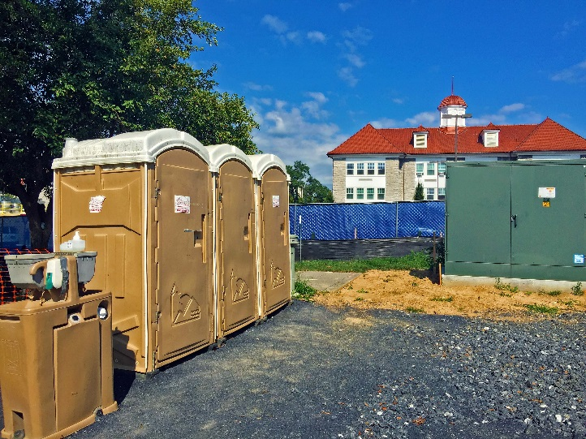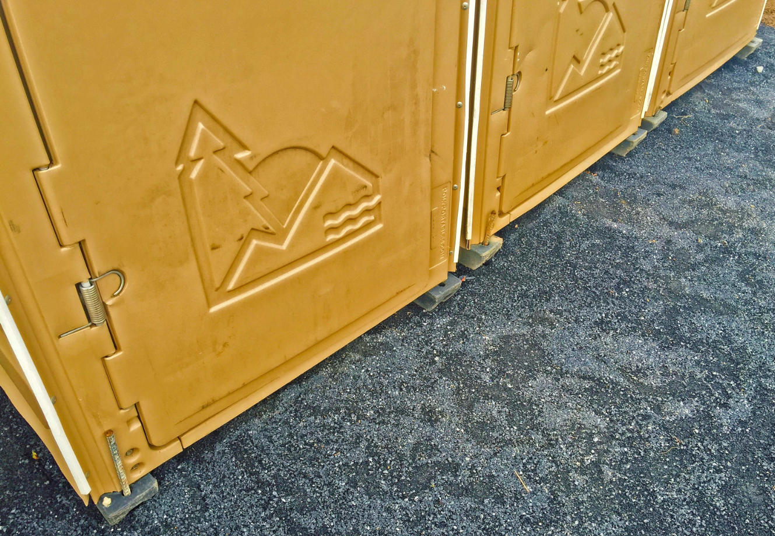

6.8 Washout BMPs for Concrete and Other Activities
Measures for washout operations for concrete, masonry, or other activities shall be provided for on-site. Washout measures shall be waterproof and sized appropriately for the construction activity.
Washout facilities should be inspected daily and after heavy rains to check for leaks, identify any damages to linings, and determine whether the capacity is over 75%. Repairs and maintenance shall be made as needed.
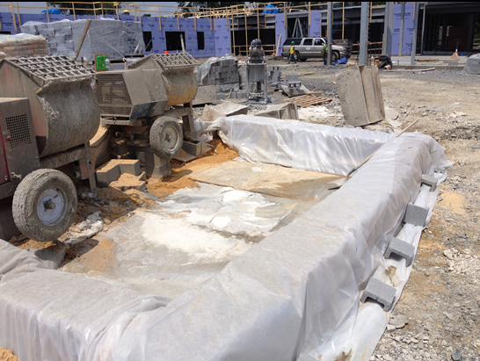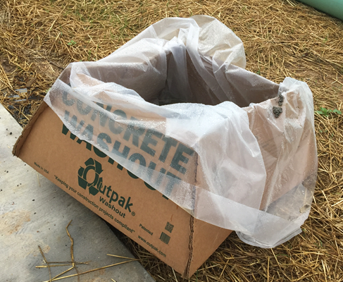
For additional reference and selection of possible measures, visit the EPA’s website and view their publication for Concrete Washout. (http://www3.epa.gov/npdes/pubs/concretewashout.pdf ).

6.9 Waste Management
Dumpsters and/or trash cans shall be provided for on-site. Litter and debris is to be cleaned up daily, and containers completely covered at the end of each day and during precipitation events. Containers are to be emptied on a regular basis to prevent overflow.
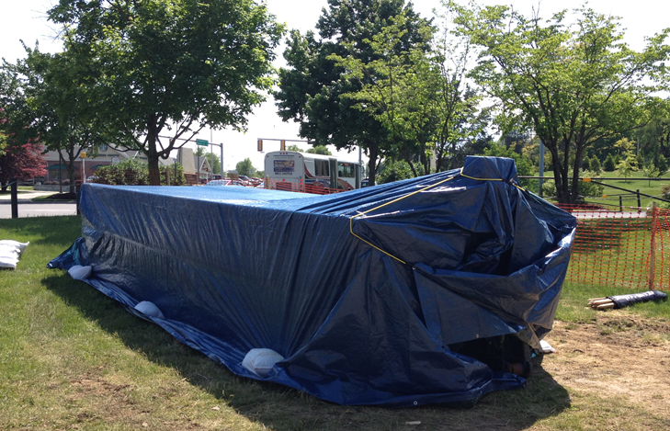

Section 7: Inspections and Maintenance

7.1 Inspections
Personnel familiar with all aspects of the SWPPP and the employed control practices shall perform regular inspections of the construction site. Inspections shall be conducted as required in Part I-B of the general permit, which states “Inspections shall be conducted at a frequency of (i) at least once every four business days or (ii) at least once every five business days and no later than 48 hours following a measureable storm event.” Inspections are intended to identify areas where the pollutant control measures at the site are ineffective and are allowing pollutants to enter surface waters, and to identify measures that require maintenance.
If as a result of the inspection, the site conditions and/or control measures are found to have changed, this SWPPP shall be updated within a period of 7 calendar days. If control measures need to be modified to assure effectiveness or if additional measures are determined necessary, implementation shall be completed prior to the next anticipated storm event or as soon as practicable.
A report summarizing the inspections and the subsequent maintenance activities must be completed and maintained as part of this SWPPP. The inspection forms are included in Appendix D. Required elements include major observations (including information on control measure performance and incidents of non-compliance), and information on the inspecting personnel. Please note that ESC/VSMP compliance inspections conducted by JMU or other regulatory agencies does not count toward or replace the need for contractor self-inspections.

7.2 Maintenance
Maintenance of temporary and permanent erosion and sediment control facilities shall be carried out in accordance with Virginia Erosion and Sediment Control Regulations. During the period that the project site is under construction, the contractor will be responsible for maintenance of the temporary erosion and sediment control facilities. The site contractor shall inspect the erosion and sediment control facilities on a regular basis, especially after periods of rainfall, and repair any damage immediately. Details of controls are contained in the project design plans and/or the latest revision of the Virginia Erosion & Sediment Control Handbook and are incorporated in this SWPPP by reference.

References
Approved Site Plan. Plan Title. Prepared by ENGINEER, approved for ESC on DATE and SWM on DATE.
Environmental Protection Agency. Concrete Washout. http://www3.epa.gov/npdes/pubs/concretewashout.pdf
James Madison University. Standards and Specifications for ESC and SWM.
http://www.jmu.edu/facmgt/sustainability/Stormwater/site-plan-review.shtml
Virginia Department of Environmental Quality. Virginia Erosion and Sediment Control Handbook. http://www.deq.virginia.gov/Programs/Water/StormwaterManagement/Publications/ESCHandbook.aspx
Virginia Department of Environmental Quality. Virginia Stormwater BMP Clearinghouse.
http://www.vwrrc.vt.edu/swc/StandardsSpecs.html

