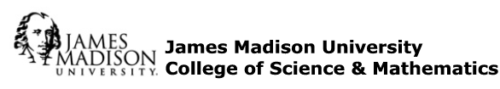

The Distinguished Service Award for 2018-2019

James Madison University prides itself on the accomplishments and commitment of its faculty. Each year the College of Science & Mathematics presents to one faculty member the Distinguished Service Award in recognition of superlative achievement in the area of service and outreach to one’s field to the local, regional, national, or international community. Service as defined by the Faculty Handbook is to include committee service and leadership at James Madison University or in professional or educational organizations, or service otherwise enhancing the profession, academic unit, college or university. III.E.2b.(3)

The recipient of the College of Science and Mathematics Distinguished Service Award will be chosen by the College Faculty Assistance Committee. The recipient will be given an honorarium of $1,500 and be recognized at a college meeting in the spring.

Candidate Requirements and Procedures

Criteria:
- Candidate has demonstrated a depth and breadth of outstanding service and outreach beyond the departmental level.
- Candidate has taken on a variety of roles and responsibilities at local, regional, national and international levels, including leadership positions.

Eligibility:
- Currently teaches undergraduates and/or graduate students.
- Currently has full-time (non-retired or non-emeritus) status.
- Has completed at least five years of service at JMU at the rank of assistant professor or above.
- Has never received the College Distinguished Service Award.

Nominations may be made by individuals, colleagues, or the department head. Nominees should submit a dossier that consists of:
- The service portion of current vitae
- A maximum of three letters of recommendation highlighting the candidate’s breadth and depth of professional-related experience. One of the letters should be from someone off campus who can attest to the distinguished service of the nominee.
- Additional supporting evidence as the recipient wishes.

There are no special forms for the nomination.

Due electronically as a PDF to the Dean’s office (College of Science and Mathematics) by noon, November 1, 2017 (nealeap@jmu.edu and).

