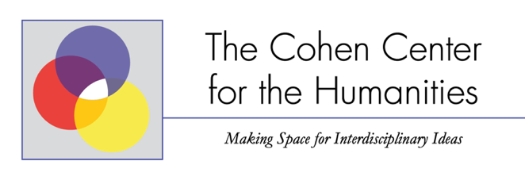
Cohen Center Sponsorship Request
The Cohen Center co-sponsors events supporting humanistic inquiry, interdisciplinary collaboration and/or graduate education. We welcome requests for funding for up to $500 for events that support these endeavors. Requests are reviewed by the Cohen Center Advisory Board and the Center Director.
For funding consideration, please complete this form and submit it to Michael J. Klein at kleinmj@jmu.edu.
Please submit requests at least two months prior to the event and allow two weeks for a response.

Your name: | Your department: | Your e-mail:
Event name: | Event date: | Event venue:
Amount requested ($500 maximum):
Event description:

How will the event support the Cohen Center’s mission?

How will you disseminate information about the event?

How will you assess the impact of the event?

Who else will be funding this event?

For those proposals selected, we ask that you state that the event is co-sponsored by The Cohen Center for the Humanities on all publicity materials (we can provide you with a print-ready logo). We also ask that, after the completion of the event, you inform us about the event attendance and impact on the JMU community.

